BCR Vendor/Class Discount
Vendor Class Discounts will allow you to set the costs on purchase orders for specific vendors to different discounts or multipliers on either the item’s List (Base) price level or the item’s Retail Price depending on the Item Class assignment of the item. These calculated costs will supersede item vendor or item standard or most recent costs.
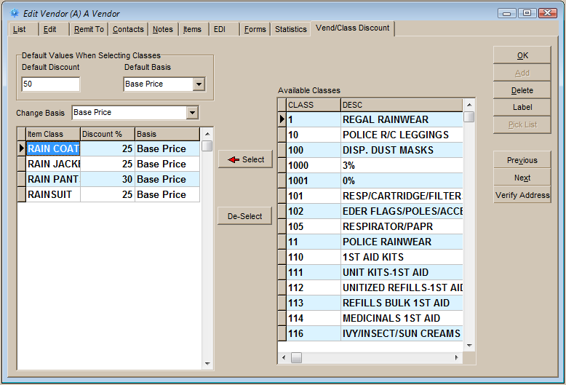
Vendor/class discounts are assigned on the Vend/Class Discount tab in Edit Vendors. Item Classes are selected from the right grid. When a class is selected the Default Discount and Default Basis is filled in the Discount % and Basis for the class. If you are selecting a number of classes and they will all have the same settings then set the defaults to those setting to save time.

After a class has been selected the Discount% can be changed from the Default Discount by entering a new discount percentage in the grid column. To change the basis, first select the class in the grid and then select the other basis, Retail or Base (List), from the Change Basis dropdown.

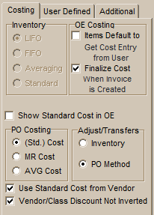
The discount percent entered can be either a discount or a multiplier, depending on the setting of the “Vendor/Class Discount Not Inverted” option on the IP>Costing tab in System Defaults. If checked, the percentage entered will be calculated as a true discount, e.g., 25% would mean a multiplier of .75 times the basis. If not checked then .25 would be the multiplier.

Note that if a PO is created for a vendor and an item with an assigned class discount, the cost calculated will be used regardless of the PO costing method or the “Use Standard Cost from Vendor” option setting.

