Unit of Measure
As a common denominator for item quantities BCR uses the smallest unit in which an item is inventoried.* Since you would want to know how many units of an item were available for sale at any given time it’s assumed to also be the smallest unit of measure in which an item is sold. In most cases a single unit of a good is its inventoried quantity and its sales quantity. Therefore, in BCR the unit of measure for inventory and for sales are always the same.
Sometimes an item is only inventoried and sold in packages of certain multiples, such as a can of tennis balls. Since tennis balls are sold in pressurized cans, once the can is opened the balls are no longer suitable for sale. So there is no reason to measure the item by the individual tennis ball and the sales unit should be the “can” or the words “can of three” could be included in the description and the sales unit might be “each.”
But if the contents of a sales package are sometimes loose, and it’s necessary to keep track of these loose items in inventory so that they can be repackaged for sale, then the item inventory unit would need to be less than the preferred selling package. An example might be cartons of eggs. You only sell the eggs by the dozen in a carton but because eggs are easily damaged you must keep track of them as individual eggs so that you know if you have sufficient eggs remaining to make up a carton for sale. This can be handled in BCR through “Selling Multiples”, which could be set to the number of units in the package to prevent sales of less than a package. So your inventory and sales unit would be individual eggs but your selling multiple would be 12 eggs.
On the purchasing side POs will need to express the quantities in either the same units as the inventory/sales unit, or a larger unit, usually because the vendor only accepts orders in larger multiples. In the egg example, this might be a gross. The vendor requires that you submit orders in quantities of grosses of eggs. You can handle this by using a purchasing unit of measure description, such as a gross, in combination with a “Factor”, in this case 144. Quantities entered on a PO would be accepted in multiples of the factor. If 288 eggs were needed, you would enter 2 on the PO.
Or if the vendor required orders in quantities of individual eggs but multiples of a gross you could set the “Box Quantity” to 144 so that only multiples of 144 would be suggested by the automated purchasing system but the PO quantity would be 288 rather than 2.
The following will detail how each of these item setups would be made in BCR Edit Items. It’s very important throughout to keep in mind that the Unit of Measure (UM) assigned in sales, quantity discounts, and purchasing, are only text descriptions and have no effect on how the actual quantities are determined or displayed. Quantities throughout BCR are expressed as the units in which items are inventoried and sold, with the exception of purchase orders as described above.
*NOTE: Items can be inventoried, sold and purchased in less than whole units using decimal quantities. This feature would typically only be used if some items are stored in bulk or variable sizes, and where the item’s value is great enough to measure it in less than a single unit. If a quantity is entered as a decimal amount BCR will adjust the pricing and costing accordingly. The number of decimal places accepted in quantities is set on the System Defaults>OE>Doc#/Misc tab under “Decimal Places Qty”. Quantities throughout the system for all items will be displayed in that number of places. If you never inventory less than a single unit, Decimal Places Qty should be set to zero (0).
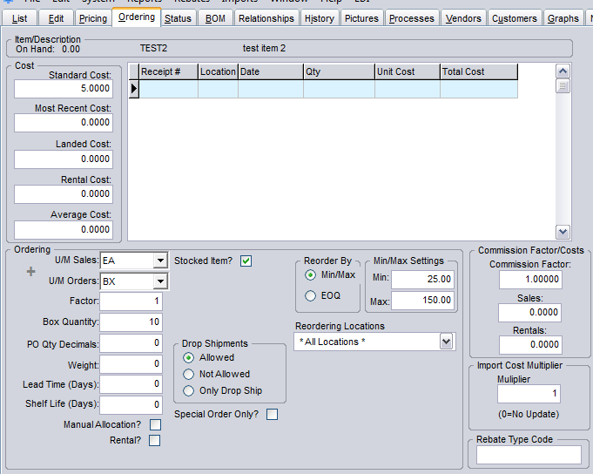
The sales and purchase order UM descriptors are defined for each item on the Ordering tab in Edit Items. If the System Defaults option is set for Unit of Measure validation then a dropdown selector is used to select the UM description for each. Otherwise any text can be entered as the UM.
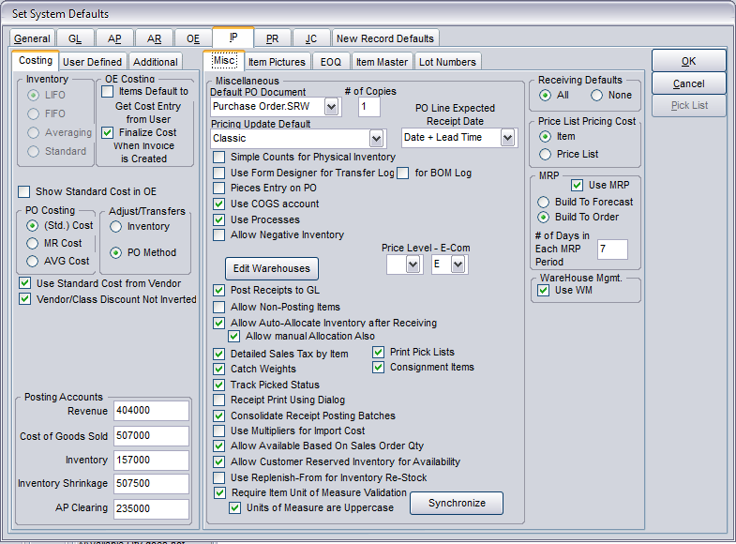
The “Require Item Unit of Measure Validation” option is found on the Misc tab of the IP tab in System Defaults. A second option will force all UMs to be uppercase. The Synchronize button will add all UM description text entries from items to the validation table if UMs have been entered prior to this option being implemented.
Once the option is implemented a plus sign (+) will appear on the Ordering tab in Edit Items and the U/M Sales and Orders fields will become dropdowns.
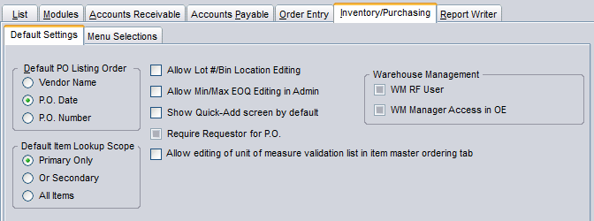
The plus sign only appears for users that have the “Allow editing of unit of measure validation list in item master ordering tab” set in Setup Users on the Inventory/Purchasing>Default Settings.
When the plus sign is clicked by an authorized user they are prompted to enter a new UM which will be available for assignment to any item on file, not just the item currently accessed.

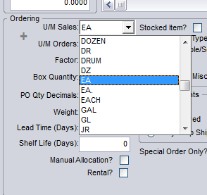
The dropdown will display all of the valid UMs. If the validation option is not turned on then no dropdown is displayed and any text can be entered. This is true for both U/M Sales and U/M Orders. If validation is turned on, it is turned on for both.
In addition to letters, UMs can contain numbers, punctuation, and spaces, for a total of 6 characters. So a valid UM might be BX(20) or CAN/3.

The U/M Sales field determines the UofM that appears on the Detail tab for the item. Remember that the UofM does not control the actual sales quantity unit. The quantity entered on a sales order should always be in the same measure as the quantity inventoried. It’s assumed that whatever the UM, it accurately relates to the quantity entered on the order for that item. If the UM is DOZEN then an order for 12 would be assumed by a user to be for 12 dozen and that the item is inventoried by the dozen.
UMs are not validated in the Qty Discounts setup on the Pricing tab in Edit Items.
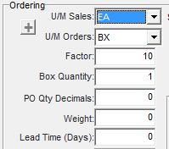
The U/M Orders field determines the UofM text that appears on the Items tab in Edit Purchase Orders for the item. This U/M might be different from the U/M Sales if the vendor simply calls the package something other than what you do, such as “case” instead of “box.”
A more common reason would be that the vendor does not accept orders in as small a unit as your inventory/sales unit. In this case you will probably want to set the “Factor” on the Order tab in Edit Items to the number of units in the package described by the U/M Orders. If the vendor requires that you order boxes of ten of something you inventory by the each, then you would want to set the U/M Orders to box and the Factor to 10.

This will mean that quantities entered in purchase orders or suggested POs will be in the units of the Factor. An item that has an inventory/sales unit cost of $5 will be multiplied by the Factor, in this case 10. A PO with a quantity of 1 would show 10 inventory units on order and would receive 10 into stock.
Remember that the U/M text does nothing to affect the unit quantities. Only if a Factor is set is the quantity in another unit.

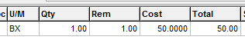

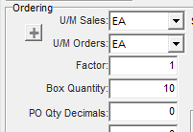
If the vendor only requires that you order in certain multiples but accepts orders in the same unit of measure as you inventory, then you will want to leave the U/M Orders the same as the U/M Sales and the Factor at 1 but set the “Box Quantity” to that multiple. This will not restrict your entry of POs for quantities other than the Box Quantity multiple but it will cause the suggested purchasing system to only suggest Box Quantity multiples.

Specific Factors and Box Quantities can be set for individual vendors assigned to an item on the Vendors tab in Edit Items.

