Basic STOCK purchasing

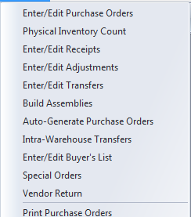

The purchasing process flow starts with a purchase order entered with an item that has an order quantity. Purchase orders can be create manually from Enter/Edit Purchase Orders or generated automatically from sales order entry, the Buyer’s List or the Auto-Generate Purchase Orders Program.

The quantity remaining (REM) is the quantity ordered less any receipts.

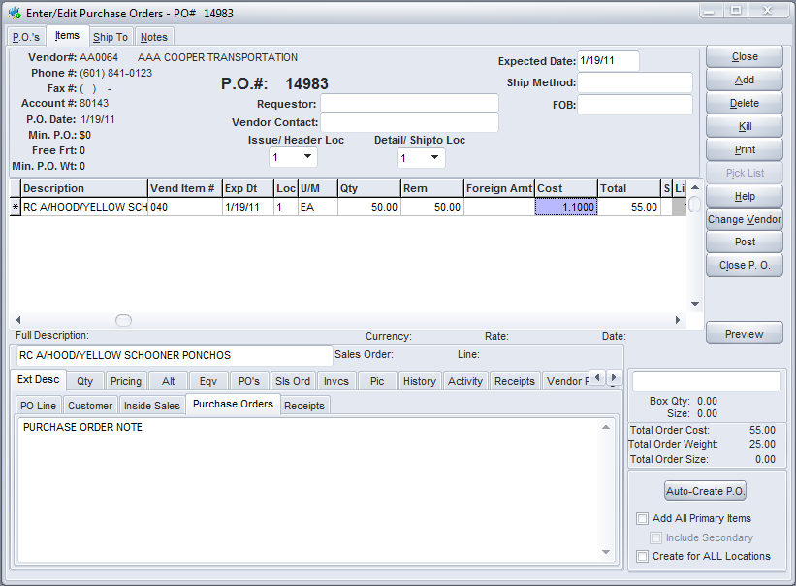

A PO must be “posted” before quantities are shown as ON PO. Until it is posted a PO is a working document. Once it is posted it is assumed that it has been sent to the vendor.

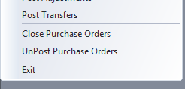

Items and quantities cannot be changed on a posted PO but a PO can be un-posted and changed if necessary.

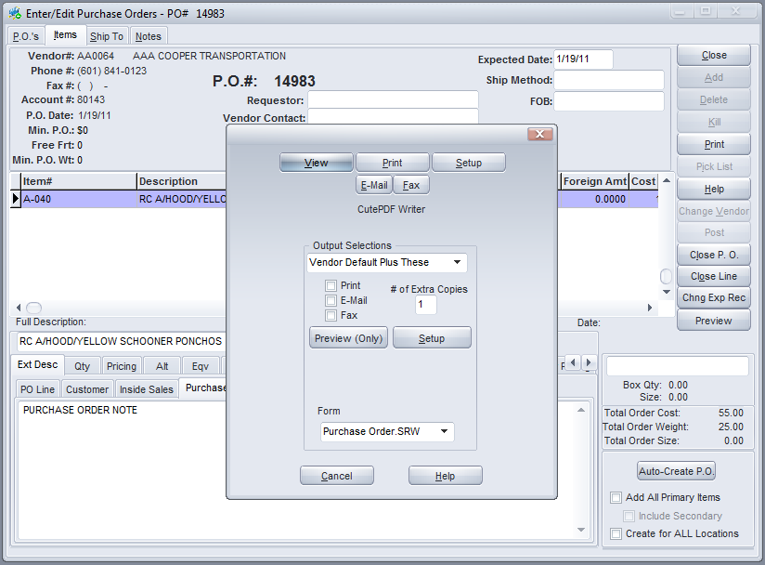

A PO can be printed before or after it is posted.

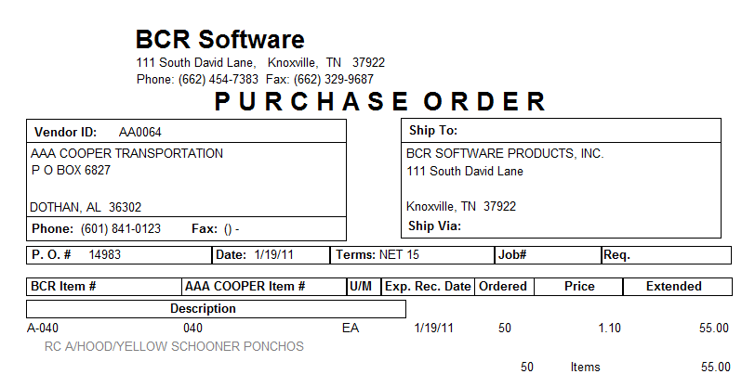

When stock is received it is entered in Enter/Edit Receipts. (Note that drop shipments are also entered as receipts when either the vendor shipping notification or invoice is received so that the customer can be invoiced.)



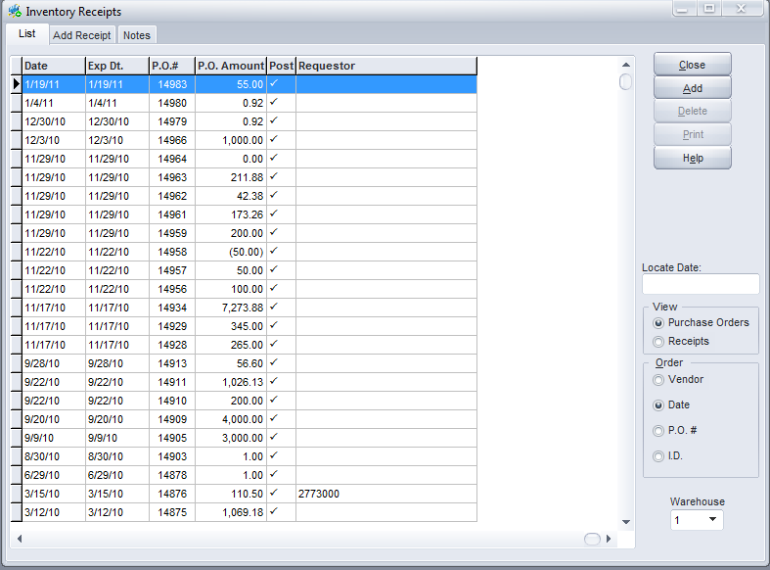

The PO being received is picked from existing posted POs and a receipt is added. Prior receipts can be listed and adjusted from this screen as well.

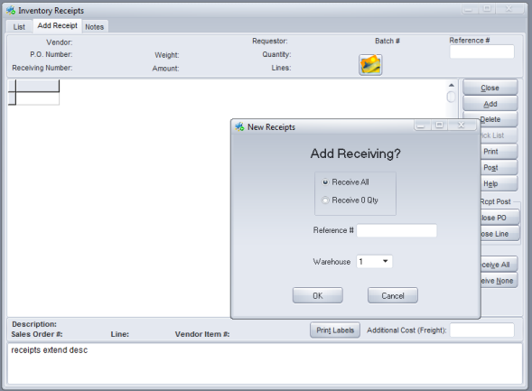

As soon as the add receipt tab is clicked the user is prompted to either receive all or none. This simply pre-fills the received quantities of the items to save time. The user can then make individual adjustments as needed.

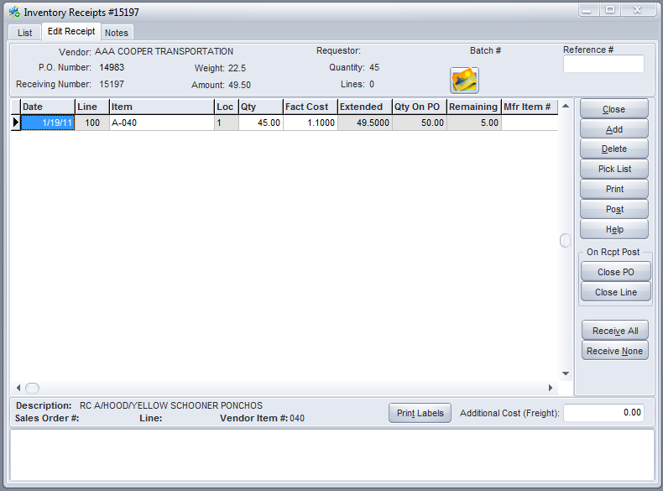

This will reduce the on PO, and increase the on hand and available, quantities in inventory and prompt the user to allocate received quantities to backorders.

Unless there is good reason to believe that the receiving information entered may be incorrect, the receiver is usually posted immediately.

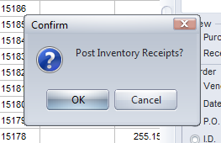

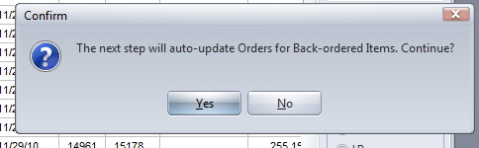

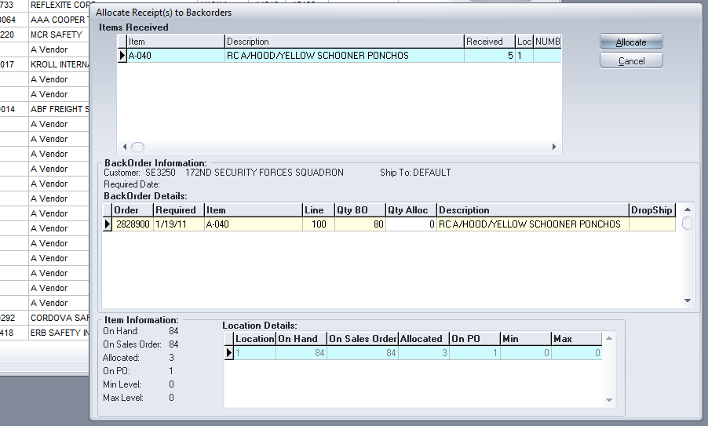

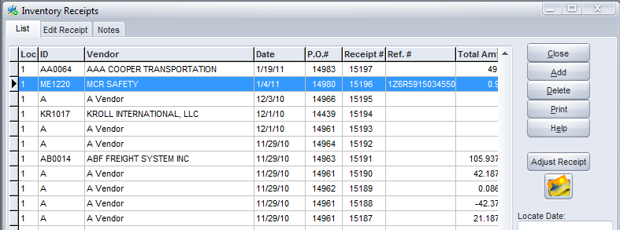

Once a receipt has been posted, the vendor’s invoice and/or related freight bill can be entered in accounts payable and reconciled to the receipt.

The Adjust Receipt button allows a user to make corrections to a posted receipt if necessary.

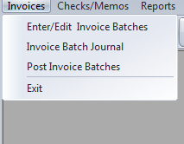

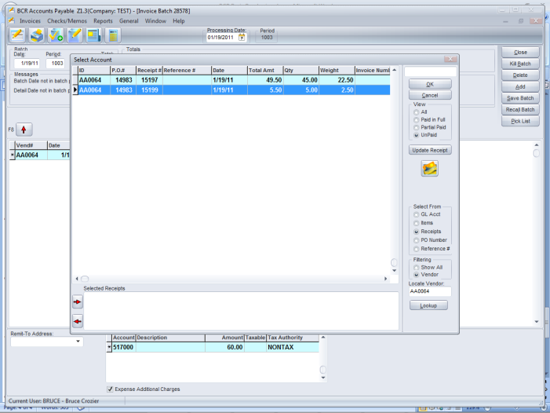

Receipts can be adjusted in the reconciliation as well.