Setting Item Price Levels
The “Actual Price” column on the Item Pricing tab is the basis for most customer pricing. Customers are typically assigned one of the six price levels for their default pricing. Setting these prices can be done in a variety of ways, utilizing the Based On dropdown setting and the Price Basis fields.
NOTE: Before making any changes to these fields it’s always a good idea to write down or screen capture the existing settings. Once a new entry is made in any of these fields, one or all Actual Prices may be changed automatically. You may wish to familiarize yourself with these fields and their functions using a test item before attempting any real price maintenance.
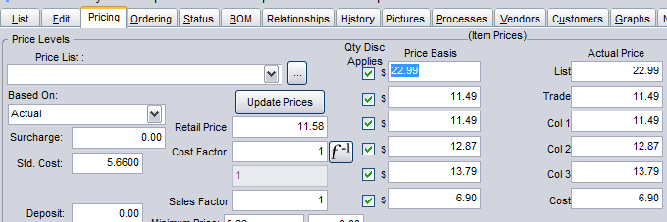
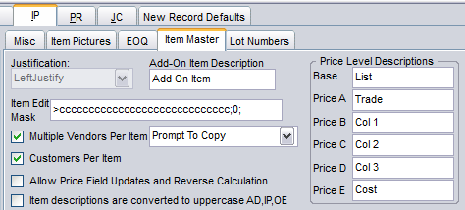
Note that the descriptions of the six levels are set in System Defaults on the IP>Item Master tab. These descriptions then appear throughout BCR.

Setting Actual Prices to already determined prices can be done by simply setting the Based On to “Actual” and entering the prices in either the Price Basis or the Actual Prices fields. When Based On is set to Actual dollar signs ($) are displayed to the left of all Price Basis fields. After entering the price and hitting Enter or clicking on another field the field corresponding to the field in which the price was entered will change to the price entered as well. If a price of $11.49 was entered in the Col1 level of Actual Prices, then the Price Basis field to its left would change to $11.49 as well, and vice versa.

Four Based On dropdown selections (Markup % and Cost Plus are the same) will calculate the Actual Price in a different way, using the Price Basis. As noted, the Actual selection simply means the dollar and cents price is entered directly in each field.
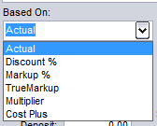

Discount % will use the topmost Price Basis as an actual price and apply each of the entries below it as a percentage discount (topmost $ Price Basis x ((100 – Price Basis %/100)). So the topmost Price Basis displays a dollar sign ($), indicating an actual price is expected in this field. Each of the fields below it display a percentage sign (%), indicating a whole percentage should be entered. An entry of $22.99 in the topmost Price Basis followed by an entry of 11.49 in the next field will produce an Actual price for the corresponding field to its right of 20.35 (22.99 x ((100 – 11.49)/100)). If a new $ entry is made in the top price basis then all other Actual Prices are updated as soon as Enter is hit or another field clicked.

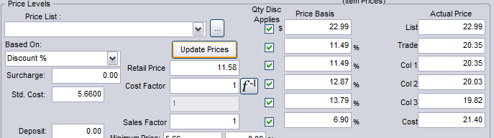
The remaining Based On selections work with the Std Cost. If one of these is used and the Std Cost is changed, either on this tab or on the Ordering tab, then Actual Prices are not updated until the Update Prices button is clicked or when you click in each of the Price Basis fields and then click on another.

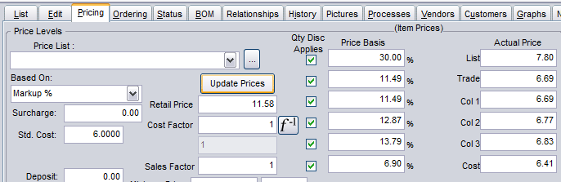

A Based On of Markup % means the Actual Price is calculated by adding the Price Basis percentage of Std Cost to the Std Cost (Std Cost + (Std Cost x (Price Basis % / 100)). The Cost Plus selection is identical to Markup % and is only provided for the convenience of those more familiar with that terminology.
True Markup means the Std Cost will be divided by the reciprocal of the Price Basis percentage (Std Cost / ((100 – Price Basis) / 100). This may also be referred to as gross margin, because the Price Basis % is the gross margin percentage of the resulting price.
Multiplier means the Std Cost is simply multiplied by the Price Basis entry (Std Cost x Price Basis). Note that the sign to the right of the Price Basis fields will be a multiplication sign (x) rather than a dollar or percentage sign.

