Setting Item ABC (Pareto) Ranks
Determine the rank types that you would like to set. Typical rankings would be by item contribution to total company sales, item number of “hits” (number of times sold, i.e., invoice lines), or item contribution to total company profits. The same rankings might be applied to item classes and then to items within their class.
Label an item user defined field for each rank you want to set in System Defaults.
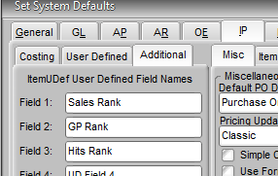
This will cause the fields to appear on the Additional tab in Edit Items.

Create a report that sorts items is the order of the rank factor(sales, margin, etc.) from high to low using the BCR report writer or SQL.

For example:
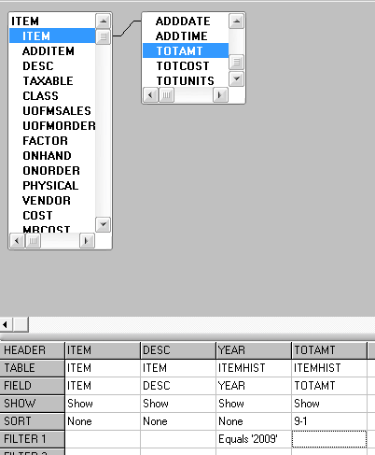
Export the report to a spreadsheet. Create formulas in the spreadsheet to determine the percentage contribution of each item as a running total of percentages (e.g., sum the item and all items above it and divide by the sum of all items. Use absolute references for all but the current item so that you can copy one formula and paste to all of the column.) Locate the cutoffs for each ranking desired. Typically these would be at 80% total contribution for “A” items, 95% for “B” items, 100% for “C” items, and remaining items with no contribution as “D” items. Note the sales (or whatever factor used) amount of the item at each cutoff.
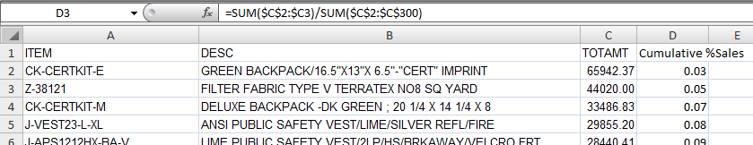
Using the UPDATE command in SQL Tools set the appropriate user defined field to the desired rank. Save the command as a template. Start by setting all items to “D”, then all items with sales (or whatever factor used) greater than the 100% cutoff to “C”, the all items with sales greater than the “B” cutoff, etc.
UPDATE ITEMUDEF SET UDEF1 = ‘B’ WHERE (SELECT ITEMHIST.TOTAMT FROM ITEMHIST WHERE ITEMUDEF.ITEM = ITEMHIST.ITEM AND ITEMHIST.YEAR = ‘2009’) > 4109

Setting MINs and MAXs
After you have assigned appropriate ranks to items then use the UPDATE command to set MINs and MAXs.
UPDATE ITEM SET “ITEM”.”MIN” = ((SELECT ITEMHIST.TOTUNITS FROM ITEMHIST WHERE ITEM.ITEM = ITEMHIST.ITEM AND ITEMHIST.YEAR = ‘2009’) / 12) WHERE (SELECT ITEMUDEF.UDEF1 FROM ITEMUDEF WHERE ITEM.ITEM = ITEMUDEF.ITEM) = ‘B’
This command sets the MIN for all ‘B’ items to one month average of units sold in 2009. The ITEMHIST table contains the sales dollars, cost of goods and units sold for in separate records for each item and each year of history you have. It also contains the by month data.

