Serial Number, Lot and Pick Location Tracking

In addition to tracking the quantities of items in multiple warehouses, Titan has the ability to track the assignment of serial numbers to individual units of items, “lots” (unique groupings of units) assigned to one or more units of an item, and specific pick locations assigned to one or more units. One or more of these tracking utilities can be used with any one item. Obviously Titan has no way to physically confirm the serial number, lot information or physical location of an item, so effective use of these features relies on proper and consistent user practices, and a reasonable understanding of how Titan is recording pertinent information.

# Serial Number Tracking

Serial numbers are assumed to be on a one number to one unit basis. In order to use them with multiple units it would be necessary to assign a prefix or suffix to the numbers to make them unique. In this case a lot tracking setup would probably be more appropriate. Usually serial numbers are used with items whose value is high, have a warranty, or may be subject to a manufacturer recall or haz/mat notification.

To setup an item for serial number tracking simply check the Serial #s option on the Edit tab in Edit Items.

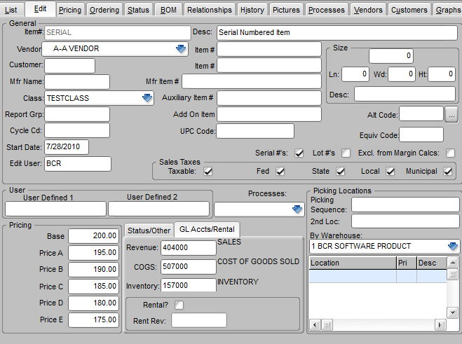

If all of the items in an item class are serial numbered then you may want to set the default for that class to **Track Serial Numbers** as well.

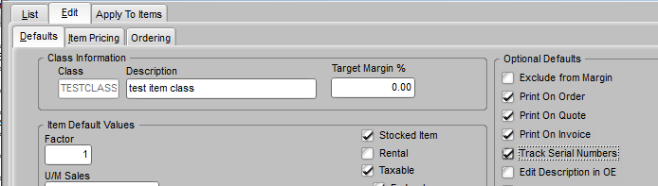

After an item has been set to track serial numbers an additional **Serial Numbers** tab will appear on the Status tab of Edit Items. This tab DOES NOT appear until the serial number option has been checked for that item.

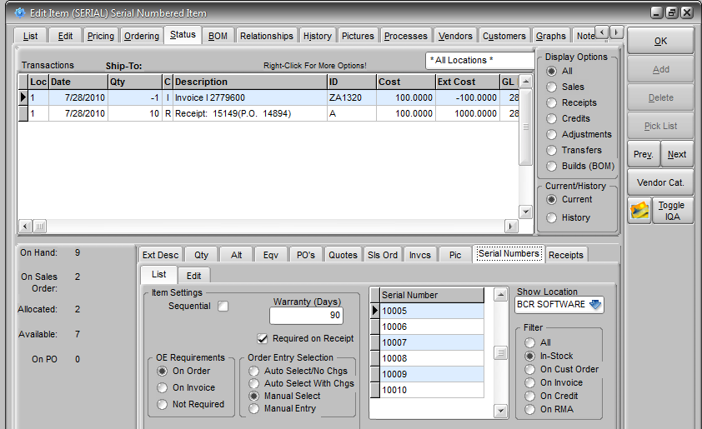

The Serial Numbers tab contains two sub-tabs that allow the user to manage all of the serial numbers recorded for an item. Serial numbers in Titan can be maintained purely automatically through transactions, or purely manually by the user via this tab, or a combination of transactions and manual entries. Each item can be set with different controls so different items may function differently. An item that you receive with pre-stamped serial numbers that is closely monitored may be maintained strictly by transactions, whereas another item that you only track a serial number on for special circumstances may be maintained exclusively by user entry at this tab. You can use the settings on the List tab to reflect and control how an item is maintained.

**Sequential** – This option is only used when you assign serial numbers internally. When it is checked two additional fields appear. You can set a fixed Prefix that will precede each number assigned and set the next serial number to be assigned to that item. Depending on when a serial number is required, the system will create new numbers starting from the next number to each unit received or sold sequentially.

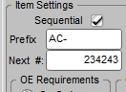

**Warranty (Days)** – This is an information field that can also be used in creating reports on that item. The number of days entered is added to the invoice date when the serial number is sold and displayed as the Warranty Expires date on the Serial Numbers Edit tab.

**Required on Receipt** – This option is typically selected when the vendor pre-stamps the serial number and tracking of the item while it is still in the warehouse is important, as in when the item has a high value. When the item is received on a purchase order the user is prompted to enter the serial numbers for each unit received.

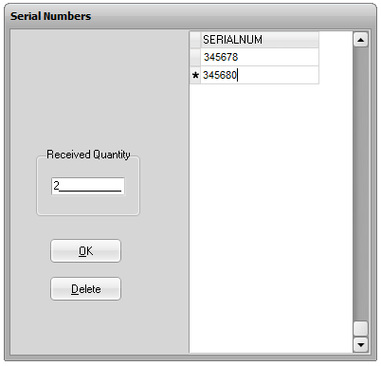

**OE Requirements** – If serial numbers are tracked it is usually at the time of sale, even if they are not logged on receipt. This setting determines whether the order entry user is prompted at the time the order is created (**On Order**), at the time the order is invoiced (**On Invoice**), or not at all (**Not Required**), though by selecting the Manual Entry in the next selection, you can give the user the option to not assign a number in some cases.

**Order Entry Selection** – This setting determines the freedom allowed the user when they assign serial numbers to sales orders. **Auto Select/No Chgs** means that a serial number will be selected from the system list of available numbers based on a first in/first out method and the user will not be allowed to override this selection. **Auto Select With Chgs** means that after the system assigns the serial number the user may choose another available serial number if they wish. **Manual Select** means that the user will be given a list of available numbers and must choose from them. **Manual Entry** means that the user is free to enter anything when prompted. This setting might typically be used if serial numbers are not assigned on receipt, since the system has no record of available numbers (unless they were created manually as explained below.)

When the item is entered on an order or invoice the user is prompted to select an existing serial number that is in stock by clicking the box to the left of that number. (If an item is set for entry **On Invoice** the prompt only appears when you **Auto-Invoice**. Serial numbered items set for **On Invoice** cannot be batch invoiced.) A separate number must be checked for each unit allocated on the order. If the item is set to allow manual entry and the number is not already listed (i.e., the item is not set for **Required on Receipt**) then they must enter the **Serial Number** and click the red checkmark to add it to available serial numbers.

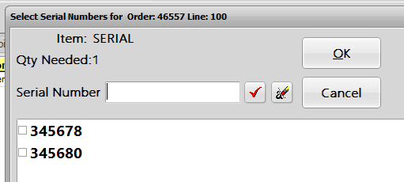

To the right of these settings is a grid listing serial numbers, filtered by the options to its right. To see all of the serial numbers ever assigned to that item in a given warehouse, select the warehouse and the **All** filter option. Each of the remaining filters will display a subset of All numbers. **In Stock** means that the serial numbers listed have been received but are not allocated on any sales documents (other than on a credit memo) and are Active (see below.) **On Cust Order** means that the serial numbers listed are Active and allocated on sales orders but have not yet been invoiced. **On Invoice** means that the orders containing these numbers have been invoiced and are presumably no longer in your possession. **On Credit** means these numbers are on credit memos and presumably back in your possession. Their order and invoice document numbers have been removed and they are now also listed if **In Stock** is selected. **On RMA** is similar to **On Cust Order**, in that the numbers are not listed as **In Stock**, but they will be if and when a credit is issued.

It is also possible to add a new number if necessary. Before clicking on the **Edit** tab, click on the last number listed in the grid (the current filter used doesn’t matter), press your down arrow and enter the new number.

The arrow to the left of a serial number listed indicates the currently selected number. Clicking on the **Serial Numbers Edit** tab will display details of the documents related to that number and allow you to edit them.

NOTE: Remember, serial numbers can be maintained exclusively via transactions, exclusively manually, or by a combination of the two. If you make manual changes to a serial number, obviously incorrect data may be created. Care should be taken that only users who understand the implications of changes on the Edit tab be allowed to make such changes. Only authorized users* can edit fields on this tab.

*Setup Users>Inventory/Purchasing>Default Settings>Allow Lot#/Bin Location Editing

When the **Edit** tab is selected the information displayed is relative to the one serial number selected. All of the fields on this tab can be edited by authorized users, including the serial number itself. So you can change the number to another number if, for example, the wrong number was logged when the item was received. If you delete the serial number its record will remain but with a blank serial number.

The **Lot** and **Loc**(ation) fields to the right of the Serial # field are discussed in the following section on lot and bin location items. The **Desc**(ription) is a user text field and can be used to add any information related to that serial number appropriate to your operation.

As described above, the filters on the **List** tab are a function of the order or invoice documents that have been recorded against each serial number. If a serial number is logged as allocated on a sales order or an invoice, it is not available. The documents recorded on the Edit tab are the sole determination of this. So if a document number is deleted on this tab it may indicate that the serial number is available. The system has no means to determine if that serial number is, in fact, physically present in your warehouse. You may show ten serial numbers available but only five units of that item in your warehouse or vice versa. Editing the information in the document fields can either fix or create these kinds of discrepancies. Note also that the system does not attempt to verify the document number entered on the Edit tab. You can enter anything in the Number field, such as UNKNOWN, and that will act as the equivalent of assigning the serial number through document creation.

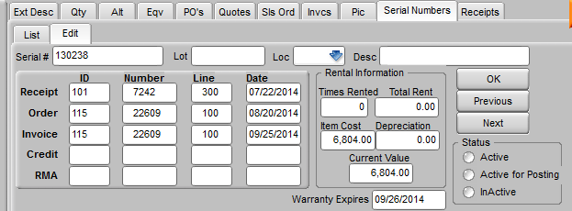

**Rental Information** only applies to items that are set as both serial # and rental. The Times Rented and Total Rent are tracked and if a Depreciation amount is entered then the Item Cost entered is decremented by that amount with each rental resulting in the Current Value.

The **Status** of a serial # can be set to InActive to remove it from the available listing even if there are no orders or invoices assigned to it. An item that has no status setting is treated as Active.

For Report Writer purposes the **SERIALNO** table contains all of the serial number records and the information related to the documents assigned. When a new serial number is created a record is created in the SERIALNO table for that specific item and serial number.

The **OEDET.RPTMEMO** field contains notes of all serial numbers, lots and pick locations assigned to each line item on an order.

# Lot Tracking

Lots can be used any time an item needs to have units grouped by some subset identifier. This could be an actual lot identification from the manufacturer that must be tracked in the event of a recall, or units with a common expiration date, or a color dye lot. Unlike serial numbers, which identify a single unit of an item, lots are assigned to a quantity of units. So you may have 10 of an item X on hand, 6 of which are assigned to lot A and 4 to lot B.

To set an item up for lot tracking check the **Lot #s** box on the Edit tab in Edit Items.



If all of the items in an item class are lot tracked then you may want to set the default for that class to **Track Lot Numbers** as well.

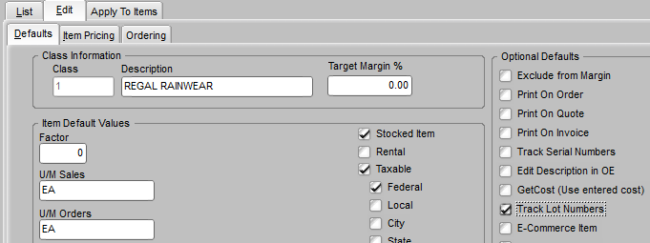

If lots are not obvious by their nature (e.g., a lot number is not printed on the items) you may want lots assigned by the system. On the System Defaults>IP>Lot Numbers tab the **Lot Number Creation Method** setting can be changed to allow the system to automatically assign a new lot to the units received based on the date and the sequence of receipts that day or the vendor and the date and sequence. This would be appropriate if you are tracking lots purely for internal purposes, such as wanting to always ship units based on a first in/first out policy.

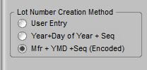

Depending on the nature of lot items you receive, you may want to check the **Allow Duplicate Lot #s** on the warehouse sub-screen (System Defaults>IP>Misc> Edit Warehouses button.) If you receive goods with the same lot# on more than one receipt you will want to turn this option on so that the system will allow you to enter the existing lot# on a new shipment. Note that multiple entries for the same lot will still appear as separate entries in the available lots listing.

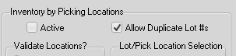

The **Lot/Pick Location Selection** can be set to **Manual** or **Automatic**. If this setting is Automatic then in order entry the system automatically will choose the lot and/or picking location based on the oldest lot created and the default/ priority of the pick location so long as that lot or location contains available units. If there are no lots or locations with available units then the user is prompted to create a new lot or location. This setting would typically only be used in special circumstances for lot items. **Manual** is the default setting.

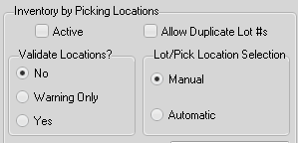

Like serial numbers, after an item has been set to track lots an additional **Lots/Pick Locs** tab will appear on the Status tab of Edit Items. This tab DOES NOT appear until the lots option has been checked for that item.

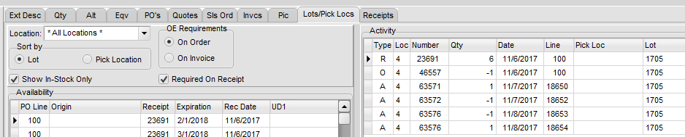

Lots can be specifically tracked in multiple warehouses. So the first prompt on the tab is for a **Location**. Details displayed on the tab are location specific.

The **OE Requirements** specify when a lot must be assigned to a sale. If lots are turned on for an item, the system will automatically prompt for a lot either **On Order** when the item is initially entered, or **On Invoice** when the invoice image is initially created but before pre-posting.

**NOTE:** When set for **On Invoice** lot prompts are only triggered when the **Auto-Invoice** feature is used. Batch invoicing will never trigger a prompt for a lot if the item is set for **On Invoice**. If you attempt to batch invoice an invoice that requires a lot entry you will be warned that the invoice has not been created and must be auto-invoiced.

**Show In Stock Only** is the default setting and filters out old lots in the **Availability** grid below that have no quantity remaining. Lot records are never deleted by the system so the list of lots could be extremely long if this filter is not checked. Old lot records can be useful because they contain the lot’s transaction history so that should you need to contact customers that have purchased units in that lot you can locate that information. (Retrieving lot transaction history can also be done using Report Writer. See below.)

**Required On Receipt** will determine if lots are to be entered at the time of receiving. This option would typically selected if you are actively tracking lots in inventory. If lots only need to be noted on the sales order then you could leave it unchecked but this will require the user to add a lot at the time the order is created or via **Enter/Edit Adjustments** (see below).

To the right of the lot listing is an **Activity** log of transactions that have affected the selected available lot’s quantities. If lots are not edited manually in the **Availability** grid then this should be an accurate audit trail for the lot.

CAUTION: All of the fields in the Availability grid listing can be edited by authorized users with the exception of the Received and Available quantities of existing lots. You might need to use this capability to edit an **Expiration** date for a lot that was incorrectly entered at receiving. If lots are being tracked closely then care should be taken to not change information that may to correlated to actual transactions. You can change the name of a lot or warehouse location, but this may throw information out of line with other system data, such as the quantities of the item in general in a specific warehouse. You can also add a new lot by using the down arrow from the last lot listed, but if you enter a quantity in this manner it will not be tied to any actual transactions and the total available quantity in the lots may not equal the available quantity of the item. Other than expiration dates, the preferred method for changing lots assigned to quantities would be to use the **Enter/Edit Adjustments** program (see below).

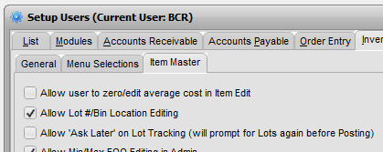

The **Allow ‘Ask Later’** option will permit a user to skip the lot entry screen in any transaction when it initially prompts after an item quantity is entered. If skipped, the user will be re-prompted when the transaction is to be posted. If the lot entry is skipped on an order it will be re-prompted if you attempt to invoice the order.

NOTE: If you attempt to include such an order in an invoice batch you will be warned that the order cannot be invoiced until the lot entry has been completed. You must use the **Auto-Invoice** feature to complete the lot entry and invoice the order. If you wish to enter the lot information before you’re ready to invoice you can return to the order later, edit the allocated quantity and change it to zero, move to another item line, then return to the item and re-enter the allocation. The lot entry screen will reopen when you move to the next line.

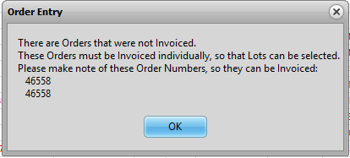

Another option in system defaults (IP>Lot Numbers) will force an “ask later” condition for items that are part of an auto-build of a BOM (bill of materials) in order entry. The user will not be prompted to enter lots for components of the BOM when the BOM is built from order entry but still must when the order is auto-invoiced. This option disregards the user’s individual **Allow ‘Ask Later’** setting when a BOM is entered.



For Report Writer purposes the **ADLOT** table contains all of the lot record information. (It also contains records for pick locations.) When a new lot is created, a new record is created for the lot and item in the ADLOT table. Each record keeps a running track of the units received and remaining available.

The **OEDET.RPTMEMO** field contains notes of all serial numbers, lots and pick locations assigned to each line item on an order.

## Entering Lots

When a lot is required by receiving, order entry, invoicing, or inventory adjustments, a lot tracking sub-screen will appear. The screen will reappear for each lot item on the transaction.

### Receiving Lots

If you are receiving, the screen will list the item, warehouse, the quantity received (**Total Quantity Added**), and the quantity that you still need to assign (**Total Quantity Needed**). The **Qty to Add** will pre-fill with the total quantity, but if not all of that is assigned to the same lot you can reduce the quantity. The other fields, such as **Expiration Date**, can be used as appropriate. There are three user defined fields whose labels are set in System Defaults>IP>Lot Numbers.

On the right are the existing lots. In receiving the assumption is that lot #s are probably new lots. You must enter a **Lot Number** and then click the **Add Lot** button.

If you enter a lot # matching one of the existing lot numbers available to the right, the system will reject your entry unless the **Allow Duplicate Lot #s** option (noted above) is turned on for that warehouse. Note that even though the lot number is a duplicate, it can still have a different **Picking Location**, **Expiration Date**, or other details. The **Availability** grid on the **Lots/Pick Locs** tab on the **Status** tab of **Enter/Edit Items** will list duplicate lots as separate lots and their available quantity. But the **Activity** grid to the right will list all of the activity of a lot with that **Lot Number**.

The new entry will be added to the list on the right. If you entered less than the **Total Qty Still Needed** you must repeat this process until the quantity needed is zero. Once you have all of the quantity assigned the **Finished** button will be enabled and you can click it to complete the receipt of that item.

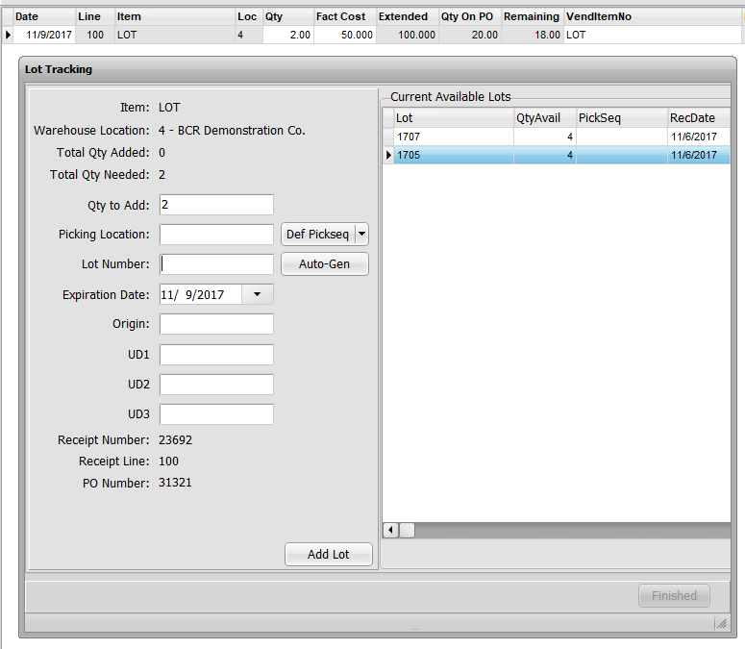

### Selling Lots

The sub-screen that appears when you sell lot items is somewhat different from the receiving sub-screen. The initial assumption is that you will be selecting from lots that have already been received into Titan. If lots are not recorded in receiving then new lots must be created.

On sales orders the quantities are based on the quantity allocated, not ordered. Allocated quantities will be negative since it will be reducing the quantity available in that lot, unless the sale is a credit. The **Total Qty Adjusted** (x of y) is the quantity assigned so far (x) and the total that needs assignment (y). The **Qty Still Needed** is the difference between the quantity that needs assignment and the quantity assigned so far (y – x). The **Qty to Adjust** will default to the quantity that initially is needed (y) but can be changed to a lower quantity. The grid to the right on top lists all **Current Available Lots**. Double click one of the lots of the **Current Available Lots** to assign ALL of the **Qty Still Needed** to that lot, regardless of the **Qty to Adjust** entry. Select a lot and click the **Use Selected Lot** to assign only the value entered in the **Qty to Adjust**.

When a quantity is assigned a lot it is listed in the lower right grid **Selected Lots**. To remove a Selected Lot assignment right click on the lot and click on **Deselect**. The line will be removed from **Selected Lots** and the quantity will be added back as an available lot quantity and as a **Qty Still Needed**.

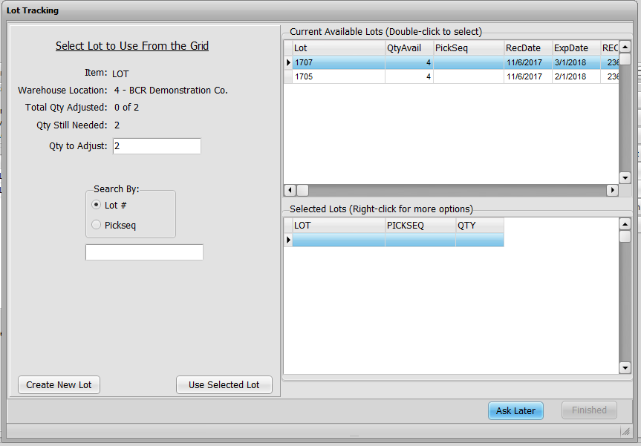

If you are not actively tracking lots in inventory (i.e., the item does not have the Required On Receipt option checked for the warehouse) then you will probably need to click the **Create New Lot** button. This would be common for items that you only must track lot sales for (e.g., manufacturer recalls, government regulations, etc.) Since the item lot is not entered at receiving, obviously it is not already in Titan. (You may also need to use it if you find the lot is not available due to an entry error in receiving.) When you click Create New Lot a sub-screen similar to the lot receiving screen is displayed. The Current Available Lots appears but you cannot select from it and it will probably be empty since the process for lots not created in receiving adds a quantity and then immediately assigns it to the sale, leaving no quantity available. So even lots assigned on previous sales cannot be assigned again because they have none available. Enter the **Qty to Add** (usually a positive number as if you were receiving) and the **Lot Number** (and **Expiration Date** and **Origin**, if need be) and then click **Add Lot**. You will then be returned to the lot entry sub-screen where you can select the newly created lot that is now listed as currently available.

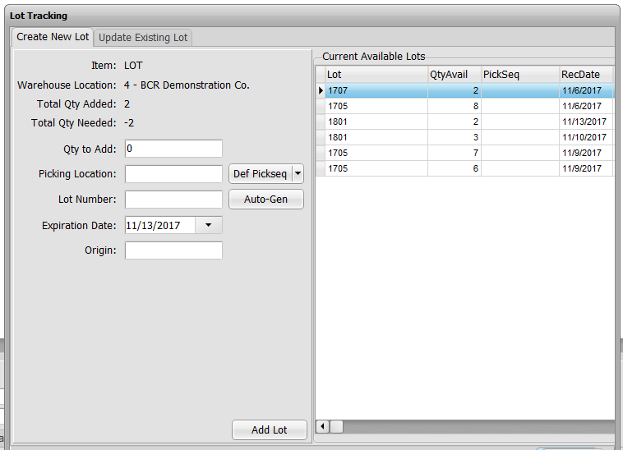

### Adjusting Lots

As noted above, if you are concerned about maintaining an accurate audit trail of lots then the preferred method to adjust lots and quantities would be by using the **Enter/Edit Adjustments** program in the Inventory/Purchasing>Inventory menu. Changes made via the grid on the Status>Lots/Pic Locs tab WILL NOT maintain an activity audit trail. Only expiration dates should be changed in that grid if the audit trail is important. In order to change the lot a quantity is assign to, enter the item and a negative value of the quantity in a lot to be changed. You will be prompted to select a lot to reduce. Then enter the same item and a positive quantity and select the lot to add to or add a new lot. This method will maintain the audit trail of the item lots.

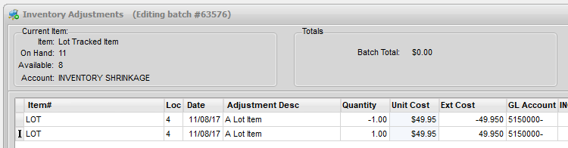

# Pick Location Tracking

Pick location tracking is essentially the same as lot tracking in functionality. The screens are the same or similar and allow you to enter both pick location and lot information on the same screen if both are required. And if both lot and pick location tracking are in effect for an item, a lot could be in two different pick locations or one pick location could contain two different lots. The major difference is that while lot tracking may apply to just specific items, pick location tracking is applied on a warehouse basis, even if you only intend to use if for one item. While individual items have serial and lot checkboxes on their Edit tab, there is no such checkbox for pick locations. Once pick location tracking is turned on, all item activity in that warehouse will be tracked, though items can just be directed to a default general location if detailed tracking is not needed for that item. If only one or a few items are to be tracked at the location level you may want to consider using lot tracking instead, assigning locations as you would lots.

In order to turn pick location tracking on, go to System Defaults>IP and click the Edit Warehouses button to display the warehouse setup sub-screen.

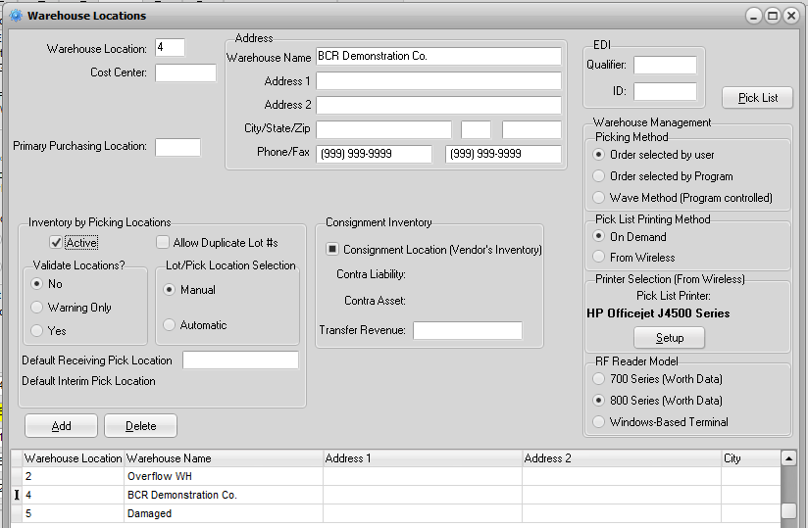

Select the warehouse you want to track locations in and set the **Inventory by Picking Locations** options you want. You must first check the **Active** box for pick locations to function in that warehouse. **Allow Duplicate Lot #s** should be checked if you are also tracking lots and units assigned a given a lot could be stored in more than one location.

Then select the **Validate Locations?** option that you want. **No** means that when a pick location is entered the system will not verify that the location selected for the item at receiving or intra-warehouse transfer is set as a Picking Location on the item’s Edit Items>Edit tab. **Warning Only** means that the system will notify the user that the location is not set for that item but it will allow other locations. **Yes** means the locations entered can only be those set for that item. The option selected may be determined by the type of warehouse location system you use. You may not want to validate locations if you use a floating location system, since you would not want to have to set every potential storage location for every item.

**Lot/Pick Location Selection** determines the method for assigning locations to receivers and pick tickets. **Manual** means that the user must always select the location from a sub-screen, even if there is only one location assigned to the item or, in picking, if only one location has an available quantity. **Automatic – With Override** means that the system will select the location based on priority (see below) or quantity available but even if there is only one appropriate choice, the sub-screen will appear, allowing the user to override the selection. **Automatic – Some Override** means that the sub-screen will only appear and allow the user to override if there are other possible choices. It will not appear if there is only one location assigned or one with sufficient available quantity. **Automatic – No Override** means the system will always choose the location for the user based on locations assigned the item, their priority, and available quantities. The user does not see the sub-screen and cannot override the system choice. The option selected here will also apply to lot selections for lot items (see lot documentation above.)

**Default Receiving/Pick Location** (e.g., UNASSIGNED, DOCK, TEMP, etc.) specifies a location that can be used if no locations are specified for the item or if the user cannot store the quantity in one of the locations specified for the item. This is especially useful if the user is not allowed to override locations or you prefer to receive goods on the system before you shelve them (in which case you would presumably use Intra-Warehouse Transfers to shelve them later.) Setting a default location is generally recommended.

You do not need to set individual items for pick location tracking. As said, once it is turned on for a warehouse it is turned on for all items in that warehouse. And even though the Lot #s option is not checked for the item, the **Lots/Pick Locs** tab (see above) will be displayed for all items. You must, however, still check the option if you also wish to also track lots for that item.

The system determines the pick locations available to the user in the sub-screen prompts in receiving and picking for individual items based on the setup in Edit Items on the Edit tab in the **Picking Locations** box.

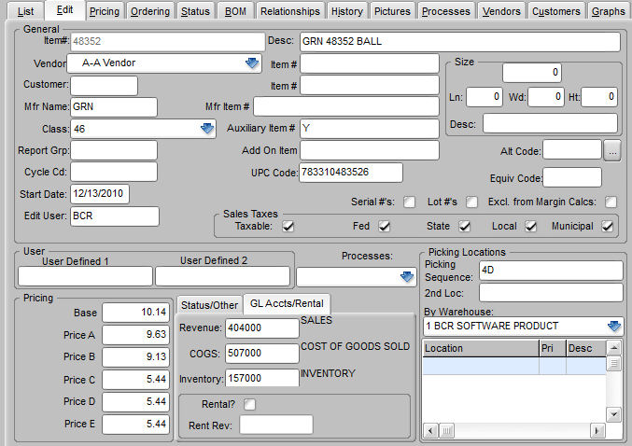

If you only want to track pick locations for select items in a warehouse and avoid any unnecessary entry by users when items are not tracked then you would likely want to set the default location for the warehouse to something like NONE and not assign any locations at the item level for items not tracked. Otherwise you can setup as many **Picking Locations** for an item as needed. You can use the **Picking Sequence** and **2nd Loc**(ation) if you consistently only track one or two locations in a single warehouse for limited items. But the warehouse specific fields are usually better for companies doing extensive location tracking. This feature allows an unlimited number of locations to be assigned an item per warehouse. Be certain to first select the proper warehouse from the **By Warehouse** dropdown, then enter each location in the grid below it. If locations are entered in Picking Sequence or 2nd Loc and in the warehouse specific locations, all locations will be listed as valid, depending on the warehouse involved. Generally locations are setup in one or the other. Locations entered in the warehouse specific list can have a **Pri**(ority) assigned. Locations are listed according to their priority (sorted in traditional alpha-numeric order) and resorted when the priority is changed. Priority will determine the order that locations are assigned by the system assuming there is a quantity available. The **Desc** field can be used as needed.

In addition to assigning locations to individual items you can, as with lots, set individual items to function differently with regard to when the user is prompted to assign a location to a quantity. In most cases, however, all items should be set the same.

**NOTE:** If items are set to prompt in **OE Requirements On Invoice**, then you must use the Auto-Invoice feature to trigger the prompt. Batch invoicing will never trigger a prompt for a location.

This setup would typically be used when it is solely up to the order picker to determine which location to pick from and then that information is placed on the invoice when the picking ticket is returned to the office. If the OE Requirements is set to **On Order**, then the location is pre-assigned when the order is first allocated and the order picker is expected to pick from the assigned locations. Note that once a location is assigned in order entry, should it be necessary to change the assignment because the quantity in a location was wrong, or there were damaged goods in the location, or for whatever reason, it will be necessary to adjust the quantities in the locations using intra-warehouse transfer program or to delete the item from the order and reenter it.

Once pick location tracking is turned on for a warehouse, and depending on the settings in System Defaults, users entering transactions will be prompted with a sub-screen to select or reassign locations to item quantities as needed. This would include receipts, inter-warehouse transfers, intra-warehouse transfers, adjustments, and sales orders.

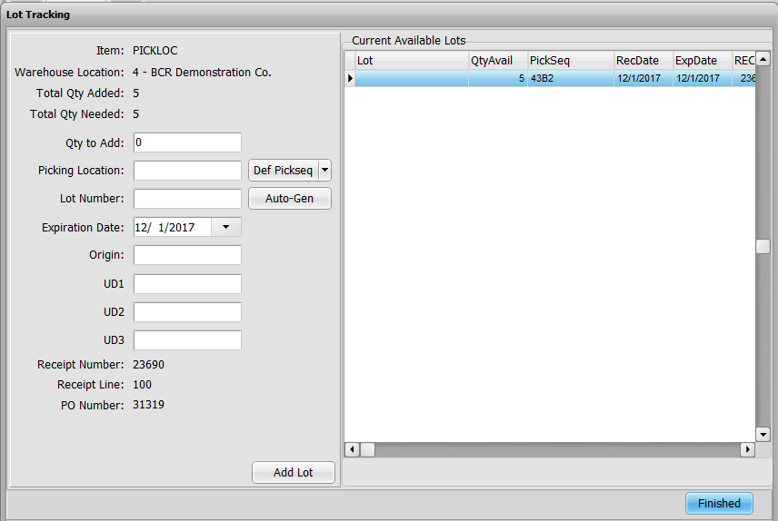

This screen functions much like the lot assignment sub-screen. If automatic assignment is turned on then the quantity in question will have been pre-assigned. The quantities entered in the Qty field must total the Quantity Needed. If the item is set to prompt On Invoice at the item level, then the screen will include the **Picking Location Entry** box at the bottom, which allows the user to create a new location for the item by selecting the **Pick Location** dropdown and typing in a new location rather than selecting an existing one. You must then click Add to place the new location in the listing above. If the item is set to prompt On Order then the Picking Location Entry does not appear and users are not permitted to create new locations at this point. If they know the location information to be wrong they should use an inventory adjustment or intra-warehouse transfer to correct it.

For Report Writer purposes the **ADLOT** table contains all of the pick location record information. When a new pick location is created, a new record is created for the location and item in the ADLOT table. Each record keeps a running track of the units received and remaining available in that location. Location records may also be lot records if lot tracking is used on the item.

The **OEDET.RPTMEMO** field contains notes of all serial numbers, lots and pick locations assigned to each line item on an order.