Sales Staff Setup and Commissions Reporting
Salespeople and their commissions are tracked by creating salespeople in the Sales Staff program (Administration>File>Edit Sales Staff) and setting up their commission structure. Commission reports are also run from this program.

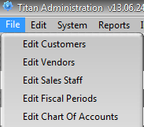

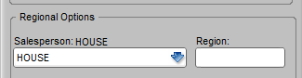
Salespeople are assigned to customers in Edit Customers on the Edit> Shipping/Regional Options tab. A separate salesperson can be assigned to individual ship to’s on the Ship To tab. A salesperson must be created in Edit Sales Staff before they can be assigned to a customer.
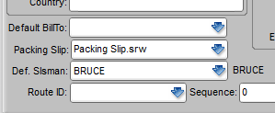
Commission reports are based on the invoice and possibly, depending on setup, payments records. The salesperson assigned to the customer or customer ship to is automatically assigned to the order at the time the order is placed. It can be overridden on the Header>Misc. Settings tab of the order. Changing the salesperson assigned to a customer does not change the salesperson assigned to orders previously entered for that customer. Commissions can also be tracked by the order’s Entered By user.

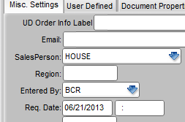

The commissions due salespeople are based on the current commission plan setup on the Sales Staff screen. Commissions are not contained in the invoice records themselves. So if you change the commission plan setup for a salesperson after the sale, the commission calculated and reported will reflect the new setup, not what it would have been under the old setup at the time of the transaction. If you wish to run a report for salesperson’s old setup for reporting on old sales you will want to temporarily set their plan back to what it was before and run the report, or create a new Staff entry for that salesperson for sales going forward.
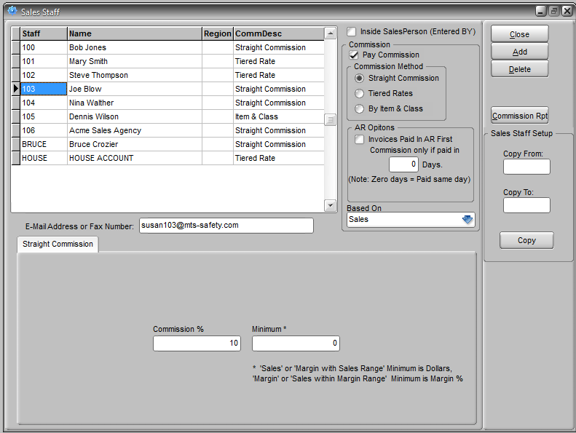
Sales staff must be created in this screen. Users’ logins are not automatically considered sales staff. To create a sales staff entry click the Add button and enter an ID (Staff), a name, and optionally a region. The CommDesc will be filled when you select Commission Method. The remaining setup on the screen will relate to the specific salesperson highlighted in the grid. You can begin by entering a salesperson’s email or fax number for reference.

You can designate a user as an Inside Salesperson by checking that option box. This will allow you to run commission reports based on the Entered By field of an order rather than the Salesperson field. An order will automatically assign the logged in user as the Entered By and it can only be changed to another valid user, so any sales staff ID designated here must exactly match the user ID. By designating a salesperson as an Inside Salesperson you can effectively setup a split commission plan. Note that the commission report would include sales where the salesperson was assigned as either the Entered By or Salesperson.

In order for a salesperson to be included in the selector screen that appears when you run a commission report you must select the Pay Commission checkbox. Otherwise you will not be able to run the report for that salesperson. (Salespeople will also not appear if they have a 0% commission setting.)

Select the Commission Method that will apply to the highlighted salesperson. Screen and options will change significantly depending on the selection. While a salesperson can only be assigned one method at a time, settings for a method are not lost if you switch to another for that person. You could setup a complex By Item & Class table for a salesperson then switch to Straight Commission then switch back to By Item & Class and the setup would still be there.

- Straight Commission is the simplest method. A commission percentage is applied to the sales or margin amount if it meets minimum criteria.
- Tiered Commission calculates different commissions depending on the level of sales or profit.
- By Item & Class allows commissions to be set for individual items or item classes and specifically by the price level used to charge the customer.

You can also use the copy tool on the right side of the screen to copy setups from one salesperson to another. All of the setup details are copied, including those method setups that are not currently assigned to the salesperson you’re copying from. You may want to setup template staff that you can copy from and then make fine adjustments to the real person’s individual setup.

For a given method for each salesperson you can set specific options beyond the rates and levels. Note that while the following options are set for the each salesperson, they are the same regardless of the commission method selected for that salesperson.

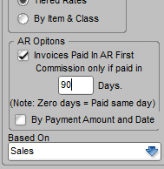
If you only want to pay commissions on paid invoices, you can set the AR Options checkbox and enter the number of days allowed for payment for commission to be allowed. So if an invoice dated 3/1 is not paid until 5/15 and the number of days allowed is 60 then no commission is paid. The invoice must be paid in full by the date specified. If the By Payment Amount and Date option is checked then commission will be based on specific payment amounts made by the date specified.

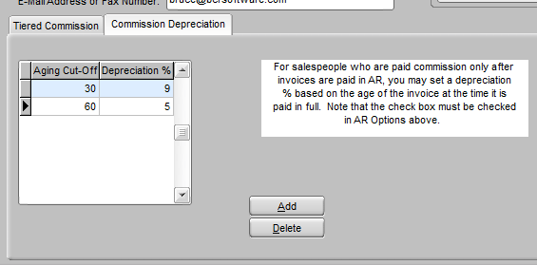
When the AR Options box is checked, a second Commission Depreciation tab will appear next to the commission method tab (straight, tiered, by item) at the bottom of the screen. Instead of simply allowing a number of days to pay or not pay commission, you can setup a table of days and percentages that will reduce the commission as the receivable ages. So up to 30 days might pay 100% of the commission (0% depreciation), up to 60 days pays 75% (25% depreciation), and so on. Entries in this tab will are in effect only up to the number of days allowed in AR Options. If the number of days allowed in AR Options is 60 and you have a depreciation Aging Cutoff set at 90 it will have no impact on commissions calculations.

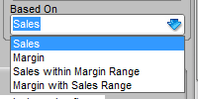
Below the AR Options is a Based On dropdown that indicates whether the commission structure is to be applied to Sales, Margin, Sales within Margin Range, Margin within Sales Range.
If Sales is selected then the straight commission method would determine the eligible sales based on the minimum sales dollars and calculate a commission of xx% of eligible sales. If Margin is selected then the minimum would be a minimum gross margin % requirement and the commission would be xx% of the margin dollars. If Sales within Margin Range is selected then the minimum would be a margin % and commission calculated on sales dollars. If Margin within Sales Range then the minimum would be sales dollars and the commission a % of margin dollars.
The table below details how settings in each of the commission methods relate to the Based On setting.

 | Sales | Margin | Sales within Margin Range | Margin within Sales Range
Straight | Commission % and minimum apply to sales dollars | Commission % applies to margin dollars and minimum is margin % | Commission % applies to sales dollars and minimum is margin % | Commission % applies to margin dollars and minimum is sales dollars
Tiered | Commissions, MIN and MAX apply to sales dollars | Commission % applies to margin dollars, and MIN and MAX are margin %s | Commission % applies to sales dollars, MIN and MAX are margin %s | Commission % applies to margin dollars, and MIN and MAX are sales dollars
Class/Item | Commission % applied to sales dollars | Commission % applied to margin dollars | Same as sales, there is no range | Same as margin, there is no range
Remember that the settings of the above options can be different for each salesperson but they are the same regardless of the commission method selected for that salesperson. Bob’s Based On may be Sales and Mary’s Margin but Bob’s Based On will be Sales whether you set him to straight or tiered unless you change it.
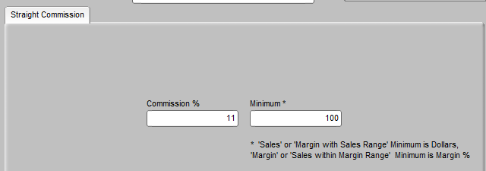

The Commission Method selected will determine the tab displayed at the bottom of the screen. Setup of a Straight Commission plan just requires the entry of a Commission % and a Minimum (percent or dollars depending on the Based On setting).

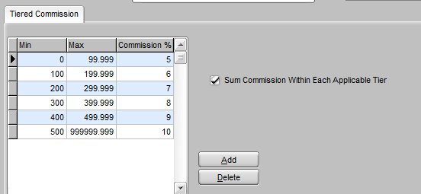
Setup of a Tiered Rates plan requires the entry of a minimum (MIN), a maximum (MAX), and a commission percent. Care should be taken to make sure that the maximum of one tier and the minimum of the next do not overlap or leave a gap. The first tier minimum should be 0. If the maximum is 100.000 then the next tier minimum should be 100.001 (entries are to three decimals.)

If checked, Sum Commission Within Each Applicable Tier means that, depending on the calculation method selected on report setup (see below), the tier is applied to the total, invoices, or invoice lines individually. For example, using the table shown and based on sales, and calculating based on invoices, the commission on an invoice of $150 with the option not checked would be $9 (150 x .06). But if the option is checked then the commission would be $8 (100 x .05 + 50 x .06). With escalating commission tier, as in this example, the total commission will always be lower if the Sum Commission option is checked.

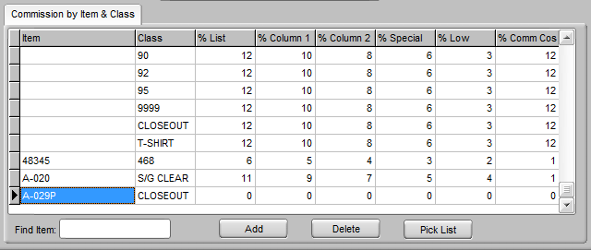
By Item & Class uses price levels to determine the appropriate commission percent rather than sales or margins. This method would typically not be used if the sales price can be overridden. An overridden price will be treated as having the “base” price regardless of the actual price and awarded commission accordingly. Also, when a price list is in effect the customer price level will determine the commission even though the price on the price list may be significantly different from the price in the item master at the same level.

Note that only items referenced specifically or via their item class will be considered for commission with this method. If an item or its class is not listed no commission is awarded. If your intention is to use this method to cover all items in your inventory then you will want to make sure that you have an entry for every item class so that new items are sure to be included. You can setup a class and setup individual items within it as exceptions.

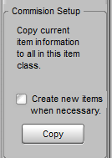
Use the Commission Setup function (displayed only when the Item & Class method is selected) to copy the percents entered from the highlighted item to any other items in the table that have the same class or to add all items from a class with identical percentages. You can then make individual adjustments to the items. Otherwise you would just set the class in general.

Commissions are only calculated for reporting purposes and reports can be run based on whatever plans are currently set. So a salesperson’s commissions can be setup as a straight method and a report run and then changed to tiered and another report run for comparison. Commission calculations can also vary depending on the setup of the report run. With one or more salespeople’s commission plan setup complete, click the Commission Rpt button. Remember that the Pay Commission option must be checked and the commission method selected must contain some commission percent to include that salesperson in the report setup selector.

On the report setup screen you can select one of the preset date ranges or enter a specific range. Note that the range applies to the date paid instead of the invoice date if the AR Options box is checked for the salesperson. Remember that commissions can be reported on any date range. If commissions are calculated monthly and the date range set for a run overlaps a previous run then double commissions could be paid.

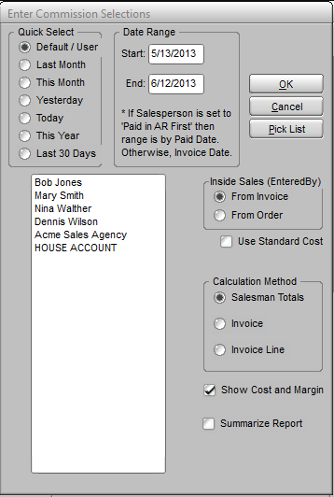
If you have staff setup as Inside Salesperson then you can choose to select eligible invoices based on who was the Entered By on either the invoice or the order that originated it. The Entered By of an invoice can be edited if it has not been posted so it’s possible they could be different. Note that if an invoice/order has the same Entered By and Salesperson commission is only paid once.

Check the Use Standard Cost option if you want to calculate margins based on the current standard cost on file rather than the cost on the invoice, which may predate the current cost or have been overridden. This would have no effect on commissions that are based on Sales, since they do not consider the gross margin.

The Calculation Method will have a significant impact on the commissions calculated for most plans. For example, the tiered plan using the Invoice Calculation Method would consider each individual invoice and compare it to the tier levels whereas the Invoice Line method would compare invoice lines to the tiers. Note that only the Invoice Line method should be used for report runs containing salespeople with By Item & Class setup since by definition every invoice line must be considered to calculate the commission.

The table below gives examples of how straight and tiered plans vary with different methods. Determining how each Commission Method and Calculation Method combination affects the commission is best observed by simply running comparative reports.

 | By Sales Totals  $210 in sales | By Invoices  $90 and $120 invoices | By Invoice Line  Invoices with lines $40, $50, $100, and $20
Straight  5% with $100 Min | $10.50 | $6 ($120 x ,05) | $5 (one line meets min)
Tiered  5% for $0 to $99  6% for $100 + | $12.60 ($210 x .06) | $11.70 ($90 x .05 + $120 x .06) | $11.50 ($110 x .05 + $100 x .06)
Tiered (as above) Sum Within | $11.61 ($99 x .05 + $111 x .06) | $11.70 | $10.46 ($209 x .05 + $1 x .06)

Once the Calculation Method has been determined that is to be used for all or most reports, you can set the default for the report setup in System Defaults (General Tab).

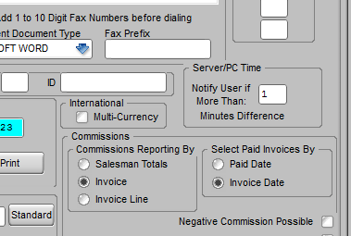
Also in System Defaults, if Negative Commission Possible is checked then credit invoices (if by invoices) or credit line items (if by invoice line) will deduct from the commission total.

Two other settings in Edit Items (Ordering tab) may affect commissions. Any item can be set with a Commission Factor the will determine the commission paid to any salesperson for that item. A factor of 1.1 would increase commissions for that item by ten percent, while .9 would reduce them by ten percent. An entry in the Sales field would be used instead of the Standard Cost for commission plans that use the margin.
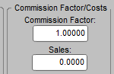
The final two options for the report are only related to report layout and do not affect calculations. Show Cost and Margin would likely be used if the commission is based on margins in any way or if you wish to review profitability in comparison to the commissions you’re paying. Summarize Report suppresses all details and only prints a total sales (and cost and margin if selected) and commission due a salesperson.

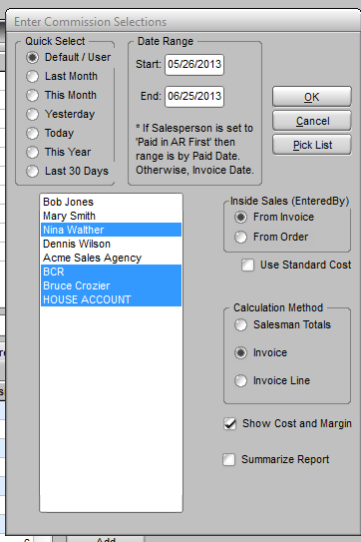
To run the report then click the OK button. Remember that commissions are not posted in any way within the system. Reports are for information purposes only and can be rerun in any number of ways as many times as you wish.

After you have setup the report you can select the salespeople for whom the report is to be run. Remember only salespeople set as Pay Commission and with a commission rate plan setup will be listed in the box to the left. To select an individual salesperson for the report run just click on them. To select an added salesperson, hold down the control key and click on them, etc. To select all or a consecutive range of sale people, click the first one, then hold down the shift key and select the last one.

