SQL Tools

A Quick Guide to Simple Commands

SQL is a very powerful query language and advanced use requires training. But a few simple commands can accomplish a great deal for the novice user. BCR contains a very handy SQL interface (Administration>System>SQL Tools) that makes the entry of SQL commands easier and facilitates data editing. This tool should never be used without training and guidance from BCR. Changing data records outside of BCR applications can cause severe damage to your data integrity!
You can display a table’s data by simply clicking the table name in the box on the left. The field names and data types for that table are listed in the box to the right. You can then manually edit field data by clicking in the grid at the bottom of the screen. You must click in another row or on the checkmark in the toolbar strip in the middle of the screen to update the change.
There is no “undo” function for edits once you have updated!
To display a different table double click it in the box on the left.
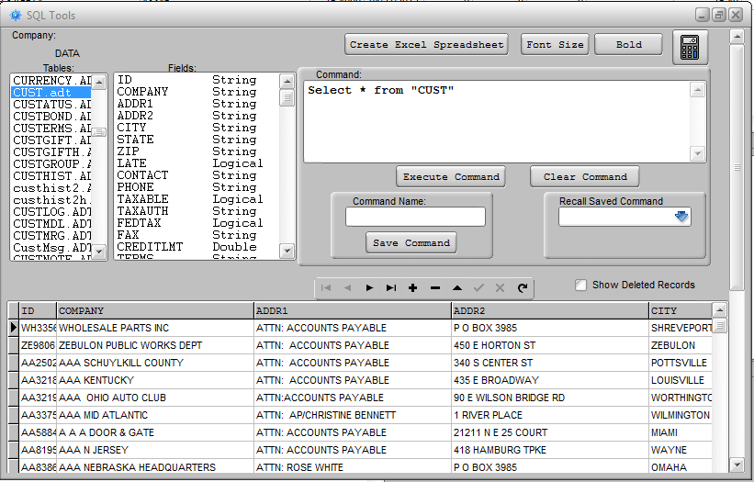
At the top of the screen is a button that will export the contents of the grid at the bottom to an Excel spreadsheet. Use the Font Size and Bold buttons to improve the readability of the grid contents. And there is a calculator for your convenience. The control toolbar in the middles of the screen will move you through the records in the grid, insert a new blank record row, delete a record, etc.
The default command that appears in the Command entry box when you click on a table simply lists all of the fields for all records in the table. The asterisk (*) means you wish to display all of the fields. To limit the listing to specific fields just replace the “*” with the field names. (Note: Examples are shown in all caps for clarity but SQL is not case sensitive.)
SELECT COMPANY, STATE FROM CUST
After you enter a command you must click the Execute Command button. Hitting enter after a command just moves to the next line in the text entry box.
If you want to see the records listed in a specific order use ORDER BY.
SELECT * FROM CUST ORDER BY STATE
To limit the records displayed you can add conditions.
SELECT * FROM CUST WHERE STATE = ‘CO’ ORDER BY CITY
or…
SELECT * FROM CUST WHERE CREDITLMT > 1000
You can combine multiple conditions.
SELECT * FROM CUST WHERE STATE = ‘CO’ AND CREDITLMT > 1000
SELECT * FROM CUST WHERE CREDITLMT > 1000 AND (STATE = ‘CO’ OR STATE = “UT”)
Be sure to use single quotes (‘) for string (i.e., alpha-numeric) values. Numeric values (designated as double in the Fields box) and logical (True or False) are not enclosed in single quotes but string values (typically alpha/numeric characters) are. Double quotes (“) are reserved for table and field names, though it’s only necessary to enclose table and field names when they conflict with SQL keywords like DESC, which indicates descending order.
You can use = (equals), < (less than), > (greater than), <> (not equal), <= (less than or equal), or >= (greater than or equal).
For strings it’s sometimes better to use LIKE rather than equals. LIKE allows you to specify wildcards (unspecified characters). Use a “%”” when you want to allow any number of unspecified characters and “-“ for just one character. So ‘JOHN%’ returns JOHN SMITH and JOHN JONES but not BOB JOHNSON, and ‘BOB JOHN-‘ returns BOB JOHNS but not BOB JOHNSON.
SELECT ID, CONTACT FROM “CUST” WHERE CONTACT LIKE ‘%JOHN%’
If you need to know the number of records that meet a condition you can just COUNT them.
SELECT COUNT(*) FROM CUST WHERE STATE = ‘CO’
You can also change data in multiple records with an UPDATE command.
IMPORTANT!
You should always make a backup copy of a table in your data folder before making changes using the UPDATE command. An UPDATE command should only be used when you are confident that changes will not do harm to your data integrity. Please check with BCR support if you have not been trained in the use of this command and what data fields can safely be changed using it. Changes made with the UPDATE command are irreversible.
UPDATE CUST SET REGION = ‘WEST’ WHERE STATE = ‘CO’
Note that the phrase starting SET must follow the table name, followed by the condition phrase WHERE. You can update multiple fields by separating them with comas.
UPDATE CUST SET REGION = ‘WEST’ , CREDITLMT = 10000

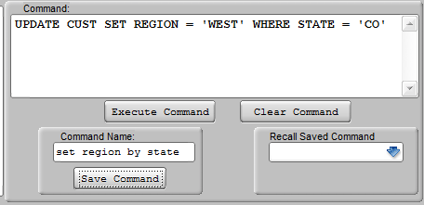
Once you have entered a command and executed it, verifying that your command is correctly stated and produced the desired results, you may want to save it to be used again or as a template for future commands. This will reduce the frustration of trying to locate minor errors made entering commands. Simply type a name for the command in the Command Name box and click Save Command. To recall the command just select it from the dropdown box on the left.

