Return Goods to Vendors
The process to return goods to a vendor is very simple. Open the Vendor Return screen from the IP>Inventory menu.
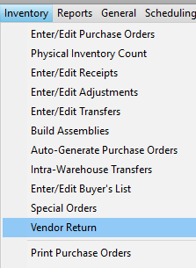
Click New and select a vendor from the popup vendor selection.
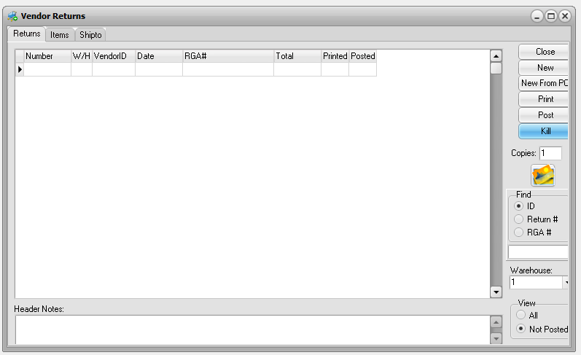
This will take you to the Items tab where you can reference vendor and/or customer RGA numbers and a general note for the return.
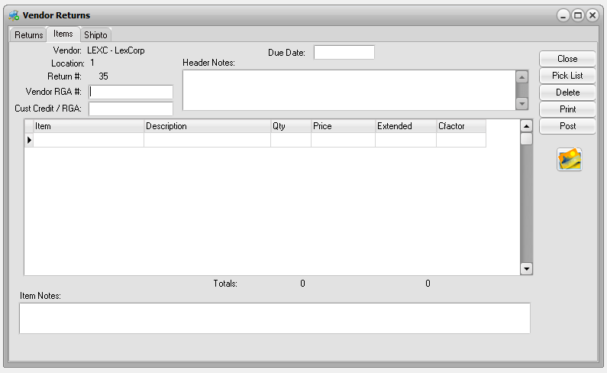
Then enter items to be returned. Note that the quantity should be positive. If necessary you can override the cost and add a note for the individual item.
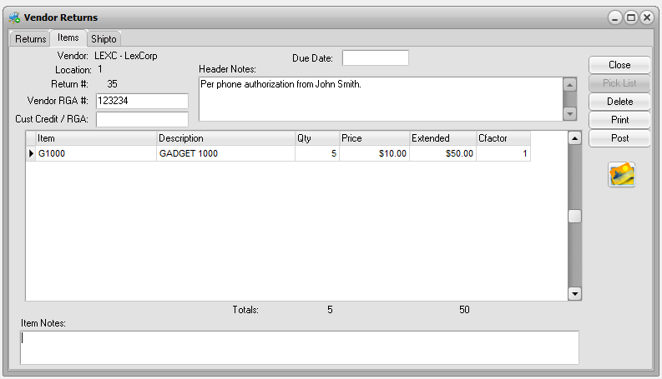
If the vendor has more than one address to ship to, you can select the Shipto tab to select the ship to address. If you have a returns form you can print it from here BEFORE you post.
When you have finished and are satisfied the entry is correct then just click Post. A CRedit will be posted immediately to the vendor’s payable account and inventory will be reduced. If you are not ready to post, click Close and you can select the return and edit when you reopen the program. Or you can Kill the return if you change your mind.
There is no undo once a return is posted. If you have made an error you will need to create a credit memo for the vendor’s account and an inventory adjustment to bring the goods back into stock. The credit memo will credit AP and the inventory adjustment will debit inventory. You will need to use a GL adjustment account for the counter-balancing debit and credit.

