BCR Reserved Inventory

The BCR Reserved Inventory system allows you to set aside quantities of items for specific customers. When a quantity is reserved for a customer it is deducted from the available quantity of that item. If another customer places an order for that item that would drive the available below the reserved quantity, that customer’s order is backordered, as though there were no stock available. This insures that the customer with reserved stock always has up to the reserved quantity available exclusively for them. Reserved inventory can be reserved for specified time periods and when the period expires the quantity is returned to available inventory.
To enable reserved inventory the “Allow Customer Reserved Inventory for Availability” option must be checked on the IP>Misc tab in System Defaults.
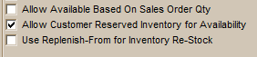

Once enabled, the Reserved Inventory grid will appear at the bottom of the Items tab in Edit Customers. In this grid you can enter any number of items and specify a warehouse location, quantity, and a starting and end date. Multiple items can be reserved for a customer. And one item can be reserved in multiple warehouses or for multiple date ranges (e.g., for seasonal reasons.) NOTE THAT IF NO END DATE IS SPECIFIED, THE QUANTITY WILL BE RESERVED INDEFINITELY.

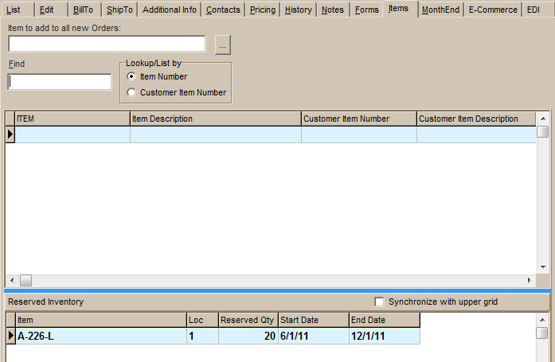
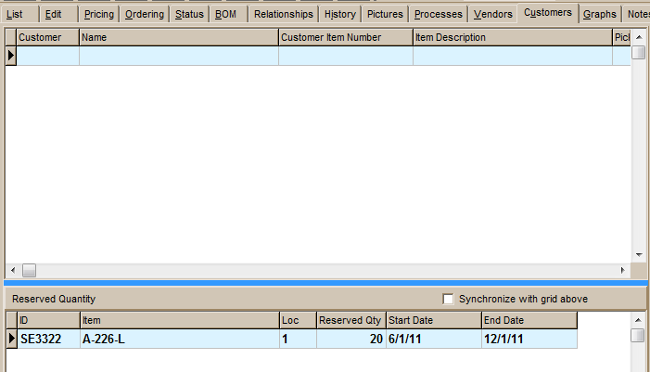
Enabling reserved inventory causes a similar grid to appear on the Customers tab in Edit Items. The data in the grid mirrors the entries in Edit Customers and vice versa, so reserved inventory can be setup and maintained from either screen. If one item is reserved for multiple customers then Edit Items would be the easier screen to use.

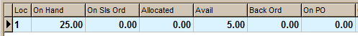
Once a quantity has been reserved for an item the available quantity will be reduced accordingly. In this example 20 have been reserved for a customer. Even though there are 25 on hand, the system only shows 5 available. On the Inventory Requirements Report, the 20 reserved are added to the open sales order quantity so that the system believes that the item is below its minimum and needs to order 35 to bring the item up to its maximum.

