Researching AR Postings
Occasionally a question arises as to whether an error has been made in the posting in AR. If you have some of the details of the posting you should be able to get all of the details using basic inquiries in Titan. Specifically the GL inquiry (GL>General>GL Account Activity) and AR inquiry (AR>Reports>Display Account Detail) should provide the information needed.
NOTE: If you don’t have much detail then a support representative may need to use the SQL tool to get the details needed. Do not attempt to use the SQL tool if you are not experienced with SQL. Contact your support representative for assistance.
If you know the batch number of the payment you can view the individual posting of the batch by doing a GL inquiry.
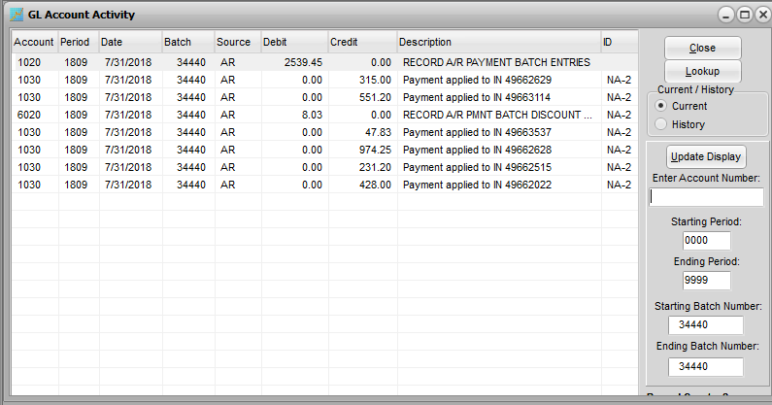
Even if you don’t know the batch you can probably locate it by searching on the bank GL account in the period it was posted for the debit amount of the deposit. Remember that you can sort the columns on this screen by clicking on the column heading (and click again to reverse the sort). You can probably quickly locate the deposit amount in the sorted deposit amounts. Then note the batch number and search for all entries from that batch.
If you know one of the invoices that had a payment applied in the batch then you can find it in the AR inquiry. Select the customer and then select the criteria for your search (Document #, Amount, Check #, Date, or Bill To) and enter the value you’re searching for. If the invoice is located the lower grid of the screen will display the payments made against it. If the Applied Amount is not the total payment from the customer then you might be able to locate the total PA record in the upper grid based on the date.
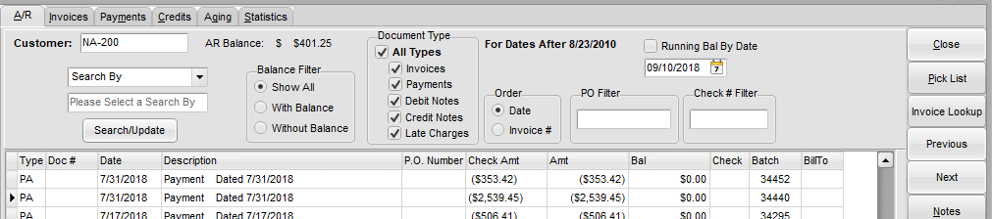
If neither of these inquiries gives you the information you need then you may need to dig deeper.

Researching AR using SQL
NOTE: If you are unfamiliar with the SQL Tools (Admin>System>SQL Tools) contact your support representative. SQL is very powerful and can do significant damage to your data if it is not used correctly.
When an AR batch is posted it is referenced in three different tables (AR, ARACT, and GL) that are interrelated. The fact that one invoice may be paid on in more than one batch, and that one batch may contain payments to multiple invoices by multiple customers, makes the data record structure more complex. Most of the details of these posting can be found with simple AR and GL inquiries in Titan. On rare occasion, however, it may be necessary to investigate the raw data using SQL or create a report in Report Writer.
To understand AR postings it’s helpful to know what records are produced as a result of each entry. The postings to the GL are the result of the batch postings. Separate records are posted for each invoice to which payment is applied, the total of discounts taken for each customer, and the total cash received.
Two tables, the AR and ARACT, contain more information needed to determine all of the specifics of batches. The AR table is a running record of invoices and payments. It might be considered the AR “ledger”. The ARACT table is a record of each posting. It might be considered the AR “journal”.
When an invoice is posted at End of Day (or later when the AR batch is posted if it is not automatically posted by the EoD program) one record is written to the AR table containing the customer ID, invoice number and amount. The balance due on the invoice is maintained in this record as payments are applied. Another record containing the invoice amount is written to the ARACT table. These two records are linked by the AR.UNIQKEY and the ARACT.ARFKEY.
When a payment is made and posted, one record is posted to the AR for each account payment was applied to in that batch, irrespective of the number of invoices it was applied to. If an amount is unapplied an additional record with a TYPE of UN is posted in AR as well, with an open balance which will be reduced if the unapplied amount is later applied to invoices.* So if an AR batch is posted that contained payments made on two accounts, one with money applied on a dozen invoices and the other account with an unapplied payment, then three records would be created in the AR, one for the first account and two for the second. Each record will have its own AR.UNIQKEY.
In the ARACT table two separate records are created for each invoice that had an amount applied. One will have a positive amount with an ARACT.ARFKEY matching the AR.UNIQKEY of the payment record and an ARACT.FROMDOC matching the AR.UNIQKEY of the invoice record. A second record will be just the reverse, with a negative amount and the ARFKEY linking the invoice and the FROMDOC matching the payment. If any payment terms discounts were taken in the posting then a separate ARACT is created for each discount taken with both the ARFKEY and the FROMDOC matching the AR.UNIQKEY of the invoice the discount was taken on. Discounts are also subtracted from the AR.BAL of the invoice.
* There are five AR.TYPEs: IN (invoice), CR (credit), DR (debit), PA (payment), and UN (unapplied)
In the following example two invoices (1234 for $500 and 1256 for $30) have been posted to an account and one payment ($480) applied to all of one (1256) and part of the other (1234). Also, a terms discount ($10) was applied to one invoice (1234).
The AR table records:
ID | INVNO | BAL | AMT | TYPE | UNIQKEY
ACE | 1234 | 40 | 500 | IN | 000AB1
ACE | 1256 | 0 | 30 | IN | 000AC8
ACE |  | 0 | 480 | PA | 000DK4

The ARACT table records:
AMT | ARFKEY | FROMDOC
500 | 000AB1
30 | 000AC8
-480 | 000DK4
30 | 000AC8 | 000DK4
-30 | 000DK4 | 000AC8
-450 | 000AB1 | 000DK4
450 | 000DK4 | 000AB1
-10 | 000AB1 | 000AB1

The most common question in researching questions about the AR postings is what did the entire AR batch look like before it was posted. Was a payment applied to the wrong account? Using either a GL inquiry or the AR inquiry (AR>Reports>Display Account Detail) you should be able to determine the AR batch number. While the batch number is not contained in the ARACT table, using the records and relationships described above you can research and reconstruct the original batch.
For example, you have a customer who sends you a payment for an invoice but you show the invoice is paid. Was money applied to the wrong account? Start with a customer account inquiry which will tell you what payments have been applied to a given invoice.
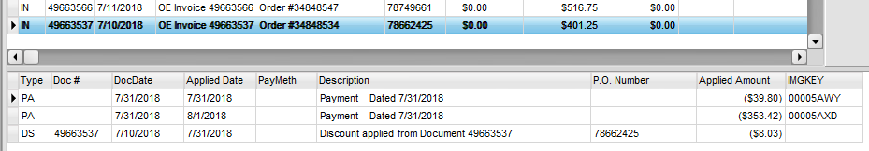
From this screen we can see that two payments and a discount have been applied to this invoice. But we don’t know what the batch was. In order to reconstruct all of the postings made in that batch and possibly find which accounts received credit we can start by locating the invoice record in the AR table. If you want to go quickly to the postings made with one of those payments, note the IMGKEY and look for that value in the AR table.
If you only know the payment information and not the accounts or invoices, find that payment in the upper grid of AR tab. The invoices paid by that payment will be listed in the lower. Find one of those invoices in the upper grid and select it. This will give you the IMGKEY for that payment.
NOTE: In some of the screenshots below the fields in the SQL query results have been repositioned for easier viewing.
Select * from "AR" where IMGKEY = '00005AWY'
Now you can use the batch number to do a GL Account Activity inquiry which will tell you which invoices received payments.
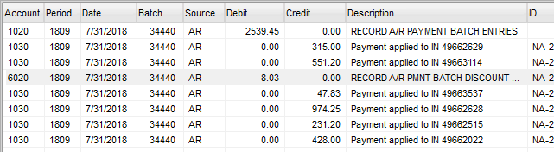
Note the UNIQKEY of this record and search for records in the ARACT table with that value in ARFKEY.
Select * from ARACT where ARFKEY = '0000066JXF'
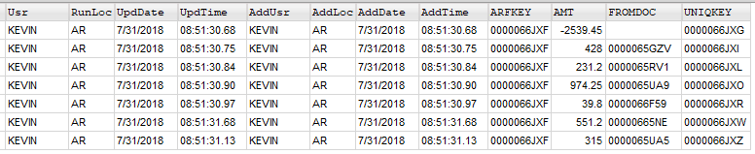
This will give you all of the records created in that table by that batch posting FOR THAT CUSTOMER. You can now use the FROMDOCs of each invoice payment to locate that specific invoice record by the UNIQKEY in the AR table.
Select * from AR where UNIQKEY = '0000065GZV'
To see all of the invoices at once:
Select * from AR where UNIQKEY in ('0000065GZV','0000065RV1','0000065UA9','0000066F59','00000665NE','0000065UA5')
You can also use these keys to see other details.
Select * from AR where INVNO = '49663537'
The UNIQKEY in this AR record will be referenced as the ARFKEY or FROMDOC in all related records in the ARACT table, which links all of the postings shown in the inquiry above.
Select * from ARACT where ARFKEY = '0000066F59' or where FROMDOC = '0000066F59'
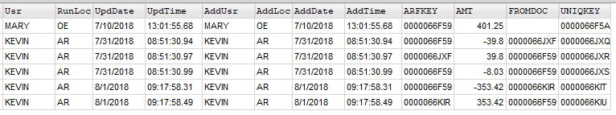
Select * from ARACT where ARFKEY = '0000066JXF'

