report writer

# What is Query-By-Example?

Query-By-Example (QBE) is a visual method to represent a database search. QBE is generally easier to understand than Structured Query Language (SQL), which is the industry standard for defining a database search.

QBE and SQL were developed simultaneously in the 1970’s as potentially competing standards. Instead, they became complimentary. SQL is now the industry standard language for searching databases while QBE is the most common technique for generating SQL code quickly and easily.

BCR Report Writer implements a powerful Query-By-Example system for users that want results instead of computer jargon. The time you invest with BCR Report Writer will empower you to transform raw data into meaningful information – when you need it!

# In the beginning…

All databases begin with one or more tables, which may contain vast amounts of information. Typically, this information is only useful in small amounts. BCR Report Writer provides an easy way to choose a subset of fields and records from your database.

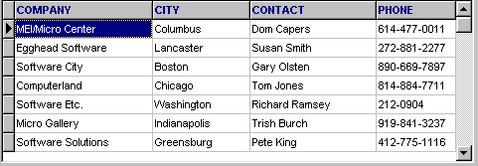

Fields are selected using simple drag-and-drop techniques.

Records are selected by defining powerful search filters from the “Define Search” tab of BCR Report Writer. This is the heart of BCR’s Query-By-Example interface. Define Search provides an easy way to indicate the values or range of values that a record must have to appear in your report.

Consider the following query:

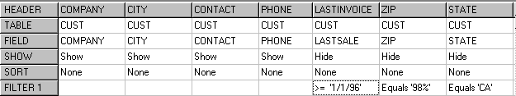

This query informs BCR to display the Company, City, and Contact and Phone from the Customer table where the Last Sale Date is greater than or equal to 1/1/96, **AND** the first two digits of the Customer’s zip code is 98, **AND** State equals California. Since each filter value appears on the same line, all statements must be true for the record to be included in the result set. The following query contains the same elements but produces very different results:

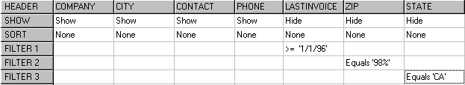

This query informs BCR to display the Company, City, Contact, and Phone from the Customer table where the Last Invoice Date is greater than or equal to 1/1/96, **OR** the first two digits of the Customer’s zip code is 98, **OR** State equals California. Since each filter value appears on a different line, at least one of the filter values must be true for the record to be included in the result set.

**NOTE:** In a multi-line query, duplicate records will be returned if a record matches two or more filter lines (see Query Options for information about turning off duplicate records).

As you can see, BCR Report Writer offers powerful record filtering tools (see Edit Fields and Filter Records for more information). However, this is only the beginning of BCR’s query power.

## Relating Tables

Database information is usually saved in groups of tables, each with unique information. For example, a typical order-entry system will have information about customers, their orders, and the line items that appear on each order, detailed part information that is referenced on each line item, and vendors who supply those parts.

These tables are related to each other, resulting in the term “Relational Database. The orders table, for example, will contain the customer number that requested the order. Since customer number appears in both the customer and orders tables, it becomes clear that we need a way to dynamically link or join the tables together.

BCR Report Writer provides a graphical way to link related tables. You simply drag-and-drop the related field from one table to another. This visual representation makes complex relationships much easier to understand.

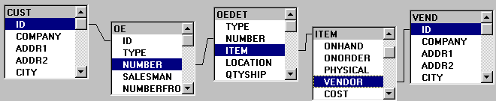

Table linking allows you to ask questions about your data when the answer is dependent on multiple tables, or multiple instances of the same table (see Link Tables for more information).

## Calculating Information

It is quite easy to see how SRW can display fields and records, as they exist in the database. However, BCR Report Writer offers even more powerful features to calculate or derive new information form the database. SRW makes it easy to perform calculations on your data, and choose a subset of records based on the results of these calculations. You can even compare these calculations by the values in other fields, turning previously hidden data into strategic information (see Edit Fields for information about using the Show property with aggregate calculations).

## Full Power Ahead

BCR Report Writer delivers the true power of a relational database to you. It supports Paradox, dBase, Access, SWL Server, Advantage Server, Oracle, Informix, InterBase, Sybase, and other ANSI-SQL compliant database management systems. SRW helps you turn raw data into useful information quickly. BCR Report Writer is instant reporting at its best.

**Using Define Search**

Define Search is like a detective who searches the countryside for evidence that matches his clues. Your job, as a user, is to provide the clues needed to solve the mystery. This is, in fact, where the term “Query-By-Example” gets its name: You provide examples of data to indicate which records should be included and excluded from your query.

The graphic below shows a picture of Define Search with key elements highlighted. Information following the graphic describes how to use Define Search.

**Report Setup**

**Add Tables**

##### Remove Tables

##### Remove Links

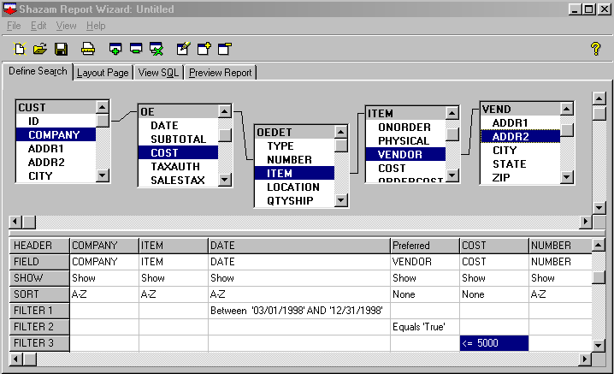 **Edit Field**

##### Table

**Link**

**Field**

**Alias**

**Display**

**Status**

##### Sort Filter

The tasks you can perform within Define Search are discussed in the following sections.

**Add Tables**



Press the toolbar button to displaythe “Add Tables” dialog, or use the

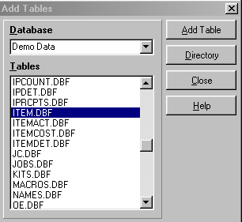“Edit | Add Tables” menu. The following dialog is displayed:

The “Add Table” dialog consists of the following elements:

## Database

Type in the database name or path, or select a predefined alias from the drop-down list box. If you typed an entry, press [Enter] when done.

## Tables

Database tables are displayed in this list box. With your mouse or arrow keys, highlight a table name and either double-click or press the [Add Table] button. This will add your selected tables to the main BCR Report Writer window.

## Add Table

The [Add Table] button adds the currently highlighted table to your report (see Tables above).

## Directory

The [Directory] button allows you to select a DOS Directory/Folder that contains Paradox or dBase tables without a predefined database Alias. This displays a standard File Open dialog box.

**NOTE:** Selecting tables from the open dialog will not add them to the report. It only selects the directory in which the tables exist. Once you press [OK], you must double-click on the desired tables or select the [Add Table] button.

#### **Close**

The [Close] button closes the “Add Tables” dialog box.

## Help

The [Help] button displays its associated help topic.

## Removing Tables

Removing tables from a report is a two-step process:

* Select the table to delete by pressing your left mouse button over the selected table.
* Press the tool bar button to remove the table, or use the “Edit | Drop Table” menu.

**Link Tables**

Database information is usually saved in groups of tables, each with unique information. These tables are related to each other using common fields. The orders table, for example, contains the customer number that requested the order. BCR Report Writer provides a graphical way to link related tables together. You simply drag and drop the related field from one table to another, as follows:

1. Using your mouse, point to a field in the first table.
2. Press the left mouse button and drag your mouse to a corresponding field in the second table.
3. Release the left mouse button to create the link between the two fields.

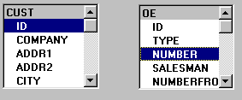

**Above:** Table linking in progress.

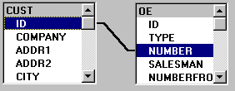

**Above:** A completed table link.

You can have up to 40 table links in a single report, and a single field can participate in up to 10 links. Most database management systems cannot efficiently process more than seven tables at a time. If you need to process many tables for a single report, you may want to break the report into multiple steps, exporting the results of each step to a temporary table and linking that table into subsequent steps. This will often be substantially faster than processing many tables in one report.

**Removing Table Links**

Removing table links from a report is a two-step process:

* Select the table link to delete by pressing your left mouse button over the selected table link. This will highlight the selected table link.
* Press the tool bar button to remove the table link, or use the “Edit | Unlink Tables” menu.

The following question will be displayed:

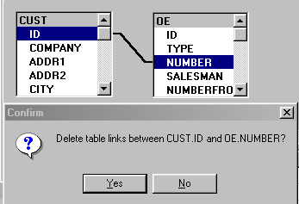

If you answer [Yes], the links between CUST.ID and OE.NUMBER will be removed. If you answer [No], the link will be unchanged.

Make certain that you replace a table link or remove the table before executing your report. A table without a link may generate an error. You can also remove table links by removing their associated tables from the report.

**Customizing Table Links**

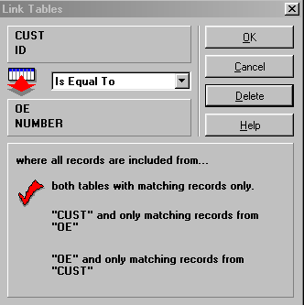Normally, you can link two tables together and accept the default characteristics of the table link without doing anywhere else. If you need to change the default settings, simply double-click on a table link to display the “Link Tables” dialog:

The “Link Tables” dialog consists of the following elements:

**Link Operator**

The upper left-hand portion of the “Link Tables” dialog displays the currently selected link operator. The example above would be read as:

The “Is Equal To” phrase determines how the comparison will be made between the two linking fields. Available choices include:

**Link Operator Symbol**

Is Equal To =

Is Greater Than >

Is Greater or Equal To >=

Is Less Than <

Is Less Than or Equal To <=

Is Not Equal To <>

Link operators other than “Is Equal To” are useful when your report needs to compare the values of two columns and choose records based on the comparison. In this case, you are actually using a table link as a search filter. Link Operators should only be changed when you are familiar with relational databases, and the effect these operators will have on your report.

**Add Fields**

After you have added tables to your report, selecting fields is a three-step process:

1. Press the left mouse button over the selected field.
2. Drag your mouse down to the query grid.
3. Release the left mouse button.

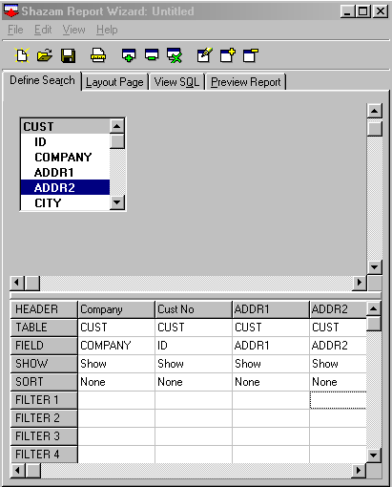

Once you have released the left mouse button, the field will appear in the query grid. The number of fields in your report is limited only by your hardware and memory.



Use this button to insert a new, blank field in between existing fields.



Use this button to remove existing fields from a report.



Use this button to change the settings and filters of a field.

To rearrange fields, perform the following steps:

1. Point to the field header.
2. Hold your left mouse button.
3. “Drag” the field left or right.
4. “Drop” the field by releasing the left mouse button

**Edit Fields**

To modify a field’s characteristics or properties, press the button, double-click directly on the field in the query grid, or select the “Edit | Edit Field” menu. This displays the “Edit Field Properties “ dialog.

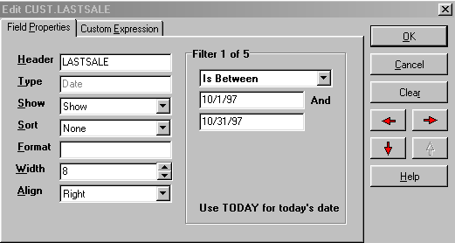

The “Edit Field Properties” dialog consists of the following elements:

**Header:** The Header property is the description of the field that will appear on the report and cannot be blank. It defaults to the name of the field in the database. Some field names will be cryptic or unacceptable on a business report. The Header property allows you to customize the field description, as it will appear on the report. BCR Report Writer manages headers that contain spaces or reserved words automatically. Headers cannot be blank.

**Type:** The Type property is the data type of the field and cannot be modified. For example, the SaleDate in our report can only accept valid Date values. If you type anything else, an error message will be displayed.

Show: The Show property determines how a field will be displayed in your report. The two most common settings are:

* Show, to include the field in Preview Records
* Hide, to hide the field from Preview Records and Preview Report.

Use the Hide setting to search on fields that you do not need to display.

**NOTE:** Some database engines do not permit sorting on hidden fields. See Summarizing Data for more information on how to use the Show property.

**Sort:** The Sort property determines if the field will be used to rearrange the order in that records are displayed on the report. When more than one column is selected to sort on, the collective sort order is based on the left-to-right sequence of these columns in the “Define Search” grid. Sort property values are:

* None for no sort
* Or “1-9” (data type dependent) for Ascending sort order.
* Or 9-1” (data type dependent) for Descending sort order.

The Define Search sort order and Layout Page section order must match. If they do not, BCR Report Writer will prompt you for automatic correction.

**Format:** The Format property determines the manner in which the field will be displayed. See *Date Formatting Masks* and *Numeric Formatting Masks* in SRWHELP.HLP for more information.

**Width:** The Width property determines how long the field will appear on the report. If you want to hide the field, change the Show property to Hide.

**Align:** The Align property determines if the values in a field will display Left, Right, or Center within the width of the displayed field. Most date and numeric data types automatically align themselves to the right.

**Navigating from the “Edit Field Properties” Dialog**

Once the Edit Field dialog is displayed, you can navigate between columns or search Filters within your report without leaving this dialog. The four arrow buttons are defined as follows:

**Left:** Move to the column that is left of the current column.

**Right:** Move the column that is right of the current column.

**Next:** Move to the next Search Filter.

**Previous:** Move to the previous Search Filter.

All four of the navigation buttons automatically save any changes to the current field before moving. Remember this when you press the [Cancel] button and find that some changes have already been saved.

While the Left and Right navigation commands change fields, the Next and Previous buttons change Search Filters within the same field. Each field can have up to 5 separate Search Filters. Each line that starts with Filter # in the “Define Search” grid is treated as a completely separate search on the database. Within each line, a record must match all Search Filters between columns to be included in the report.

**Filter Values**

See Filter Records for detailed information about using BCR’s filtering process.

**Filter Records**

Filtering records is at the heart of meaningful reports. Sham’s filtering process is very easy. You may edit search filters from the “Edit Field Properties” dialog (see Edit Fields for more information).

A search filter consists of a Filter Command and one or more search values. Valid Filter Commands are:

**Is Equal To:** Include records that equal any one of up to 5 values.

**Is Between:** Include records that are within a range of 2 values.

**Is Greater Than:** Include records that are greater than a single value.

**Is Greater or Equal To:** Include records that are greater than or equal to a single value.

**Is Less Than:** Include records that are less than a single value.

**Is Less or Equal To:** Include records that are less than or equal to a single value.

**Contains:** Include records that contain up to 5 matching values within the field. Use “value%” to search for all records that start with value. Use “%value” to search for all records that end with value. Use “%value%” to search for all records that include value anywhere in the field.

**Is Not Equal To:** Exclude records that are equal up to 5 matching values.

**Is Not Between:** Exclude records that are within the range of 2 values.

**Does Not Contain:** Exclude records that contain a value (see Contains above).

**Filters and Aggregate Calculations**

See *Summarize Data* below for information about how aggregate calculations change the meaning of a query.

**Custom Expressions**

In addition to displaying fields, as they exist in tables, you can also create field expressions to calculate values from two or more fields, such as (ITEMS, QTY * PARTS, Price).

To display the “Custom Expressions” tab of the “Edit Field Properties” dialog, follow these two steps:

* Place your cursor on a blank field in the query grid



* Double-click on the blank field or press the button.



See Edit Fields for detailed information about the buttons that appear on this dialog box.

**Using Custom Expressions**

Double-click on Tables/Fields and Operators/Functions to add them to the custom expression field. You must observe the following rules when using custom field expressions:

* When adding field names to a custom expression, always double-click on fields from the table’s outline rather than entering them by hand. BCR Report Writer automatically checks for reserved words and punctuation when fields are selected from the tables outline.
* Use a table name (as aliased by SRW) in a custom expression.
* Surround table and fields names that have punctuation or spaces, or are reserved words with double quotes. Example: CUSTOMER, “Active” and “Cust-95”, “Active both require quotes. If selected from the tables outline, they will be automatically quoted.
* Some database engines do not support filters on custom expressions, such as Paradox and Dbase for Windows 3.1. See Paradox and dBase for a work around.

If these rules are not followed faithfully, the SQL code that is generated may fail. If you receive a TOKEN error after executing a report, the problem is most likely a missing table name in a custom expression, or a name that cannot be processed correctly without double quotes.

**Resolving Token Errors**

BCR Report Writer automatically checks for over 270 reserved words, spaces, and punctuation when fields are selected from the tables outline. However, if a TOKEN error occurs on a field name chosen from the tables outline, you can use custom field expressions to work around the problem. This is a two-step process:

* Add quotes to the Header if it matches the field name.
* Select the field from custom field expressions and add quotes.

**NOTE:** If an existing database field is selected, and you create a Custom Expression by switching tabs, the original field will be replaced in the query grid when you press [OK]. This allows you to convert a specific field to a custom expression without leaving the “Edit Field Properties” dialog.

**Summarize Data**

The Show property determines how a field will be displayed on your report. Valid Show property values include:

**Show:** Displays the field on the report. This is the default setting.

**Group:** Use when one or more fields has a Show setting of Sum, Count, Average, Minimum or Maximum. Any fields that do not have one of these settings MUST be set to a Group.

**Hide:** Prevents the field from displaying on the report. Use Hide when you need to search a field but do not want that field displayed. Example: Display all orders where Company equals “Unisco.” Since there is only one company, there is little need to repeat the Company name.

**Sum:** Total up all the values in a set of records (field must be numeric).

**Count:** Count the number of occurrences in a set of records.

**Average:** Display the average value in a set of records.

**Minimum:** Display the minimum value in a set of records.

**Maximum:** Display the maximum value in a set of records.

**Understanding Filters with Aggregate Calculations**

The Sum, Count, Average, Minimum, and Maximum values are called aggregate functions. Filter values that are used on columns with an aggregate function are treated differently. For example:

* “Display customers where AmountPaid is greater than 500” displays the RECORDS that exceed an AmountPaid greater than 500.
* “Display customers where the SUM of AmountPaid is greater than 500” displays the records where the collective TOTAL of AmountPaid exceeds 500.

The first example applies the filter values against the actual values of the records. The second example applies the values after a calculation has been performed on a set of records. You may have other fields and filter values as needed in a report with aggregate functions, but they must have a Show setting of Group or Hide.

**Key rules governing Show**

Key points to remember when using the Show property.

* Use a Show value of “Hide” to hide fields that are only searched but not displayed.
* Use a Show value of “Group” to calculate summary values by other columns (i.e., “Display all customers BY CITY where AmountPaid is greater than 500”). The City field would have a Show setting of “Group” and the AmountPaid field would have a Show setting of “Sum.”
* Never use a Show setting of “Group” if the report does not include aggregate functions.

**What is a report?**

|  |  |
| --- | --- |
| Report Header |  |
| Page Header |  |
| Group Header |  |
| Detail Section |  |
| Group Footer |  |
| Page Footer |  |
| Report Footer |  |

Creating a report is like wring a letter. You start with an opening paragraph followed by topics, sub-topics, detailed comments and final conclusions. Of course, letters are not required to follow this or any structure. Reports, however, are structured documents. They follow a strict outline that helps you turn raw data into meaningful information.

For example, a report may begin with a **Report Header**, which summarizes the purpose of the report and only appears on the first page. Likewise, when the report has completed, you may want a **Report Footer,** which summarizes the entire report.

The Report header and footer are called sections or bands of the report. As the graphic above shows, all sections with a Header have an alter ego, the Footer. Headers are like an opening paragraph in a letter, while footers are the closing paragraph. Reports have several types of opening and closing paragraphs.

The second type of section is the **Pager Header,** which always appears at the top of the page. Its alter ego, the **Page Footer,** always appears at the bottom of the page. These sections are especially useful for displaying page number, report title, and other information that must appear on each page of the report. Page Header and Footer produce the same results as the “View, Header and Footer” menu in Microsoft Word but are defined quite differently.

The third type of section, **Group Header,** combines records from a database that are of the same type and presents them as a single package of information.

For example, suppose you have Customer and Order tables. By adding a Group Header, we are now able to see orders for each customer more clearly.

If we added a **Group Footer**, we could total the [AmountPaid] field by customer. The fourth and final type of section in a report is the **Detail Section**. Its purpose is to display individual records at the lowest level of detail in your report.

**Using Layout Page**



Layout Page is like a painter’s canvas, and the Page Designer dialog is like a painter’s palette and brush set. As a painter transforms simple colors into works of art, you will use Layout Page to transform rows and columns of raw data into professional business reports.

The graphic below shows an image of Layout Page with key elements highlighted. Information following the graphic describes how to use Layout Page.

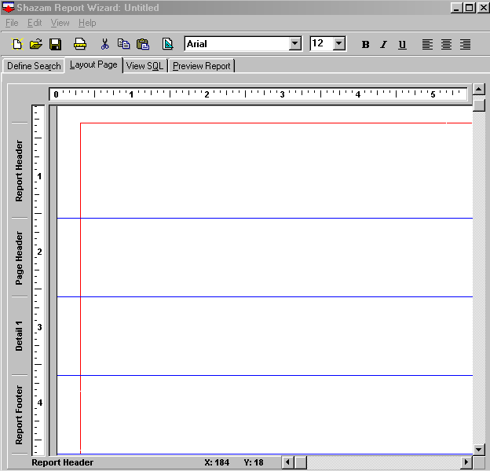

##### Current Section

##### Margin

##### Mouse Position

##### Layout Objects

##### First Name

##### [First Name]

##### Resizing Cursor

##### Section Divider

##### Section Title

**Report Setup Icon**

##### Page Designer Icon

**Arrange Sections**

You may add, edit, and delete Sections by displaying the Arrange Sections tab of the Page Designer dialog.

**Resize Sections**

To change the height of a section, follow these steps:

1. Point to the blue separate line, waiting until your mouse changes to an up-down (resizing arrow).
2. Press the left mouse button.
3. Move the section up or down as desired.
4. Release the left mouse button.

All objects below the current section will move accordingly.

**NOTE:** When decreasing section height, the lowest object within the section determines the minimum height to which you can resize.

**Place Objects**

You may place fields, labels, memos, shapes, images, and other objects from the Place Objects tab of the Page Designer dialog.

**Customize Objects**

You may customize the characteristics or properties of layout objects from the Customize Objects table of the Page Designer dialog.

**Align Objects**

To align objects, see the Align Objects topic

**Select Objects**

To select objects, follow these steps.

1. Point to an object with your mouse.
2. Press the left mouse button to display the object’s selection and resizing handles.
3. Release the mouse button.

**Select Multiple Objects**

To select more than one object at the same time, choose one of the following options:

* Hold the shift key while selecting objects.
* Point to the layout page, press the left mouse button and drag the mouse down and to the right to contain or *lasso* the desired objects.
* Select the “Edit | Select All” menu option.

**Move Objects**

To move objects, follow these steps:

1. Select one or more objects.
2. Point to the middle of any selected object (away from its selection handles).
3. Press the left mouse button, drag the objects to the desired location and release the left mouse button.

**Unselect Objects**

To unselect objects, choose one of the following options:

* To unselect all previously selected objects, point to any area of the layout page that does not contain objects and press the left mouse button.
* To unselect one previously selected object, hold the shift key, point to the object, press and release the left mouse button.

**Delete Objects**

To delete objects, follow these steps:

1. Select one or more objects.
2. Press the Del key or select the “Edit | Clear” menu option.

Cut, Copy, and Paste Objects

To cut, copy and paste objects, follow these steps:

1. Select one or more objects.
2. To cut objects, press Ctrl-X or select the “Edit | Cut” menu option.
3. To copy objects, press Ctrl-C or select the “Edit | Copy” menu option.
4. To paste objects, press Ctrl-V to select the “Edit | Paste” menu.

**Note:** If you close the main BCR Report Writer window before pasting objects, the clipboard will be cleared and you will not be able to paste previously copied objects from one report to another, simply open the second report without closing the main BCR Report Writer window.

**Resize objects**

To resize objects, follow these steps:

1. Select one object (resizing does not work when multiple objects are selected).
2. Point to the resizing handles that appear when an object is selected.
3. Press the left mouse button, drag the object to its new size and release the left mouse button.

You can also resize objects by changing the Left, Top, Right, and Bottom properties within the Customize Objects tab of the Page Designer dialog.

**Context-Sensitive Menu**

You can display the context-sensitive menu at any time by pressing the right mouse key. This menu gives you quick access to the individual tabs of the Page Designer, as well as the Caption property. You can also use this menu to cut, copy and paste objects, display report setup and activate object alignment.

**Align Objects**

BCR Report Writer offers desktop-publishing style alignment guides. This gives you extremely powerful features to align all objects horizontally and vertically.

**Creating Alignment Guides**

To create alignment guides, do the following:

1. From Layout Page, point to the horizontal or vertical ruler.
2. Press your left mouse button.
3. Drag an alignment guide to the page.
4. Release your mouse.

**Using Alignment Guides**

To use alignment guides, move any object within 5 pixels of the guide and it will snap to position when you release the mouse.

**Deleting Alignment Guides**

To delete alignment guides, do the following:

1. Point to the alignment guide and press the left mouse button.
2. Drag the alignment guide to its corresponding ruler.
3. Release the mouse button.

**Arrange Sections**



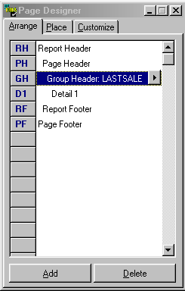To arrange sections, press the Page Designer icon or right mouse click over the layout and select the “Arrange Sections” menu to display following dialog:

Press here to edit Section properties and add footers to existing headers

The Arrange Sections tab of the Page Designer displays all active sections of a report in a hierarchical format. If a section has been suppressed from printing (see Edit Section), the word “(Suppressed)” will appear to the right of the section name. You may also perform the following actions from the Add Section dialog:

**Edit**

Pressing the button to the immediate right of a section displays the Edit Section dialog, allowing you to edit properties of existing sections, and add footers to existing headers.

**Add**

Pressing the Add button displays the Add Sections Wizard, which walks you through the process of adding one or more sections to a report.

**Delete**

The Delete button removes a section and all of its objects from a report (use with caution).

**Accessing pop-up menu options**

Press the right mouse button over the Page Designer dialog to display its pop-up menu. This menu displays Report setup, sets the default font, and sets the Page Designer’s “Stay on Top” status.

**Add Section**

The Add Sections Wizards is a powerful tool to add one or more sections to a report at the same time. You can access this wizard from the Arrange Sections tab of the Page Designer dialog.

The Add Sections Wizard displays the following panels:

**Add Sections**

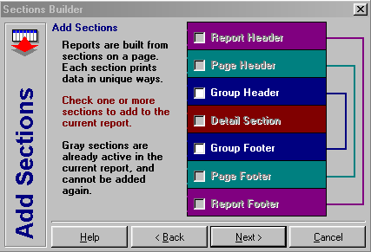

The Add Sections panel displays all possible sections that can be added to a report. Disable sections cannot be added again to the report because the maximum number of that section type have already been added to the report. In the example above, Page Header and Footer have already been added to the report and cannot be added again.

When selecting section headers, also decide if you want section footers to appear.

**Note:** You cannot add section footers from the Add Sections Wizard for section headers that already exist in the report. Use the Edit Section dialog to add footers to existing headers.

When you have selected the sections you want, press the [Next] button.

**Add Groups**

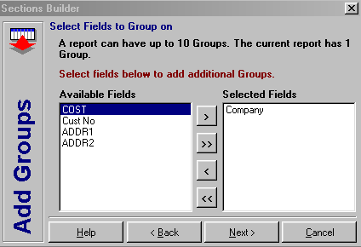

If you selected Group Header from the Add Sections panel, the Add Groups panel will be displayed.

The Add Groups panel displays “”Available Fields” that have not already been used as groups in the report, and allow grouping (e.g., memo and graphic fields do not appear).

To add groups, press the right arrow (>). To remove groups that were selected within the Add Sections Wizard, press the left arrow (<).

**Note:** To remove groups that already exist within the report, return to the Arrange Sections tab of the Page Designer dialog, and press the [Delete] key.

When you have selected the groups you want, press the [Next] button.

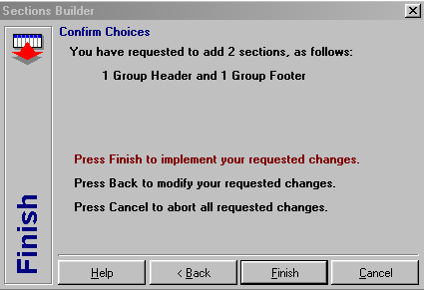**Confirm Choices**

The final panel of the Add Sections Wizard displays the number of sections that you have requested. Press [Finish] to add your selected sections, [<Back] to make changes or [Cancel] to stop adding sections.

**Note:***As a result of adding new groups, the section order in Layout Page and sort order in Define Search may not match. If they do not, BCR Report Writer will inform you of the problem when the query is executed and offer to automatically change the Define Search sort order to match the Layout Page section order.*

**Place Objects**



To place objects, press the Page Designer icon right mouse click over the layout and select the “Place Objects” menu to display the following dialog:

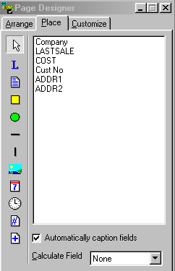

##### Horizontal Line

##### Circle

##### Memo

##### Label

##### Pointer

##### Rectangle

##### Field Caption

##### Field Aggregates

##### Data Fields

##### Page Count

##### Page Number

##### Image

##### Time

##### Date

##### Vertical Line

**Placing Objects**

The left-hand side of the Page Designer’s “Place” tab displays all the objects available within the designer. To place these objects, press an icon and point to the layout page (pick-and-plop). To place multiple copies of an object, hold your shift key and click on the layout page as many times as needed. To cancel the placement of an object, select the Pointer icon.

Information about specific objects follows:

|  |  |
| --- | --- |
| **Object** | **Comments** |
| Label | Displays 1 to 245 characters |
| Memo | Displays 1 to 32,767 characters. For maximum performance, use labels where possible. |
| Rectangle, Circle, Lines | Displays various shapes |
| Image | Displays Window Bitmap (BMP). |
| Date, Time | Label object with @Date or @Time function |
| Page Number, Page Count | Label object with the @PageNumber @PageCount function. |
| Barcode | Label object that displays its contents as a barcode (requires third-party add-on; contact your software provider to have barcodes activated). |
| Fields | Fields are label objects containing a [Field Header] in square brackets. The [Field Header] must have been defined in Define Search before field data will be displayed. |

**Placing Fields**

The right-hand side displays all the fields that were previously selected from Define Search. To place fields, press the left mouse button over the selected field, move your mouse over the layout page and release the left mouse button (drag-and-drop). To place multiple fields, hold your shift key, select all desired fields and drag-and-drop them as described above (Holding the shift key throughout the process).

**Placing Fields without Captions**

Captions are normally added when placing fields. To turn this off, uncheck the “Automatically Caption Fields” option.

**Placing Fields with Aggregate Calculations**

To place fields with aggregate calculations, select Sum, Count, Minimum, Maximum or Average from the “Calculate Field” combo box. This will cause the field name to be surrounded by a calculation function. See Using @ Functions below for more information.

**Accessing Pop-up Menu Options**

Press the right mouse button over the Page Designer dialog to display its pop-up menu. This menu displays Report Setup, sets the default font, and sets the Page Designer’s “Stay On Top” status.

**Customize Objects**



To customize objects, press the Page Designer icon or right mouse click over the layout and select the “Customize Objects” menu to display the following dialog:

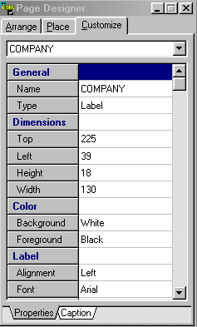

**Caption or Memo**

**Properties**

**Categories**

**Object Name**

All objects on a page have characteristics or properties that you can change.

To change the properties of multiple objects at the same time, hold the shift key, click the desired objects, release the shift key and change their properties.

If all selected objects are of the same type (e.g., label) all properties except General will be available. If you mix object types, only common properties (e.g., Dimensions) will be available.

**Captions and Memos**

When Label or Memo objects are selected, a second tab will appear at the bottom of the Properties list. The Caption or Memo tab displays the current value in a wider area than other properties to improve readability. The display also includes the current font and color, which can be changed from the Properties tab.

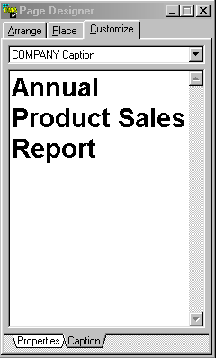

If you want to reference a field name in the caption of a label or memo, surround the field alias or header from Define Search in square brackets, as in [AmountPaid]. If you want to perform aggregate calculations on a field, surround the field alias in one of the supported functions, such as @Sum([AmountPaid]). If you want to suppress all information between a starting and ending point if the field is blank, use the @IsData function (see Using @ Functions for more information). Always reference a field name by its Header in Define Search. If the physical field name is “Paid” but its Header is “AmountPaid”, you must use [AmountPaid] in Layout Page.

**Note**: Label objects are limited to 2345 characters, while memo objects are virtually unlimited in the number of characters they can hold. For maximum performance, use label objects were possible.

**Tip:** For quick access to the Caption property, select a label object, press the right mouse key and choose the “Edit Caption” menu option.

When you have completed your updates, point at the layout page or select Preview Report to apply your changes.

**Selecting Objects by Name**

To select an object by name, use the Object Name combo box that appears at the top of the “Customize” tab. This is also a helpful method of viewing all object names within your layout.

**Accessing Pop-up Menu Options**

Press the right mouse button over the Page Designer dialog to display its pop-up menu. This menu displays Report Setup, sets the default font, and sets the Page Designer’s “Stay on Top” status.

**Using @ Functions**

BCR Report Writer supports 10 special functions available in Layout Page, as follows:

**@DATE**

Displays the current date according to the system clock

**@TIME**

Displays the current time according to the system clock.

**@PAGENO**

Displays the current page number.

**@PAGECOUNT**

Displays totals pages in the report.

**@ISDATA~strings and [fields] and strings~**

Displays strings and fields between delimiters (~) if the [fields] within the delimiters contain data. This function is especially helpful for mailing labels, such as:

[FirstName] @ISDATA~and [SpouseName] ~[LastName]

where “and [SpouseName]” will only be displayed if the [SpouseName] field contains data.

**@SUM([FieldHeader])**

Totals numeric fields within the current section.

**@MIN([FieldHeader])**

Displays the minimum field value within the current section. If the field is a string value, only the first 15 characters are used to determine the minimum value, without regard to case.

**@MAX([FieldHeader])**

Displays the minimum field value within the current section. If the field is a string value, only the first 15 characters are used to determine the maximum value, without regard to case.

**@AVG([FieldHeader])**

Displays the average value of numeric fields within the current section using the formula @SUM divided by @COUNT.

**@COUNT([FieldHeader])**

Displays the number of records within the current section.

**Using @ Functions**

All functions are case insensitive and can be used as part of a field or label caption. Examples include:

**Page @PageNo of @PageCount**

This caption displays “Page 1 of 10”

**The minimum value is @MIN([FieldHeader])**

This caption displays “The minimum value is 10”

**Report printed @DATE at @TIME**

This captions displays “Report printed May 7, 1999 at 12:30 pm (the actual date and time formats depend on how BCR Report Writer is configured by your software provider).

**Preview Report**

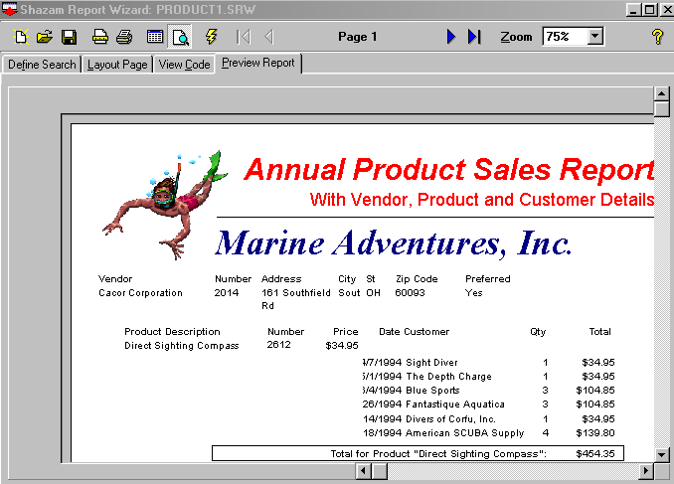The “Preview Report” tab offers a way to view your report while you are designing it. This not only saves paper but it also saves time.

To preview a port in progress, press the “Preview Report” tab or select the “View | Preview Report” menu.

Press the First, Previous, Next or Last buttons to display the corresponding page.

Press the Print toolbar button or select “File | Print Report” to print the report.

Select “File | Export” to export the report to Paradox, dbase, or ASCII text files.

**Preview Records**

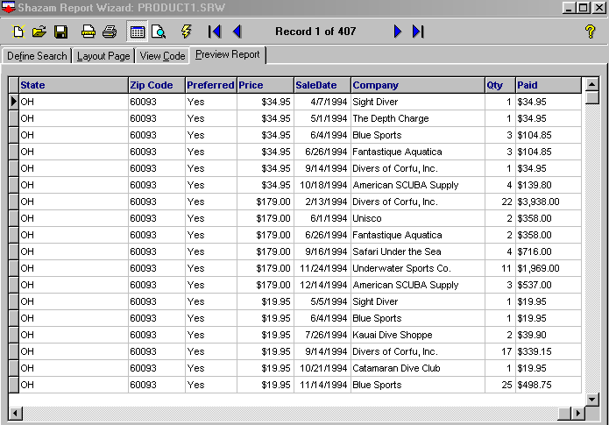You can preview the records of a report anytime by selecting the “Preview Report” tab and the “Preview Records” icon on the toolbar. You can adjust the title, sub-title, footer and fonts used when printing the grid from the Grid tab of Report Setup.

If you have not defined a report layout, Preview Records will be the only view available when previewing the report. If a layout is defined, you can switch between record and layout view on demand.

**Export Reports**

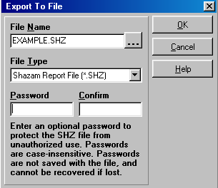You can export files from BCR Report Writer while previewing a report by selecting the File, Export menu or the “Print to File” option when printing a report.

The Export To File dialog supports a variety of file formats.

The *.SHZ format is useful for sending reports by disk, e-mail and the Internet (requires the SHZ16.exe or SHZ32.exe programs to view). These files will be automatically compressed by BCR Report Writer and ready for immediate distribution. When exporting to the SHZ format, please keep in mind that you cannot export a range of pages; you must export the entire report.

The Paradox and dBase formats save the records of the report without any formatting. The fixed field text file is useful for viewing records as plain text. The delimited ASCII format is useful for mail-merge programs.

**Page Setup**

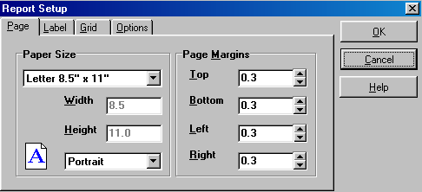To format your report, press this button or select the “Edit | Edit Report Properties” menu. This will display the Report Setup dialog:

The Page tab consists of the following elements:

## Paper Size

Determines the Height and Width of the page. Selecting Custom allows you to enter a custom paper size.

## Page Orientation

Determines if the printed page will appear in Portrait (Tall) or Landscape (Wide) mode.

## Margins

Determines the distance from the edge of the paper to the point at which report content begins.

**Label Setup**

The Label tab allows you to enter all the information required to define a label.

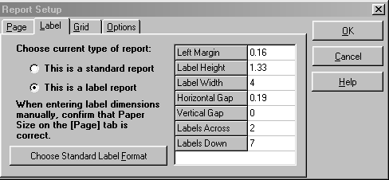

This tab consists of the following elements:

**Choose current type of report**

BCR Report Writer supports two types of reports:

* Standard with Headers, Footers, Groups, Totals, and
* Label with a repeating format across and down the page.

Label reports do not support the banding features of Standard reports. When you define the current report using the label format, the “Layout Page” tab change to a single band called “Label.” When you press [OK], BCR Report Writer will confirm that you want to convert the report to a label format. You can always return to this dialog and simply reset the report to a standard format if you accidentally selected this item.

**Label Dimensions**

Labels are defined with eight data elements as listed above, plus the page size. The Top and Left margins are automatically transferred to the “Page” tab and it’s Bottom and Right Margins are calculated automatically. If you enter label dimensions manually, you must confirm that the page size is correct.

**Choosing Standard Label Format**

Instead of entering the label dimensions manually, select the [Choose Standard Label Format] button to display the following dialog:

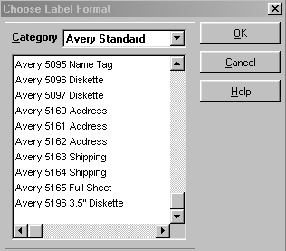

This dialog offers over 150 pre-defined label formats. Simply choose the Category and double-click on a label format. The label’s dimensions will be transferred to the label dimensions grid in the Report Setup dialog.

**Grid Setup**

The Grid tab allows you to assign a title and other attributes to reports that are printed from Preview Records instead of Preview Report.

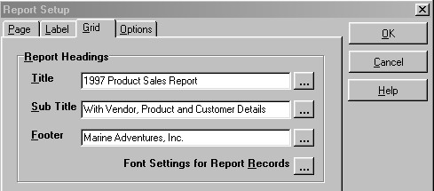

This tab consists of the following elements:

**Title**

Determines the title of the report. Press the related font button to change the title’s font.

**SubTitle**

Determines the subtitle of the report that appears immediately under the title. Press the related font button to change the subtitle’s font.

**Footer**

Determines the footer that appears at the bottom, left edge of the report. Press the related font button to change the footer’s font.

**Font Settings for Report Records**

Press this button to change the font that will be used for displaying records.

Press [OK] when your changes are completed, or [Cancel] to close this dialog.

**Note:** Font changes are saved when you press [OK] from the Font Dialog. [Cancel] has no effect on font changes.

**Report Options**

The options tab allows you to define query and layout options.

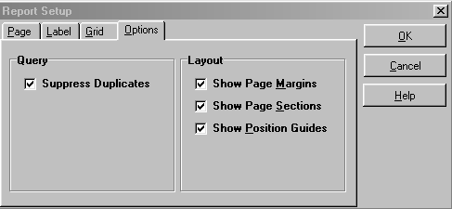

This tab consists of the following elements:

**Query**

The “Suppress Duplicates” option informs BCR Report Writer to exclude more than one instance of a record with identical field values.

**Layout**

The layout options determine where margins, sections, and guides will be displayed when the Layout Page tab is selected.

**Frequently Asked Questions**

**How do I calculate values and group the calculations by other fields?**

A field’s Show property controls how fields are processed and displayed. Consider the query below:

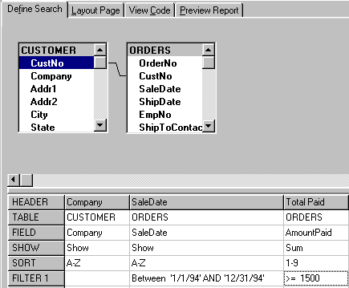

This query calculates the Sum of Orders Paid by Company and Sale Date, excluding any orders that were not sold between 1/1/94 and 12/31/94. Once this part of the report is completed, additional records are excluded where the Sum of Total Paid is less than $1,500. This means that BCR Report Writer and your database management system are filtering on the values of records (Sale Date) and on the results of Calculations (Sum of Total Paid) in the same report! Many database management systems do not permit additional fields in this type of query unless they have a Show property of Group or a calculation (Sum, Count, Min, Max, and Average). As a general rule, keep the number of fields for this type of report to a minimum. You can also export the results of this report to a temporary table, and use that table in a second report to display additional data.

**How do I search for blank or non-existent data?**

Type BLANK as a filter value. See Filter Records for more information.

**How do I search for today’s date?**

Type TODAY as a filter value. See Filter Records for more information.

How do I display Customers who have ordered Products A and C and D?

It is common to search for customers who have ordered products A, C, or D, as follows:

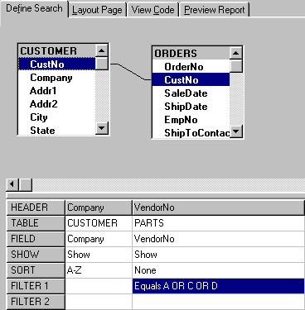

This will return customers who have ordered either product A, C, or D.