Repair Process Flow
The following is a very generalized process flow for repairs. Numerous optional courses might be defined depending on more specific requirements of your company. Contact BCR support for further advice on repair processes.
A repair order would begin by the creation of an order containing the item brought in for repair. This could be a specific item in inventory but it could also be a miscellaneous item, as shown here, to avoid any confusion with actual stock for sale.
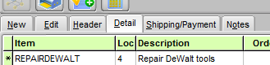
The item description can be changed to reflect the actual item brought in. A negative quantity is entered to indicate that the item has been added to inventory in the repair division (shown here as warehouse 4.) The bin that the item will be placed in is entered to the right.
The serial number of the item can be entered in the extended Order Line section below. This will insure that the information sticks to that line item. The information regarding the quote or repair amount could also be entered on the notes for the order in general.
If there is a separate printer in the repair division, a repair order could be printed there. Or a notification of the order could be emailed to the division using BCR Notify. If the repair division determines that the item can be fixed without getting approval or ordering parts, they would simply add the labor charge and any parts from stock to the order. Notify might be used to let the customer know that the item has been repaired and is ready for pickup. When the item is picked up the item order quantity is changed to 0 to indicate that it is no longer in your possession.
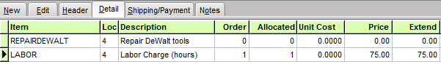
If the repair division needs approval the items needed for repair (estimated labor, parts) are entered on the order.
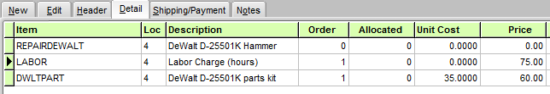
The order can then be copied to a quote. This may not be a necessary step though since any form can be printed from the order. So a “Quote” form could be sent to the customer without actually creating a quote document in the system.
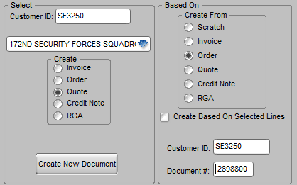
If the repair is approved and parts needed to be ordered, that can be done from within the order using the Add/Update PO button, which will “attach” the PO to the order.
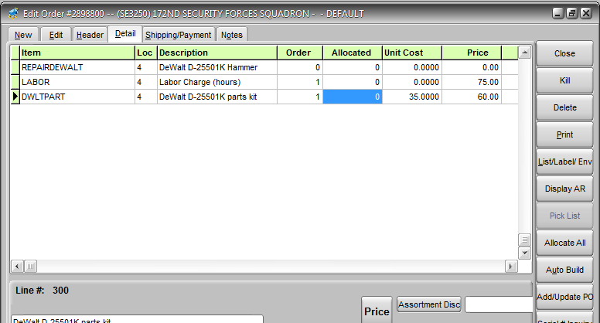
A screen prompts the user to create a new PO or add to an existing unposted PO.
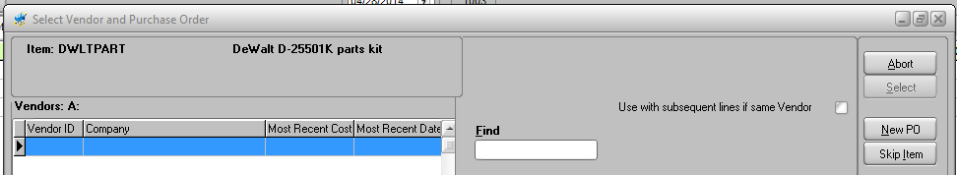
The new PO shows up on the PO entry/edit screen highlighted in green to indicate to purchasing that it has been created via order entry rather than manually in purchasing.
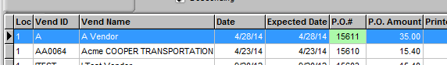

When the part is received the system automatically checks to see if it is currently on backorder and, if so, tied to a sales order. If it is it can be automatically allocated to that order.
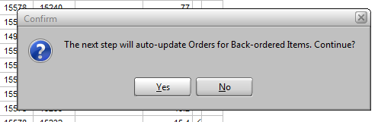
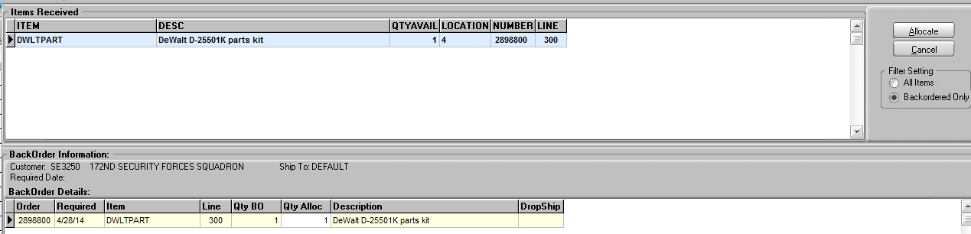
If necessary, Notify can be used to let the repairs division know that the part has been received. Or the division can run a report periodically to let them know if parts have been received for open orders. The order is then completed as described above.

