Rebate Management
Rebates typically involve a vendor who will return some of the original cost of an item to you when you sell that item to certain customers or types of customers or for a certain purpose. At some time the vendor will require that you produce a report detailing those sales and the amount of rebated costs you are expecting from the vendor. BCR provides two rebate tracking methods for this purpose. The method used will depend on the exact nature of the rebate program structure.
One method uses the BCR price list functionality to tie rebate costs, or actual rebated amounts, to a price list assigned to one or more customers. This method would be used if the customer(s) is also receiving special sales pricing, though it is not necessary that the customer receive special pricing. The price list can simply replicate the customer's normal pricing. Rebate costs or amounts are automatically tied to the sales orders that utilize the price list for pricing, which permits rebate reports associated with customers, order types, price lists, or any other data associated with order records.
The other method simply associates rebate costs or percentages to specific customer or vendors on those tabs at the item level. These costs are not recorded at the order level and so are not posted as rebates due you in the general ledger. But rebate costs entered here can be used for reports that detail the sales or purchases of items and their rebate costs on file.

Price List Rebate Tracking
The price list method will automatically post a rebate amount to a clearing account when the invoice is posted at End of Day. The Rebate Clearing account must be entered on the System Defaults/AR/Statements tab. This will be the account holding the balance of unpaid rebates from vendors. Debits originate from order entry end of day processing and Credits originate from AR payment processing against the rebate clearing account instead of the AR account.
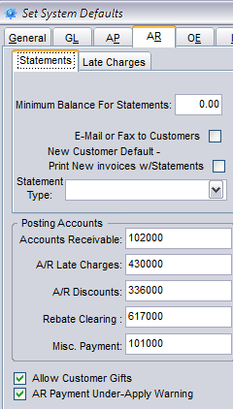
Setting up rebate costs using price lists is simply a matter of creating or editing a price list, entering the rebate cost, and selecting the method the rebate is to be calculated. To setup a rebate create the price list containing all items covered by the rebate and assign it to the appropriate customers and/or customer ship to addresses (jobs.) Remember that a price list can also be selected for an item pricing during order entry, if the rebate is determined by individual order rather than customer or ship to. Then enter the Cost Override $ for each item. The Rebate Method (NONE, STANDARD, ACTUAL) will determine how the Cost Override $ is used to calculate the rebate. STANDARD means the override will be used as a rebate cost and the rebate amount on the order will be the standard cost (from the item record) minus the override cost. ACTUAL means that the override cost is the amount of the rebate itself. NONE means that no rebate is calculated.
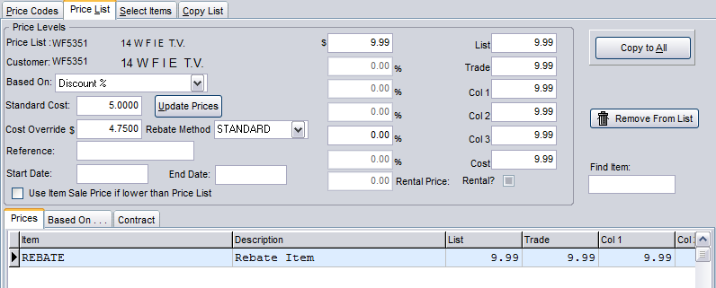

Item Level Only Tracking
Item level rebates do not track rebates by invoices or post to the general ledger. But reports can be created that will calculate rebate amounts based on the association of an item and customer, or item and vendor, to invoices. Reports might pull the Rebate $ or use the Rebate % into the report to calculate rebates due or owed.
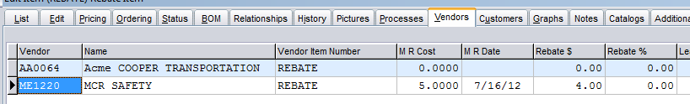
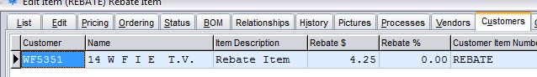

Rebate Reports
Rebate reports frequently must be designed to meet the specifications of the rebating entity. For users creating custom rebate reports using the BCR Report Writer the following table identifies rebate related fields in various tables that might be required. There are rebate reports created using the Report Writer available that can be modified as needed. Contact BCR support if you need assistance creating the necessary report.

Table Name | Table Contents | Field Name | Field Contents
IPITMCUS | The item/customer records from the Edit Item/Customers tab | REBATEAMT | Customer rebate amount by item
 |  | REBATEPRC | Customer rebate percentage by item
IPITMVND | The item/vendor records from the Edit Item/Vendors tab | REBATEAMT | Vendor rebate amount by item
 |  | REBATEPRC | Vendor rebate percentage by item
OEDET | The line item detail records of orders | IREBTYPE | Item Rebate type code.
 |  | REBATE | The rebate expected on this sale.
 |  | REBATEMETH | Rebate method (NONE, STANDARD, ACTUAL) from price list if used.
 |  | STANDCOST | The standard cost for an item from which the rebate cost, from the price list or the rebate master, is subtracted to determine the rebate amount.
OEDETH | The historical line item detail records of orders | REBATE | The rebate expected on this sale.
 |  | REBATEMETH | Rebate method (NONE, STANDARD, ACTUAL) from price list if used.
 |  | STANDCOST | The standard cost for an item from which the rebate cost, from the price list or the rebate master, is subtracted to determine the rebate amount.
PRICELST | Price list item records | COST | The override cost from the price list item record.
 |  | REBATMETH | Identifies the cost of the item to be rebated based on:  NONE (Does not apply. No rebate will be calculated.)  STANDARD (Rebate = Standard Cost minus Override Cost)  ACTUAL (The amount in the Override Cost it used as the rebate amount.)

