Product Assortment Discounts and Price Schedule Codes

In addition to the most common methods of pricing in Titan (price levels, category pricing, matrix pricing, and price lists) there are a couple of other methods that may be useful in certain circumstances.

Product Assortment Discounts (PAD) allow you to establish discounts for groups of items that are not in the same sales category and apply quantity discounts. For example, you have a line of products of a particular type or from a single vendor that you want to offer a quantity discount on. Regardless of whether the items are in the same Pricing Category or not, categories do not permit quantity discounts. So if you want to offer an additional discount when a customer buys a total of ten of any of the items of that type or from that vendor, you can assign a PAD to those items. The only limitation here is that PADs are not customer specific. You can, however, choose to apply or not apply the discounts on specific orders. The discounts applied will be over and above any customer specific discounts determined by levels, categories, matrix, or lists.

Price Schedule Codes (PSC) are also used when you wish to setup pricing that crosses categories or adds quantity discounts to categories like PADs but want it to be customer specific. PSCs can use either specific vendors, or PADs, to identify items. When PADs are used to identify items then the quantities and discounts assigned those PADs are disregarded and only the discount rules assigned the PSC are used. PSCs can work in conjunction with category pricing and a switch in system defaults determines which takes precedence. PSCs allow quantity discounts and can be set to work with multiple items, like PADs, or only individual items, like item price level quantity discounts. PSCs are limited, however, by the fact that they can only calculate prices using cost multipliers.

It is theoretically possible for one order to have items priced by:

* an item sale price
* pricing levels
* pricing levels with quantity price breaks
* categories/matrix groups
* price lists
* price lists with quantity price breaks
* PADs
* and a PSC.

Combining all of the different pricing methods available in Titan can make it very difficult to manage prices, and difficult for users or customers to understand why prices are what they are. Adding PAD and/or PSC pricing to an existing setup that uses price categories (for either individual customers or via the matrix), or uses quantity breaks in addition to item level or price list quantity break pricing, should only be done in consideration of the attention to price understanding and maintenance that will be required. But PADs and PSCs can be effectively used to solve unique pricing needs. Contact BCR support for advice on the best means to meet your needs.

# Price Assortment Discount Setup

Use Price Assortment Discounts (PADs) when you want to create quantity break discounts that a customer can qualify for by purchasing a total quantity of more than one item. For example, a PAD might be setup for two items and a quantity discount of 10% is a customer buys a minimum of 100 of those two items combined. The customer might buy 100 of either item, or 80 of one and 20 of the other. Either order would qualify for the 10% discount.

To setup a PAD it must first be created using the Edit Assortment Discounts on the Edit menu in Administration.



Click Add to enter a new PAD code and description.

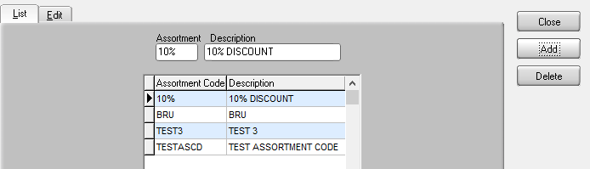

Then click the Edit tab to enter the details of the PAD. Click Add to enter a Min(imum) Quantity and Discount Percent. You can enter as many quantities as needed. If quantities are not entered in numeric order (e.g., 100, 150,200) from low to high the system will automatically resort them after you exit the tab. The Discount Percent is entered as a whole percentage and will be applied to a customer’s normal price, which could be initially determined by their price level, category pricing, or price list.

IMPORTANT NOTE: PADs can be used like pricing categories to identify groups of items for PSCs, as described below. When a PAD is used in a PSC the Min Qty and Discount Percent are completely disregarded since the PSC may have quantity discounts of its own. If you are using PADs for this purpose it is recommended that you leave the Edit tab entries blank.

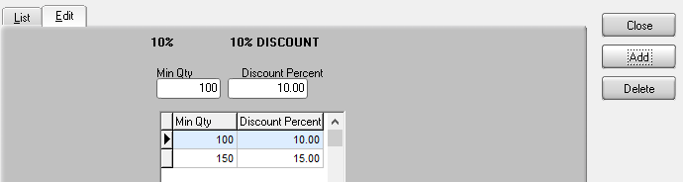

Since PADs are designed to discount multiple items it’s assumed that you will want to assign a PAD to at least two items. There is no limit to the total number it items a PAD can be assigned to and a PAD can be assigned to any items regardless of their vendor or pricing category. To assign a PAD to an item after the PAD has been created simply go to the item maintenance Pricing tab and click the Special Pricing sub-tab. In the Assortment Discount Code click the dropdown to access available PADs. Only one PAD can be assigned to any one item. If you need to assign a PAD to a large number of items your BCR support representative can assist you.



Assortment Discounts are not automatically applied on orders. You must signal to the system that you have entered all items and quantities on the order so that the system knows when to calculate the discount. If PADs are used extensively then users should be trained to always calculate any possible discounts. If used sparingly then they should be alerted to which specific items might qualify.

To apply an Assortment Discount to an order you must first complete the entry of the order. The Assortment Discount only considers order quantities, not allocations. All items could be backordered on the order and it would still qualify. If you do not want to backorder an item you should only enter the order quantity you intend to ship. NOTE: Once the system calculates the Assortment Discount you cannot change the order since the order may not qualify for the discount after a change. After you have correctly entered all items and quantities click on any item on the order detail tab and then click the Assortment Disc button just above the order detail sub-tabs.

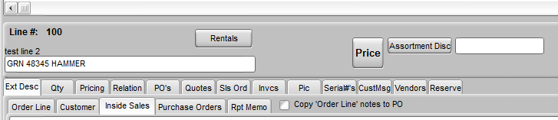

The system will calculate all of the discounts that the items on that order qualifies for. Click OK and the unit prices, extensions, and total of the order will be updated accordingly.

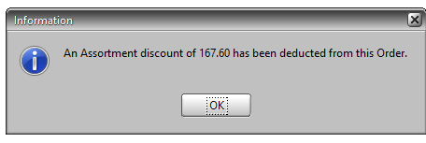

# Price Schedule Codes Setup

Price Schedule Codes (PSCs) are similar to matrix pricing but with the added advantage of the capacity for quantity breaks. Breaks can be either for individual items like item price level breaks, or they can be for combined quantities like assortment discounts. PSCs are assigned by either items’ primary vendors or by the can be assigned using PADs. PSCs can be used as a part of the pricing hierarchy, either above or below categories (including category pricing in the matrix.) If categories are not used, PSCs fall between item price levels and price lists. PSCs are limited in that they cannot be assigned via the matrix. They must be assigned to the individual customers, but a change to the PSC affects all customers assigned it. Also, PSCs can only calculate prices with a standard cost multiplier.

PSCs must be enable using the Use Price Schedule Codes switch on the Pricing sub-tab or the OE tab in System Defaults. If PSCs are not enabled the PSC maintenance program will not be available on the Administration Edit menu. The Categories Before Schedule Codes checkbox below it will determine the hierarchy of pricing. If a customer and item are assigned both a pricing category and a PSC and it is not checked then a PSC will be used to price the item. If it is checked then the pricing category takes precedence.

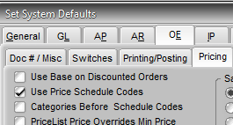

After PSC pricing is enabled the Edit Price Schedule Codes program will be available on the Edit menu in Administration. (After checking the Use Price Schedule Codes option, exit Administration and reopen it to see the program.)



Click Add to enter a new code and description.

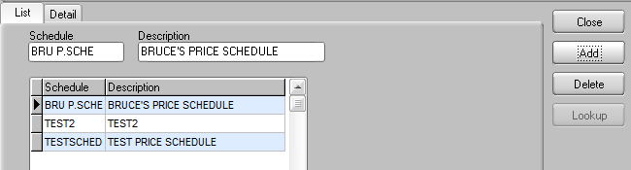

Because a PSC can relate to items in multiple ways the setup can be confusing. You can enter a Vendor (the primary vendor assigned to items) or you can enter a “Group”, which is synonymous with a PAD, or both. If you enter both then an item must be assigned both that vendor AND that PAD for that rule to apply. Each entry constitutes a pricing rule. So you can create a rule for items assigned a specific vendor but you can assign a rule for items assigned both that vendor and that group (PAD). You can create multiple rules for vendor/group for different levels of quantity break discounts.

IMPORTANT NOTE: When a PAD is used in PSC setup the quantity discounts of the PAD (described above) is disregarded and only the PSC setup is considered. In other words, PADs in PSC setup are used exclusively for identifying groups of items, similar to pricing categories. It is not recommended that you setup PAD quantity discounts AND use PADs in PSC, where they could also have assortment quantity discounts, since this makes it very difficult for a user or customer to determine why they received the prices they did on an order.

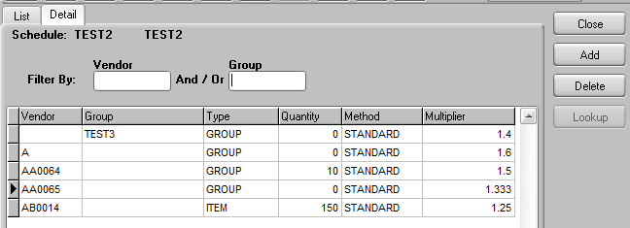

If you are looking for an existing rule(s) you can search for it by entering a specific Vendor or Group or both at the top of the screen.



Next enter the Type of quantity break. This field is a dropdown selection of either ITEM or GROUP. NOTE: The word GROUP here does not apply to the Group field to the left. If you enter ITEM then any Quantity entered will only be qualified for by the order quantity of a single item. If you enter GROUP then all items on an order that have that vendor and/or group (PAD) will be combined to qualify. Obviously if there is no Quantity then this setting does not matter. Enter the Quantity required to qualify for that price.



The Method filed should only be set to STANDARD. Other selections in the dropdown for that field are not functional. Pricing for PSCs is always based on Standard Cost regardless of the Method. Finally enter the cost multiplier.



After a PSC is created you can assign it to a customer. Since it can be assigned to multiple customers a PSC is a little more like matrix pricing than just price category discounts assigned at the customer level. A change to the PSC will affect all customers assigned that PSC. To assign a PSC double-click the Price Schedule field on the Sales Options sub-tab of the Edit tab in customer maintenance.

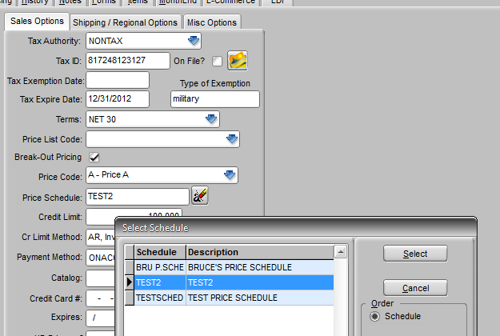

If there are Type GROUP and Quantity cost Multipliers (as with PADs described above) then the system will need to calculate the discounts on an order. To apply an PSC GROUP/Quantity Multiplier to an order you must first complete the entry of the order. As with PADs only order quantities, not allocations, are considered. All items could be backordered on the order and it would still qualify. If you do not want to backorder an item you should only enter the order quantity you intend to ship. NOTE: Once the system calculates the prices you cannot change the order since the order may not qualify for the PSC prices after a change. As with PADs, after you have correctly entered all items and quantities click on any item on the order detail tab and then click the Assortment Disc button just above the order detail sub-tabs.



The system will calculate all of the prices that the items on that order qualifies for. Click OK and the unit prices, extensions, and total of the order will be updated accordingly.

