Sales Pricing System Overview

The BCR sales pricing system allows you to set your pricing in a variety of ways. You could give all of your customers the same prices on items. Or you could give every customer a unique price for every item. While neither pricing strategy is appropriate for the majority of distribution enterprises, most companies can profitably apply a mix of those and other tactics to achieve a profitable sales price strategy.

There are three major components that can be used to set sales prices in BCR:

The first component is the pricing levels maintained for each item. In the Item Maintenance program six dollar and cents prices are calculated for each unique item record. These prices can be calculated in a variety of ways using the preferred calculation method selected in the Based On drop down and the six fields to the left of the price levels. At the very minimum an item should have an amount in the first price level since this is the default price if no other pricing level has been defined for the customer. This would typically be the highest price you would charge any customer for this item. This is sometimes referred to as the “list” or “base” price.

For some companies these six prices are all that is required. Other companies may need to use the six prices as a basis for more complex customer price calculations.

In the Customer Maintenance program the Price Code can be left blank or set from A to E (Price Codes can have user defined names instead.) Leaving this field blank indicates you want the first, or base, price to be charged to the customer for any items that did not have another pricing component defined. If the customer price code were set to B then the item’s price would be the B, or third, price level. If you set the two to six of the available price levels for all items then you can preset which of those prices each customer is to receive.

You can further define the price level that a customer receives for individual ship to’s setup for the customer.

Each price level in the item record can be set to use quantity break pricing. The quantity break setting for an item specifies the minimum quantity necessary to qualify for the price break, and either a further discount to be applied to that price level or the actual dollar and cents price to be used. Quantity break pricing can be turned on selectively for one or more levels by item.

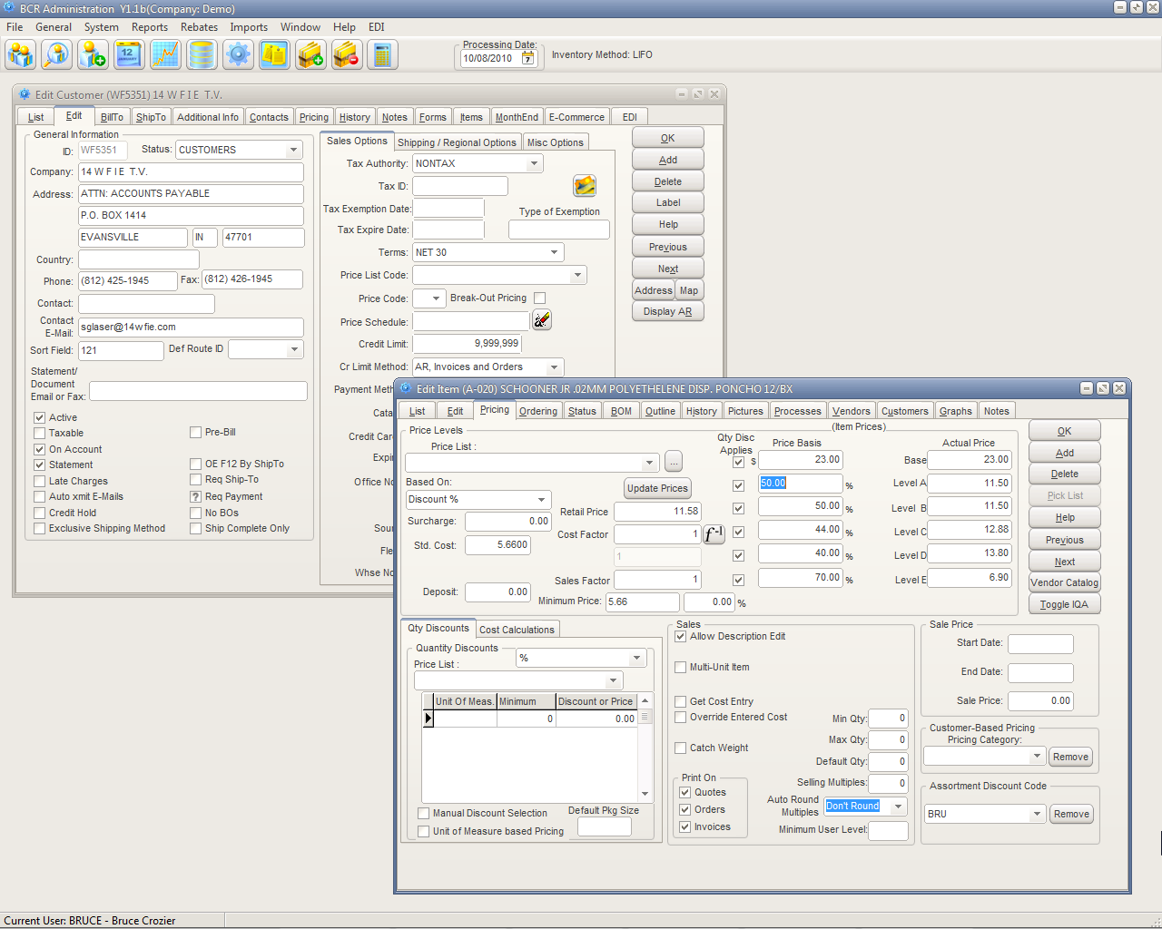
The price code (null, A, B, C, D, or E) assigned to each customer determines which of the six base level prices the customer gets if no other pricing overrides it. Price code names can be user defined (e.g., List, Trade, Catalog, etc.)

Quantity breaks can be setup for each item and can be applied selectively by price level.

The second major component of the sales pricing system is the pricing categories. In the Item Maintenance you can select one Pricing Category to assign to that item. Any number of Pricing Categories can be created and any category can be assigned to any number of items. You could have one category and assign all items to it or you could have a category for each item. Typically categories are assigned to items that have something in common, such as a specific vendor, type of item, or the relative popularity of the item.

Price categories are then assigned to customers. Specific customers can be assigned no categories or any number of categories. Each category assigned to a customer allows that customer to be setup for a unique pricing level and/or discount for the items assigned that category. A customer may be assigned a price code (level) of B but assigned a category of ALPHA and items that are assigned the ALPHA category receive the C level price. That customer may also be assigned category BRAVO and on BRAVO items receive a D price plus a 15% discount. But another customer who also happens to be level B may be assigned ALPHA and BRAVO and receive level B with a 5% additional discount for items in those categories.

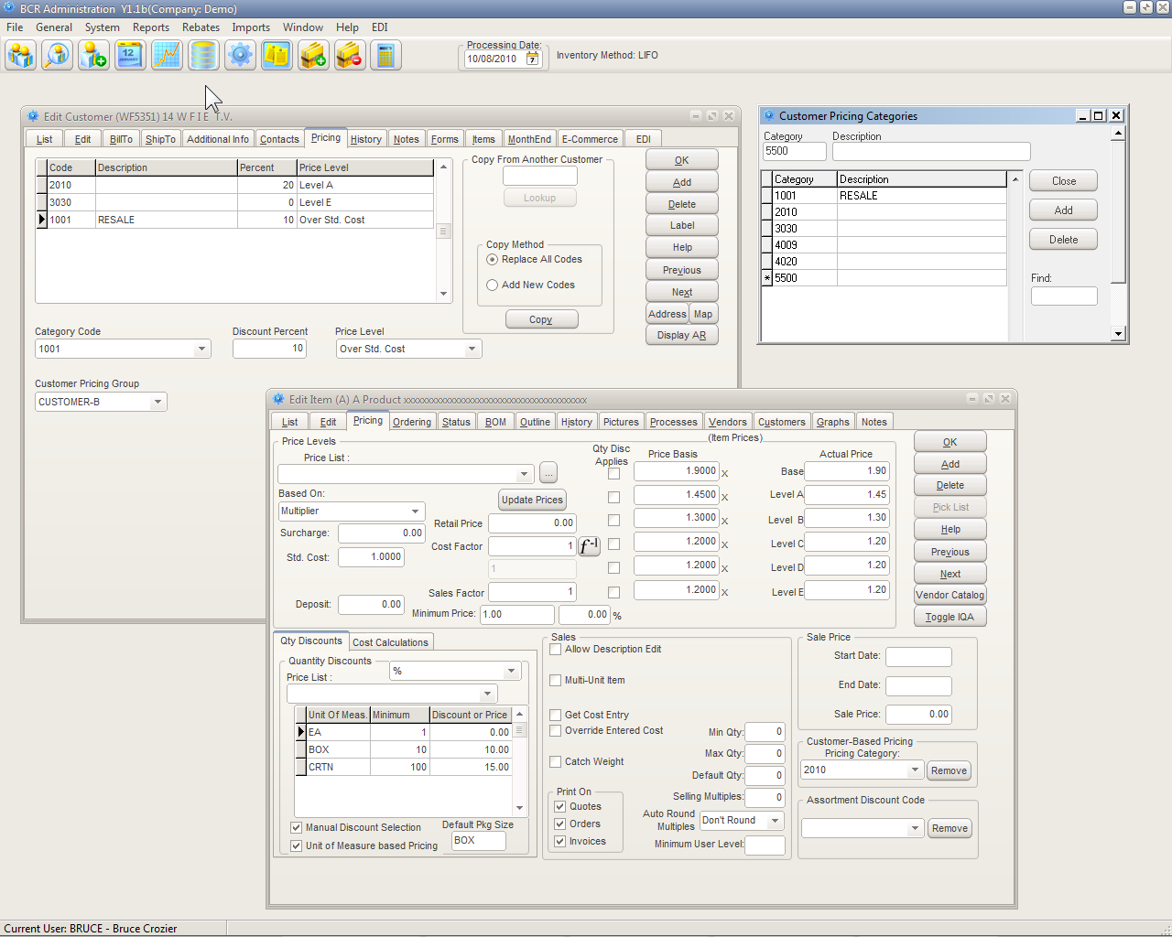
Price Categories are setup and one category can be assigned to an item on the item Pricing tab. Any number of categories can then be assigned to a customer and a unique discount and level specified. When that customer buys that item their discount and level override their normal price code.

Some companies may use categories for just certain groups of products and customer. But a company could use categories exclusively, assigning all items categories and all categories to all customers. There are maintenance functions and programs that make this approach easy to manage, either by copying the setup of one customer to another or by what is commonly known as “matrix” pricing, which allows customers to be assigned to groups and the discounts for categories to be set for all customers in that group to be set at once.

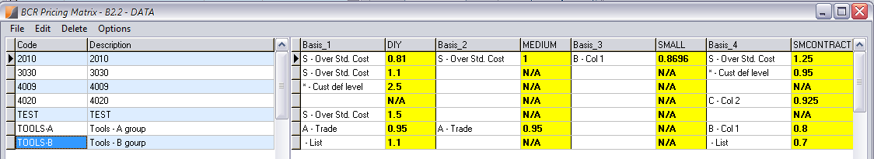

The third major component is the Price List. A price list is the ultimate tool for pricing control. A price list can specify a single unique price for a specific item for a single customer. Or a price list could contain every item and specify unique prices for many customers. Every item assigned to a price list can have a unique set of six price levels. And an item can be assigned to any number of price lists. So in addition to the six prices an item has in Item Maintenance, it can have an additional six unique price levels on each of multiple other price lists.

Every item placed on a price list can have a unique set of six base price levels, independent of its record in item maintenance. The price code assigned to the customer determines which level is used for that customer.

Every customer can be assigned any number of price lists, and ship tos can be assigned an exception price list. If a customer is a price code B then the B level price on the customer’s price lists is used. If you wanted multiple customers that are assigned that list to receive the same price, regardless of their price code, you could then set all six price levels for items in that list to be the same.

Price lists can also be given dates that they become effective and expire for each item on the list. Multiple price lists that contain the same item(s) can be assigned to a customer, so that a tiered pricing scheme can be implemented. The hierarchy of pricing in such a scheme is determined by a simple alphanumeric prefix sorting (e.g., if price lists 10ALPHA and 20ALPHA contain the same item, then 10ALPHA is used.

Multiple price lists can be assigned to a customer. Each price list can have an optional start and end date.

The steps determining the customer’s price for an item on an order are:

- If the customer is assigned a price list that contains that item then the price level corresponding to the customer’s price code is used. If not…

- If the item is assigned a price category and that category is assigned to the customer, directly or via the matrix, then the discount and level indicated in customer maintenance is used. If not…

- The item price level corresponding to the customer’s price code is used. If that level is flagged for a quantity break and the order quantity qualifies then the quantity break discount or amount is used.

Creating a unique price list containing specific prices for every item for each customer would give you the maximum control. But if you have a large number of customers and items, maintaining all of those price lists might be overly time consuming. For some companies, the vast majority, if not all, of their pricing can be defined by assigning one or more of the six price levels, possibly with quantity breaks, to their customers as price codes. If some customers or groups of items need finer control then they can be assigned price categories, which will set them to vary from the their assigned code and use another level and/or discount for items in those categories. If necessary, items and customers that cannot be priced efficiently using these methods can then be setup to use one or more price lists. This allows you to efficiently manage pricing for the majority of your customers and items while allowing you to exert as much specific control as needed.

