Pricing Matrix

The BCR Pricing Matrix provides an efficient means to more finely control customer pricing than the basic BCR Price Code levels using item Pricing Categories and customer Price Groups. A single change to one multiplier or Code basis in the Matrix can change the pricing for numerous customers and items. The Pricing Matrix supersedes Price Code level pricing where applicable, and replaces individual customer Pricing Category discount when a customer is assigned a matrix Group, but does not supersede any applicable Price Lists.

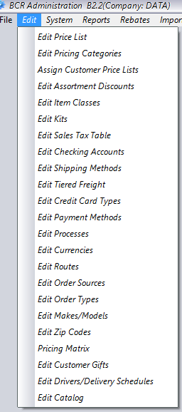 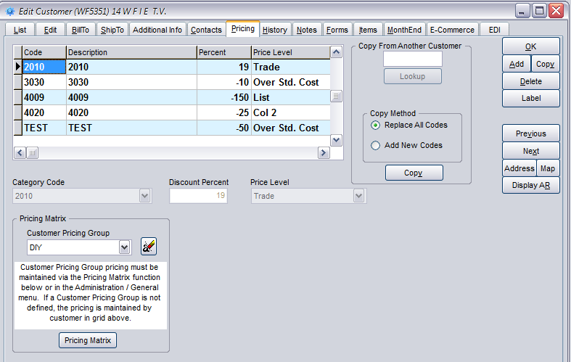

The BCR Pricing Matrix can be started from either the Edit menu in Administration or from a button on the Edit Customers Pricing tab. The Pricing Matrix is a standalone program and will open its own window. It must be closed independent of the Administration module.

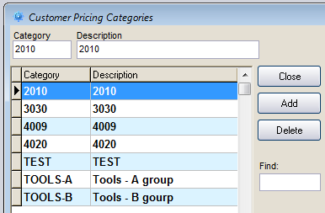

The Pricing Matrix references items through Pricing Categories. Categories must first be established using the Edit Pricing Categories screen on the Edit menu in Administration.

Once established, a Category can be assigned to items using the dropdown selector on the Pricing tab in Edit Items. Only one Category can be assigned to any one item.

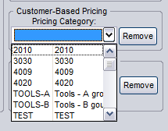

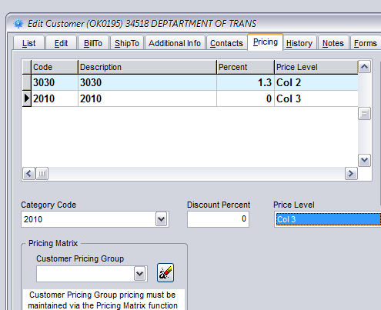

Categories can be assigned to customers and given specific basis levels and discounts if that customer is not assigned a matrix Pricing Group.

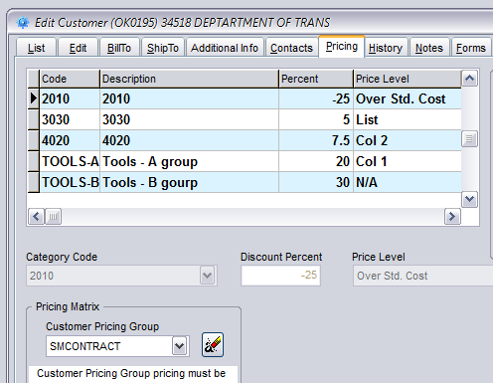

If a Pricing Group is assigned to a customer, any and all previous Category discounts assigned that customer are overwritten by the matrix category discounts for that Group.

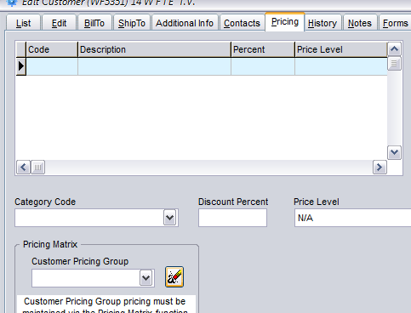

Note that if a customer is assigned a Pricing Group and the Group is later erased, using the button to the right of the Group, all Categories and discounts are erased.

The Pricing Matrix is basically a spreadsheet. All Pricing Categories, created through Edit Pricing Categories, are listed on the left as rows. Customer Pricing Groups columns are created within the Pricing Matrix program. There are two columns for each group, a Basis column and a multiplier column. If there are no entries in these columns at the intersection of a category row and group (i.e., the basis is blank and the multiplier is N/A) then customers assigned that group will not have matrix pricing for that category of items and their pricing for those items will default to the customer’s Price Code assignment in Edit Customers on the Edit tab.

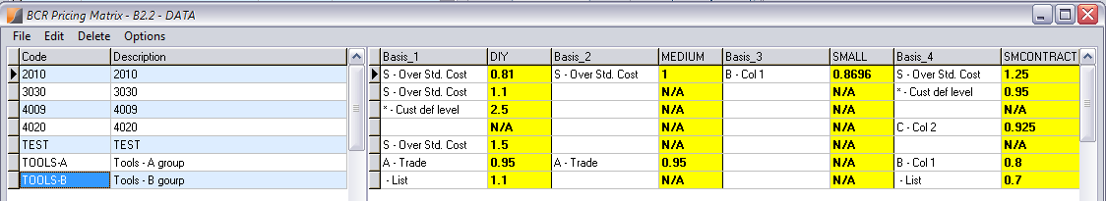

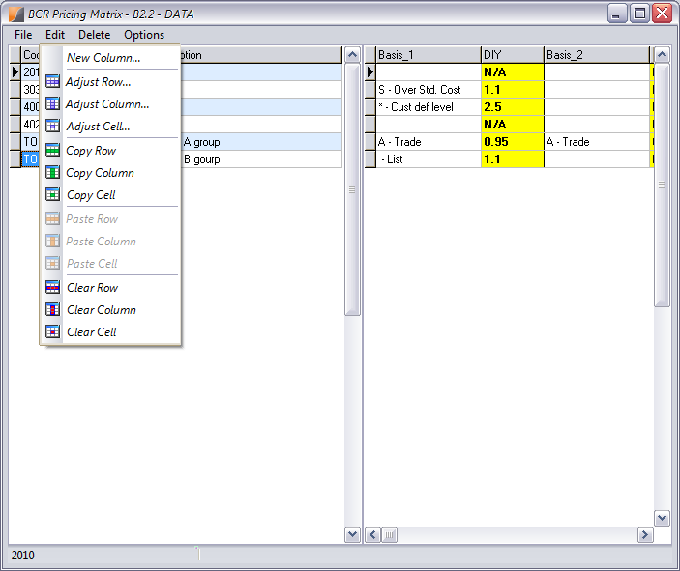

Pricing Groups can be deleted by selecting any field in either the basis or multiplier column of the group and using the Delete menu, Column selection. Groups cannot be deleted if they are assigned to any customer.

New Pricing Groups can be created using the New Column selection on the Edit menu. New Groups are placed in alphabetic order on the matrix spreadsheet.

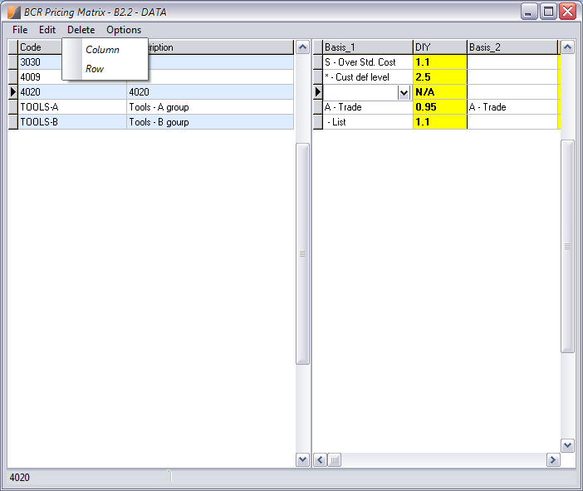

The matrix screen layout can be changed using the Options menu to turn on or off the Category Code description or the Basis description.

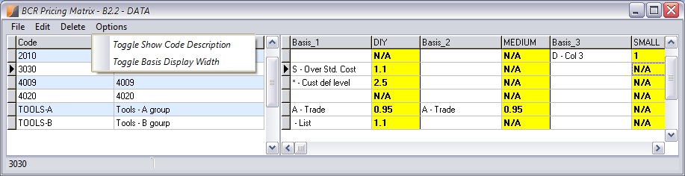

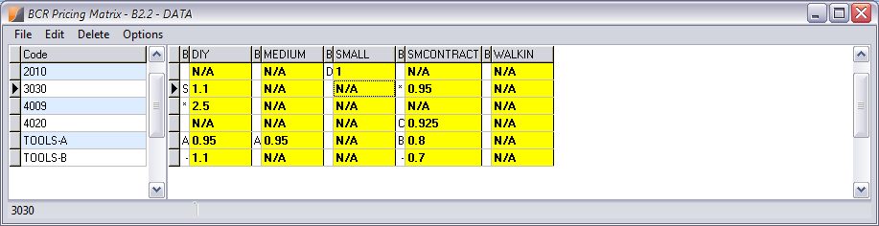

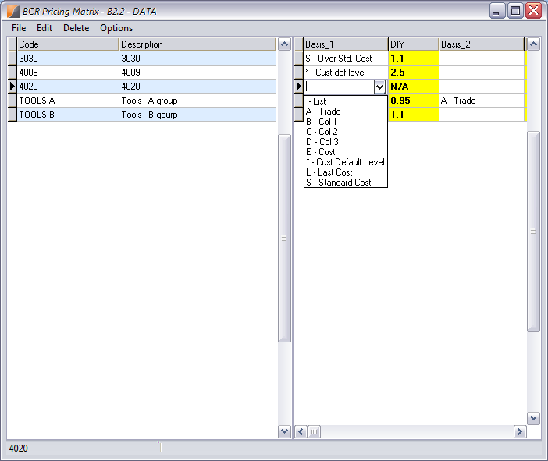

The Basis for a matrix calculation is selected from the dropdown in the field. The first six selection in the dropdown represent the BCR price codes with your corresponding user defined titles. The Cust Default Level (*) indicates the customer’s Price Code should determine the basis. The Last, or most recent, Cost and Standard Cost would typically be used with multipliers greater than 1.

The multipliers entered to the right of the basis entries are true multipliers and not percentages. Note that a valid matrix “cell” must consist of both a basis and a multiplier, even if the multiplier is just 1. The cell highlighted here will not be saved by the program. An entry of a basis of Cust Default Level (*) and 1 would be the equivalent of an empty cell.

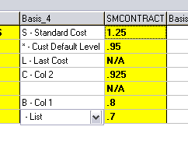

Unlike most BCR screens, changes to basis and multiplier fields are not automatically saved when the screen is closed. **You must select Save from the File menu in order to retain any changes you’ve made.** New Groups (columns) created are automatically saved but not their field contents.

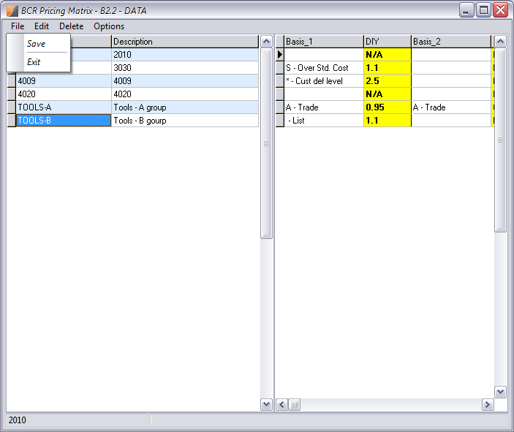

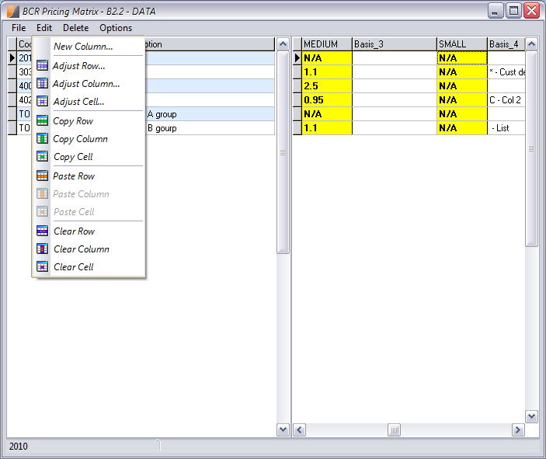

The Edit menu lists functions that allow you to copy and paste, or clear a selected row, column or individual cell. The function will apply to the row, column, or cell where you have currently selected either a basis or multiplier field.

The Adjust functions prompt for a Percentage Modifier. The Row, Column, or Cell multipliers will be adjusted by the percentage entered. An entry of 90 as an adjustment to a multiplier .80 will produce a new multiplier of .72. Note that the adjustment is applied the multiplier that has been saved, not an unsaved multiplier just entered.



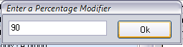

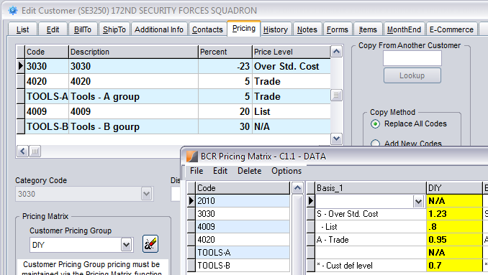

When a customer is assigned a group, the matrix categories that have a basis and multiplier for that group are displayed in the grid on the Edit Customers Pricing tab. Note that the multipliers from the matrix are expressed as discount percentages in the grid. So a .8 multiplier is shown as a 20 percent discount and a 1.23 multiplier is a reverse discount of -23 percent, in this case over cost.

Remember that the basic hierarchy for BCR pricing is to first check to see if the item is on a price list assigned to the customer, then to check to see if the item is in a category with a discount assigned to the customer, either individually or through a matrix group assignment, and finally to use the customer price code assignment to select a price level.

**Customer Price Lists**

**Customer Price Matrix Group**

**Customer Price Code**

**Customer Category Discounts**