physical inventory

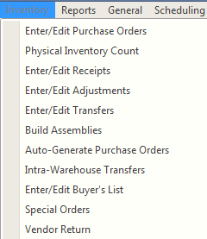

To create a physical inventory batch click the New button of the batch list screen. Typically a new batch is created for each inventory count. It remains as an open batch until the count is completed and the count results are entered. It is then posted and the inventory adjustment created.

The Titan Physical Inventory Count screen can be used to perform annual physical inventories and periodic, or cycle count\*, inventories, and automatically process the inventory adjustment batches required to correct the on hand counts . Individual item corrections that come to light as a byproduct of other operations are typically performed directly using the Enter/Edit Adjustments screen. See the Inventory Adjustments documentation for detailed information of that process.

\*Cycle counting is a technique for maintaining inventory accuracy by counting selected items, such as popular items, on a schedule more frequently than annually, or for breaking down the annual physical into more manageable segments to be performed over the course of the year.

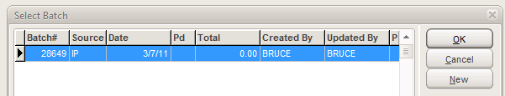

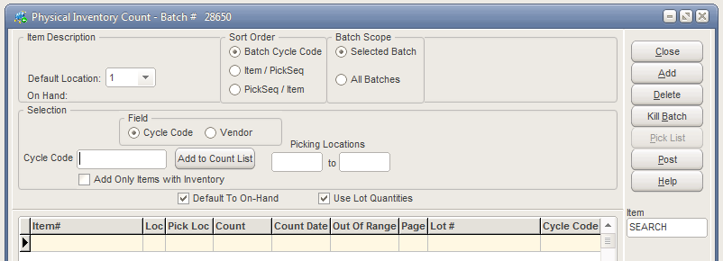

The Physical Inventory Count screen is used to form a list of items that will be counted. Count sheets are then printed based on that batch list. There are a number of selection and sorting options that allow you to create this list as necessary for the type of count you intend to perform.

To begin you must specify the location, or warehouse, that you wish to list items from.

The Sort Order is determined by the way you manage your warehouse and perform your counts. If you have assigned Cycle Codes to items and they represent regions in your warehouse you may want to sort items that way. Otherwise you will want to sort items by item and then pick sequence of bin locations, or vice versa. If you have not assigned bin locations then items will be sorted by item.





Usually you will create just the Selected Batch but you can group all pre-existing batches on the list into this one batch by selecting All Batches. This is useful when you’ve broken your count into a number of more easily managed batches but wish to post the counts as one adjustment. When you post this batch the other batches will be cleared of items.

The item selection criteria can be based on either cycle codes or vendors. The list can be refined further by specifying a range of picking locations. The type of selection will be determined by whether you’ve assigned cycle codes and/or picking locations and whether you’re performing a cycle count or full physical.





If your system on hand tends to be accurate and you list a number of items in inventory that you do not carry on hand, then you might select to only list items that currently indicate an on hand quantity to keep your count list shorter. If items are found during the inventory that are not on the list you can add them to the count list manually when you enter counts.



If you believe your system inventory is fairly accurate you may want to have the count on the list Default To (the current) On- Hand so that entering counts will go faster because only those in variance will need entries. If you are concerned that having the count there may influence the person doing the entry then you can have them start as zero but then all item counts that are not zero will need to be entered.

If you use the lot quantities feature of Titan you can choose whether to include them in the on hand. If lot quantities are to be counted then you will want to Use Lot Quantities.

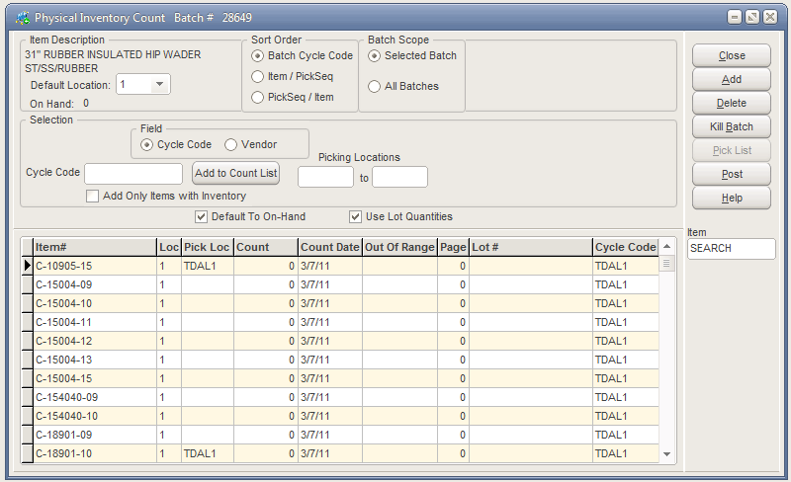

You can Add or Delete individual items to the list as needed. Once a list has been created to your satisfaction you can simply note the batch# and Close the batch. If you decide not to use the batch you can Kill it.

You will not want to Post the batch until you have performed your count and entered the results.

The Count Date is the date you create the batch. Batches should be created just before you count. The count date is very important because the system will apply your count relative\* to the on hand as of the day it was counted, not the day you enter the count. It may be days before you enter the counts. Say that the system on hand of an item was 6 the day of the count and that was correct. But when you entered the count of 6 you had sold 2 and the on hand was now 4. You would not want the system to add 2 to the on hand. So the system only considers you entry relative to the on hand as of the count date. Batches should be created on the day that you intend to count.

\*A System Default > IP > Misc tab setting “Simple Counts for Physical Inventory” can be checked and the counts entered will update the inventory regardless of the count date. This setting would typically only be used if you were entering a beginning inventory and not entering transactions.

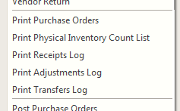

When the batch is ready, you can print your count sheets. All unposted batches will be listed.

These are the sheets on which you will enter your counts. The layout of the count sheets can be customized using the BCR Report Writer.

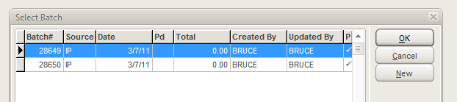

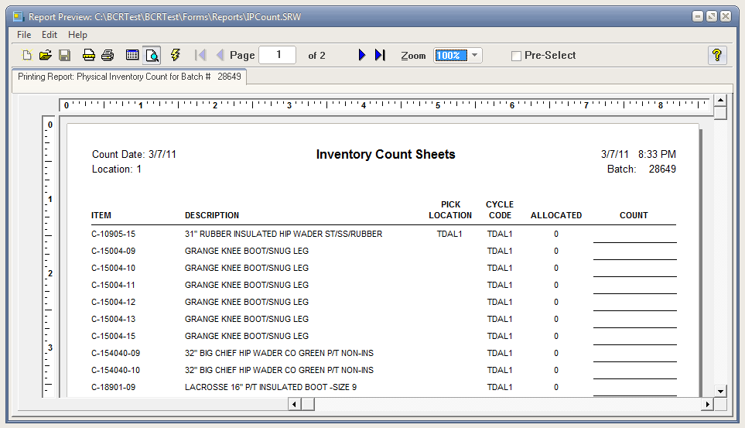



After the count is completed the actual counts are entered from the sheets in the count column of the batch. If the Default To On-Hand was set then only counts that are at variance with that quantity are entered. Items that were counted but are not on the list can be added as needed. Once the counts have been completely entered you can Post the count and an Inventory Adjustment of the same batch number will be created. This will delete the Physical Inventory Count batch.

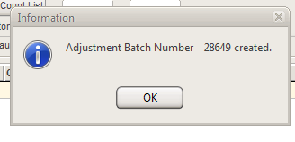

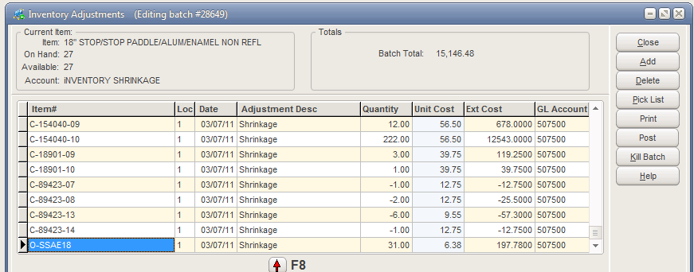

The adjustment created will contain only the items that require a change to the on hand. The adjustment quantity will be the relative adjustment, plus or minus, required to correct the on hand. The adjustment must be posted for it to update the on hand quantities. See Inventory Adjustments documentation for further information on this process.