Order and Invoicing Flow Options

Possibly the most important decisions in setting up Titan are those regarding the flow of orders and invoices through the software. Titan offers a number of options in this flow, and the variations in the way companies operate means that no one flow is right for everyone. Different sales and delivery channels within one company may require more than one process flow for that company. The number of options in Titan can be confusing at first but once your company’s best flows are determined, the day to day operation becomes very simple. The following should help to determine the best process flow for each company and the different channels within it.

Forms are an integral part of any business operations flow and Titan allows a great deal of flexibility in forms. Forms are created in the Titan Report Writer and most forms can be designed to your exact requirements. Forms are stored in the FORMS folder in your data folder. Default forms are setup for your company in System Defaults but, depending on the function of the program, a print request will default to either the last form selected in that program by that user, or, in some cases to a form specific to that customer or vendor. But other forms can be selected at the time. So while you may usually want to print “Picking Ticket A”, you may alternately choose another form “Picking Ticket B.” Forms can also be designed with different multiple parts. So the first copy of a two copy form may not have customer prices on it but the second part does. Or the first part is a picking ticket but the second is a packing slip/invoice. This flexibility allows some additional options in the basic flow outlined below.

# QUOTATIONS

Quotes are created the same way orders are. You simply select Quote on the sales order entry New tab. You can later copy the quote to a sales order. To print, email or fax the quote click the Print button on the right side of the screen. The system will automatically select forms in your Forms folder that are named starting with QU. You will typically want a separate form designed specifically for this purpose. No other special setup is required.

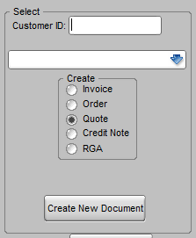 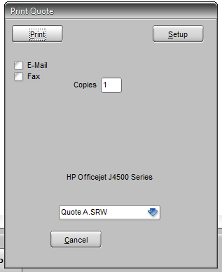 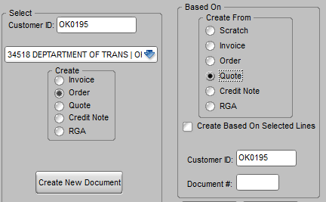

# ORDER ACKNOWLEDGEMENTS

If you frequently print, email, or fax separate order acknowledgments then you will probably want a separate print routine and form (a form name starting with OR) for this. Individual users can be setup to print an order acknowledgment using the Print button. Picking tickets would then be printed by those users by clicking the List/Label/Envelope button. If you infrequently print order acknowledgments or wish to print the picking ticket at the same time, then you can have a secondary form that starts with PI such as PiOrderAck that you can select when you just want an order acknowledgment. This does however indicate to Titan that you have printed a picking ticket, which may be a problem later in the process. Another approach would be to print two copies of the form, with the first copy being an order acknowledgment and the second being a picking ticket. This assumes however that the picking ticket will either be used immediately or kept on file until you are ready to pick the order. Generally if you sent order acknowledgments you will want to use the first method.

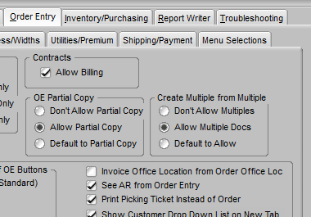 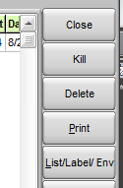 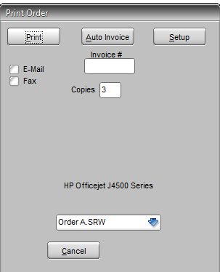

# PICKING TICKETS

Picking tickets are the forms that are sent to the warehouse for order picking. They are sometimes called pick lists. Titan recognizes them as form names that start with PI. In some companies a copy of the pick ticket doubles as a packing slip and/or invoice to be delivered with the goods.

## Immediate printing of pick tickets

Some companies pick goods immediately and some hold orders to start picking at specific times. Some do both. If you pick any orders immediately, especially for retail/walk in counter sales, then you will want to print directly from the order entry screen. Depending on the user setting (discussed above) that determines the function of the Print and List/Label/Envelope buttons, a picking ticket can be printed at any time directly from the sales order entry screen using one of those buttons. And it can be printed at whatever printer is appropriate, assuming it is available on the network. (If Print is used to print orders and List/Label/Envelope for pick tickets then there is a secondary prompt to chose Picking Ticket from other options.)

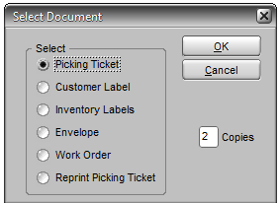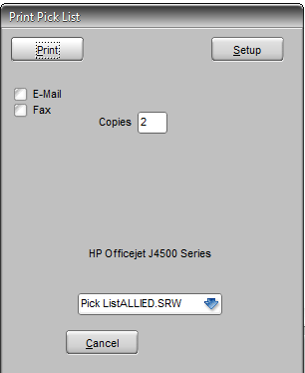

## Batch printing of picking tickets

Depending on how your goods are delivered to customers you may print batches of picking tickets one or more times a day. Orders that have not been printed already can be printed singularly or as groups from the Print Picking Tickets program. This program is usually preferable when a manager is overseeing the picking operation. This program allows one person to see all orders that have not yet been invoiced. They can see orders that have already had picking tickets printed, either earlier from this program or directly from the order screen as already described. They can see the items on the order as well. They can select any number of orders and print tickets or they can enter a single order number to reprint. The reprint screen allows them to selectively reprint different versions of the same order depending on what changes might have been made between printings.

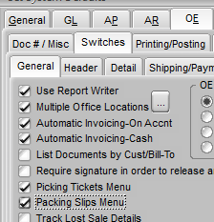 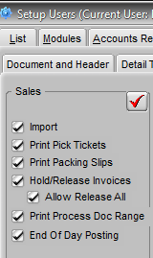 

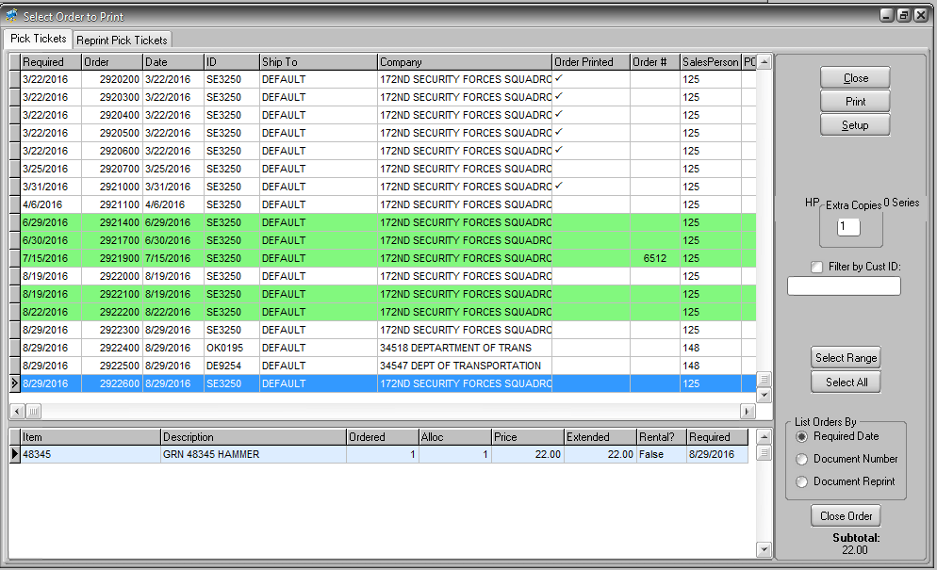

## Reprinting of picking tickets

Once a ticket is printed, you can reprint it if necessary but what is on the reprinted ticket may depend on whether you want to reprint the entire list of items (which may include items added to the order after the original print) or only the items that have subsequently been added or become available. Some companies receive additional goods before actual shipment, either because they hold orders until they are more complete to economize on shipping or because they receive goods constantly during the day that might fill backorder before they have shipped. Tickets can be reprinted by either selecting the List/Label/Envelope button or the Reprint tab in Print Picking Tickets. If any of these scenarios applies to your operation then ask your BCR support staff for additional information on reprint options.

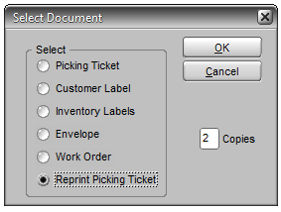 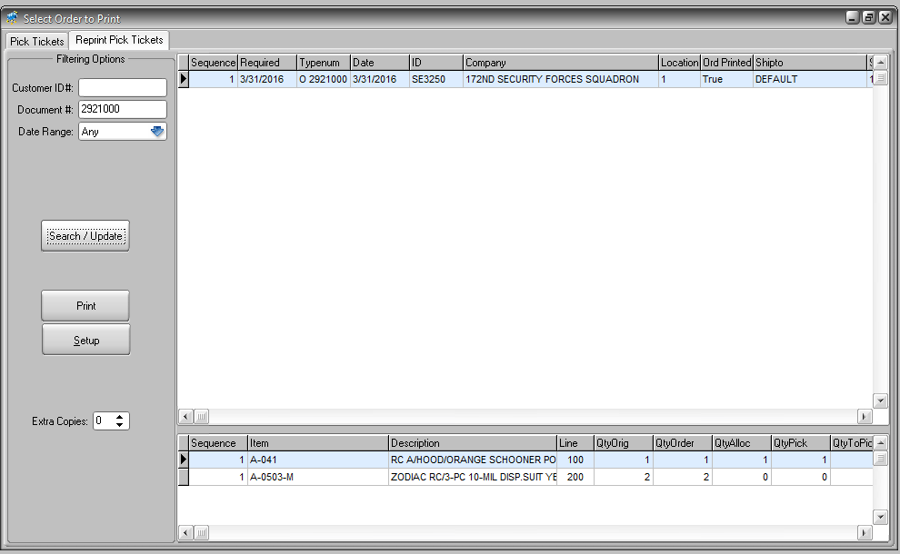

# INVOICES

An invoice form and the Titan process of accounting for the sale (reducing inventory, posting to a customer’s AR account, and to the GL) are not necessarily the same. Any document can have the word INVOICE printed on it but the actual invoicing process within Titan may not have been completed. Some companies print a two copy picking ticket and the second copy acts as a packing list/invoice to go with the goods. The actual invoicing might take place hours or even days later. So the printing of the invoice may not coincide with the process. But if it is part of that process then the form used will have a name that starts with IN.

Regardless of the invoice form that may be printed, the invoicing process consists of three steps. All three must be completed before the invoice amount is posted to AR and GL.

1. The invoice record is created from the order. The order is not “turned into” an invoice. Order records remain and may still be open if there are backorders. All of the items allocated on the order at that point are assumed to have been shipped so those items and quantities are placed on the invoice record. After an invoice record is created but before it has been pre-posted, you can add items or change certain details on the header such as the address.
2. The invoice record is “pre-posted” (also referred to as “finalized.”) Depending on the process flow invoice forms might be printed at this point. Usually batches of invoices are pre-posted in one step. This step reduces the on hand and allocated quantities. No changes can be made once an invoice has been pre-posted (an exception being costs and date if Hold and Release is used.) You must complete the posting (3.) and then credit and re-bill.
3. The invoice records that have been pre-posted are posted to AR, and GL. Invoices can be printed at this point as well. This step is called End of Day, though it can be done multiple times a day or every few days. This step is usually done as a batch.

## Making changes to orders before invoicing

Generally the invoicing process of an order does not begin until you are confident that the order has been or will be shipped as indicated on the order. Only a few types of changes can be made to invoice records and only after step 1, after which a credit and re-bill is required. Obviously it’s more efficient to only invoice after the details of the order are accurate. This is especially true if quantities originally allocated on the order prove to be incorrect because the warehouse found more or less stock than the system had on record. Usually pick tickets are marked with corrected quantities and returned to the office so that the order can be updated. Depending on a company’s desire to keep inventory records accurate, it may be necessary to do an inventory adjustment rather than let the inventory count go negative. So most companies do not invoice immediately. Some companies will reprint tickets after corrections to produce an accurate packing slip or invoice copy.

The most common exception is with showroom or counter sales because the goods are delivered immediately. In this case users may want to use the “Auto-Invoice” feature. This feature is enabled at the user setup level. When the user clicks the Print button on the order screen, the Auto-Invoice button appears as an option. The user can either immediately click Auto-Invoice or they can print a pick ticket first. If a customer has brought goods to the counter or the goods are picked by the person behind the counter there may be no need for a pick ticket. After the goods are in hand, the user can click the Print button and select Auto-Invoice. This will immediately create the invoice record (step 1 above) and prompt again to Print, this time with the INvoice forms selected to print.

If you don’t Auto-Invoice all orders then you will need to use the Batch Invoice program to invoice the remaining orders. The Batch Invoice program allows the user to pick and choose which orders are ready for invoice records to be created. Every open order is listed.

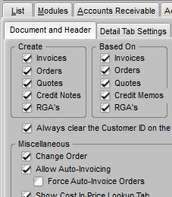 

## Printing Packing Slips

Packing slips are frequently just second copies of picking tickets that say PACKING SLIP and may have some different information like prices. If goods are delivered directly on a company truck then they may print three copies, the third acting as a delivery receipt to be signed. If goods are typically picked as indicated on the picking ticket then the packing slip should be an accurate listing of what was shipped. Some companies will make manual corrections if errors are infrequent and minor. If however there are frequent discrepancies then they may choose to correct the order and reprint the picking ticket so that the packing slip is correct. Or you may want to correct/update orders, and print the packing slip as a separate process. This is sometimes done because a freight charge needs to be added to the packing slip. In this case you can use a separate program called Print Packing Slips. Print Packing Slips must be turned on for both the system (SysDflts>OE>Switches>General) and the individual user (Setup Users>Order Entry>Menu Selections.) This program only functions with orders that have invoice records already created but not posted. So it’s used after either Auto-Invoice or Batch Invoice but before invoices are finalized (below.)

  

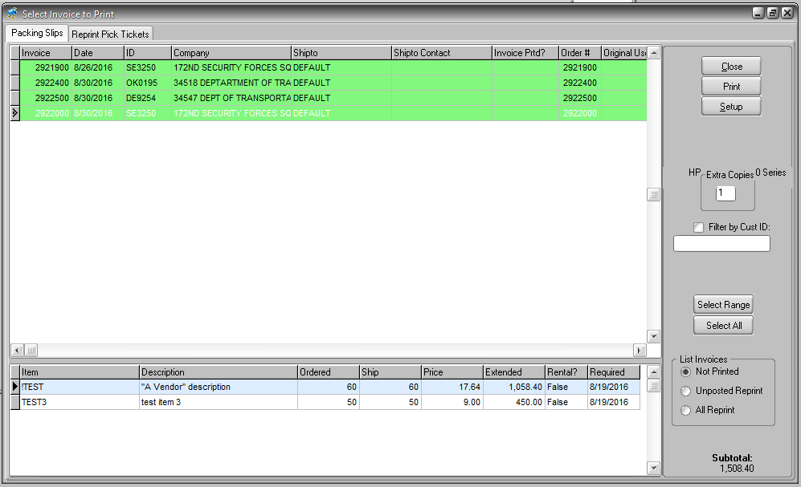

## Review and Batch Invoices

There are two programs that can be used to review invoices before completing them. If you don’t Auto-Invoice, any order that has allocated goods on it will be listed on the Batch Invoice Orders program. This program is the only program that will create the initial invoice record other than Auto-Invoice. But this also gives a user the opportunity to review the details of an order, verify that a pick ticket has been printed, and check the price and cost of the items. Once the user is satisfied that the order is ready to be invoiced then they can release the hold on the order for invoicing. Usually most of the orders on the screen are released at once and then when the Invoice Selected button is clicked invoice records are created for those released.

 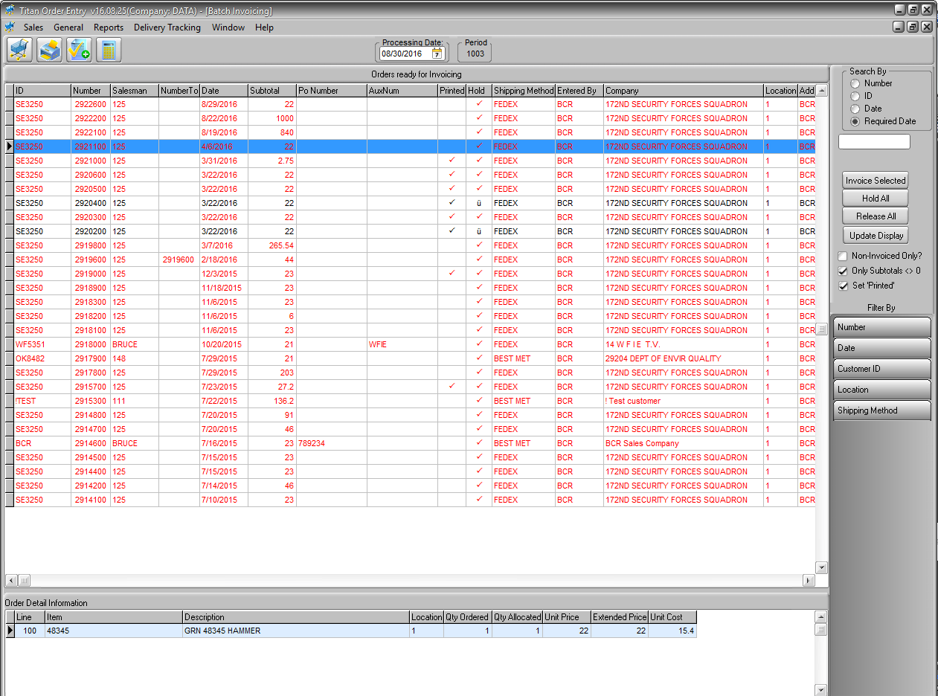

At this point most companies would proceed to print (or email or fax) invoices and complete the final two steps of invoice posting as batches. Some companies want an opportunity for an additional review of individual invoices before final posting. The Hold and Release program provides this and additionally allows a user to change the cost of items on an invoice. This is useful to companies that have particularly volatile costs, especially when items are purchased outside of normal channels and the actual cost is not known when the order is originally placed. While only limited other corrections can be made to an invoice record at this point, it is still possible to “Kill” the invoice, return to the order and make corrections, and then re-invoice. (NOTE: The Batch Invoice and Auto-Invoice routines offer the option of closing an order when invoiced. An order cannot be modified once it has been closed so users may want to avoid this option if they think they will need to kill an invoice and correct the order later. However, a closed order could be copied to a new order.)

The Hold and Release program also has the ability to change the invoice dates of invoices. This is useful if payment terms are dependent on the invoice date and the invoice process has been postponed for a number of days. For example, if an invoice record was created (via Auto-Invoice or Batch) on 1/2, but the invoicing process is not completed until 1/11, customers would probably be upset to have their due date reduced by nine days. Hold and Release would allow a user to reset the invoice date to 1/11.

Hold and Release has the option of finalizing (pre-posting) the invoices, allowing the user to skip that step in the usual invoicing process. The one drawback to this is that Hold and Release does not print invoices. Invoices may be printed at other times. Invoices can be printed when they are Auto-Invoiced. Or invoice forms may be created outside of the invoicing process, possibly as a second copy of the pick ticket. A few companies don’t print invoices at all and rely exclusively on statements or invoice reports to notify customers of amounts due. Barring these cases, invoices will need to be printed at the time of the End of Day final processing.

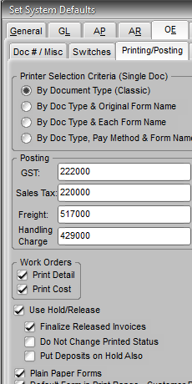  

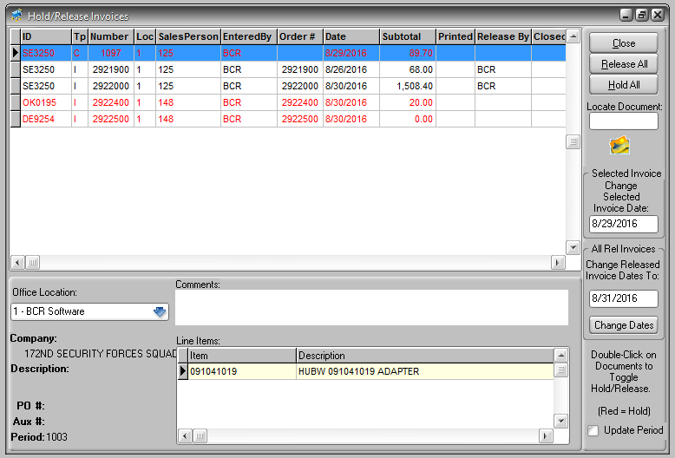

## Print, Finalize and Post Invoices

If invoices are not finalized (pre-posted) in Hold and Release, then they must be finalized using the Print/Process Range>Invoices program. This is the most common route for companies to printing and processing invoices. This program is designed to process groups rather than individual invoices, though you can specify one invoice using the document range selection. By this point it’s assumed that invoices have been sufficiently reviewed and no further changes should be necessary. Once an invoice is finalized it cannot be changed or killed. It must proceed through End of Day posting and any corrections will require a credit and re-bill. There are a number of options in the program that allow the user to filter the batch however, including invoices with selected document numbers, dates or customers. Until invoices are finalized the quantities allocated on orders remain allocated. The on hand quantity and allocated quantities are not reduced until the invoice is finalized.

 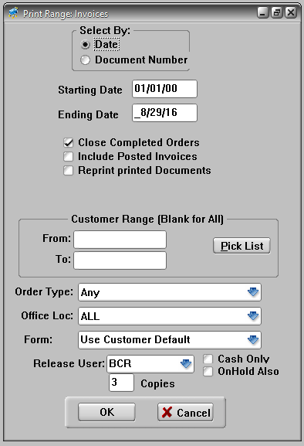

The final step in invoice processing is End of Day Posting (EOD). Despite its name EOD can be run at any time and with any frequency. It could be run twice daily or once weekly, though most companies run it once daily. The AR and GL are not updated until EOD is run. For this reason, companies usually want to run EOD at least daily so that the invoices are in the AR when the customer makes a payment. Otherwise payments must either be posted as unapplied and applied to the invoice later when it is posted, or cash receipts are not posted at all until days later.

 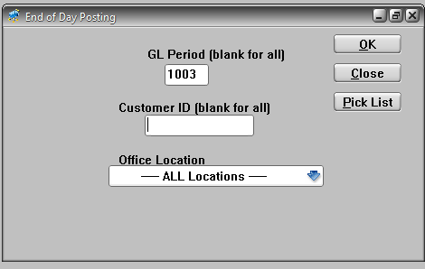

# Process Flow Chart

The primary flow shown here in white is a typical flow for many companies while optional courses are shown in gray.

Orders are created from quotes.

Quotations are created and printed.

Orders are created .

Order acknowledgments are printed.

and/or

Pick tickets are printed using the Print Picking Tickets program.

Pick tickets are printed immediately from order entry .

and/or

Invoice records are created using the Auto-Invoice option.

Invoice records are created using the Batch Invoice Orders program.

Packing slips are printed using the Print Packing Slips program.

Invoices are printed as a copy of another form or at End of Day processing.

Invoices are printed when they are Auto-Invoiced.

Invoices are printed using the Print/Process Range Invoices program.

and/or and/or

or

Invoices are finalized using the Print/Process Invoice program.

End of Day is used to complete invoice posting to AR and GL.

The Hold and Release program is used to finalize invoices.