Order and Invoice numbering schemes
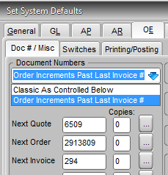
There are different numbering schemes for orders and invoices possible in Titan. Usually a scheme is selected during your software implementation but it is possible to change schemes later. This documentation is provided to describe your options. Setting schemes should always be done with the advice and assistance of a Titan support representative.
Two settings on the System Defaults>OE>Doc#/Misc tab control the numbering of orders and invoices. The first choice listed in the Document Numbers dropdown is Classic As Controlled Below, meaning that the orders and invoices will be numbered using the numbers assigned them in the boxes below the dropdown. The other option in the dropdown is Order Increments Past Last Invoice#, meaning that the order number and invoice number are tied in sequence.
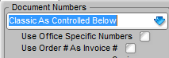
The Use Order # as Invoice # checkbox below the dropdown, when combined with the Classic selection in the dropdown, causes orders to be numbered by hundreds and invoices created from the order to be numbered by the order number and backorder invoices by ones.
Classic = Numbers all orders and invoices separately using the Next numbers in the boxes below the dropdown and increments them by 1.
O 100006 | I 60002
O 100007 | I 60003
O 100006  backorder | I 60004
Classic and Use Order# = Numbers orders and first invoices by 100s. Increments invoice by 1 for each backorder. The Next Invoice number in the box below the dropdown is not used.
O 10000100 | I 10000100
O 10000200 | I 10000200
O 10000300 | I 10000300
O 10000200  Backorder | I 10000201
Order Increments = Numbers orders by 1s. First invoices are numbered same as orders. Increments invoices (and next order number) by 1 for each backorder. When this option is used then the setting of Use Order# has no affect.
O 100006 | I 100006
O 100007 | I 100007
O 100006  Backorder | I 100008
O 100009 | I 100009

The Use Office Specific Numbers option can be used to segregate orders and invoices when the Multiple Office Locations option (System Defaults>OE>Switches>General) is selected. This option only appears and can be selected when the Classic option is selected. It will refer to the next number fields in the Office Location setup sub-screen.

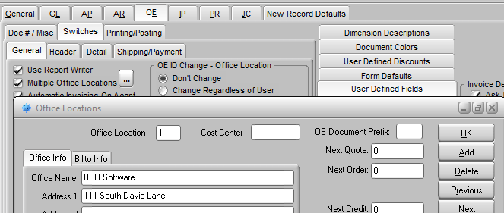
A unique OE Document Prefix must be entered in each location for the option to function correctly. Up to three characters can be entered. Less than three will fill with zeros. Numbering will then be assigned orders and invoices according to the Office Location assigned the order. If the Next numbers in the locations are identical then the system will use one numbering system and increment by one for each order in the company but with the location prefix, e.g., A0010001 and B0010002, A0010003, etc. If the numbers assigned as next numbers in the locations are different then the numbering will be independent, e.g., A0010001, B0060001. Note that if the numbering is independent the system will number two orders the same with only the prefix to differentiate them (i.e., two location numbering systems were close enough and orders for one overran the numbering of the other.) If the Use Order Number option is selected numbering is by 100s as described above for all locations.

