Order Entry Payment Processing
Payments from customers for goods are either received through the AR payment system or through order entry on the Shipping/Payment tab. Payments entered through order entry may be for goods purchased and delivered at that point (e.g., retail or counter sales), a prepayment or deposit for goods to be delivered later, or some payment beyond goods ordered to be applied to the customer’s account. How the payment is processed will depend on how much is being paid, the method of payment, and how you process the invoice or payment.

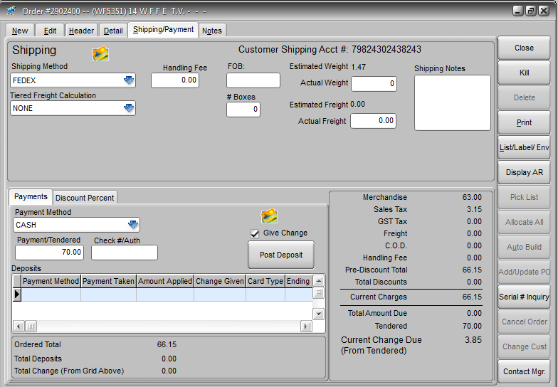
The amount due back to the customer
The full amount offered by the customer
Listing of payments made related to this order using Post Deposit
Amount due for item quantities currently allocated
Typically cash, check, or credit card (CC)

Give Change
The Give Change option will determine whether any payment amount that exceeds the amount due on the order is assumed to be returned to the customer or is posted as an unapplied payment on the customer account. This option only apples to the Post Deposit function. The default for this option is set at the customer account level but can be overridden on the Shipping/Payment tab. If Give Change is checked when Post Deposit is used then any amount over the amount due on the order is listed as change. If not checked then the amount is posted as an unapplied payment.
NOTE: Whenever the Auto-Invoice feature is used, if the payment amount exceeds the amount due then the system assumes you will give change. If you want to post the excess to the customer’s account you must first use the Post Deposit feature, then Auto-Invoice.

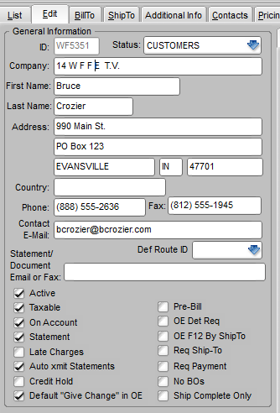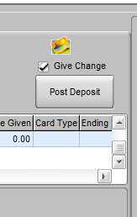

Cash Sales
The most common reason that a customer would offer payment during order entry is that the customer is a “cash” customer, meaning that the customer either does not have an account of their own or they have an account but are not permitted to charge on it. So when goods are delivered to the customer the customer must pay for them.*
If there is an amount due on the order and the customer is making payment you must first verify that the correct payment form is selected in the Payment Method field. You then enter the amount the customer is offering as payment in the Payment/Tendered field. If this amount is greater than the Total Amount Due then the amount due back to the customer will be displayed. If you use the Auto-Invoice feature then the payment will be automatically applied to the invoice, any excess will be assumed to have been returned to the customer in change, and the transaction is complete.
If you do not use the Auto-Invoice feature and the order will be invoiced later, either individually or as a batch, you could leave the amount paid on the order and wait until the order is processed as an invoice and the payment would be posted just as with the Auto-Invoice. If you prefer to post the customer’s payment immediately so that you are assured there is separate record of the payment, then you can use the Post Deposit button and the payment will be posted to the customer account independent of the invoice processing. When the Post Deposit button is used the payment will be noted in the grid at the bottom of the tab. When End of Day is run the payment will be setup to be posted to the AR account.
IMPORTANT NOTE: If you use the Post Deposit button and you intend to give change back to the customer the Give Change box must be checked. Otherwise the change will be posted to the customer account as an unapplied payment.

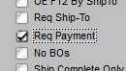
*A customer’s account is flagged as requiring cash payment in Edit Customer on the Edit tab by checking the Req Payment option. If an order is entered for the customer and has an amount due (i.e., items are allocated) then the system will not allow you to exit the order without either a Post Deposit or Auto-invoice to indicate payments has been received.

Prepayments/Deposits
If you require payments in advance from some customers or for some products then you will need to use the Post Deposit button to record the payment. Otherwise the payment would not be posted until the order is shipped and invoiced, which may be well after the deposit was taken. This would mean there were funds in hand un-posted in the accounting system. The payment is recorded in the grid at the bottom of the tab. The payment will be posted like an invoice in the invoice processing flow and when posted to the accounts receivable it will be posted as an unapplied payment. The accounts receivable department can apply the payment to the open balance on the account, if there is one, or wait and apply it when the corresponding invoice is posted to AR.

Over Payments
Usually if a customer gives you more in payment than is currently due on the order (i.e., for quantities allocated and/or freight, handling or tax is owed) they are either expecting to receive change or it is intended as a prepayment/deposit. If the amount tendered is greater than the amount due on order including unshipped goods and they do not want change, then it can be received as a payment on their AR account. This is exactly the same as a prepayment/deposit, in that the excess amount will be posted as an unapplied payment.

