Order Entry Partial Document Copy
The partial copy function allows users creating credit notes from invoices or orders from quotes to only copy selected items and quantities. This is especially useful if a customer has returned only one item on an invoice that included many more items. Rather than creating a return with all of the items and then deleting all but one, just the one item is copied to the new document.

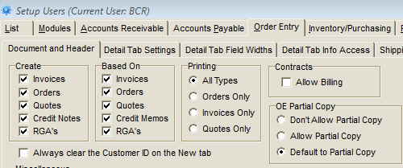
The user’s access to this capability is determined by the setting in Setup Users>Order Entry>Document and Header tab.

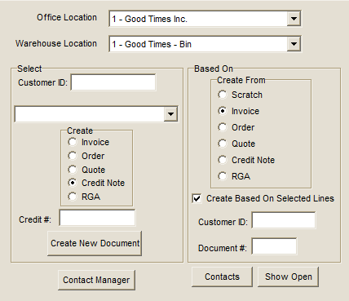
This setting will determine the status of the “Create Based on Selected Lines” checkbox when any “Create From” option is selected other than “Scratch” . If “Default to Partial Copy” is set then the box will be checked. If “Allow Partial Copy” will display the checkbox unchecked. “Don’t Allow Partial Copy” will not display the checkbox.

The most likely use of the facility is to copy only selected items from a customer’s invoice to a credit note when only one or a few items are being returned from a multi-line invoice. But it can also be used to copy selected items from a quote to an order or from and invoice to a quote, etc.

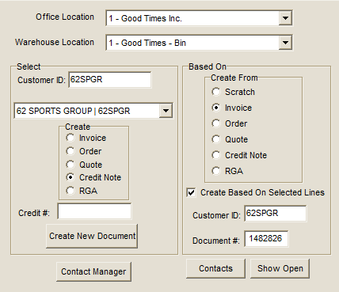
If the checkbox is selected, the copy lines screen will appear after the user has entered a “to” Customer ID, a “from” Customer ID, a “from” Document #, and clicked the Create New Document button.

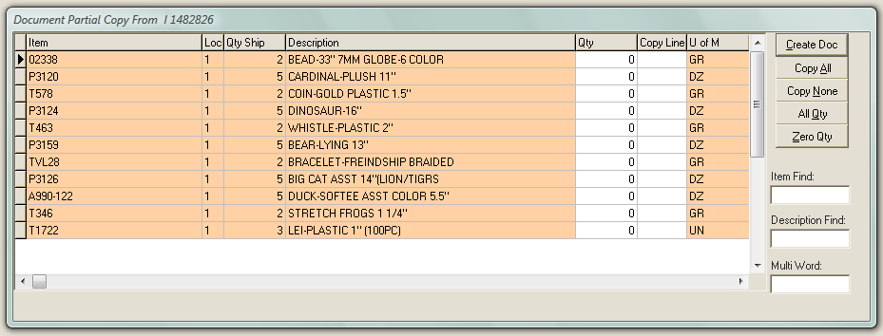
The Partial Copy screen lists all of the items and their ship quantities from the original document. The “Qty” column begins with all zeros and the “Copy Line” column empty. Only items with a check in the Copy Line column will be copied to the new document, regardless of the number in the Qty column.

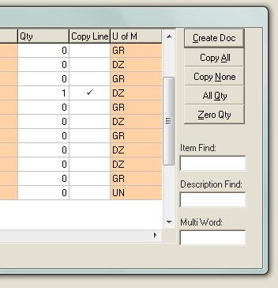
The buttons to the right manipulate these columns as a group. “Copy All” will set all Copy Line fields to checked. “Copy None” will reverse that. “All Qty” will set the Qty column fields equal to the ship quantities and all copy line fields to checked. “Zero Qty” will set all Qty fields back to zero but will not affect the Copy Line fields.
Once the proper item quantities and Copy Line fields have been set, select the Create Doc button to create the new document. The items selected will be automatically entered on the Detail tab with the quantities entered.

