BCR Notify

BCR Notify is a BCR Premium product that allows you to schedule BCR Report Writer reports to run at specific times and be automatically sent to designated email addresses as PDF or MS Excel attachments. Reports can be general in nature and scheduled to run daily, weekly or monthly. For example, a listing of sales orders for each sales person could be sent to them at the end of each day or financial performance reports could be automatically sent to owners each week.
Reports can also be highly specific, triggered by an event, and scheduled to test for that event every few minutes. An example might be a notification to a specific customer that an order has been shipped. This report could be set to run every half hour but would not send an email until there was actually data meeting the report requirements.

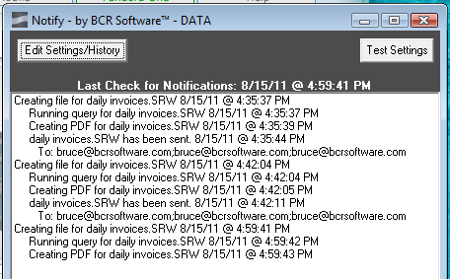
Notify typically resides on your server in your executables folder and once started is left running at all times. The program must be running in order for reports to run and be sent. A listing of recent activity is displayed in the main Notify window. BCR does not need to be running for Notify to run.
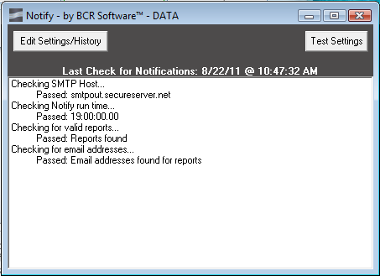
Click the Test Settings button to verify that Notify has been setup to run properly, that there are reports available in the Notify folder to run, and that all active reports have at least one email address assigned.
Click the Edit Settings/History button to add or modify Notify report settings.

NOTE: Notify will not run scheduled reports while you are in the edit mode. You must exit the edit screen to resume Notify operation. However, all reports that were missed during the period that the edit screen was open will run once Notify resumes operation. If the Notify program is closed completely and reopened it will also run a missed report once, regardless of the number of cycles missed.

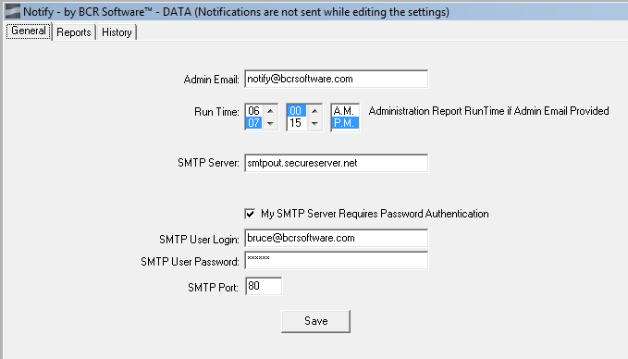
The General tab contains the email settings required for Notify to send emails. Contact your system administrator or BCR support if you need assistance with these.

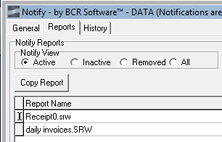
The Reports tab is used to setup and maintain Notify report schedules. In order for a report to function in Notify a copy of the report SRW file must be found in the Notify folder in your BCR data folder (yourdatafolder\FORMS\ REPORTS\NOTIFY). Any report in Notify that is not found is this folder is classified as “Removed” by Notify.
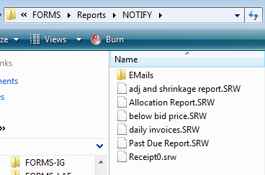
You can see all of the reports (SRW files) available in the Notify folder by clicking the All option in Notify View. Reports listed that are currently set to run are shown in white and are “Active.” Reports that are in the Notify folder but not currently set to run are shown in orange and are “Inactive.” Reports shown in pink have been setup in Notify but cannot be found in the Notify folder and are “Removed.”
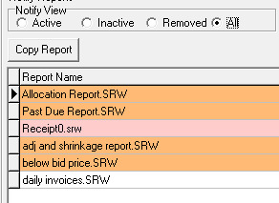

You can change the name of a report in both the Reports setup tab and the Notify folder by selecting a report and then clicking on the Report Name and typing a new name. The new name must have the SRW file type extension or it will not function in Notify.
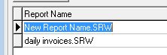

You can create duplicates of reports and their setups by selecting a report and clicking the Copy Report button. Each time the button is clicked it will create another report with the suffix of COPY and a sequence number in the Notify folder and in the setups. Each new setup will be identical to the source setup. You can then make changes such as a different cycle or day for different email recipients.

An Inactive report (shown when the Notify View is set to either All or Inactive) can only be setup to run by selecting the report and then checking the Active option. This will automatically move it from Inactive to Active and change its color from orange to white. Active reports can likewise be made Inactive regardless of their cycle or next scheduled run by removing the check from the Active option.

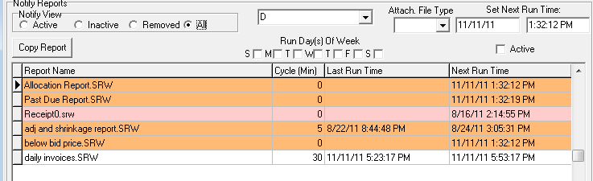

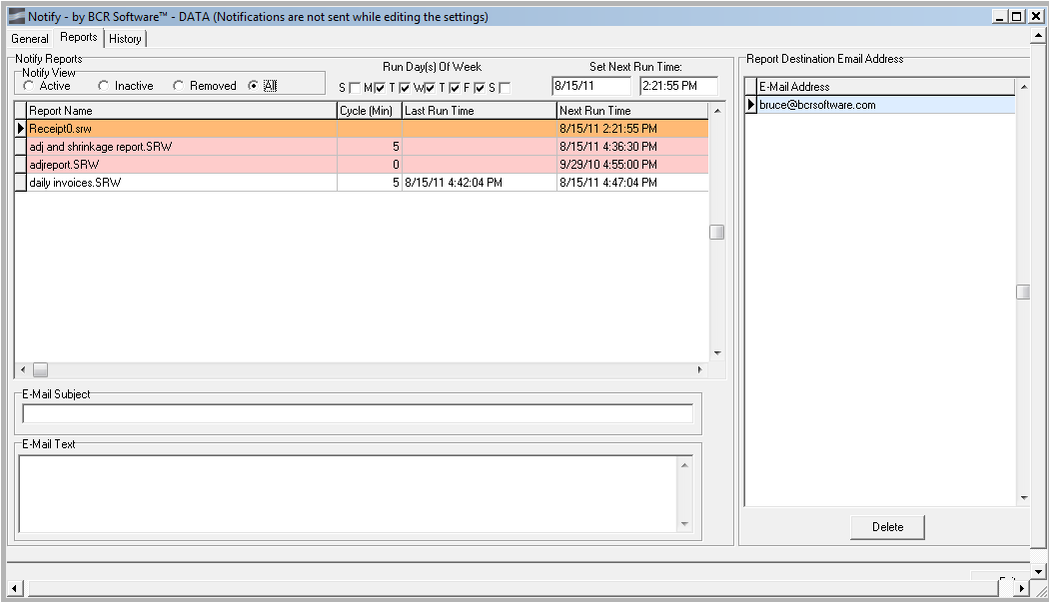
All of the settings including the next run time can be maintained for Inactive or Removed reports but only Active reports will run. This allows you to “turn off” a report without losing its setup.
Each report has a setting for the daily timing, the file type to attach, the next time to run the report in its cycle, the day(s) of the week to run the report (if appropriate), and the number of minutes to cycle before running the report after the next run time.

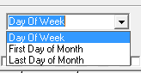
The day of week selection will display the Run Day(s) Of Week options. Check the boxes for each day of the week the report should be run. Optionally you can choose to run the report only on the first or last day of the month.
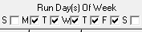

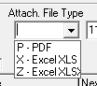
Select the file type that you would like the report in that is attached to the email. Select Z for Excel 2007 and later version format.
You can set the next run date and time manually and regardless of the cycle, that will be the next run time for the report. If you do not manually set it the system will calculate the next run as the current time plus the cycle. If you are editing an existing setup you can use this field to override the calculated next run to get it to run sooner or later.
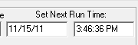

The Cycle is the number of minutes that should pass between each run of this report. Daily or monthly reports should have a cycle of 1440 (the number of minutes in a day. Reports designed to wait for particular events like the shipment of a particular order might be set to run every hour. If a report does not contain data no email is sent so this would not fill a user’s email inbox with meaningless emails.
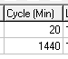

NOTE: Changing the Cycle of a report does not automatically change its next run time. Notify will only run the report at its next run time and then calculate the next run time based on the cycle. If the next run is scheduled in 45 minutes and you change the cycle to 15 minutes, the report will run in 45 minutes and then every 15 minutes. You must change the next run time if you want to run the report sooner.

Every active report should have at least one email destination. The email address listing will show the emails assigned the currently selected report. Reports without a valid email assignment will still run but not go anywhere (though the report can be viewed on the History tab.) One or many email addresses can be assigned. Use the Add Email button (or down arrow from the email list) to create a new assignment and the Delete Email button (or delete key) to remove an address. You can type an address into the listing field or use the Select Email button to open a listing of all emails currently used in Notify assignments that you can pick from.
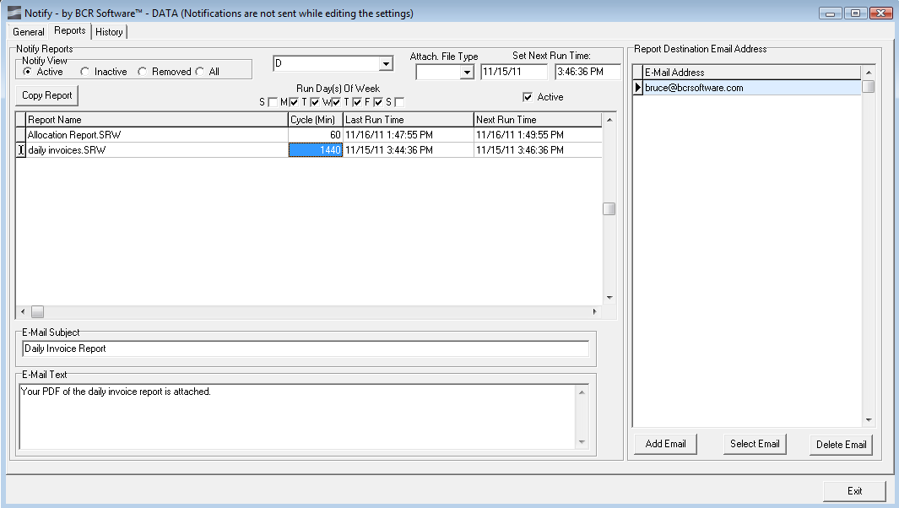
The History tab will display a listing of all past report runs by Notify. You can use the Filter options to list All, Successful, or Unsuccessful. Unsuccessful report runs are shown in orange. The grid displays the date and time of each run, the report name, the cycle setting at the time the report was run (though this may have been manually over ridden to produce the actual run), and the subject given the email for the run.
Each report can be assigned an email subject and text to be included in the email. At the least a report should probably be assigned a subject so that the recipient knows the purpose of the email.

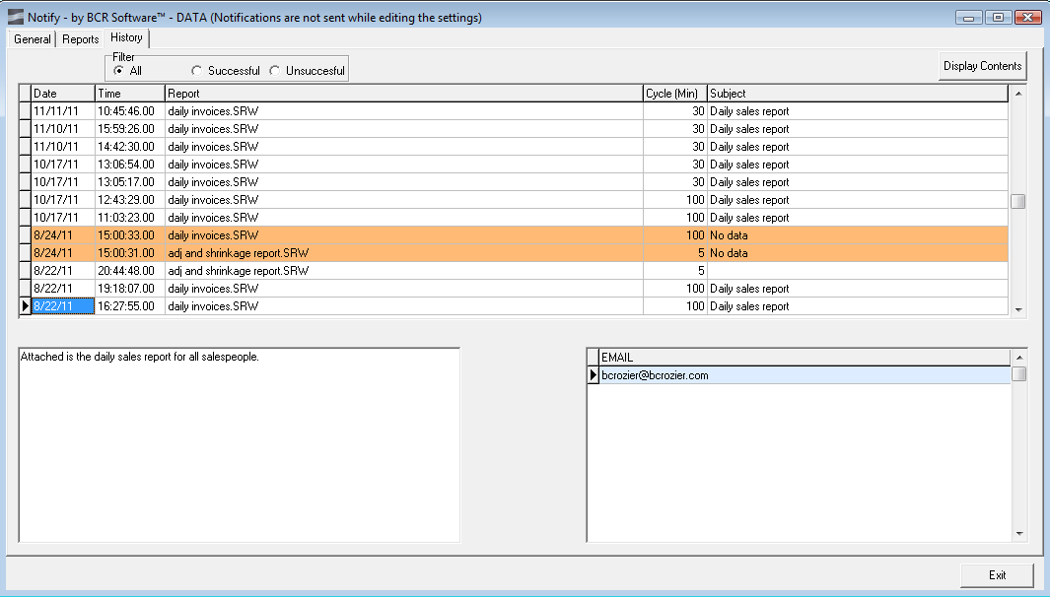

The text box in the lower left displays the text assigned the email for the selected run.
The emails that the run was sent to are displayed in the list to the right.
The Display Contents button in the upper right will open the attachment (PDF, XLS, XLSX) that was sent.

