BCR Notes and User Defined Fields
BCR Software includes a number of note and data entry fields that can be used in any way convenient to meet a business information need. These fields (or text boxes for notes) are mostly found in the primary data tables for items, customers, vendors, and transactions, though the actual data entered into the fields may be contained in subsidiary tables. “User defined” (UD) data fields are so called because their field label is set by the user in system defaults rather than preset by BCR. Their content does not affect any process in the software, so they can be used for any purpose without concern for what impact it might have on other data. UD fields do not appear on program screens if they do not have labels assigned in system defaults. Entering a label in system defaults effectively activates a UD field.
The description or location of some note fields may suggest that they appear on certain forms. Remember that all BCR forms are user controlled and can be customized so that virtually any information in the database related to a form’s primary contents can be included on a form. That in mind, note fields do not necessarily appear in the same forms their description or location implies, and will not appear at all if they have not been included in the form design.
Note fields are stored in the database as “memo” fields. The actual contents of the memo type field are stored in another table, separate from the table the note field is found in. Because note field memos are not defined in size, in Report Writer these fields will only display as “memo” in a simple report grid. In order to see the text of a note field it must be part of a form layout.
This document will detail their various locations, and their field and table names for use in the BCR Report Writer. At the conclusion of the document is a form reviewing the locations of all note/UD fields with space to list the names and functions assigned to them in your organization.

Item Related Notes/UD Fields

Item Primary UD Fields
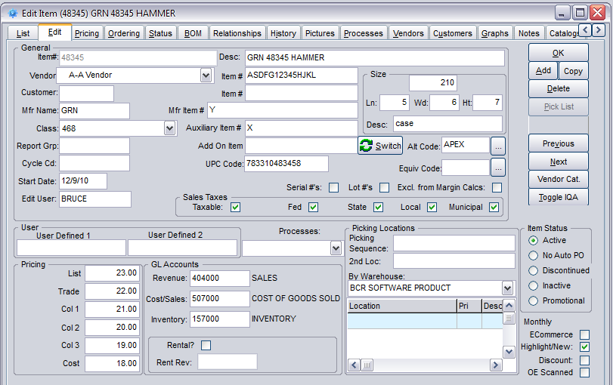
There are two primary UD fields for items on the Edit tab.
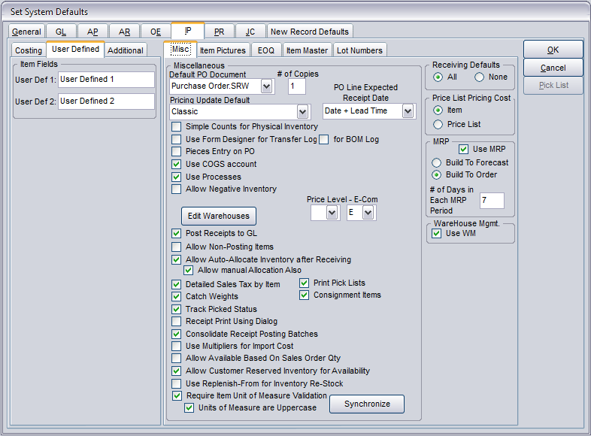
Their labels are created in System Defaults on the User Defined tab of the IP tab.

Item Extended Descriptions
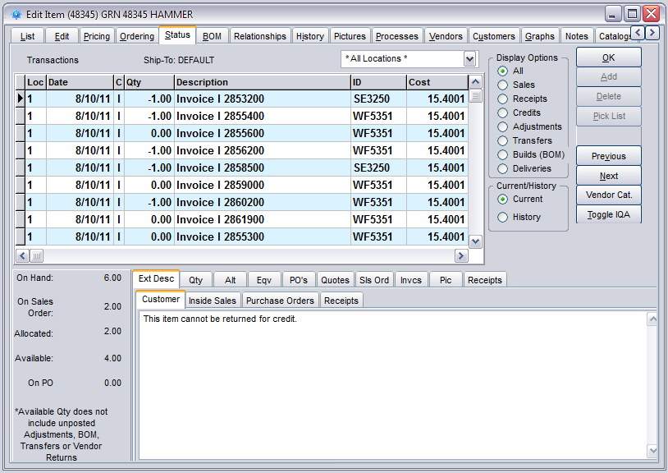
There are four extended descriptions for each item on the Status tab. While they have titles that suggest specific types of information, they can be used in any way that suits the need.

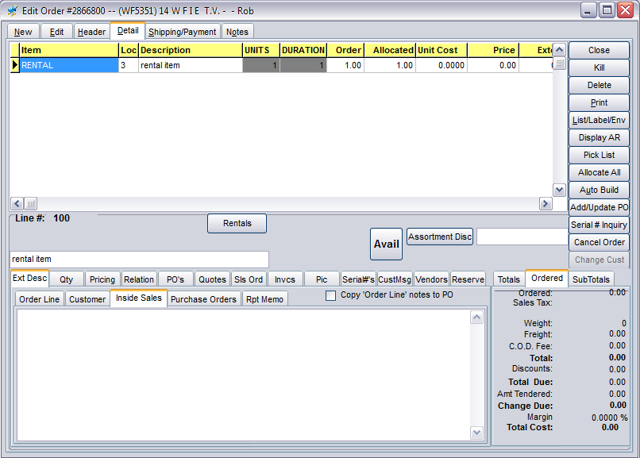
Extended descriptions are displayed in sales orders on the Ext Desc tab of the Detail tab.
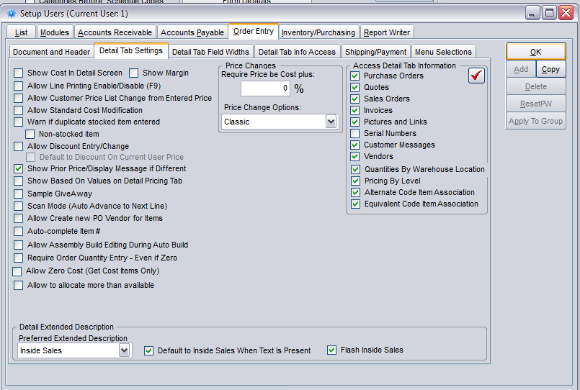
In Setup Users on the Order Entry> Detail Tab Settings tab a user can be set to see a specific extended description tab when they select the Ext Desc tab, whether to always view Inside Sales if it contains text for the item, and whether to flash the text in Inside Sales when that tab is viewed.
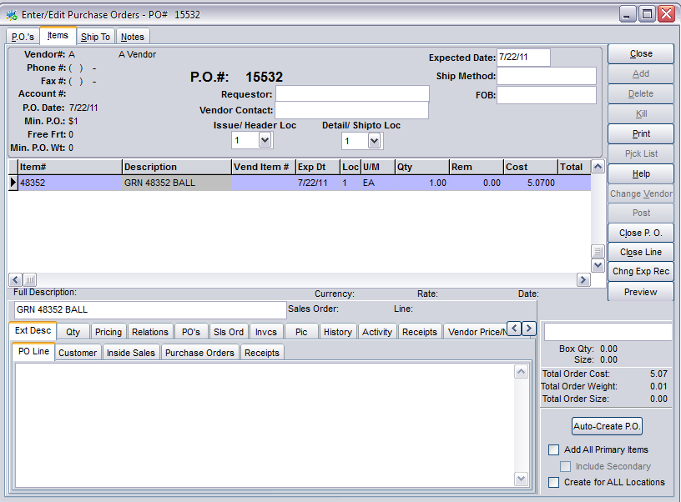
Extended descriptions are also displayed in Edit Purchase Orders on the Ext Desc tab on the Items tab.

Item Vendor Notes
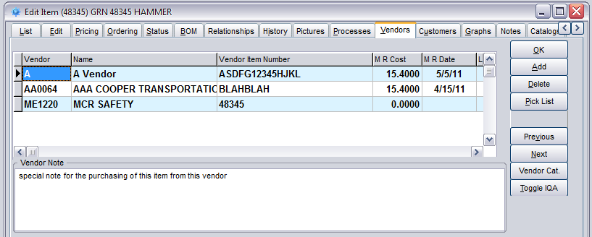
A vendor note can be entered for each vendor that is assigned to an item on the Vendors tab in Edit Items.
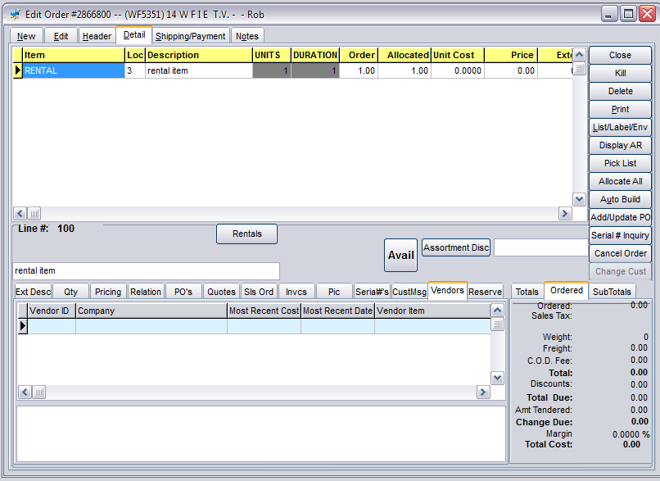
The notes can be viewed in sales orders on the Vendors tab on the Detail tab. Vendors listed in the tab are those assigned to the product selected and the note displayed are those entered for that item for the vendor selected in the grid above.
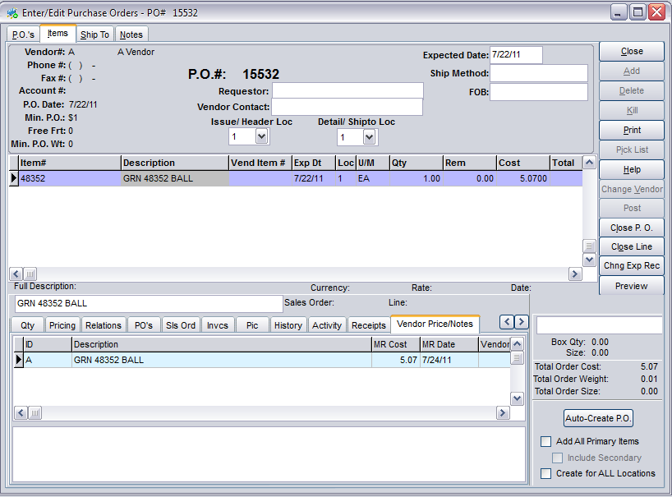
A similar tab is available in purchase orders on the Items tab. The note can be edited in this tab and it will update the item record.
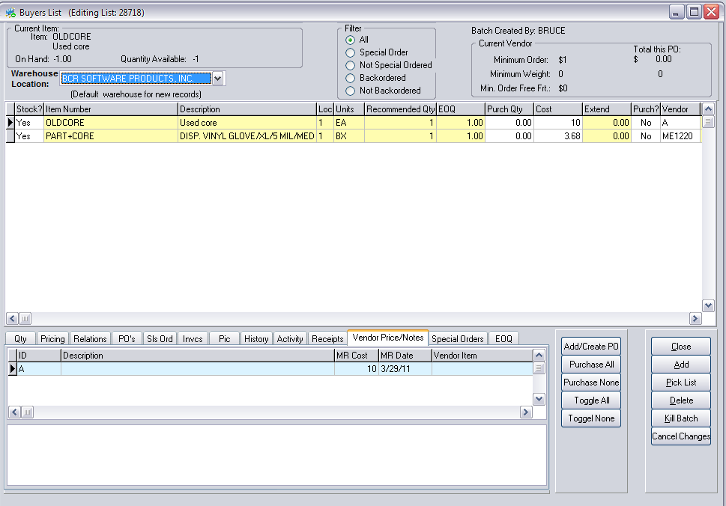
That tab is also available on the Buyer’s List.

Item Forum Notes
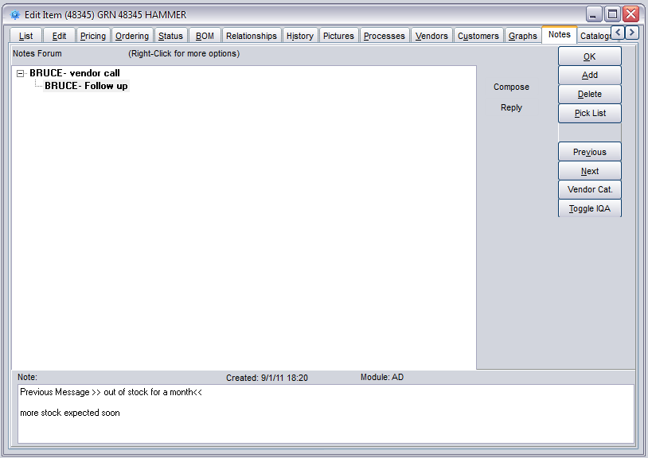
The item Notes tab allows the entry of forum style notes. Enter notes by either clicking the Compose button to the right or right clicking in the window. Then enter a subject and note text in the boxes that appear below. Forum style notes utilize a tree directory so users can respond to posts and respond to a response, etc. The date, time and user is automatically added to each note.

Item Secondary UD Fields
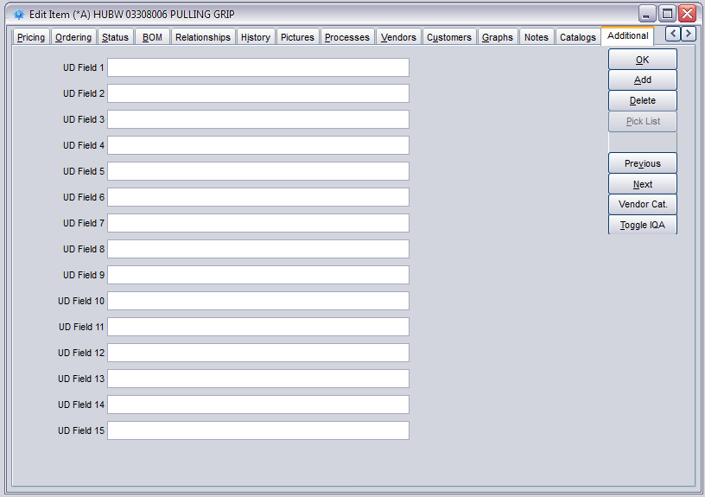
There are fifteen more UD fields on the Additional tab in Edit Items.
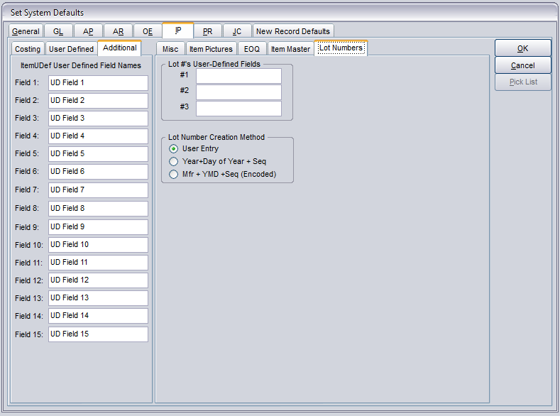
The labels for these fields are created on the Additional tab of the IP tab in System Defaults.

Customer Related Notes/UD Fields

Customer Primary UD Fields
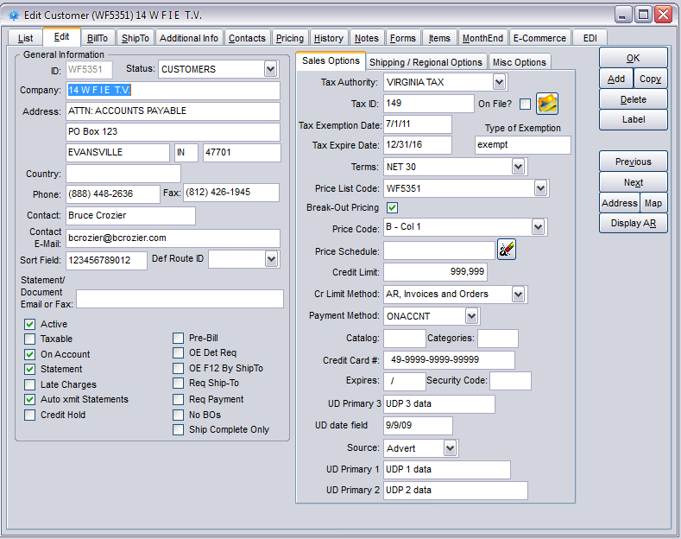
There are three primary UD fields and a UD date field on the Sales Options tab of the Edit tab in Edit Customers.
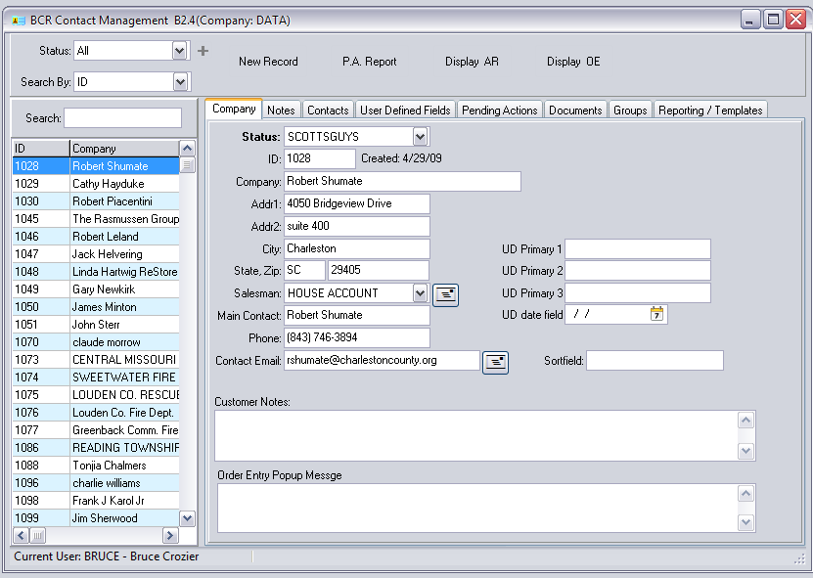
The labels for these fields are created on the AR>User Defined Fields>Primary tab. If the “Copy data to New OE Documents” option is selected then data entered in these fields will be copied into the sales order UD fields 1 and 2 and the UD date field (see Sales Order Related Notes/UD Fields below) respectively for orders for that customer.
These fields are also displayed and can be maintained on the Contact Management Company tab.
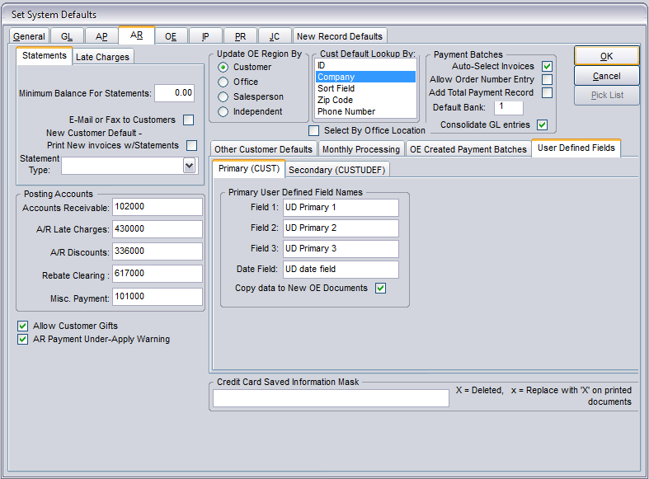
Bill To Additional Information
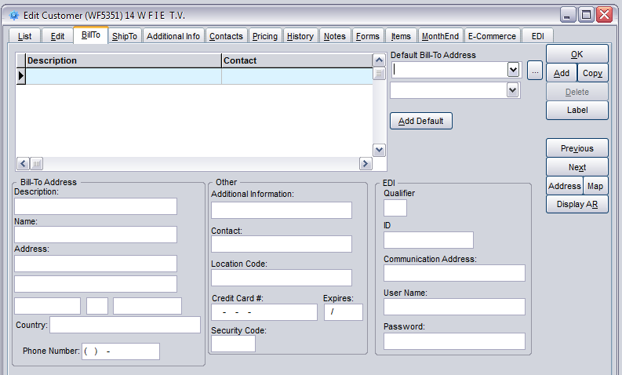
The Additional Information field on the BillTo tab in Edit Customers is specific to the Bill To selected in the grid above it.

Ship To Notes
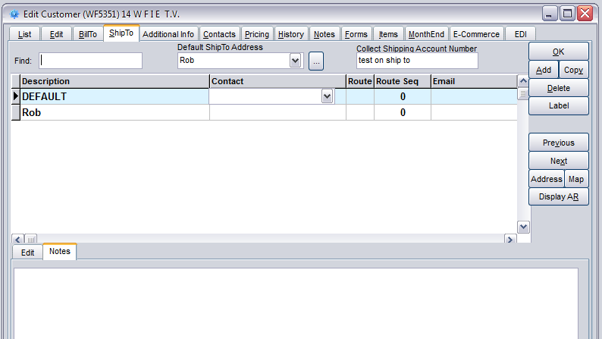
Notes can be entered specific to the ship to address selected in the ShipTo tab of Edit Customers on the Notes tab below the grid.
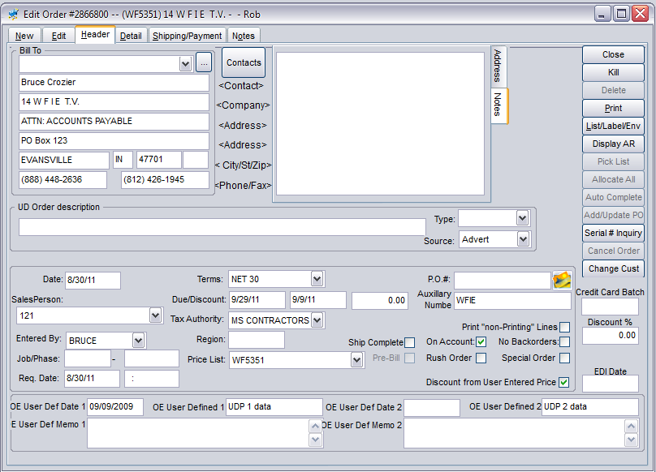
Ship to notes are also displayed and can be edited on the Notes tab of the Header tab of sales orders.

Ship To Additional Info
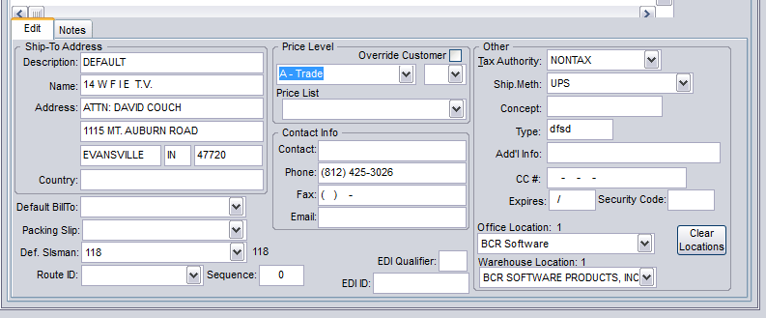
On the Edit tab of the ShipTo tab in Edit Customers there is an additional information field specific to the ship to address selected.

Customer Secondary UD Fields
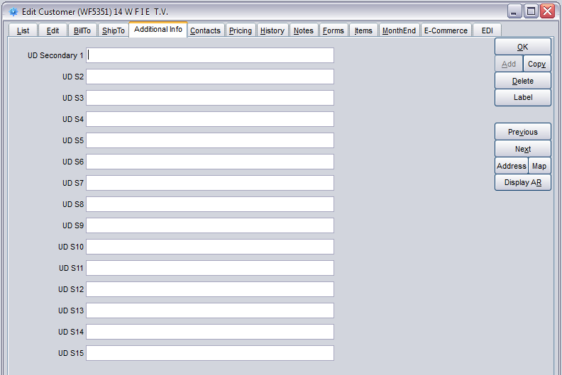
There are fifteen more UD fields on the Additional tab in Edit Customers.
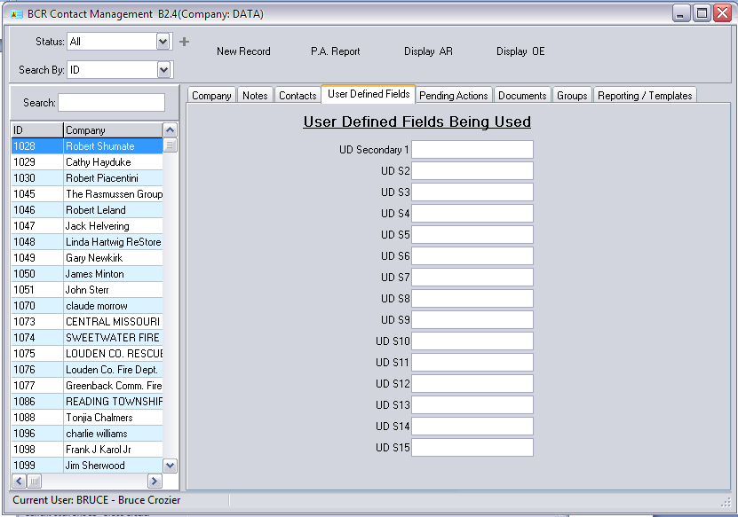
These fields are also displayed and can be maintained on the Contact Management User Defined Fields tab.
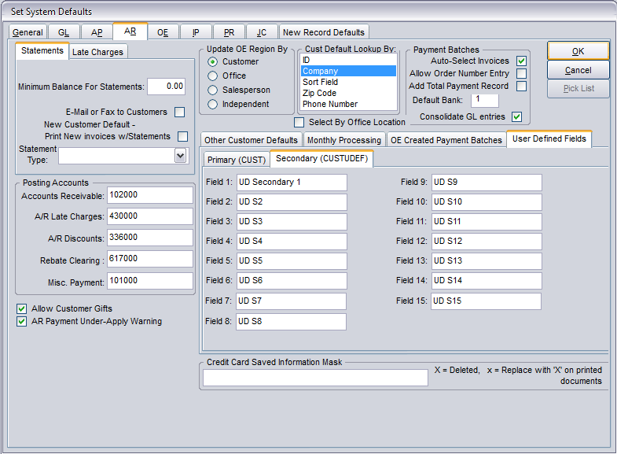
The labels for these fields are created in System Defaults on the AR> User Defined Fields> Secondary tab.

Customer Contact Notes
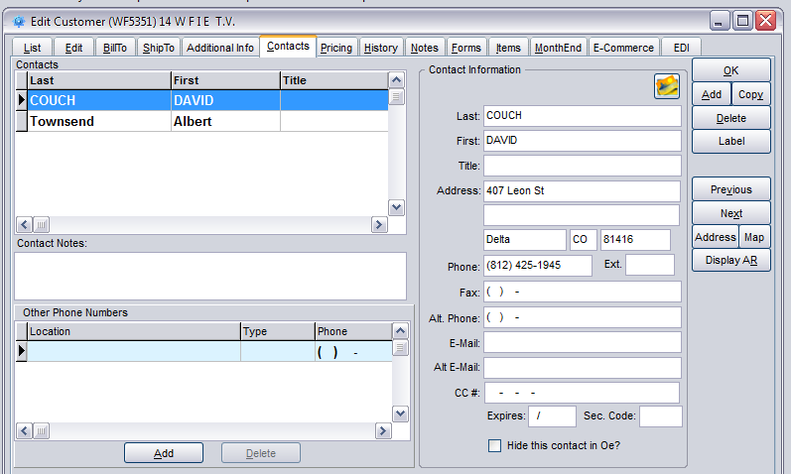
Notes can be entered for each customer contact selected in the grid above the field on the Contacts tab in Edit Customers.
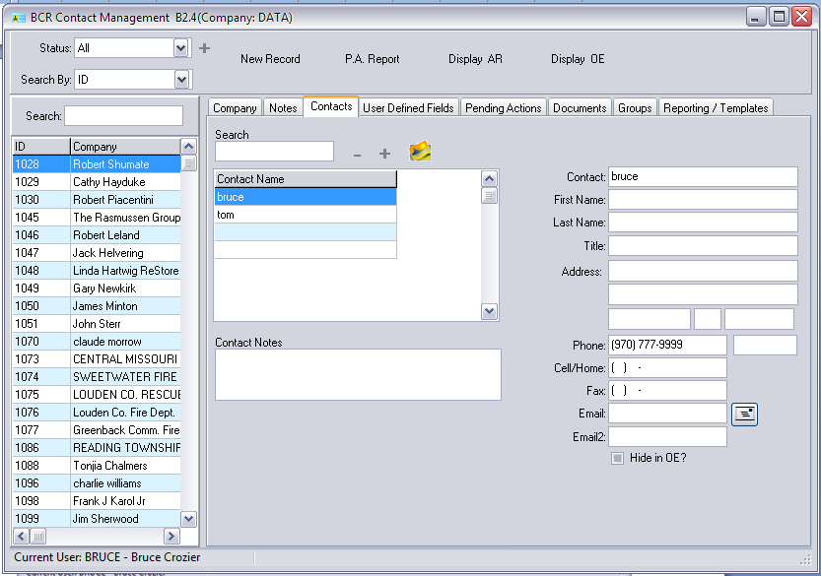
These notes are also displayed and can be maintained on the Contact Management Contacts tab.
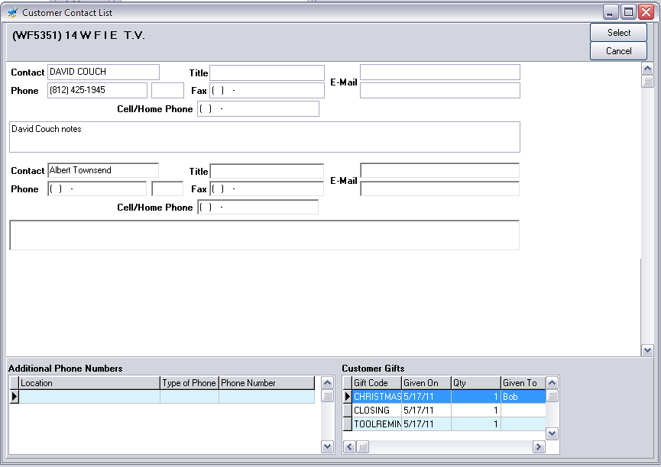
Contact notes for each customer contact are displayed in sales orders on the Customer Contact List sub-screen accessed by clicking the Contacts button in the middle top of the Header tab.

Customer Journal Notes
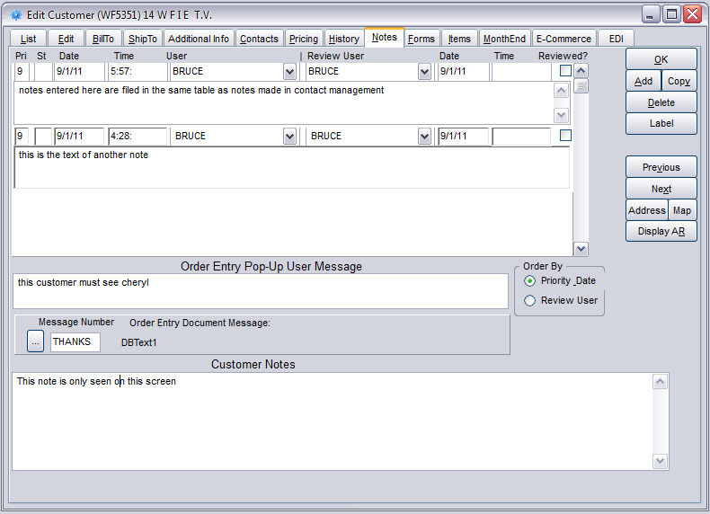
The Notes tab in Edit Customers includes a journal style notes function. Users that do not use the Contact Management forum style notes may want to use these notes for customers.

Customer Pop Up Message
The Order Entry Pop-Up Message entered on the Notes tab will appear whenever an order is created for that customer before the sales order Header tab appears.
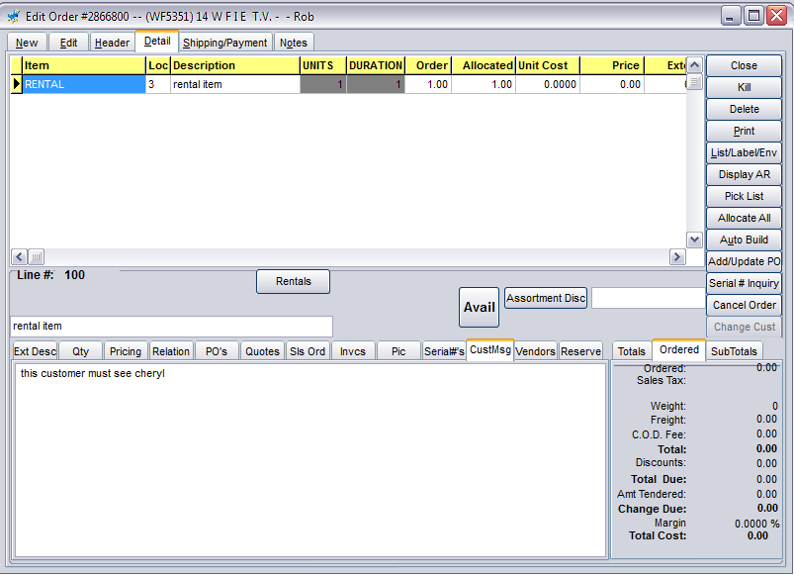
The Order Entry Pop-Up Message is also displayed on the sales order Detail tab on the CustMsg tab. This tab displays the message regardless of the item selected in the grid.

Customer Document Message
The Order Entry Document Message is typically used as an form field to be included on invoices or other customer facing documents. Click on the browser (…) button to the left to select a user defined message or add a new one.
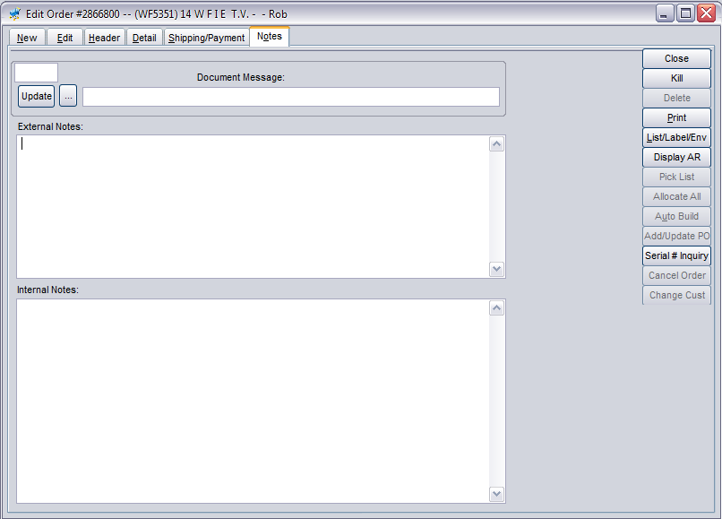
The Document Message is displayed and can be changed or overwritten on the Notes tab in the sales order. Use the browser (…) button to select a different message or enter new text in the text box.

Customer General Notes
Any general customer notes can be entered in the Customer Notes text box at the bottom of the Notes tab.
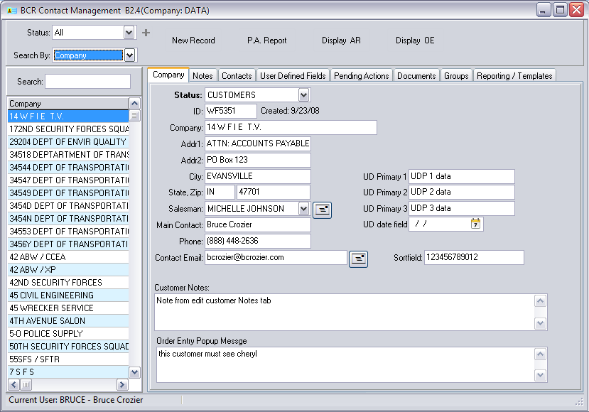
This note also is displayed and can be maintained on the Contact Management Company tab.
The Contact Management Notes tab allows the entry of forum style notes. Enter notes by either clicking the Compose button to the right or right clicking in the window. Then enter a subject and note text in the boxes that appear below. Forum style notes utilize a tree directory so users can respond to posts and respond to a response, etc. The date, time and user is automatically added to each note.

Customer Forum Notes
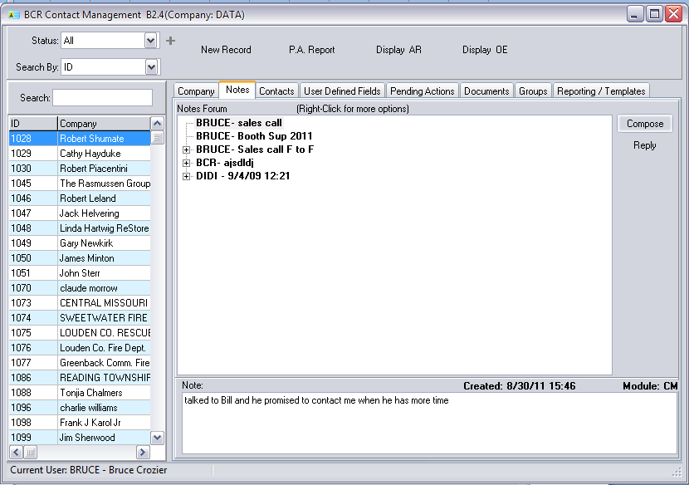

Customer External Documents
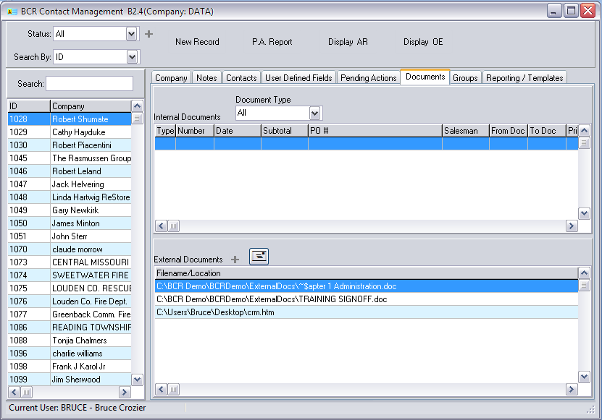
External documents can be tied to specific customers on the Contact Management Documents tab. MS Word documents, PDFs, spreadsheets, or any valid Windows file path can be stored. Double-clicking the path will open the file using the default Windows programs. Only the path is stored so actual files should be stored securely, typically on the BCR server for access to all users.

Vendor Related Notes/UD Fields

Vendor UD Fields
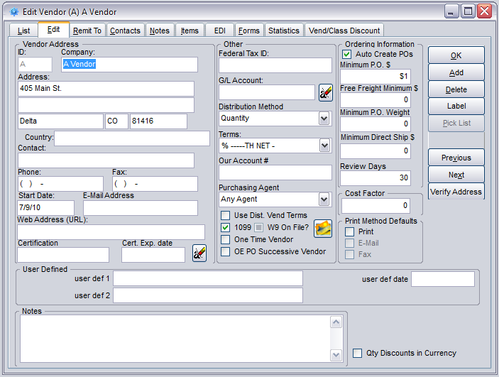
There are two UD fields and a UD date field on the Edit Vendors Edit tab.
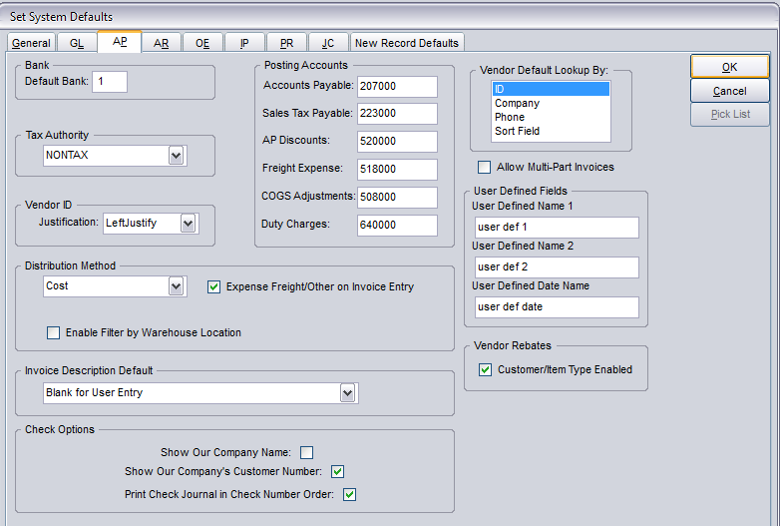
Labels for these fields are created on the AP tab in system defaults.

Vendor General Notes
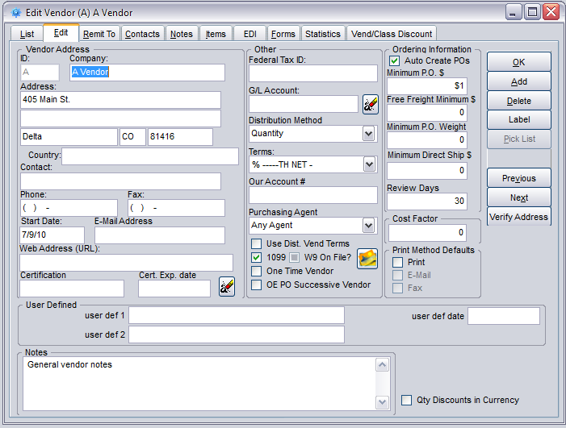
General vendor notes can be entered in the text box at the bottom of the Edit Vendor Edit tab.
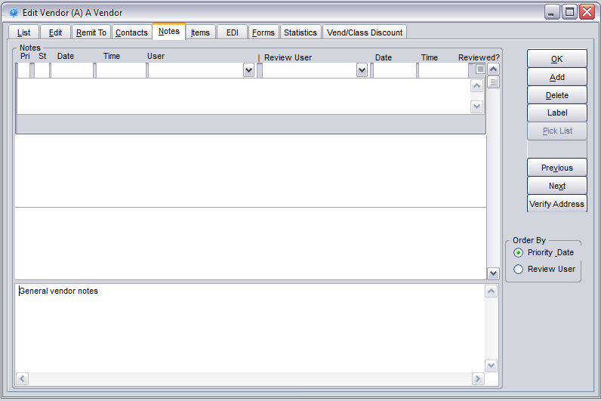
They can also be entered in the text box at the bottom of the Notes tab.
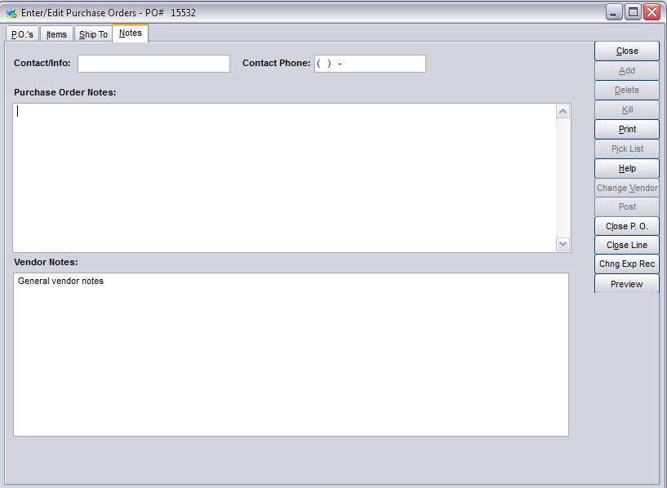
These notes are displayed on the Notes tab in Edit Purchase Orders.
Remit To Additional Information
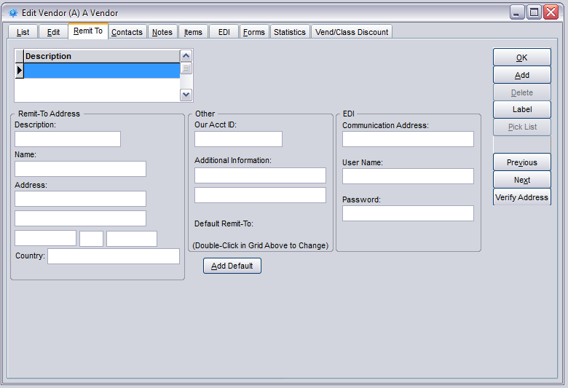
The Edit Vendors Remit To tab has two Additional Information fields for each remittance address for the vendor. These fields apply to the remittance address selected in the grid in the upper left part of the screen.

Vendor Contact Notes
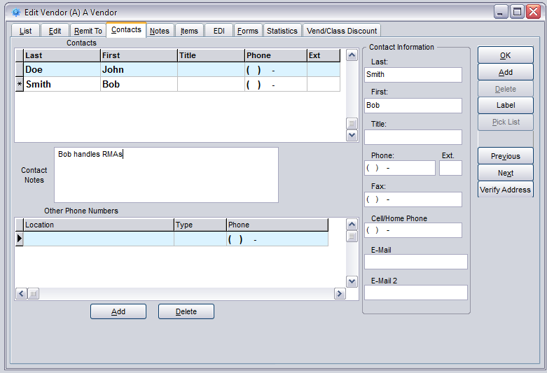
Notes can be entered for each vendor contact selected in the grid above the field on the Contacts tab in Edit Vendors.

Vendor Journal Notes
The Notes tab in Edit Vendors includes a journal style notes function. A number of fields in the header of each note help to track the individual notes.

Sales Order Related Notes/UD Fields

Sales Order Header UD Fields
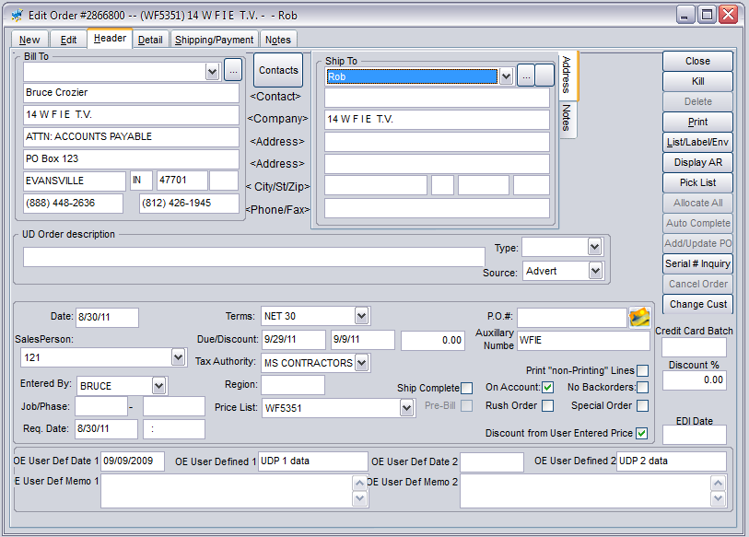
There are up to three UD data fields, two date fields, and two memo (note) fields available on the sales order Header tab.
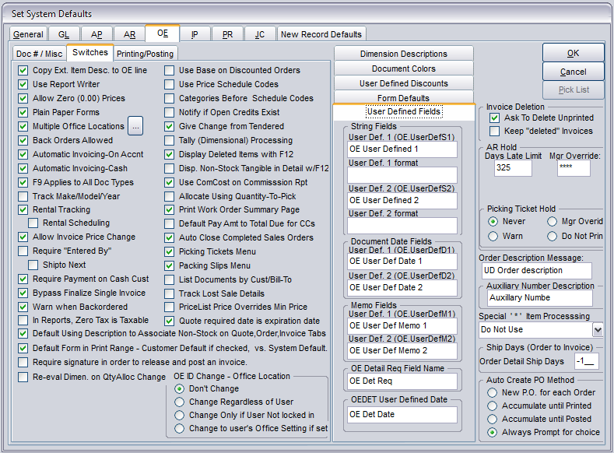
The labels for these fields are created on the System Defaults OE> User Defined Fields tab. User data input to the UD 1 and 2 fields can be restricted using the format fields beneath each of them. Refer to “BCR Field Edit Masks” documentation for details on the use of the UD format fields.
Remember that if the “Copy Data to New OE Documents” option is selected for the customer primary UD Fields then data from the customer record will be copied from UD data fields 1 and 2, and the UD date field, to the sales order UD fields 1 and 2, and UD date field 1, when a new order is created, though the user can overwrite that data in the order.

Extended Description Order Line
The Order Line tab on the Detail> Ext Desc tab is specific the the individual order and line item. If the “Copy Order Line notes to PO” option, above and to the right of the text box, is selected then text entered will be copied to the PO Order Line if a PO is created (for a drop ship or special order) for that line item.
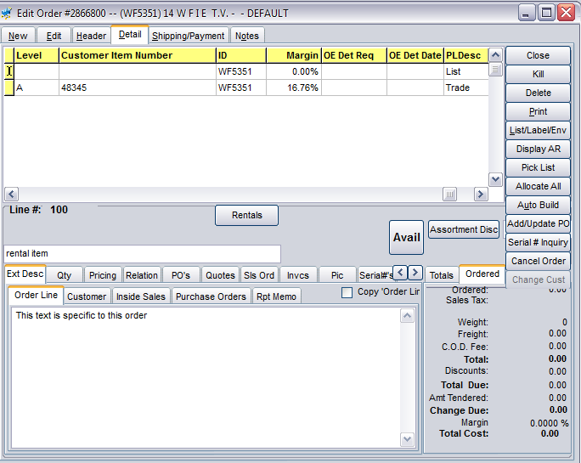

Sales Order Detail UD Field Columns
There are two UD field columns available on the sales order Detail tab item grid, one for data and one for dates. Remember that UD fields only appear if they have labels assigned them in system defaults.
Labels for these columns are created in system defaults on the OE> User Defined Fields tab. Note that the data field is called the OE Detail Req(uired) Field Name.
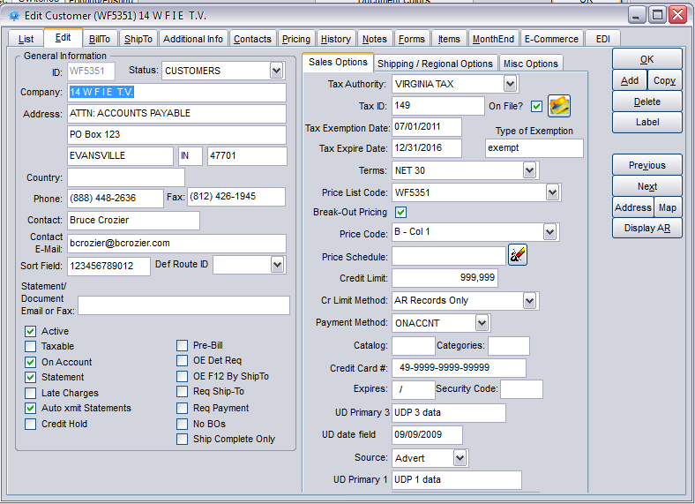
If a customer has the “OE Det Req” option selected on the Edit Customers Edit tab then users must make some data entry in that field for each item on a sales order for that customer.

Sales Order Notes
There are two order specific note text boxes on the Notes tab in sales orders. External Notes are typically used for customer facing forms while Internal Notes are only added to internal forms or only viewed on the order screen. Remember, however, that notes and fields only appear on forms if they are designed to.

Purchase Order Related Notes/UD Fields

Extended Description PO Line
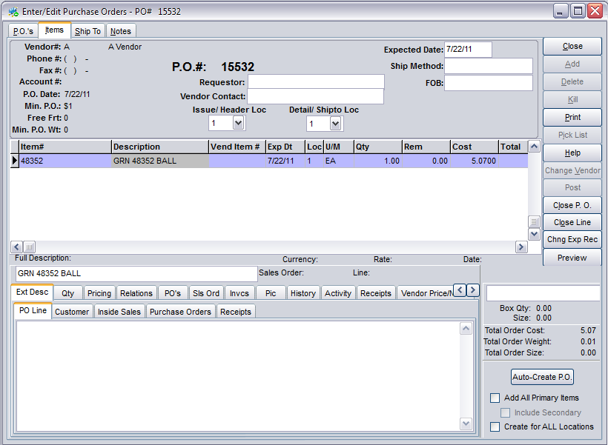
The PO Line tab on the Items> Ext Desc tab in the purchase order is specific to the individual PO and line item. Remember that text from the Order Line in a tied sales order will automatically appear here if the “Copy Order Line notes to PO” option is selected in the sales order.

PO General Notes
Notes specific to the purchase order in general can be entered on Notes tab.

Note/UD Field Usage Form

Note/UD Field | Location(s) | TABLE.FIELD | UD Label | Used For
Item UD Field 1 | Edit Items> Edit tab | ITEM.USERDEF1
Item UD Field 2 | Edit Items> Edit tab | ITEM.USERDEF2
Item Ext Desc Cust | Edit Items> Status> Ext Desc tab,  Edit Orders> Detail tab> Ext Desc tab,  Edit Purchase Orders> Items tab> Ext Desc tab | ITEM.COMMENTS
Item Ext Desc Inside Sales | Edit Items> Status> Ext Desc tab,  Edit Orders> Detail tab> Ext Desc tab,  Edit Purchase Orders> Items tab> Ext Desc tab | ITEM.ORDERNOTE
Item Ext Desc Purchase Orders | Edit Items> Status> Ext Desc tab,  Edit Orders> Detail tab> Ext Desc tab,  Edit Purchase Orders> Items tab> Ext Desc tab | ITEM.PONOTE
Item Ext Desc Receipts | Edit Items> Status> Ext Desc tab,  Edit Orders> Detail tab> Ext Desc tab (Rpt Memo),  Edit Purchase Orders> Items tab> Ext Desc tab | ITEM.RCPTMSG
Item Additional UD Field 1 | Edit Items> Additional tab | ITEMUDEF.UDEF1
Item Additional UD Field 2 | Edit Items> Additional tab | ITEMUDEF.UDEF2
Item Additional UD Field 3 | Edit Items> Additional tab | ITEMUDEF.UDEF3
Item Additional UD Field 4 | Edit Items> Additional tab | ITEMUDEF.UDEF4
Item Additional UD Field 5 | Edit Items> Additional tab | ITEMUDEF.UDEF5
Item Additional UD Field 6 | Edit Items> Additional tab | ITEMUDEF.UDEF6
Item Additional UD Field 7 | Edit Items> Additional tab | ITEMUDEF.UDEF7
Item Additional UD Field 8 | Edit Items> Additional tab | ITEMUDEF.UDEF8
Item Additional UD Field 9 | Edit Items> Additional tab | ITEMUDEF.UDEF9
Item Additional UD Field 10 | Edit Items> Additional tab | ITEMUDEF.UDEF10
Item Additional UD Field 11 | Edit Items> Additional tab | ITEMUDEF.UDEF11
Item Additional UD Field 12 | Edit Items> Additional tab | ITEMUDEF.UDEF12
Item Additional UD Field 13 | Edit Items> Additional tab | ITEMUDEF.UDEF13
Item Additional UD Field 14 | Edit Items> Additional tab | ITEMUDEF.UDEF14
Item Additional UD Field 15 | Edit Items> Additional tab | ITEMUDEF.UDEF15
Item Vendor Note | Edit Items> Vendors tab, Edit Orders> Detail tab> Vendors tab, Edit Purchase Orders> Items tab> Vendor Price/Notes tab | IPITMVND.NOTE
Item Notes Forum | Edit Items> Notes tab | ITEM.NOTES
Customer Primary UD Field 1 | Edit Customers> Edit tab,  Contact Management> Company tab | CUST.USERDEF1
Customer Primary UD Field 2 | Edit Customers> Edit tab,  Contact Management> Company tab | CUST.USERDEF2
Customer Primary UD Field 3 | Edit Customers> Edit tab,  Contact Management> Company tab | CUST.CRTTYPE
Customer Primary UD Date Field | Edit Customers> Edit tab,  Contact Management> Company tab | CUST.CRTEXPDATE
Customer Bill To Additional Information | Edit Customers> Bill To tab | ARBILLTO.COMMENT1
Customer Ship To Notes | Edit Customers> Ship To tab> Notes tab,  Edit Orders> Header tab> Notes tab | SHIPTO.NOTES
Customer Ship To Additional Information | Edit Customers> Ship To tab> Edit tab | SHIPTOCOMMENT1
Customer Secondary UD Field 1 | Edit Customers> Additional Info tab,  Contact Management> User Defined Fields tab | CUSTUDEF.UDEF1
Customer Secondary UD Field 2 | Edit Customers> Additional Info tab,  Contact Management> User Defined Fields tab | CUSTUDEF.UDEF2
Customer Secondary UD Field 3 | Edit Customers> Additional Info tab,  Contact Management> User Defined Fields tab | CUSTUDEF.UDEF3
Customer Secondary UD Field 4 | Edit Customers> Additional Info tab,  Contact Management> User Defined Fields tab | CUSTUDEF.UDEF4
Customer Secondary UD Field 5 | Edit Customers> Additional Info tab,  Contact Management> User Defined Fields tab | CUSTUDEF.UDEF5
Customer Secondary UD Field 6 | Edit Customers> Additional Info tab,  Contact Management> User Defined Fields tab | CUSTUDEF.UDEF6
Customer Secondary UD Field 7 | Edit Customers> Additional Info tab,  Contact Management> User Defined Fields tab | CUSTUDEF.UDEF7
Customer Secondary UD Field 8 | Edit Customers> Additional Info tab,  Contact Management> User Defined Fields tab | CUSTUDEF.UDEF8
Customer Secondary UD Field 9 | Edit Customers> Additional Info tab,  Contact Management> User Defined Fields tab | CUSTUDEF.UDEF9
Customer Secondary UD Field 10 | Edit Customers> Additional Info tab,  Contact Management> User Defined Fields tab | CUSTUDEF.UDEF10
Customer Secondary UD Field 11 | Edit Customers> Additional Info tab,  Contact Management> User Defined Fields tab | CUSTUDEF.UDEF11
Customer Secondary UD Field 12 | Edit Customers> Additional Info tab,  Contact Management> User Defined Fields tab | CUSTUDEF.UDEF12
Customer Secondary UD Field 13 | Edit Customers> Additional Info tab,  Contact Management> User Defined Fields tab | CUSTUDEF.UDEF13
Customer Secondary UD Field 14 | Edit Customers> Additional Info tab,  Contact Management> User Defined Fields tab | CUSTUDEF.UDEF14
Customer Secondary UD Field 15 | Edit Customers> Additional Info tab,  Contact Management> User Defined Fields tab | CUSTUDEF.UDEF15
Customer Contact Notes | Edit Customers> Contacts tab,  Contact Management> Contacts tab | CONTACT.NOTES
Customer Notes (journal style) | Edit Customers> Notes tab | CUSTOMER.NOTES
Customer OE Pop Up | Edit Customers> Notes tab,  Contact Management> Company tab,  Edit Orders> Create New Document pop up | CUST.USERMSG
Customer OE Document Message | Edit Customers> Notes tab,  Edit Orders> Notes tab | CUST.MSGNO
Customer Notes | Edit Customers> Notes tab, Contact Management> Company tab | CUST.NOTES
Contact Management Notes (forum style) | Contact Management> Notes tab | CUSTNOTE.NOTES
Contact Management External Documents | Contact Management> Documents tab | DOCS.PATH
Vendor UD Field 1 | Edit Vendors> Edit tab | VEND.VENDUDF1
Vendor UD Field 2 | Edit Vendors> Edit tab | VEND.VENDUDF2
Vendor UD Date Field | Edit Vendors> Edit tab | VEND.VENDUDFD
Vendor Notes | Edit Vendors> Edit tab,  Edit Vendors> Notes tab,  Edit Purchase Orders> Notes tab | VEND.NOTES
Vendor Remit To Additional 1 | Edit Vendors> Remit To tab | VNDBILL.COMMENT1
Vendor Remit To Additional 2 | Edit Vendors> Remit To tab | VNDBILL.COMMENT2
Vendor Contact Notes | Edit Vendors> Contacts tab | VENDCONT.NOTES
Vendor Notes (journal style) | Edit Vendors> Notes tab | CUSTNOTES.NOTES
Sales Order UD Order Description | Edit Orders> Header tab | OE.DESCRIPT
Sales Order UD Field 1 | Edit Orders> Header tab | OE.USERDEFS1
Sales Order UD Field 2 | Edit Orders> Header tab | OE.USERDEFS2
Sales Order UD Date Field 1 | Edit Orders> Header tab | OE.USERDEFD1
Sales Order UD Date Field 2 | Edit Orders> Header tab | OE.USERDEFD2
Sales Order UD Memo 1 | Edit Orders> Header tab | OE.USERDEFM1
Sales Order UD Memo 2 | Edit Orders> Header tab | OE.USERDEFM2
Sales Order Ext Desc Order Line | Edit Orders> Detail tab> Ext Desc tab | OEDET.NOTES
Sales Order External Notes | Edit Orders> Notes tab | OE.COMMENTS
Sales Order Internal Notes | Edit Orders> Notes tab | OE.NOTEINTRN
Purchase Order Ext Desc PO Line | Edit Purchase Orders> Items tab> Ext Desc tab | IPDET.NOTES
Purchase Order Notes | Edit Purchase Orders> Notes tab | IP.COMMENTS

