BCR Multiple Quote Copy
BCR Multiple Quote Copy allows a user to use the Based On function in order entry creation to create more than one new order, from more than one original quote. This functions as part of the partial copy function, which allows a user to specify line items and quantities to be copied to a new document. This function will only create one or more orders from quotes, though the partial copy function works for all types of documents.
In order to use this function a user must first have either Allow Partial Copy or Default to Partial Copy checked under OE Partial Copy on the Order Entry>Document and Header tab in Setup Users. The user must then have either Allow Multiple Docs or Default to Allow check under Create Multiple from Multiple.
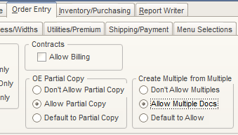

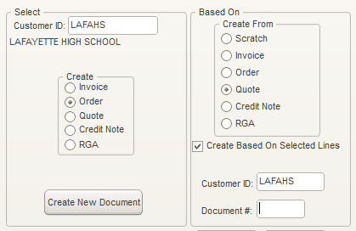
To create multiple documents first select a customer to create the documents for, select the document type you wish to create, select a type to create the documents from, enter a customer ID to select the original documents from, double click in the Document # field to display available documents of that type, and select the first document you wish to copy from. Be sure to check the Create Based On Selected Lines option if it is not already checked. Then click Create New Document.

The next screen will be for the partial line copy. This screen allows you to specify which line items and in what quantities you want copied to the new document. Use the buttons to the right to toggle selections and quantities or just make entries for the individual lines in the white Qty and Copy Line columns. When done click the Add Another Quote button. If you like you can select each of the quotes first and then set the Qty and Copy Line values for all items.

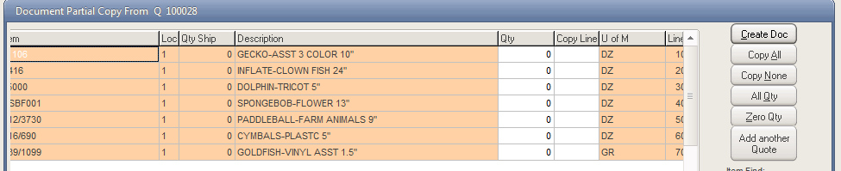
After clicking Add Another Quote you are prompted to select another quote from the customer listing.
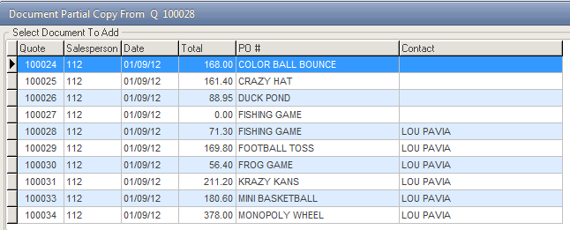

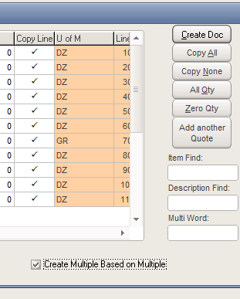
The partial copy screen will now display the added items from the second quote. Continue this process until you have all quotes added to the partial line screen and have set the Qty and Copy Line values for each line item. Note that you will also be able to change quantities and make other adjustments to line items on the newly created orders. If you do not copy a line item you will have to add it to the order manually once you create it. When ready click the Create Doc button. If the Create Multiple Based on Multiple option is checked then a new order will be created for each quote selected, with each order containing only the items copied from a corresponding quote. If it is not checked then only one order will be created containing all of the line items copied.

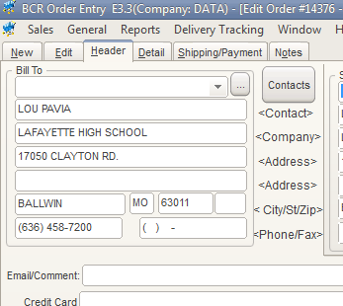
After clicking Create Doc you will be taken to the Header tab for the last order created.

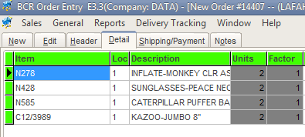
On the Detail tab you will find the items copied from the last quote selected.
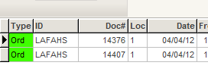
To view or edit the other orders created go to the Edit tab and, if necessary, use filters to locate the newly created orders.

