BCR Kits and Bills Of Materials

BCR’s kit and bill of materials (BOM) functions can be used in a variety of ways to manage item combinations to form other, more complex items in inventory and sales. But the two functions are different in key ways and those differences will determine which function best suits your need.
The primary difference is that a kit is a collection of items in your inventory packaged as one item, whereas a BOM is something built of items from your inventory into a new item.
Kits are items that only exist as a byproduct of their components. When a kit is entered on a sales order the system looks at the quantity status of the items assigned to the kit and maintains their statuses as individual items. The kit does not exist as a real item in inventory and there is no function that assembles the kit. Kits are assumed to be in house products and kits cannot be placed on purchase orders. The purchase of their components in sufficient quantities, in effect, purchases the kits. The sales history of a kit is posted to its components. Kits have a variety of options as to how they are displayed and priced in sales orders.
A BOM item is a distinct item. When it is sold there must either be assembled quantities of that item already on hand or they will have to be assembled from available quantities of the component items. Once a BOM is assembled the quantities of its components used are no longer in the inventory. They are “used up” in the assembly process and the BOM is created. BOMs can also be purchased as items from a vendor and received into inventory. When they are purchased their component items are not affected. The sales order description, pricing, and costing of a BOM is strictly a function of the BOM item and not its components. The sales history of a BOM is posted to the BOM item and not its components.
Examples of kits and BOMs might be a fruit basket and fruit salad. If the fruit basket kit item consists of a basket, a pineapple, five pears, four apples, and three oranges and you have those quantities of those individual items available for sale then you have a fruit basket kit item available for sale as well. If you sell a fruit basket kit item then the system knows to deduct those quantities of those items from inventory. It does not deduct a quantity from the fruit basket kit item because the fruit basket only exists as a function of those individual items.
If, on the other hand, you sell an item that is a BOM container of fruit salad, then you must either have a container of fruit salad already made up ready for sale or you must assemble one, by taking a container and the required quantities of fruit out of inventory, and making the salad. Once the salad is made the items in it are no longer available for sale as individual items.
Both kits and BOMs can be “nested” (one kit or BOM as a component of another) and both can be set to allow them to be modified “on-the-fly” in the order entry process. Both can contain intangible items such as a labor charge. Both can be composed of a single component item, enabling the sale of one item as another.
Whether you chose to setup a kit or BOM will really depend on which best suits the business requirement.

Kits
A kit consists of a kit "item" and the component items contained in it. Before a kit item is created the kit item components must be items already in the item file. Kits are then created using the Admin/Edit/Edit Kits screen. Note: You cannot create a kit as an item in Edit Items first and then add components. Once created in Edit Kits, a kit can then be maintained in Edit Items if the Systems Defaults/IP/Item Master "Show Kits in Lookup" option is checked. Otherwise the kit will not be listed among items there and cannot be maintained as an item. Depending on the kit type it may be necessary to allow the kit to be maintained as an item so that its pricing and costing can be managed. This setting applies to all kits in the system.
Kits cannot be entered on purchase orders. It's assumed that a kit only exists as a function of its components. If a kit consists of one each of two items and you have at least one of each of those items on hand then you have at least one kit available. If not, then you cannot have a kit available.
Kits can function in a variety of ways depending on the Kit Type assigned. There are four kit types (two more are not currently supported.)
Kit Type 1 Non-Template: When entered on a sales order, only the kit description is displayed, not its components. The kit price is determined at the kit item level. In order to maintain the pricing of the kit item, kits must be listed in item lookup. Revenues are posted to the account assigned to the kit but the cost of goods are posted to its components.
Kit Type 2 Template: When entered on a sales order, only the kit components are displayed. This type of kit is ideal for adding a number of items (components) to a sales order with the entry of just one kit item number. The user can then remove components or change the individual component quantities. Only the component revenue and cost of goods accounts are used. Pricing is determined by the components and not the kit item. If all kits are this kit type then lookup of kits in Edit Items should probably not be allowed so that users will not mistakenly set prices for them.
Kit Type 5 Ship Components: On a sales order, both the kit and its components are displayed. Typically the kit description might end with "consisting of", so that the component listing that follows does not confuse the user or the customer. Type 5 kit and component lines will display in a different color from other items on the order. The quantities of the components are allocated but the price is determined by the kit item and only that price is extended. Changes to the kit components of any kind will not affect the price of the kit charged. In order to maintain the pricing of the kit item, kits must be listed in item lookup. Revenues are posted to the kit but the cost of goods is posted to the components' accounts.
Kit Type 6 Ship Components/Update Price: The only difference between this type and type 5 is that the price of the kit is strictly a function of its components, rather than the kit item. So even though the kit item may have a price set as $12, if the kit consists of a $3 and two $4 components, then the price will be $11. So the kit item should probably not have a price so that it will not confuse users. If any of the components are changed or the quantities or prices of components changed on the order, then the price of the kit item is changed accordingly on the order. If all kits are this kit type then lookup of kits in Edit Items should probably not be allowed so that users will not mistakenly set prices for them. Type 6 kit and component lines will display in a different color from other items on the order.
Kit Type (3) and Kit Type (4) Component w/Auto BOM are not currently supported.
In the following example screens each of the four kit types have been created consisting of two components, one with a quantity of 1 and the other a quantity of 2. The kit item price is $12 and cost is $6 and the kit component prices of $3 (cost $1.50) and $4 (cost $2.50) are the same for all four,
With the kit type 1 (above) only the kit description is shown. The price is the kit price. Note that the cost is the total of the components.
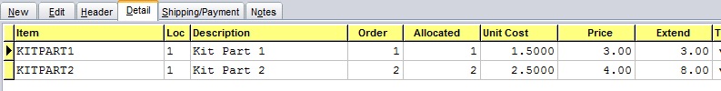
With kit type 2 only the components are shown. At this point they are just items on an order and they can be changed in any way, just as though they had been entered on the order one at a time. The prices and costs are those of the component items.
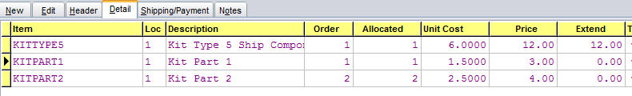
Kit type 5 shows both the kit and its components. The price and cost are taken from the kit and any change to the component pricing or quantity will not affect them.
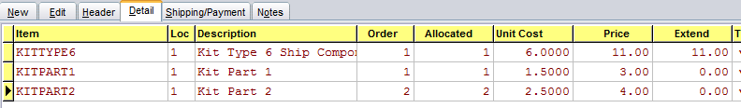
With kit type 6 automatically changes the price to the total of the components and if any of the component prices or quantities are changed on the order the price of the kit is changed.

Kit Setup
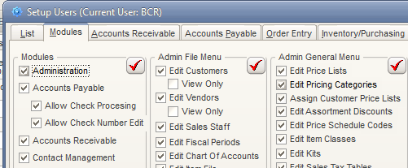
In order to create kits a user must have access to Edit Kits in Admin.
If kit types 1 or 5 are used for any kits, the kit will price based on the kit item rather than the components. In that case you will need to be able to access kit items in item maintenance. The "Show Kits in Lookup" must be set in System Defaults to allow this.
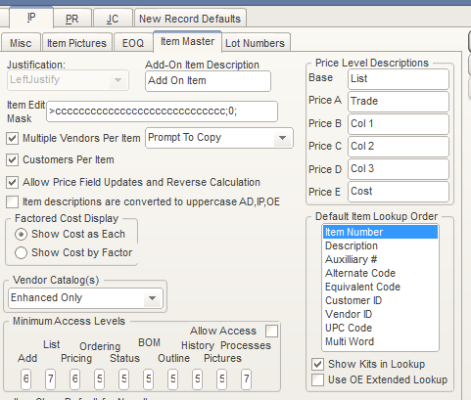

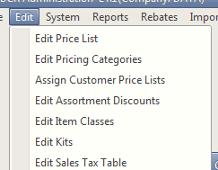
Kits are created in Edit Kits on the Edit menu of the Admin module.
To create a kit simply click Add on the list tab and on the Edit tab enter a Kit (item) Number and Description. If you select a Kit Type of (5) or (6) you will probably want the description to end in "consisting of" or "containing." Select a Kit Type and then click in the component grid to add existing items as components and the quantity required of each component. You can use the Copy Components From Kit tool to select another kit to copy its components into the new kit, and then make changes as needed. Use the Sort order to view the components in the order they were entered or in item number order.
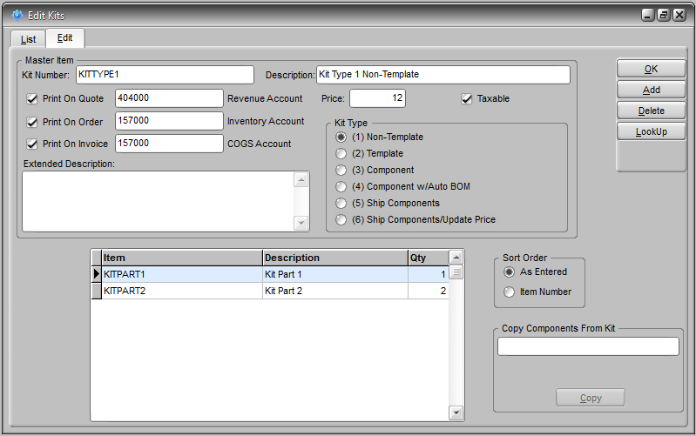
The shaded fields are mirrored in the kit item in item maintenance. They can be maintained here or in Edit Items if Show Kits in Lookup is turned on. The Price field only reflects the BCR base price level. Prices should typically be maintained in Edit Items for kits that are type (1) or (5).

Bills of Material
A bill of materials (BOM) item is just like any other item in the item file. The sales of a BOM item are posted to the BOM item’s sales history. A BOM item can be purchased and its pricing and costing is the same as any other item. The only difference between a BOM and any other item is that you can create a BOM from within your inventory. Unlike kits however, just having the components available does not automatically mean you have the BOM available. A BOM must first be "built", though depending on the setup of the BOM you could build it at the same time you enter it on a sales order, assuming there are sufficient quantities of the components available. And, depending on the setup, you can change the components of a BOM during the build process. If BOM quantities are not built at the time they are entered on the order then they are built as a separate process in the Inventory/Purchasing module.

BOM Setup

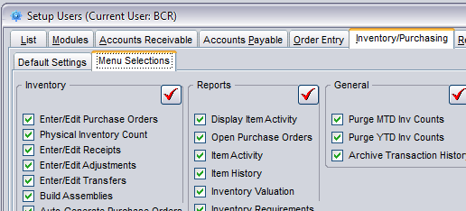
In order to build BOMs outside of order entry a user must have access to Build Assemblies in Inventory/ Purchasing on Menu Selections in Setup Users.
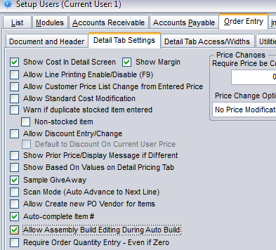
Users may also need the BOM editing option on the Order Entry> Detail Tab Settings tab in Setup Users so that they can change components of BOMs from within the order entry build process.

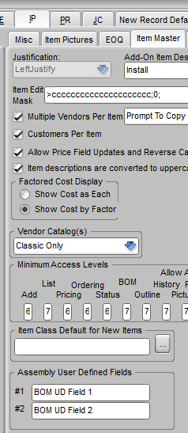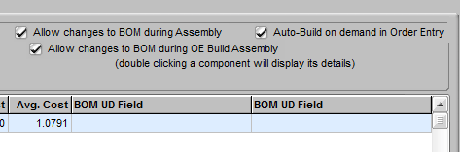
There are two user defined fields that can be setup for BOM screens. These fields are unique to each component of a BOM and can contain different data for the same component assigned to a different BOM. The UD fields only appear if labels are assigned them in Systems Defaults>IP on the Item Master tab under Assembly User Defined Fields. If they have been assigned labels. BOM UD fields are displayed on the BOM tab in Edit Items.

Bom Creation
To create a BOM, first create an item as you would any other in Edit Items. On the BOM tab add components and the quatities required for each. After a component is entered you can double click it to see its quantities (on hand, on PO, on sales order, etc.) status in each warehouse in a popup screen.
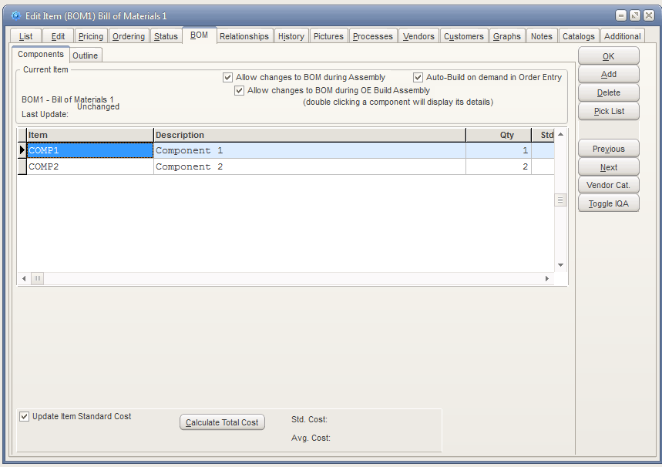
You can click the Calculate Total Cost button to see the total standard and average cost of the component quantities on the BOM. If you select the Update Item Standard Cost option and then click the Calculate Total Cost button, the standard cost (on the Ordering tab) of the BOM item will be changed to equal the total costs.
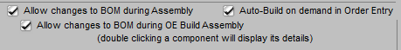
The BOM can be set to allow changes to it in the build process. If the BOM components never change then this option should not be checked. If the build on demand option is checked then the item can be built immediately in OE rather than in the separate build process in Inventory/Purchasing. If the option to build in OE and the option to allow changes in the build are both checked then the option to allow changes during OE build can be checked. This option only appears after the option to allow changes in the build is checked.
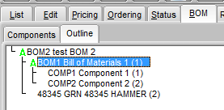
The Outline tab is useful when a BOM contains other BOMs nested as components. The green icon indicates that a component is a BOM, and its components are listed beneath it in tree directory layout (double click to expand/collapse the tree.) The quantity required of the component is shown in parentheses.

Building BOMs
BOMs must be built or purchased before they appear as on hand quantities and can be allocated on sales orders. They can be built beforehand using the Build Assemblies process in Inventory/Purchasing, or they can be built directly from order entry as needed. In either case sufficient quantities of the components must first be on hand. The on hand quantities of components will be reduced when a BOM is built.
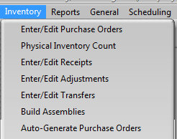
To build BOM quantities as a process independent of order entry use the Build Assemblies program on the Inventory/Purchasing Inventory menu.
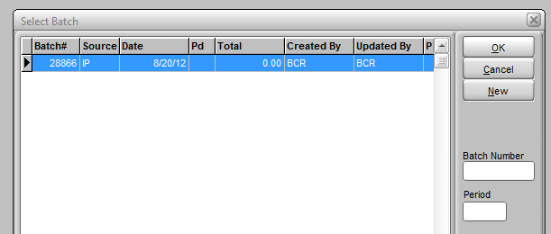
Select and existing unposted assembly batch and click OK, or click New to create a new batch.

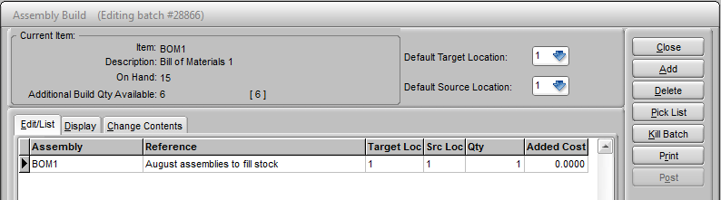
Any number of BOMs can be created in one build batch. To create a build add a BOM item (to the Edit/List tab, enter the Target Loc (warehouse) where you want the quantities of the BOMs added after the build, and the Src Loc (warehouse) from which you want to draw component quantities. Enter the Qty (quantity) of BOMs that you wish to build. Remember that there must be sufficient quantities of the components available to complete the build of the BOMs. You can enter an amount in Added Cost to be added to the total cost of the BOM. This cost is specific to this build and does not update the standard cost of the BOM. It applies to the build of the total quantities and is distributed among them to update the most recent BOM item cost. If $5 is entered and a quantity of 5 BOMs is built then $1 is added to the MR cost of the BOM.

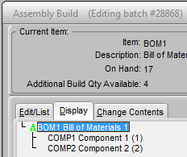
The Display tab is comparable to the Outline tab in Edit Items.
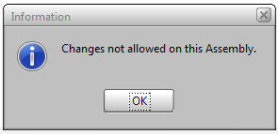
The Change Contents tab is only functional if the BOM has the "Allow changes to BOM during assembly" option checked on the BOM tab in Edit Items.

If assembly edit are allowed for this BOM then you can access the Change Contents tab. From this tab you can change the quantities of components required or the components themselves.
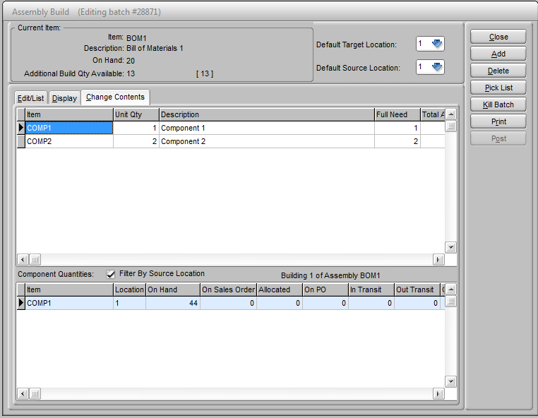
Once the batch is ready Print (or view) the assembly log and then Post the batch. This will reduce the quantities on hand of the components and increase the on hand of the BOMs.
If the "Auto-build on demand in order entry" option is checked for a BOM in Edit Items, then you can build BOMs directly from the Detail tab in order entry.
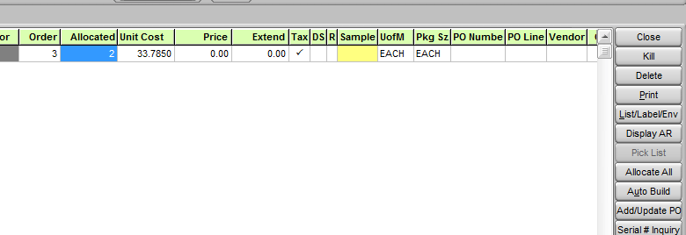

If you have entered a BOM with an order quantity greater than the available quantity, and if there are sufficient quantities of the components available, Clicking the Auto Build button will build a quantity of BOMs equal to the backordered quantity. No assemblies batch is created or needs to be posted.
If the BOM item has the "Allow changes to BOM during OE build assembly" option turned on then at the time you click the Auto Build button the Change Contents screen (from Build Assemblies above) will be displayed and you will be able to modify the BOM components if necessary.

