Item Catalogs

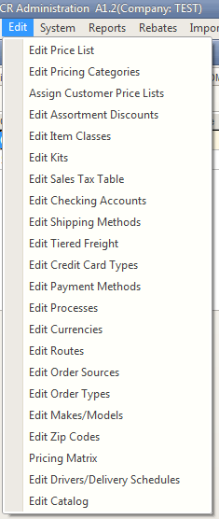

Items can be tied to catalogs and catalog pages. Catalogs must first be defined on the Edit Catalog screen at the bottom of the Edit menu in the Administration module.

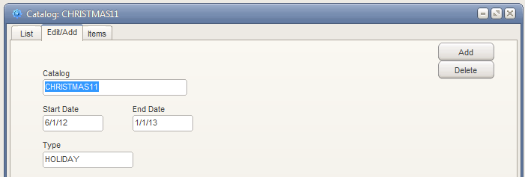

New catalogs can be added from the Edit/Add tab of this screen. Start and End Dates and the Type of the catalog can be defined from this screen.

Once a catalog is added is will be available to select on the List tab.

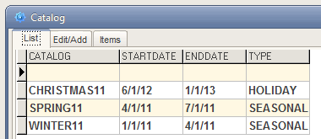

When selected the Items tab can be used to add and maintain items tied to the catalog. Click on the Add button to display the item pick list and select items. Then enter the Page # for the item.

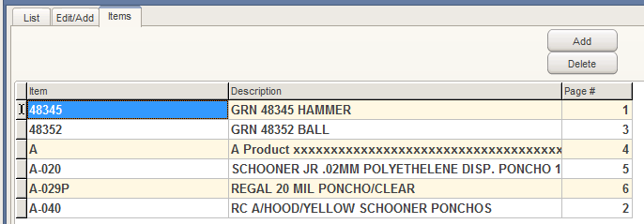

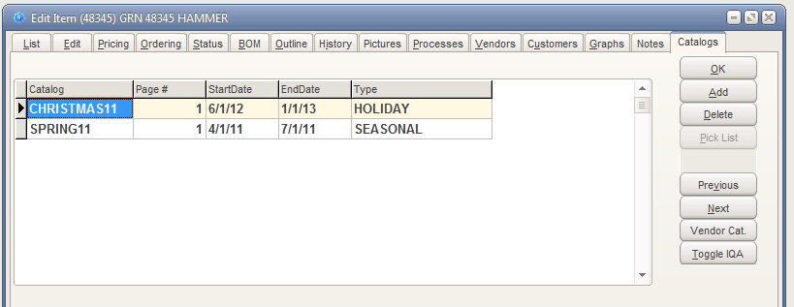

Items added to catalogs will list those catalogs on the Edit Items Catalogs tab. An item can also be added to a catalog from this grid by clicking the Add button and selecting from the catalog pick list. Then the Page # can be entered on the grid cell for that catalog.