Inventory transfers

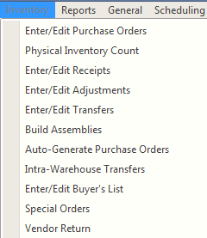

To create a transfer batch click the New button of the batch list screen. If the new transfer cannot be completed and posted in one session, you can return to the batch later by selecting it from this screen. A transfer batch will remain in the list until it is posted or killed.

BCR inventory transfers can be created manually or they can be generated automatically based on inventory replenishment parameters using the Inventory Requirements Report. The setup required to auto-generate transfers is covered later in this document.

The Enter/Edit Transfers screen, on the Inventory menu in Inventory / Purchasing is used to move inventory from one warehouse location to another. Warehouses may be traditional physical warehouses located miles from each other or they could be virtual warehouses that exist only in the system memory.

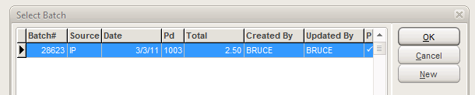

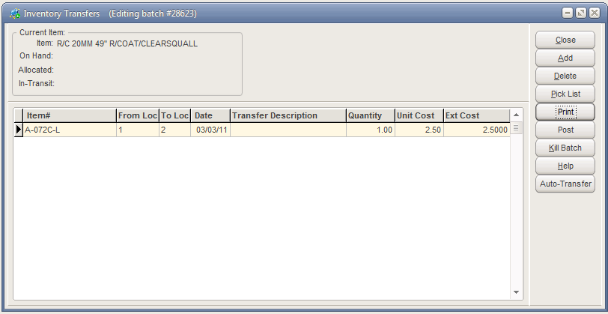

Enter an item number or use the Pick List (or double click in the field) to enter an item. Then enter the warehouse location to transfer from and the location to transfer to and adjust the date if needed.

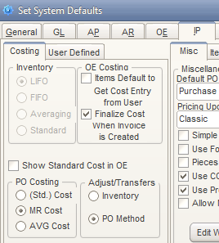

The Unit Cost will automatically fill with a cost determined by settings in System Defaults on the IP > Costing tab. If Adjust/Transfers is set to Inventory then the setting for Inventory Costing will be used. I.E., if it is LIFO then the most recent receipt cost is used. If it is FIFO then the oldest receipt cost is used. If it is Averaging or Standard then the corresponding item cost is used. If Adjust/Transfers is set to PO Method, then the setting for PO Costing (Std, MR or AVG) determines the item cost used.

You can also enter a unique cost by entering an amount in the Ext Cost field. The system will automatically calculate the new Unit Cost from the Quantity and the Ext Cost.



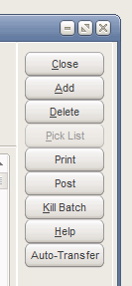

A transfer can be saved by clicking close and then reopened as a batch later. If the transfer is not to be posted then it should be deleted by clicking Kill Batch (the Delete button only deletes the current line item.)

The next step in the transfer process depends on your business operation. If the transfer requires a real physical process of picking goods, loading a truck, time in transit, and unloading and shelving those goods, then a two-step transfer process is probably warranted. The Auto-Transfer button will update the item quantity status for the two location. The Transfer Out and Transfer In quantities will be increased and the Available quantity of the transfer from location will be reduced.

The Auto-Transfer can be performed at any point regardless of the GL Auto-Post setting.

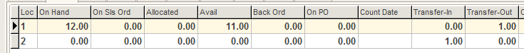

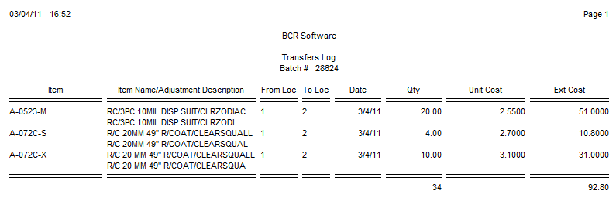

If Auto-posting is not checked for Transfers in System Defaults on the GL tab, it will be necessary to at least View the Transfers Log by clicking the Print button before you will be able to Post the transfer. If Auto-post is checked then the printing is optional.

The transfer log can be used as a transfer document for shipping and receiving.

 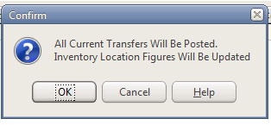

In order for a transfer to be received in the “To” location it must finally be posted. This will clear quantities from transfer out and transfer in and update the on hands of both locations and increase the available of the receiving location.

Posted transfers can be viewed in various places in the system including the Status tab of the Enter/Edit Item screen. The transfer is signified by a “T” and the batch number is listed as the GL Batch.

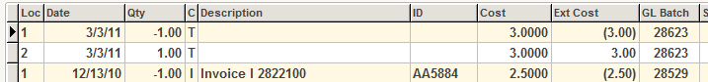

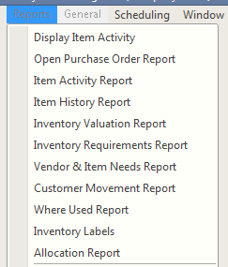

As noted at the beginning of this document, transfers can be created automatically using the Inventory Requirements Report on the Reports menu of Inventory/Purchasing. This functionality assumes that you are using min/max item level parameters and replenishment locations.

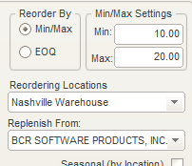

This means that items at the receiving location must have a Min and Max set for any items that are eligible to be transferred and must have a Replenish From location other than itself. Typically the supply location will also have Min and Max set as well.

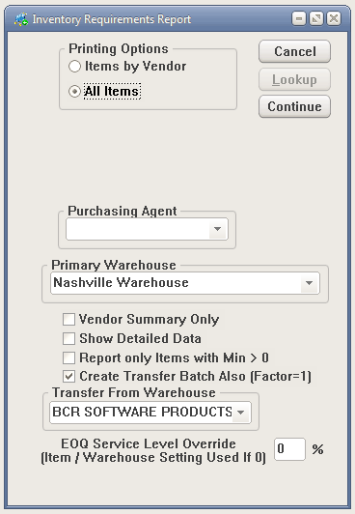

In order to generate transfers from the Inventory Requirements Report check the Create Transfer Batch option. Set the receiving location as the Primary Warehouse and set the shipping (replenishment) location as the Transfer From Warehouse. You can choose to run the process for All Items or Items by Vendor assigned to items.

Click Continue to start the process.

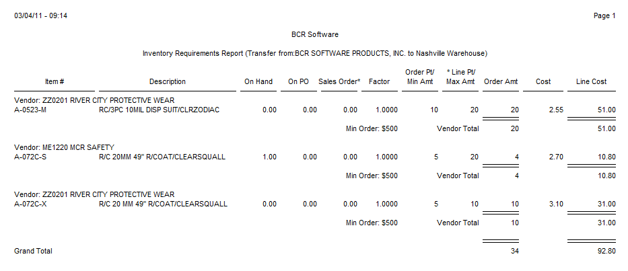

The process generates a report of all items that have available quantities in the replenishment location and have less than their max in the receiving location. It will suggest that the replenishment available be shipped to fill up to the receiver location’s Max. Note that other System Default settings may affect this logic.

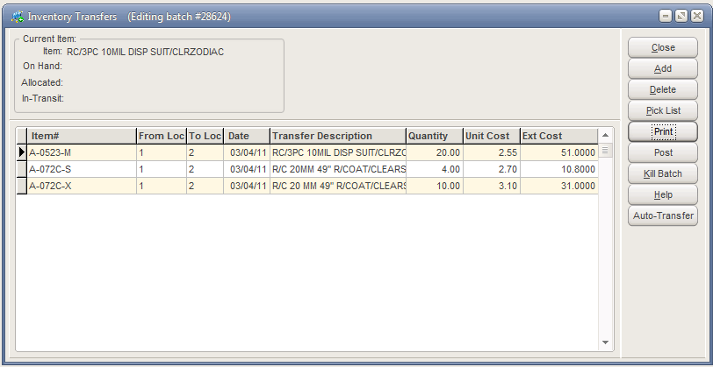

The process also generates a transfer for the items on the report. The transfer is created with the auto-transfer step already completed, so the available, transfer out and in quantities are already updated. The transfer can be printed and posted or killed, which will reverse the auto-transfer.