Inventory Adjustments

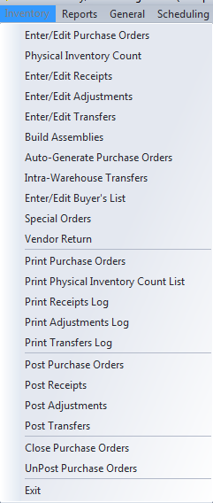

The Enter/Edit Adjustments screen, on the Inventory menu in Inventory / Purchasing is used to adjust the inventory on hand quantity of items when there is no other appropriate transaction that will affect the quantity. Typically adjustments are used when a discrepancy is found between the on hand quantity in BCR and the actual physical quantity of the item in inventory. This may have been caused by such things as an earlier physical count error, pilferage or damage. Adjustments can also be used to move quantities between warehouses but the Enter/Edit Transfers screen would usually be used for that. Adjustments should not be used in lieu of business transactions such as sales or purchases.

To create an adjustment batch click the New button of the batch list screen. If the new adjustment cannot be completed and posted in one session, you can return to the batch later by selecting it from this screen. An adjustment batch will remain in the list until it is posted or killed.

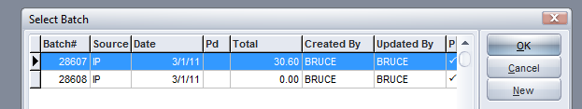

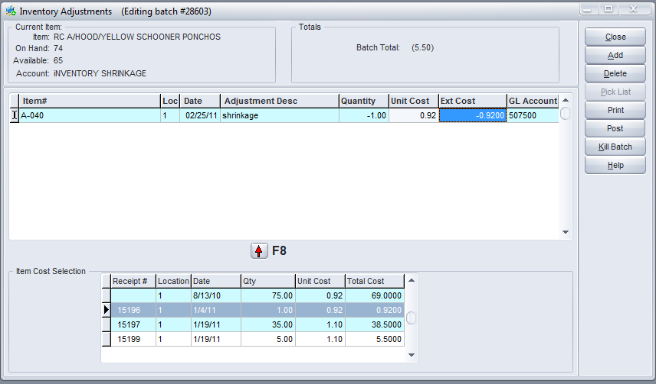

Usually adjustments are made to a limited number of items. When adjustments are required for a large number of items it probably is the result of a physical inventory. The Physical Inventory Count can be used to gather and update large numbers of items and automatically create the adjustments required.

Enter an item number or use the Pick List (or double click in the field) to enter an item. Then enter the warehouse location and adjust the date if needed. If the date of the adjustment is outside of the current accounting period then you will need to enter that period when you post the batch.



Enter a negative quantity to reduce the on hand and a positive to increase it.

A negative quantity for one location and a positive to another will result in a warehouse transfer but care should be taken to post to the proper GL Account. Normally warehouse transfers should be done using the Enter/Edit Transfer screen.

Entering the same item twice, once with a negative and once with a positive quantity, for the same location but with different Unit (or Ext) Costs, is sometimes done to correct an over or under stated inventory GL account.

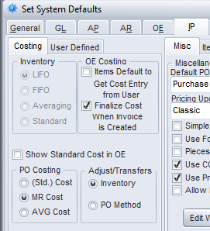

The Unit Cost will automatically fill with a cost determined by settings in System Defaults on the IP > Costing tab. If Adjust/Transfers is set to Inventory then the setting for Inventory Costing will be used. I.E., if it is LIFO then the most recent receipt cost is used. If it is FIFO then the oldest receipt cost is used. If it is Averaging or Standard then the corresponding item cost is used. If Adjust/Transfers is set to PO Method, then the setting for PO Costing (Std, MR or AVG) determines the item cost used.



Selecting any of the receipts in the grid and clicking the red arrow button or pressing F8 will automatically fill the quantity with a negative of that received quantity and the cost on that receipt. Reversing or correcting receipts in this manner should only be done when a receipt has already been paid.

You can also enter a unique cost by entering an amount in the Ext Cost field. The system will automatically calculate the new Unit Cost from the Quantity and the Ext Cost. Be careful to enter a negative Ext Cost if the Quantity is negative.



The GL Account field is automatically filled with the default Inventory Shrinkage account found on the System Defaults > IP > Costing tab. It can be overridden if necessary.

If Auto-posting is not checked for Adjustments in System Defaults on the GL tab, it will be necessary to at least View the Adjustments Log by clicking the Print button before you will be able to Post the adjustment. If Auto-post is checked then the printing is optional.

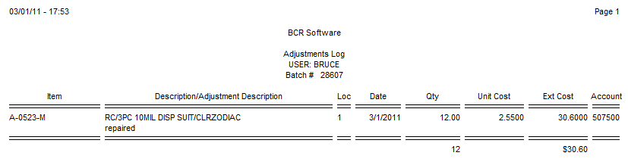



An adjustment entry can be saved by clicking close and then reopened as a batch later. If the adjustment is not to be posted then it should be deleted by clicking Kill Batch (the Delete button only deletes the current line item.) For an adjustment to actually update the item on hands and the GL, you must click the Post button.

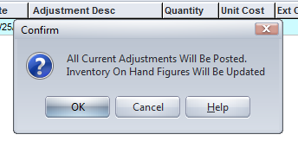

Posted adjustments can be viewed in various places in the system including the Status tab of the Enter/Edit Item screen. The adjustment is signified by an “A” and the batch number is listed as the GL Batch.

