Import Excel
The Import Excel program, found on the Administration System menu, allows you to use an Excel spreadsheet to update records or insert new records to your BCR Titan data. (NOTE: This program does not work with older BDE .dbf files.) Additionally other fields can be updated that are not contained in the spreadsheet. Once an import is setup it can be saved as a template for future imports. If a vendor regularly sends you product updates in a consistent spreadsheet format then this program can make updates extremely simple once the first update is setup. Obviously this is a very powerful program and it should only be used by authorized personnel after training. If you have not used this program in the past or have any questions at all about it, you should contact BCR support.
While the screens of the program may appear complex, its use is actually fairly simple and straight forward. Before you begin the setup you will need an Excel spreadsheet to import from. The core requirement of any spreadsheet is that it contain a column of data that matches data in an existing Titan table or is intended as the ID of new records to be created. Typically this would be the ID of records in that table, such as the item or customer ID. If the spreadsheet is updating existing table records, the ID column data in the spreadsheet must match the ID data in the table exactly, so if there are leading zeros, prefixes, suffixes, or punctuation in one they must be in the other or the program will not be able to match them together.
Before opening the Import Excel program save your spreadsheet in the IMPORT\EXCEL folder of your data folder to make it easy to locate.
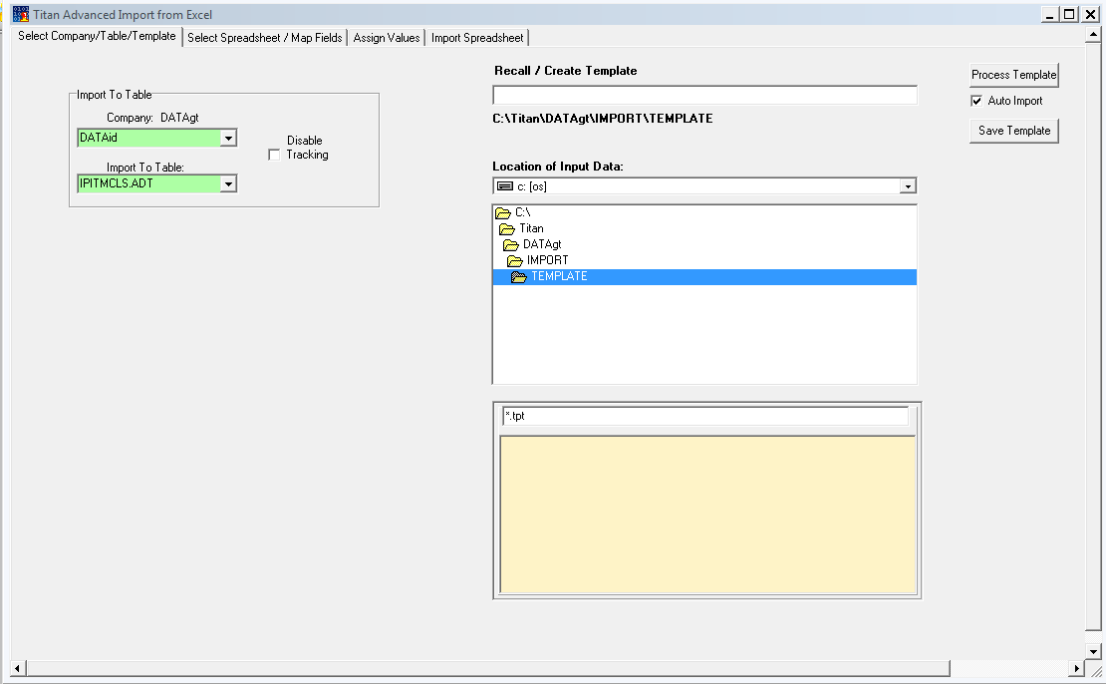
The first step to importing data is to select the BCR Titan table that you want to import to. Using the dropdown select a data table. Typically this might be ITEM.ADT for item data or CUST.ADT for customer data. Contact BCR support if you need assistance identifying the right table.

Next click the Select Spreadsheet tab and double click your spreadsheet in the yellow box. Then click the Get Fields in the upper right corner to populate the Spreadsheet Fields Map and the Import Table Fields. The Spreadsheet Fields should match your column headings (row 1) from the spreadsheet. The Import Table Fields will be all of the fields in the selected table. Click on a field to see field documentation.

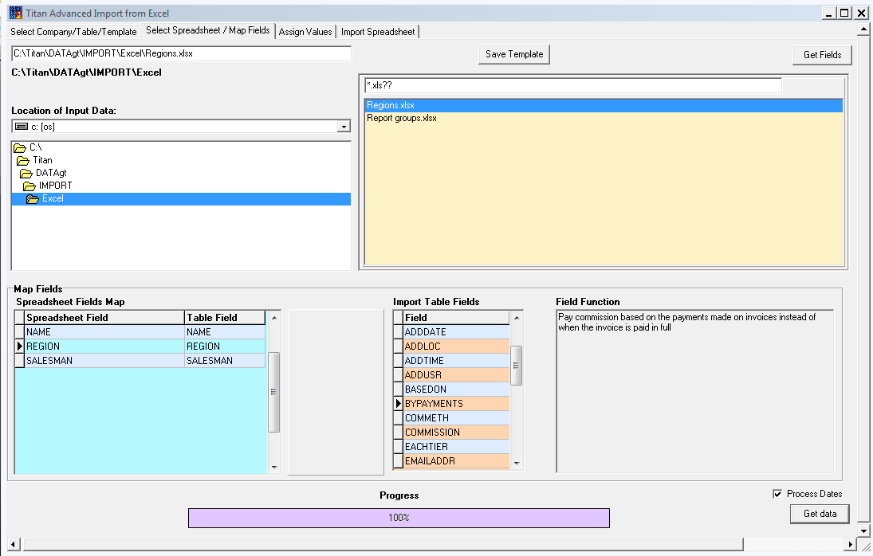

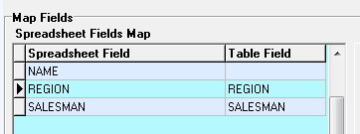
If there are columns in your spreadsheet that you do not wish to update you must double click the table field to blank them before you move to the next tab.

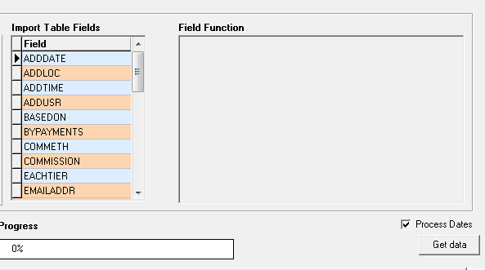
When you’re satisfied that you have the right spreadsheet and table and that you have eliminated any spreadsheet columns you don’t wish to update then click Get Data to retrieve the table data and move to the next tab.

The next tab will allow you to assign values beyond those contained in your spreadsheet. In imports where you are updating data in existing records this will probably not be necessary because you are only changing specific fields. In that case you can simply move to the Import Spreadsheet tab. But if you are importing new records you can add data to fields that are not on your spreadsheet, either from BCR default values, or values you wish to assign fields, collectively or to individual records, effectively making the grid at the bottom of the tab an edit tool for your spreadsheet. The BCR default values are shown for the fields not already referenced by your spreadsheet when you access the tab. You can change them or enter values in other fields as needed. If you click Entered Defaults only the values you’ve entered will fill the grid below. If you click BCR Defaults both the prefilled defaults and any values you’ve entered will fill the grid. The values in the grid are the values that will update records imported.

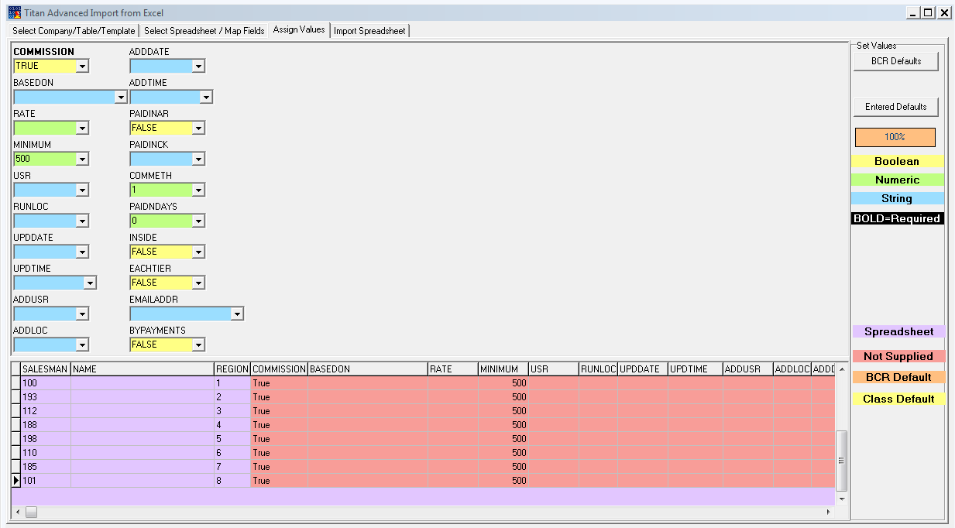
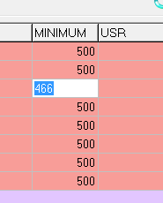
You can also simply double click on any cell in the grid and enter a value specific to that record.

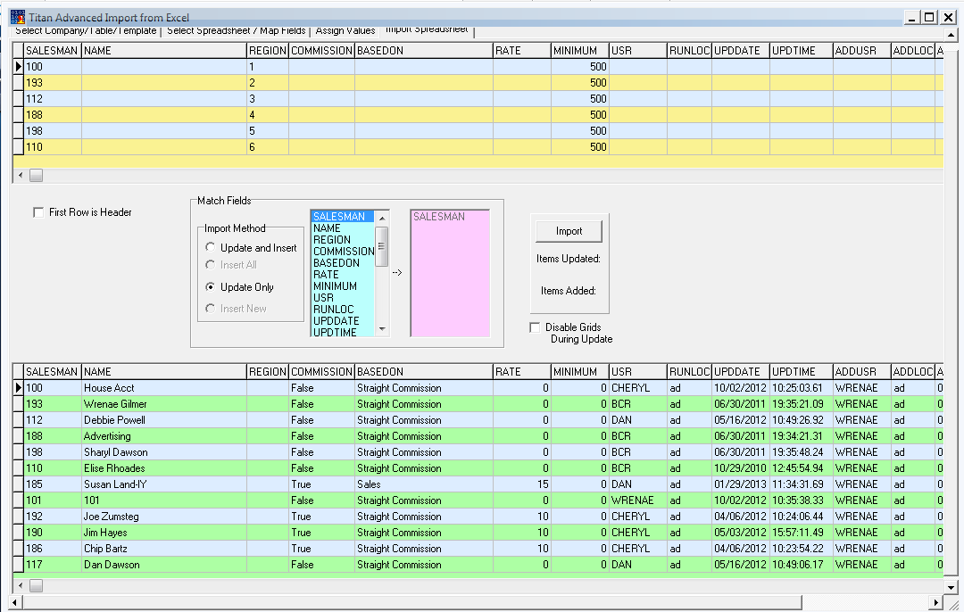
Next click on the field that you will be matching records to from the spreadsheet. This is usually the ID field for the table. Click the arrow to designate that field in the pink box on the right. If you have selected any import method that includes insert then any rows from the spreadsheet that are not matched in the table using this field will be inserted as new records in the table. If you think you might have mismatches between the spreadsheet and the table then do not select any method that includes insert.
Finally click the Import button to complete the data import. The upper grid will clear and the lower grid will reflect your imported data.
Once you have values assigned you can click the Import Spreadsheet tab. The Import Method should match whether you want to update existing records or insert new records or both. Insert All will create new records for all rows of the spreadsheet regardless of existing records.

Setting Up Import Templates
If your import is one that might be repeated in the future then you will probably want to save it as a template. After you have completed your import, but before you exit the program, return to the Select Company/Table/Template tab.
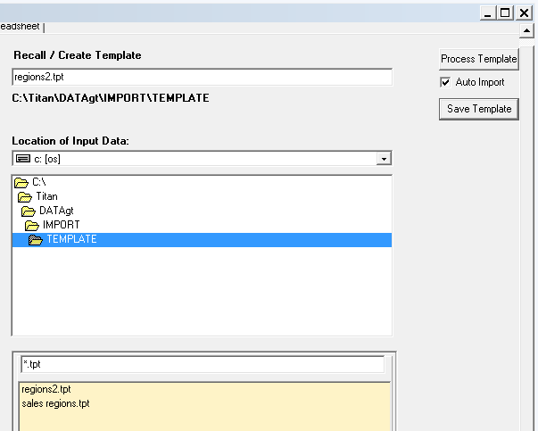
Enter a name for the template and click Save Template. When you return to the program double click the template in the listing at the bottom. Make changes as needed on the other tabs before clicking Import on the last tab or just click Process Template if no changes are necessary to immediately perform the Import.

