General Ledger

The BCR Titan general ledger (GL) is fed by the batches created through the various transaction processes in the software. With the typical Auto-Posting setup in System Defaults>GL (all boxes checked), transaction processing (posting) creates a journal entry directly to the GL. Batches are created by the transaction processing and then the batches automatically posted to the GL. Sources for GL batch journal entries are:
- accounts payable (AP), which includes vendor invoices, payables checks, vendor debits, and vendor credits
- accounts receivables (AR), which includes customer invoices (depending on settings) and cash receipts
- inventory/purchasing (IP), which includes stock PO receipts, inventory adjustments, and warehouse transfers
- order entry (OE), which includes invoices and cash receipts at point of sales (depending on settings)
- general ledger (GL), which would include manual journal entries and closing adjustments
- and payroll (PR) and fixed assets (FA) if these modules are used.
Batches are not summarized as totaled entries to the GL accounts. Instead, all individual transactions within a batch are posted as individual entries to the GL. For example, a single invoice would typically be listed in the GL as postings to the inventory, COGS, sales and AR accounts. NOTE: The Summarize GL option on the System Defaults>OE>Printing/Posting tab will cause individual invoices to be totaled and summary postings created in the GL batch instead. Many users prefer this setting because it reduces the volume of postings in the GL.

GL Setup
There are a few setups that are required for the GL to function according to your company’s needs:
- Setup the account number structure
- If needed, create entities and cost centers
- Create the chart of accounts
- Set system defaults for the GL and GL account defaults
- Setup fiscal periods

Setup Account Structure
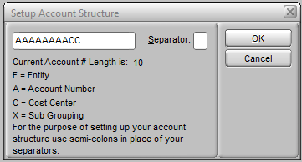
The setup of the account structure determines some of the facets of GL reports. The account structure is typically setup by BCR support as part of your software implementation. Once it is setup it should only be changed under the direction of your company accountant in consultation with BCR support. The setup consists of a string of “A”s (account number), ” X”s (sub-account number), “E”s (entity number), and “C”s (cost center number). The different designations must be separated by semicolons (;), and a punctuation character is designated to be used in the actual account number wherever there is a semicolon. For example, a setup of AAAAA;XXX with a separator of “.” would interpret 10300040 as 10300.040 where 10300 was the account number and 040 the sub-account. CC;AAAA;XX with a separator of “-“ would produce 10-3000-40, meaning cost center 10, account 3000, and sub-account 40.
Contact BCR support for additional advice and assistance in the setup and application of entities and cost centers in your GL setup.

Edit Cost Center Descriptions
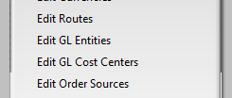
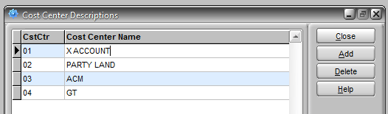
The Edit Cost Center Descriptions program only appears on the GL>General menu if your account structure contains a “C”. Contact BCR support for additional advice and assistance in the setup and application of cost centers in your GL setup.

Edit Entity Descriptions
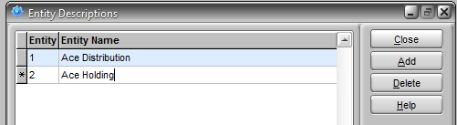
The Edit Entity Descriptions program only appears on the GL>General menu if your account structure contains a “E”. Contact BCR support for additional advice and assistance in the setup and application of entities in your GL setup.

System Defaults
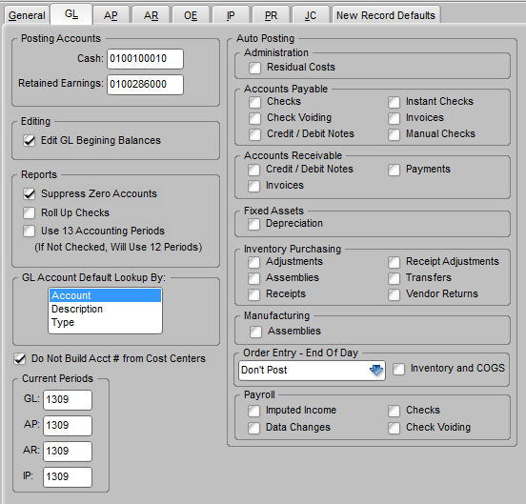
In addition to certain settings in System Defaults that determine aspects of the GL, there are a number of GL accounts that must be assigned as default accounts for specific processes in Titan. Even if you don’t plan to use a particular function or module you still must enter a valid GL account. You can use an account designated as miscellaneous or some similar category if you wish. The program will not let you exit without a valid account number in a field once you click on it. You can assign the same account to more than one field. The system will highlight duplicate accounts in yellow and warn you when you exit the program that duplicates have been assigned but this is not an error and you will be allowed to exit the program.
The following fields on these tabs in System Defaults must have valid GL accounts entered:
GL
CASH
RETAINED EARNINGS

AP
ACCOUNTS PAYABLE
SALES TAX PAYABLE
AP DISCOUNTS
FREIGHT EXPENSE
COGS ADJUSTMENTS
DUTY CHARGES

AR
ACCOUNTS RECEIVABLE
A/R LATE CHARGES
A/R DISCOUNTS
REBATE CLEARING
MISC. PAYMENT

OE
GST
SALES TAX
FREIGHT
HANDLING CHARGE

IP
REVENUE
COST OF GOODS SOLD
INVENTORY
INVENTORY SHRINKAGE
AP CLEARING

PR
FIT LIABILITY
FICA LIABILITY
FICA EXPENSE
MEDICARE LIABILITY
MEDICARE EXPENSE
FUTA LIABILITY
FUTA EXPENSE
SUTA LIABILITY
SUTA EXPENSE

The System Defaults GL tab also displays the current period for the GL, AP, AR, and IP modules. These setting are mirrors of what is set in the individual modules. They can be changed here but are usually maintained from the modules themselves (see Month End Closing below.) This is especially true for the AR module because setting it from within the module does affect the content of some customer statement form layouts.

Edit Chart of Accounts
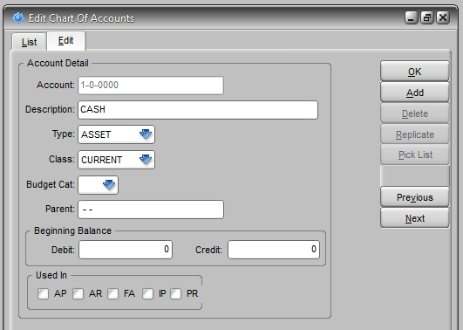
In most cases the creation of your GL chart of accounts has been done for you in the data conversion from your previous software. It may be necessary, however, to add new accounts or make changes to existing accounts on occasion. You can view or print a complete listing of your chart of accounts using the Chart of Accounts Listing on the Admin>Reports menu. The Edit Chart of Accounts program allows you to establish the Type of account (Asset, Liability, Equity, Income, Expense). Different types of accounts then allow the setting of different classes in the dropdown below it.
Type Asset – Class Current, Fixed or Other
Type Liability – Class Current, Long Term or Other
Type Income – Class Revenue or Other
Type Expense – Class Current, Operating, COGS or Other
A Budget Cat(egory) of IN(come) or EX(pense) can be set for specific income and expense accounts if desired.
If you have a chart hierarchy you can enter Parent accounts for sub-accounts. Enter the account number that is higher in the hierarchy than this account. Contact BCR support for additional information on setting up parent and sub-accounts.
Usually the Beginning Balance, Debit or Credit, of an account is set at the time of the your data conversion. Once established they can only be edited if the Edit GL Beginning Balances option is checked in System Defaults>GL. The Beginning Balances will be updated at year end if you Archive Previous Years’ Data (GL>Year End menu.)

Edit and Update Fiscal Periods
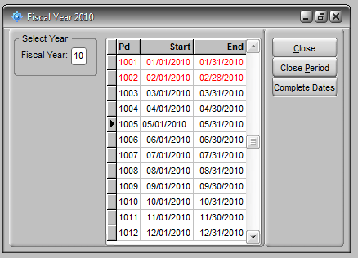
Fiscal accounting periods are usually measured in one month increments though Titan does permit thirteen accounting periods (the thirteenth typically used for annual adjustments that are not date specific.) The period is named in a year and period format, e.g., if the fiscal year is the calendar year, April of 2011 would be 1104. But if the fiscal year ended in October then 1104 would correspond to February of 2011. Period start and end dates do not necessarily have to start and end on the first and last days of the calendar months, though this is usually the easiest and because the Titan monthly closing process is so flexible, there’s no system reason not to.
The Edit Fiscal Periods program is found on the Admin>File menu. The primary function of this program is to close and open periods for posting. Click on a period that is black and the button to the right will allow you to close the period. Click on a period that is red to Open Period. You can close or open any period independently of other periods. If a period is closed no new posting can be made to it. But you can reopen any period at any time if you are authorized to do so. Obviously if this is done new financial reports must be run to reflect those postings for all subsequent periods.
Fiscal periods can be set in four Titan modules (AR, AP, IP and GL) independently. The AR and IP modules can be set at 1303 so that new invoices and PO receipts will be posted in the new month, while AP and GL can remain set to 1302 while backlogged vendor invoices are posted and miscellaneous journal entries made. This capability is discussed further in the month end closing section.
A red fiscal period indicates that the period is currently closed. A module cannot be set to a closed period.

Processing Date
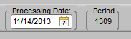
If the Toolbar (on the View menu of all modules) is turned on it will display the Processing Date and the current fiscal Period. In Titan you can change the processing date of individual modules from today’s date to any other date. This will cause transactions created within that module to be dated as of that date rather than the current date. So an inventory adjustment could be dated as of a month ago instead of the current date. This change in dating, by itself, DOES NOT change the fiscal period that the transaction will be posted to in the GL. The period that will be affected is determined by the period of the GL batch containing the adjustment. That period can be changed in the Enter/Edit Batch program in the GL module IF the period is open. If the period is closed you will not be allowed to post the batch until either the period assigned to the batch is changed or the period is reopened via Edit Fiscal Periods.

Change/Merge GL
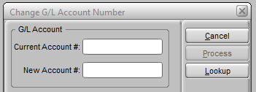
On occasion your accountant may wish to change the accounts within the GL by moving records from one account to another account. This might be to a new account or an existing account, combining records for the two accounts in one. This can be done using the Change/Merge GL program. Note that if entries are merged into another existing account that already contains other entries, it will be difficult to reverse this action, so care should be taken to only merge when you are certain that is what you want and that you are merging into the correct account.

GL Batch processing
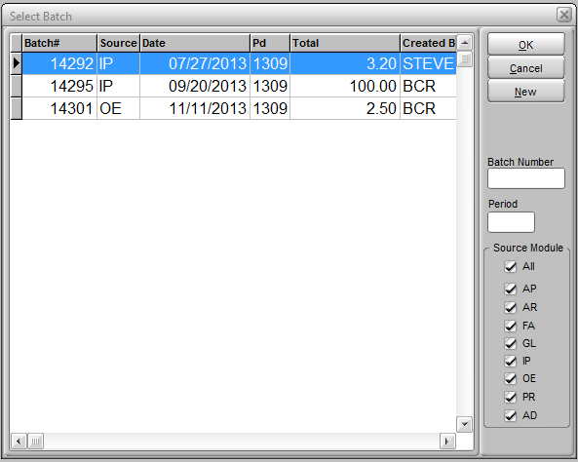
The majority of postings of transactions become batches which can be viewed and edited using the Enter/Edit Batch program on the Entry menu in the General Ledger module. For example, when a check run is posted from accounts payable, it does not post directly to GL. It creates a batch that is listed in this program. It must be posted to the GL from here before it will be reflected in the financial reports. (Note: Some transactions and certain system setups will post directly to the GL. Contact BCR support if you have questions about what your system is setup to post directly to the GL.) This program is also used to make GL journal entries that do not originate from other transactions within the system.
The period that a batch will be posted to can be overridden. This can be especially handy when you don’t wish to change the period a module is currently set to because it would interfere with other operations. Other details of the batch can be changed as well. It is very important to remember however that if a batch is related to transactions those transactions will likely have affected other related information in your system as well. For example, if you were to change the amounts in an AP sourced batch from check printing and posting, the vendor’s open payables records will not reflect this change and you would potentially be creating an imbalance between your GL and your AP ledger.
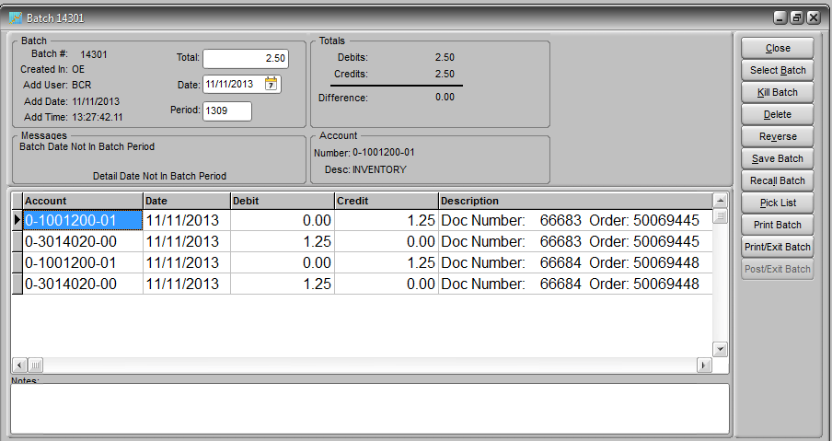
A batch can be saved and recalled later, usually as a template for a new journal entry batch. For example, there are typically entries made to specific accounts every month. The amounts of these entries may or may not be the same. Saving this batch the first time it is created, before posting it, and then recalling it the next month will save having to recreate it from scratch every month.
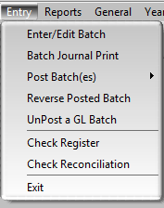
Batches must be printed or viewed before they can be finally posted to the GL. After a batch is posted it can be reversed, i.e., a batch is posted with debits and credits countering the credits and debits of the original batch. Or it can be un-posted, which simply removes the entries of the original batch from the GL and returns the batch to the batch listing.

Financial Report Preparation
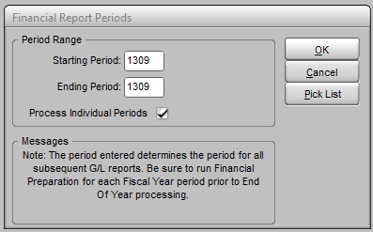
In Titan you can run financial reports for any financial period. If, for example, you reopened a fiscal period in the past and made an adjusting journal entry, you might want to rerun reports for that and subsequent periods to replace previously run reports. The financial reports that can be generated in Titan are based on a number of calculations and totals that must be completed beforehand. So in order to generate those reports you must first tell Titan which period you want to run reports for. This is done using the Financial Report Preparation program. If reports are run without first running this program they will be duplicates of reports as of the last time the program was run and may not include all subsequent GL entries. Generally then, this program should always be run before printing any of the standard financial reports on the GL>Reports menu. If you have made adjustments to a prior period then that period must be included in the period range of the program or reports run for that period or any subsequent period will not reflect the adjustments.
The Process Individual Periods option can be unchecked if you wish to run reports reflecting multiple periods as one, such as a quarterly report, with a range of three periods. Usually this option is left checked. If no adjustments have been made to earlier periods since you last ran reports then you can just set the range to the current period.

Standard GL Reports
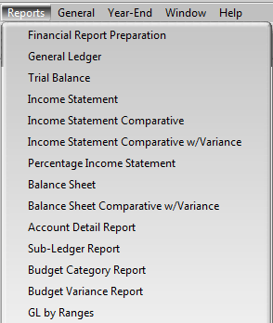
There are a number of reports on the Reports menu in the General Ledger module that are standard to accounting practices. As noted above, all of these reports are relative to the fiscal periods selected in Financial Report Preparation. This means that a Balance Sheet as of two months ago or two years ago (assuming there is financial data in Titan from that period) can be run at any time.
Custom financial reports can be created using the report writer. Usually you will need to reference the ACCT table which is only updated when you run Financial Report Preparation. Whether it is a standard report or custom, you will need to run Financial Report Preparation if the report includes periods that have had postings since the last preparation.

Show Account Activity
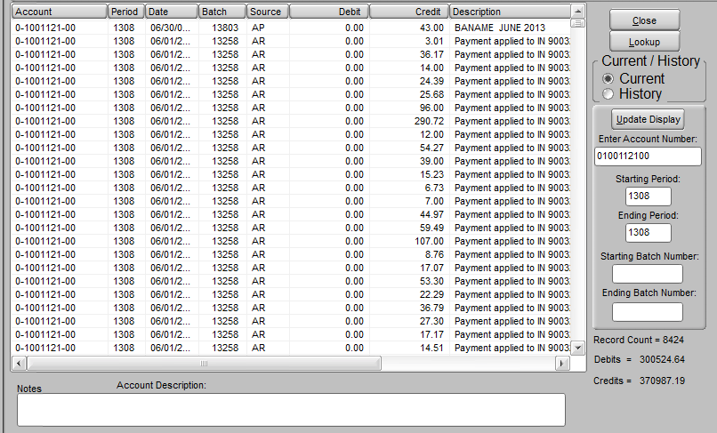
This inquiry screen permits the review of all of the transactions affecting any GL account over a given period of time. Since Titan does not post transactions to journals which are then summarized as postings to the GL and cleared, all transactions are detailed in the GL. This allows you to thoroughly audit your accounting system down to any individual transaction no matter how long ago. But this means that there are typically thousands of individual postings to major accounts like sales, purchases, cost of goods, inventory, cash in bank, AR or AP. An inquiry on the GL sales account without restricting the batch or period range could take several minutes to produce, especially if you have multiple years of GL history in Titan and you have not archived previous years’ data. If you do not select an account number all accounts are displayed and even for a single fiscal period this listing can take some time to complete. Once the posting listing is completed you can click on column headings to sort the listing by data in that column, from low to high or A to Z. Click the same column again to reverse the sort.

Initialize Budget File and Edit Budget
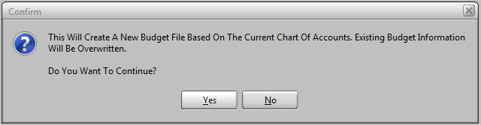
A number of Titan financial reports will compare GL accounts to their budgeted amounts if a budget has been established.
The Initialize Budget File and Edit Budget programs can be found on the GL>General menu. Initialize Budget will simply ask you if you want to clear the existing budget file and it will rebuild it with all of your chart of accounts. In most cases once you’ve established a budget file it’s easier to manage from one year to the next by not initializing. You can just adjust the existing entries. A budget file need not contain all accounts and you can use the Add and Delete button to manage the accounts it contains.
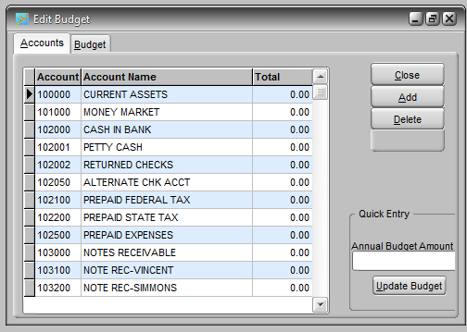
Edit Budget is a simple entry program used to manually enter/edit budget figures. If your budget is annual then you can just use the Annual Budget Amount field to enter a figure for each account. An annual entry will be spread evenly over the twelve accounting periods on the Budget tab. Or you can go to the Budget tab and enter amounts for individual accounting periods. You can also prepare a budget in a spreadsheet and import it rather than entering it manually. Contact BCR support for assistance with importing data from a spreadsheet.
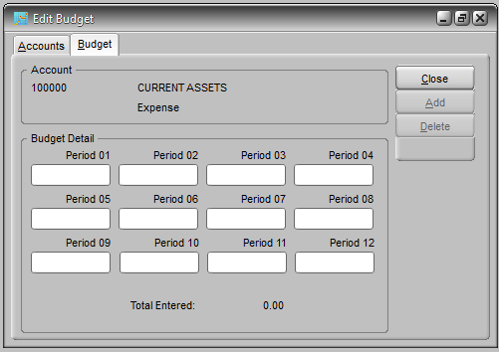

Month End Closing
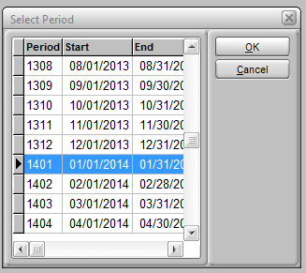
Because the Titan GL contains all of the individual transaction records and these records are retained indefinitely, traditional monthly and yearly closings requiring the shutdown of operations are not necessary. The most significant advantage of this is that users do not need to wait until all entries are posted to begin entering transactions for the new period. The only action required is to update the fiscal period of the module so that new entries will be posted to the new period. For example, even though there are unposted GL batches from period 1203 with a source of IP (inventory/purchasing), new PO receipts can be entered and posted for period 1204 once the period has been updated in the IP module. Since the four key modules that affect (AR, AP, IP and GL) have their independent fiscal period controls, it’s possible to leave AP, for example, set to one period to allow backlogged vendor invoices to be posted while the IP is set to the next period to allow new PO receipts to be posted. Note that the OE period is the same as the AR period. When the AR period is updated, so is the OE. It should also be noted that it is possible to set a module period back to an earlier one or override the period assigned to a GL batch before it is posted.
The GL, AP and IP modules each have update period utilities on their General menus. The utility in AR is identified as Month End Processing. While the other utilities do nothing more than change the period assigned the module, Month End Processing will also clear paid invoices from the AR file. If your statements are designed to include paid invoice detail then you will want to run them prior to running the Month End Processing. If you do not wish to include paid invoices on a statement then you will want to run this update before printing statements.
Your system may be configured to post invoice batches automatically to the GL. If you do not update the AR period invoices posted will be posted directly to the GL in the old period. For this reason you will probably want to update the AR after the last invoice posting on the last day of the old period so that the next invoice processing will go to the new period. If you still have AR receipts from the old period that have not been posted you can override the period of the individual AR entry batch.
NOTE: Updating the GL module fiscal period, or any of the four modules, DOES NOT update the others. All four modules must be updated to complete the month end process.

Year End Closing
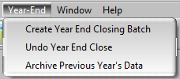
The year end closing, beyond the updating of the final month end, consists of creating the year end closing batch. The year end closing batch contains the postings that clear (with balance reversing entries) the income and expense accounts as of the year end and post the net to the retained earnings account. This can be done at any time following the closing of the last period of the fiscal year. It can be done after months in the new year have already been closed. It is even possible to reverse a year end closing. If you wish you can archive the data from the previous year, which will increase the speed of inquiries and reports, though you may wish to wait until well after the closing so that the data is there should you decide to make additional adjustments and rerun year end financial reports.
