drop shipment orders

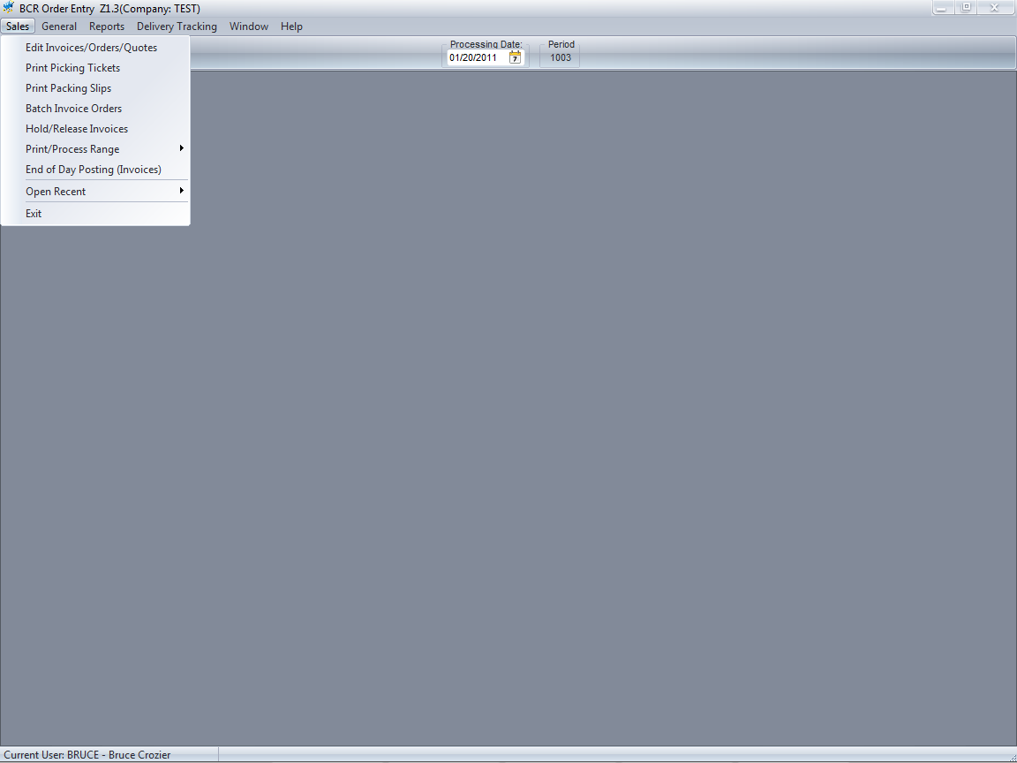

Drop, or “direct”, shipment orders from a vendor to a customer are created by first entering the customer order in sales order entry.

The item and order quantity are entered and the DS column is checked to indicate the item is to be drop shipped. The quantity allocated must be zero or the system will not detect the need to create the drop ship purchase order.

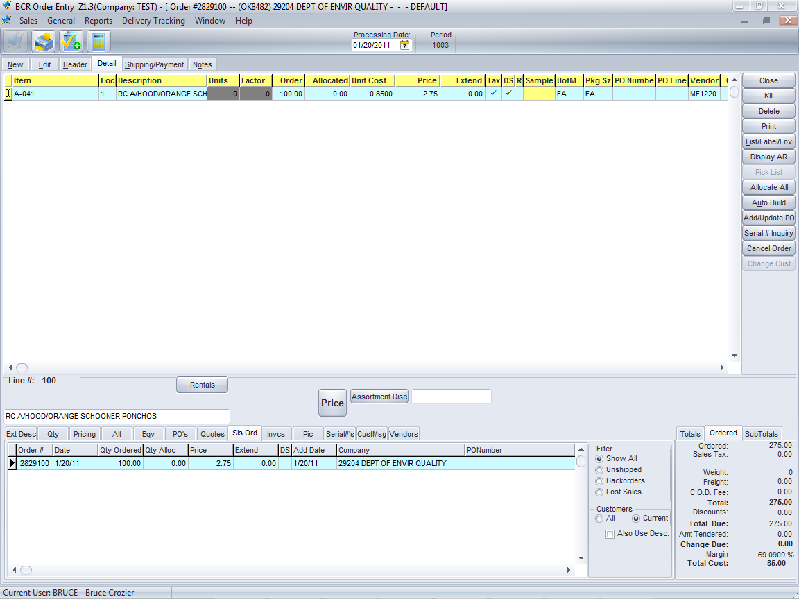

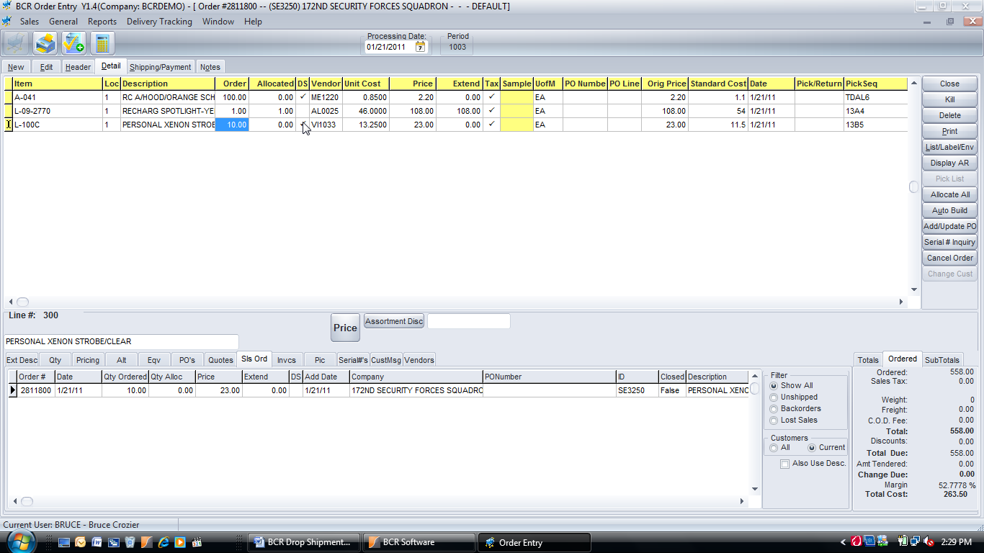

Drop ship items and stock ship items can be mixed on one order and multiple drop ships from different vendors can be entered on the same order.

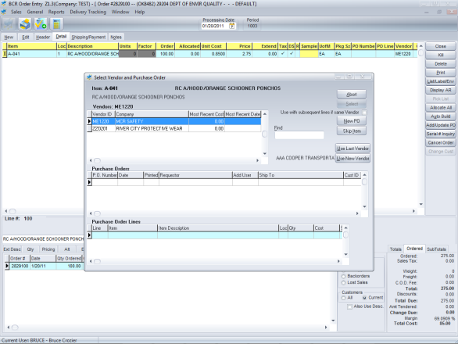

At any time the Add/Update PO button can be clicked and the system will prompt the user to create a DS PO for the DS item (or a stock PO for any item that is backordered) using one of the item’s preset vendors or a user selected vendor. If there is more than one DS item, the system will step through them, creating POs for each. POs created here are not yet posted and will typically be reviewed by purchasing and then posted.

If the user leaves the order without creating a DS PO they are warned. That sales order would create a backorder that would typically be picked up by purchasing in their inventory requirements. Most users choose to create a PO from order entry though.

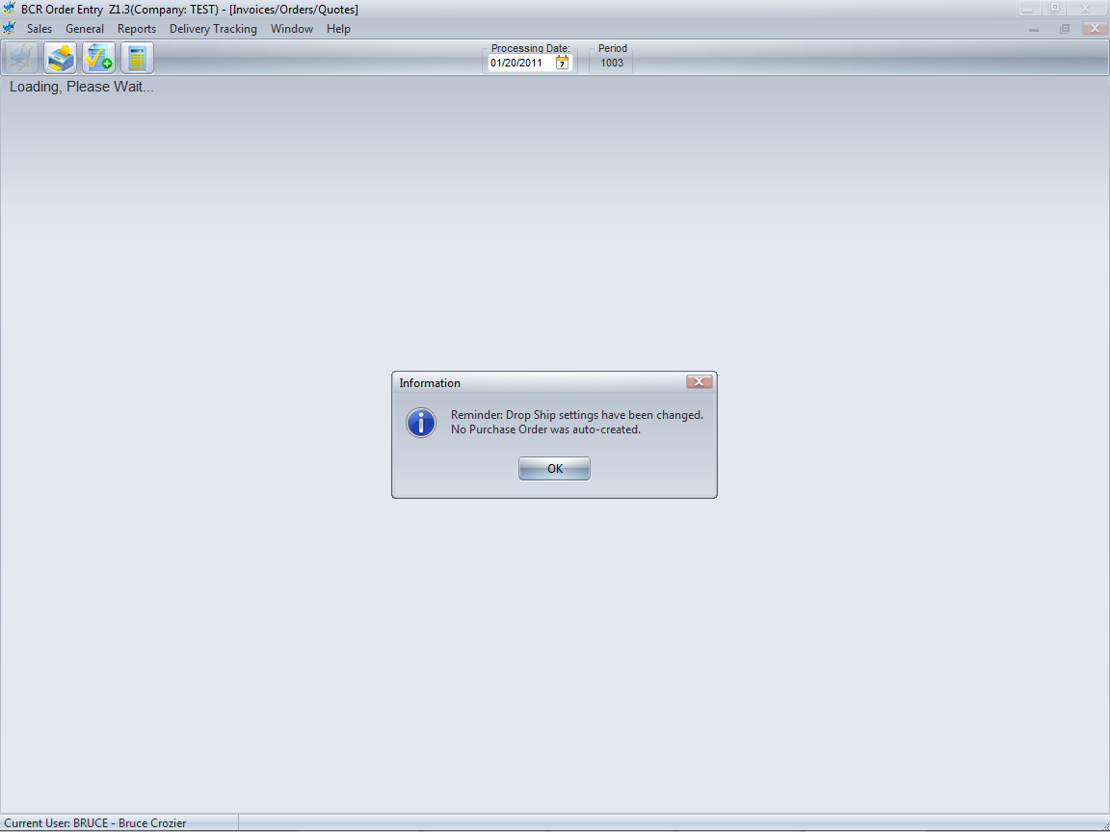

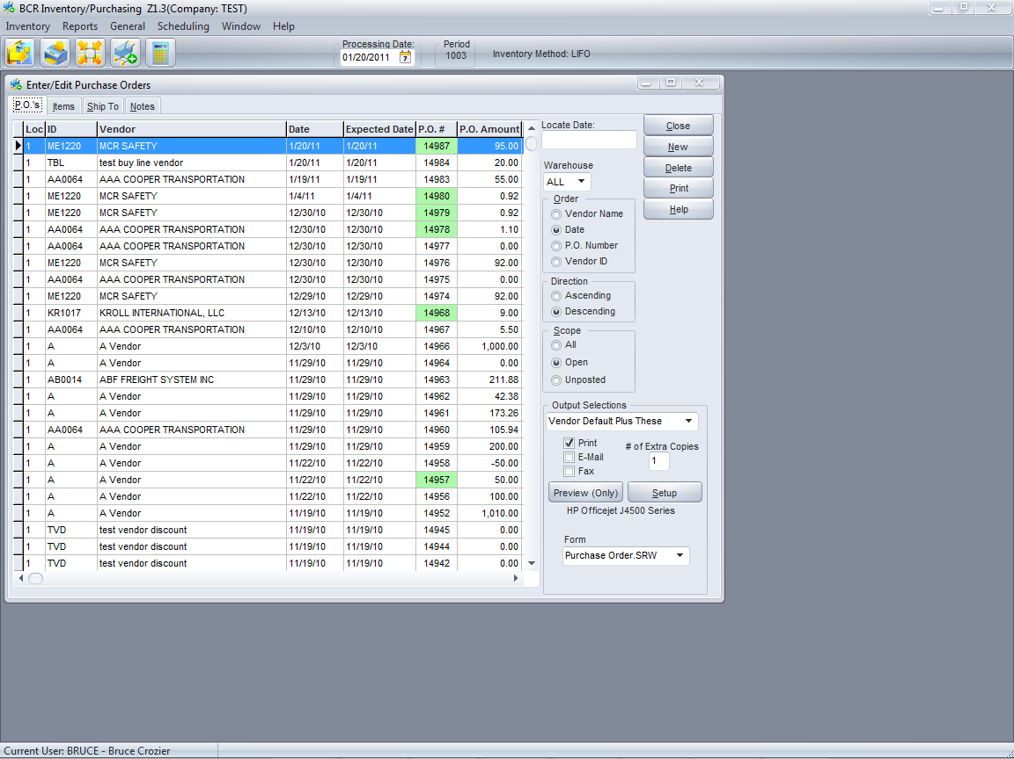

The DS POs created through sales order entry will appear listed in Entry/Edit Purchase Orders. These are un-posted POs and working documents. PO#s listed in green are system auto-created POs, such as those created in order entry or via the Buyer’s List or Auto-Generate POs programs.

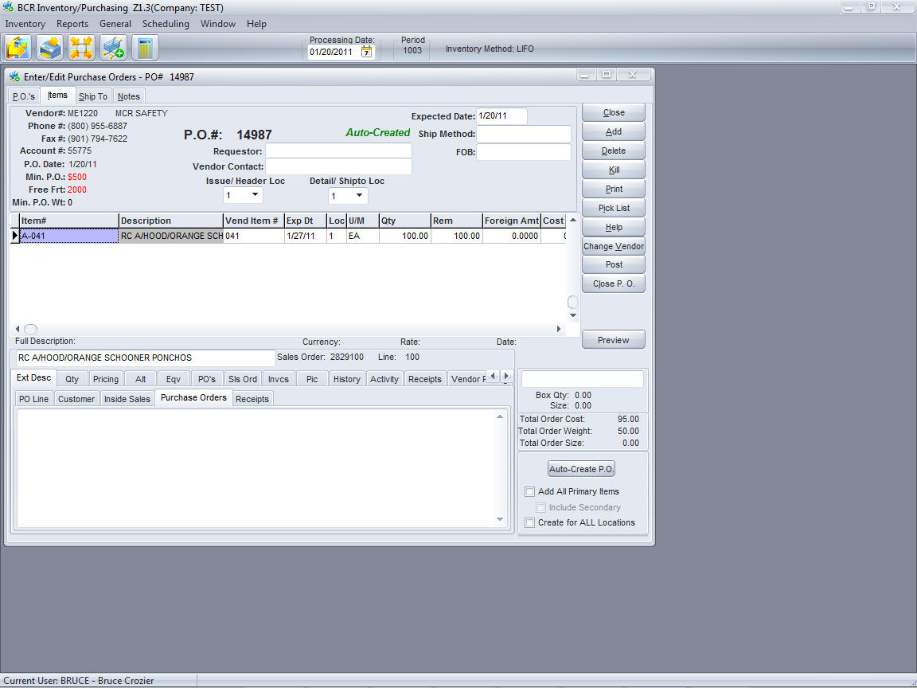

The order quantity of the DS PO has been automatically pre-filled from the sales order.

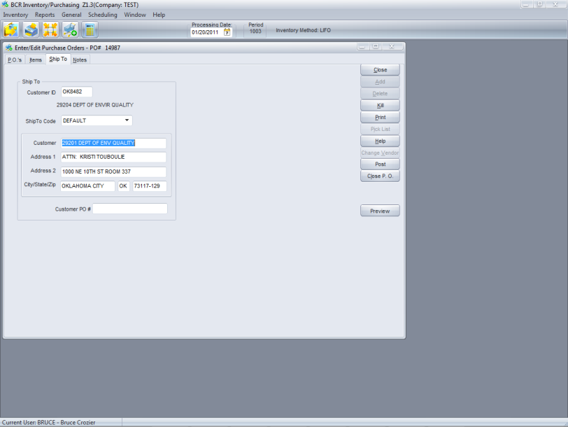

Like all POs the DS PO must be posted before it is registered as a PO in the system. DS PO quantities are treated as an item’s on PO quantities, just as DS sales order quantities are included in an item’s sales order quantity. If no DS PO is posted then the item will continue to show the need for stock to fill the backorder.

The ship to information for the customer has also been automatically pre-filled from the sales order.

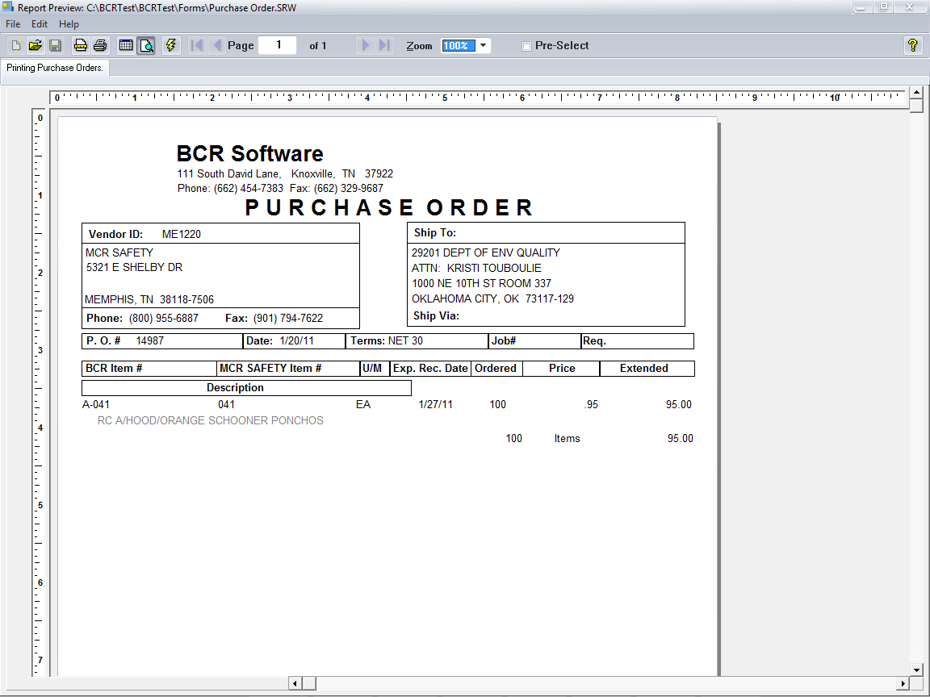

The DS PO can be printed (or transmitted) at any time.

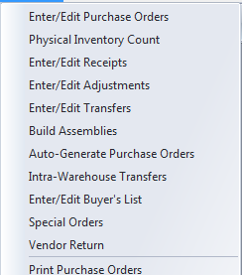

When a vendor invoice or shipping notification is received, indicating the goods have been shipped to the customer, the DS PO must be “received.” This function may be performed by either accounts payable or purchasing.

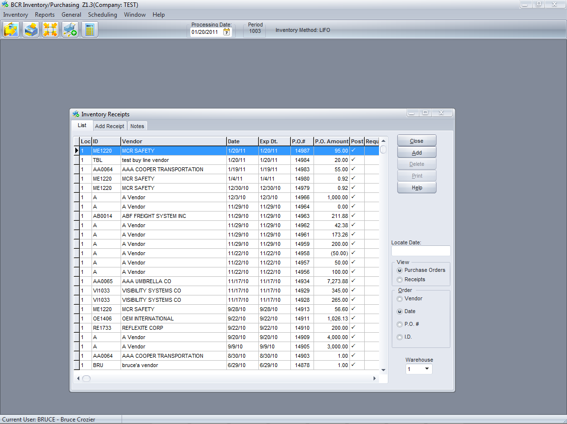

Accounts payable cannot reconcile (match up) a vendor invoice to a purchase order until it has been received. This prevents a vendor from being paid without the customer being billed, since the act of receiving will allocate the quantities shipped to the customer and allow the order to proceed through the invoicing process.

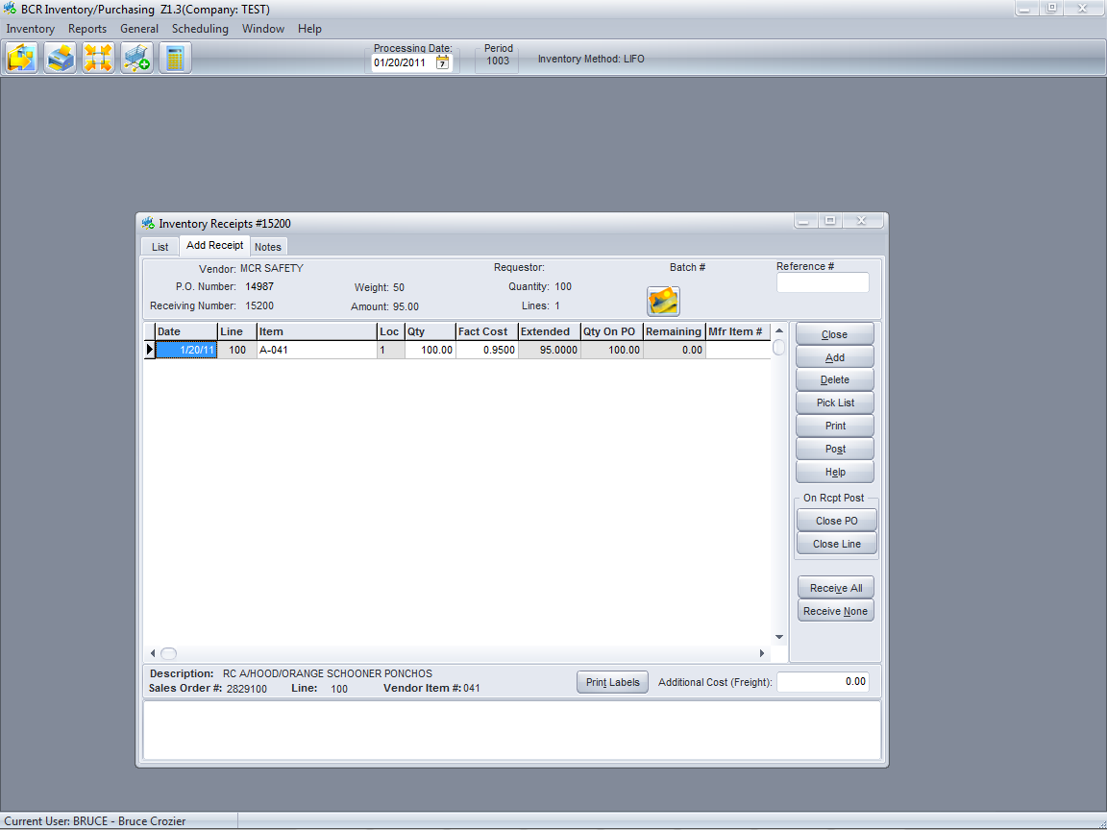

The receiving is performed just like a stock receiving. The receiver must be posted to update the inventory on PO quantity and trigger the auto-allocation process.

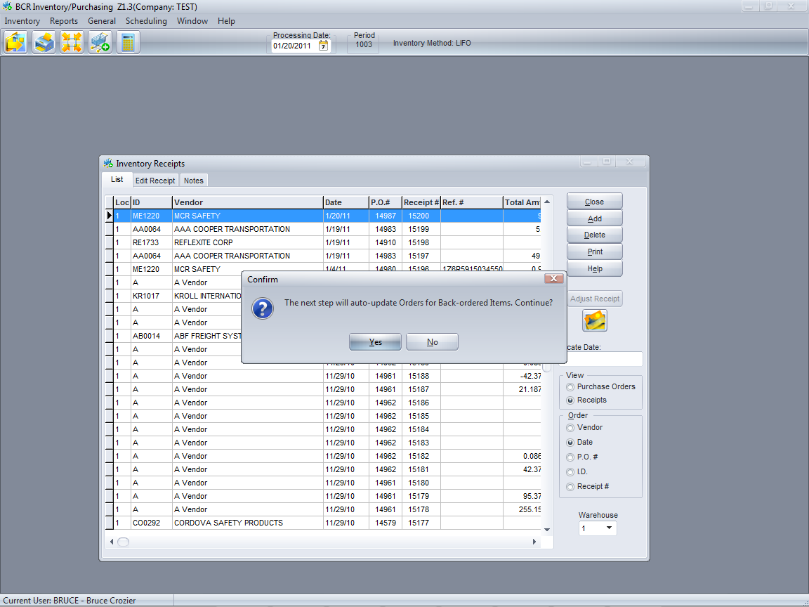

If the auto-allocation is not done then the system will receive the goods into stock and the sales order will remain open and un-invoiced. In this case the order would have to be allocated manually in order to proceed through the system.

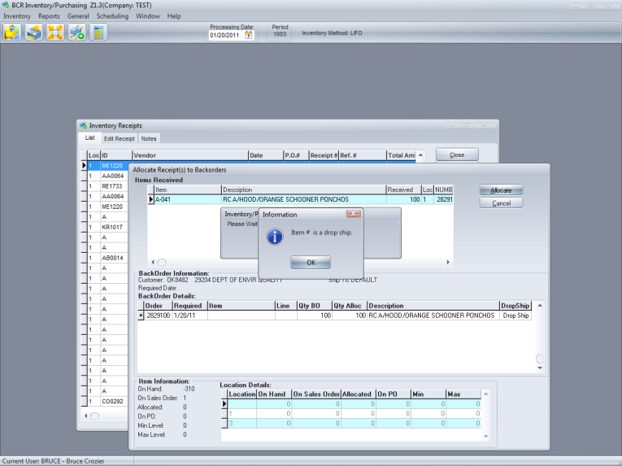

If the sales order is viewed in order entry it now shows that the quantity “received” is now allocated on that item’s DS line of the order.This permits the order to proceed through the normal invoicing flow.

The auto-allocation process insures that DS shipments are allocated directly to their corresponding sales orders.

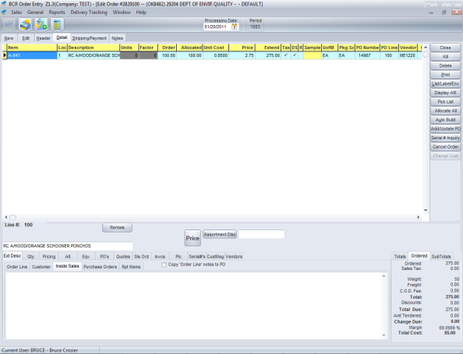

This includes the picking ticket print step, though the pick ticket form is usually designed to not print tickets for DS items. Keep in mind, however, that there may be stock shipment items on the same order, so the pick ticket step should not be ignored.

