Customer Gifts
The Customer Gifts system allows you to specify gifts, handouts or just specific messages that order takers should give to customers. Each “gift” setup can be set to operate within a specified date range, and control and track the number of gifts given to each customer. It can be targeted to specific customers, price levels or price lists and specify an item as a gift.

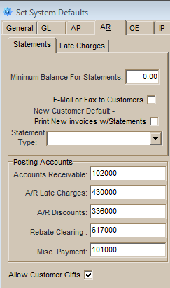
To enable the Customer Gift system check the box “Allow Customer Gifts” on the AR tab in System Defaults.

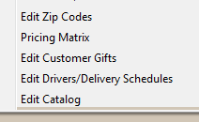
When enabled, the Edit Customer Gifts screen is located on the Edit menu in Administration.
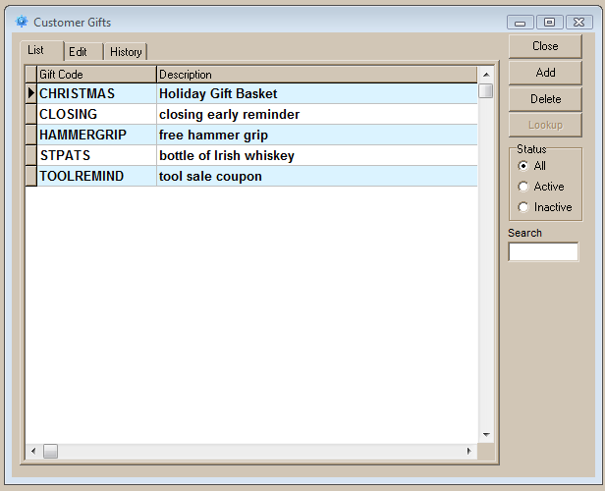
Gift programs are created and selected on the List tab. The Active and Inactive Status is determined by the Active checkbox on the Edit tab.

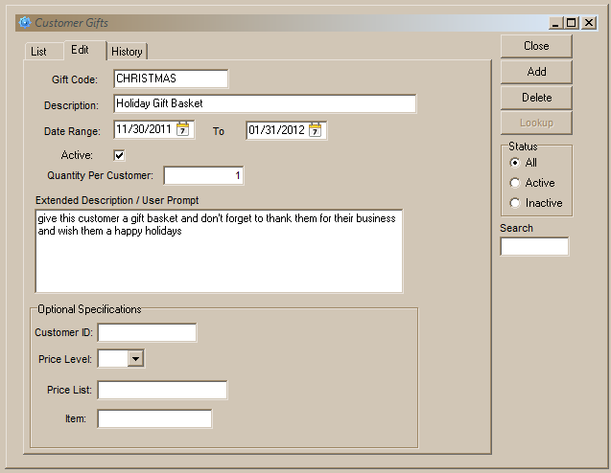
After a gift program is created you can set the “Date Range” for it. You can reuse expired programs by entering a new range after the existing range has expired, however the quantity per customer is not reset so gifts of limited quantities per customer should be setup as new programs.. You can also deactivate a program’s date range by un-checking the “Active box”. A program for a message to customers could be setup with a very long date range and then just activated as needed.
The “Quantity Per Customer” determines the number of gifts that can be given to each qualifying customer. If the user indicates that they have given a customer a gift when they are prompted then that is logged by the system and users will not be prompted to give that customer a gift again if this quantity has been exhausted.

In the “Extended Description / User Prompt” you can enter instructions to the user that will appear when an order is entered that qualifies for that gift program. This field can also contain just a message or reminder that you would like passed on to customers, such as “We will be closed next Friday” or “There’s a sale on tools today.”

Gifts can be optionally designated for a specific customer, customers assigned a specific price level, or customers assigned a specific price list.

If the gift is maintained as an item in inventory the item number can be specified and when the user dispenses the gift one unit of that item will be added to the order. NOTE THAT THE ITEM IS ADDED TO THE ORDER AT ITS NORMAL PRICE. If the item is to be given for free then its selling price must be set at zero or the user must override the pricing. An authorized user can flag the item as a sample (Setup Users>Order Entry>Detail Tab Settings>”Sample Giveaway”).

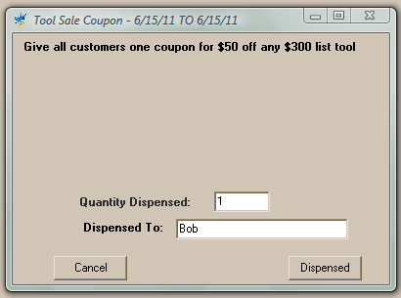
When a new order is created for a customer that qualifies for a gift the user is prompted before the new Header tab for the order is displayed. The prompt displays the Gift description, date range, extended description/user prompt, a quantity to be dispended. The prompt will not appear if the customer has already received the quantity of gift (or number of times they are to receive a message) setup. If an item in inventory has been setup as the gift, clicking the Dispensed button will add that item to the order.

As soon as a gift has been dispensed a record of it appears in on the History tab for that gift program on the Edit Customer Gifts screen.
