Contract Billing
Contract Billing is used when you need to repeat the same invoicing on a regular basis. This might be a long term rental agreement or a maintenance contract or service agreement. It could include tangible items but usually would be a non-stock/intangible item.

Setup
In order to create contract orders or invoices the user must have the Contracts:Allow Billing option checked in Setup Users. This will turn on the Contract Billing button on the sales order entry screen for that user.
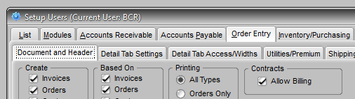
A document is identified as a CONTRACT by selecting that Order Type on the Header tab of the document. If the CONTRACT Order Type does not already exist, create it in Edit Order Types on the Edit menu in Administration.
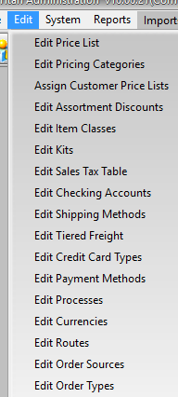
Simply click Add and enter the word CONTRACT. If you want contracts highlighted in color on the sales entry Edit tab documents, click the Color button and select a color from the pallet. The Contract Billing checkboxes are not functional. Those options are handled at the Contract Billing sub-screen in order entry.
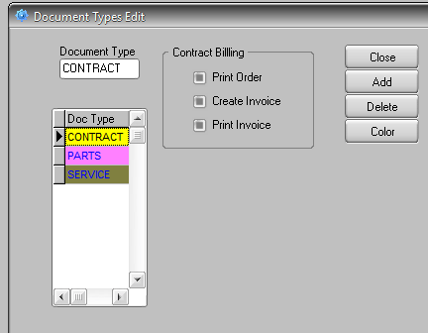

Creating Contracts
When you wish to create an original contract document (quote, order, or invoice) select CONTRACT from the order Type. Usually it’s best to create the original contract document as a quote, since the system will allow more control of that document over time.
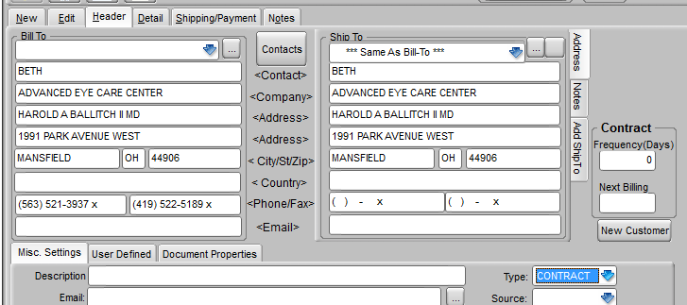
When you select this Type a Contract box will appear to the right of the ship to address. Enter the Frequency (Days) that you want the contract re-billed and the date that you want the contract to next appear when you select the Contract Billing screen. If you create new contracts as quotes you will need to decide how you want to generate the first billing and the Next Billing entered will depend on that choice. You can immediately create and order or invoice from the quote using the standard Based On: Create From function on the New tab of order entry. In this case then you would set the Next Billing to the current date PLUS the number of days of frequency. Or you could set the Next Billing date to the current date and let the person who regularly runs Contract Billing include it in the next processing. The Next Billing date would then automatically increment.
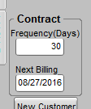
Depending on the nature of your contracts you may want to have a user assigned to run (click the Contract Billing button) contract billing daily, weekly, or monthly, or whatever is appropriate to your contracts. CONTRACT BILLING WILL NOT RUN AUTOMATICALLY. You must select to run it in order to produce new orders or invoices.
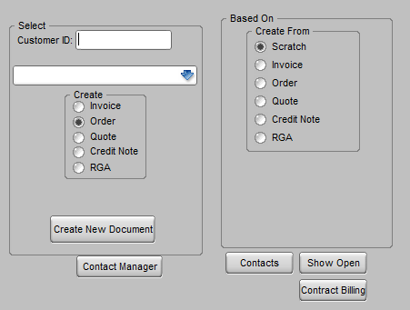
The Contract Billing screen will only display contracts of the Document Types selected and only those documents whose Next Billing coincides with, or is earlier than, the Billing Date selected. The screen defaults to Document Types:Quotes. Select the documents that you wish to process. (Ctrl-click to select multiple documents.) If you wish to generate an invoice record select the Create Invoice checkbox. You will still need to complete the posting of the invoices created as usual. If you do not select this option then an order will be created and you will need to create the invoices through normal order to invoice processing. If you are creating from an original order (or invoice, though this method is not recommended) you may want to create invoices rather than new orders since the only item on the order is usually an intangible item that does not need to be picked. If you are creating from an original quote you may want to just create an order if you might be adding tangible items or other charges to this instance of the billing before invoicing. If not then you can just create the invoice when you process. Your specific contract needs will determine your best process flow but the most common method would be to create the contract as a quote, set the Next Date for today, and process contracts daily using the Create Invoice option.
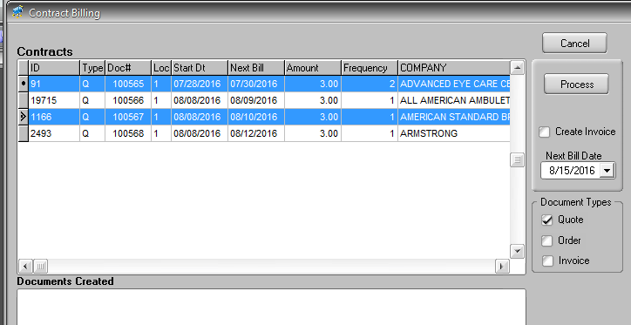
When the contract is terminated you will need to change an originating quote to remove the contract designation in order type or “kill” the quote. Otherwise it will continue to show on the Contract Billing screen. Since invoices cannot be killed after they are posted an invoice is not recommended as the source document type for contracts. The frequency, billing date, and order type cannot be changed on a contract order so an originating order must be killed. Quotes can be modified or killed. Generally using a quote as the original contract document is the best process.

