BCR Contact Management

The BCR Contact Management program allows users to maintain customer relations management (CRM) information, maintain forum style notes on a customer or prospect, email customers or salespeople directly from the program, attach external documents to a record or send attachments to them, group customers for marketing or other media campaigns, and setup pending actions for users to follow up, with the option of sending a “meeting” appointment to their MS Outlook calendar.

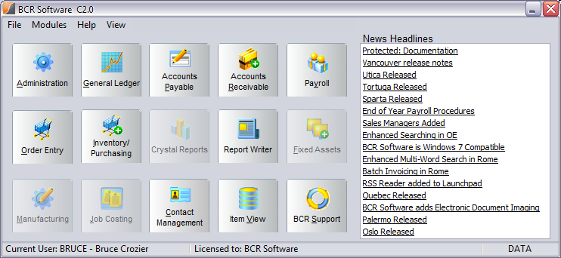

The Contact Management (CM) program can be opened from the BCR launch pad.

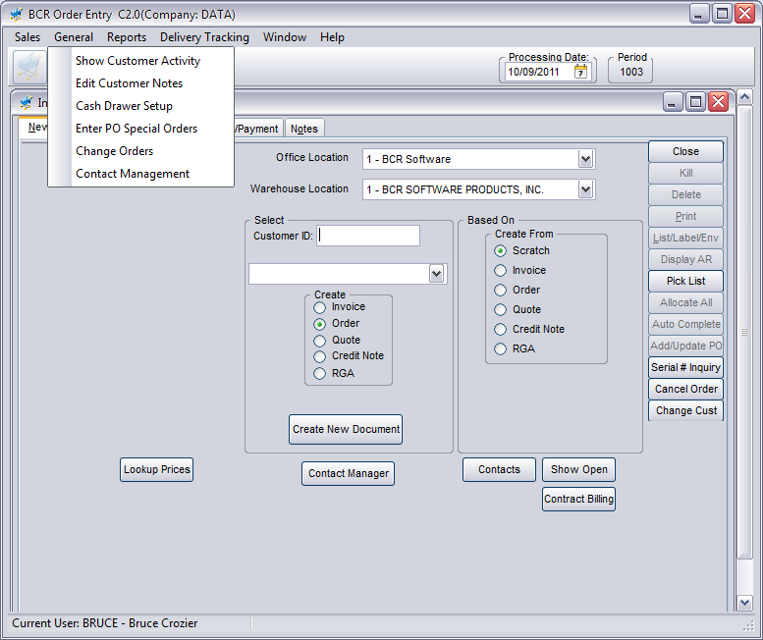

The program can also be started from the Order Entry module, from either the General menu or the button on the New tab of Edit Order. When the program is initiated from Order Entry the currently selected customer record is automatically selected in CM. This makes it easy for someone who is in the middle of taking a phone order to jump to CM to make a note or set a pending action.

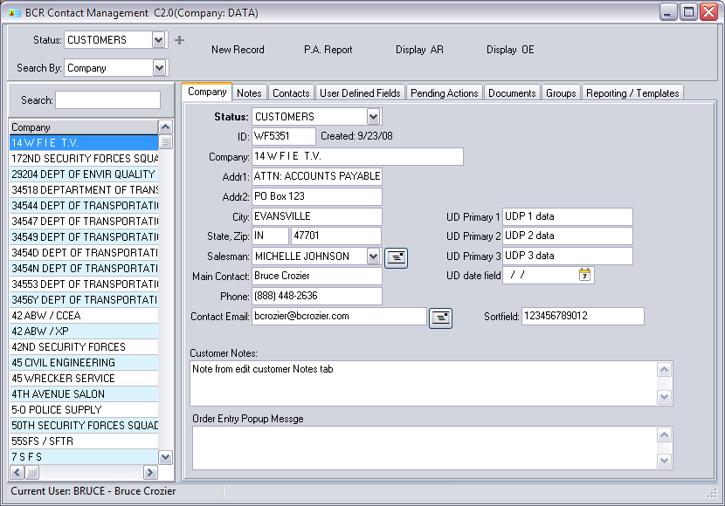

In CM all records exist in the customer table and are listed in the panel on the left unless they are filtered by the Status. Status is a user defined validated field. It can be assigned to a record in either CM or Edit Customers. For example, records that are not actual customers yet, could be assigned a Status of PROSPECT. Use the plus sign (+) to the right of the dropdown selector to create a new status. The default status when CM is opened is “All”.

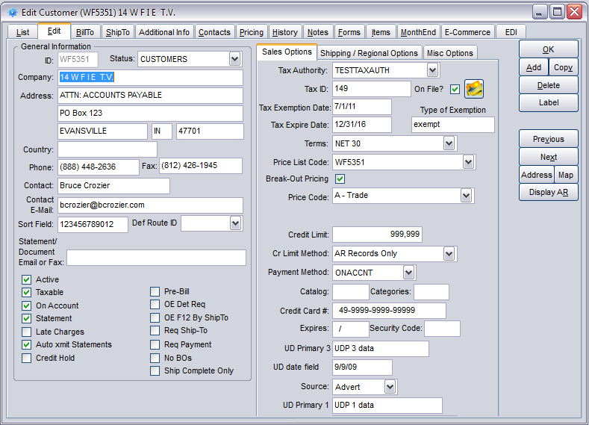

In Edit Customer the Status is found on the Edit tab to the right of the customer ID.

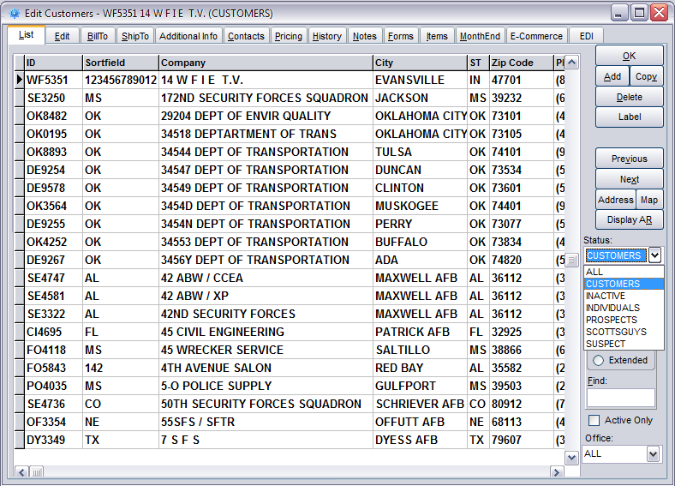

The Status can also be used to filter customer records in the Edit Customers List tab. Note that the default in Edit Customer is CUSTOMERS. You must select “All” from the dropdown to access records assigned other statuses. You will not be able to access a record assigned the Status of anything but CUSTOMER otherwise.



The Search By dropdown and the Search field in CM can be used to sort and locate records listed. The record located or selected in the list panel is immediately addressed by the tabs to the right. Fields on the Company tab are identical to fields in the customer record. Email icons to the right of the Salesman and Contact Email will access MS Outlook and open a new email addressed to the Sales Staff email or Contact Email.



The New Record button at the top of the screen will allow authorized users to create a new record in the customer table. Only fields found in CM are created when a record is created here. You must use Edit Customer to update other new customer fields.



The Display AR button will open the same Account Detail opened by Display AR in Edit Orders.



The Display OE button will open the same Customer Order Entry Activity screen displayed by the Show Customer Activity menu item on the General menu in Order Entry.

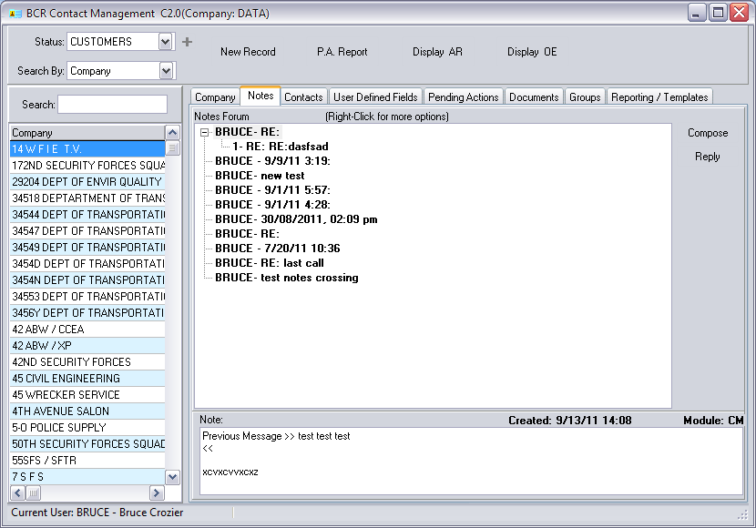

The Notes tab allows users to post forum-style notes about contact with, or about, the customer. These notes are typically event driven, such as a meeting, call or email. Clicking on a note will display its contents in the textbox below. Clicking on a plus (+) next to a note will display its replies. Clicking on a minus (-) will collapse its replies.

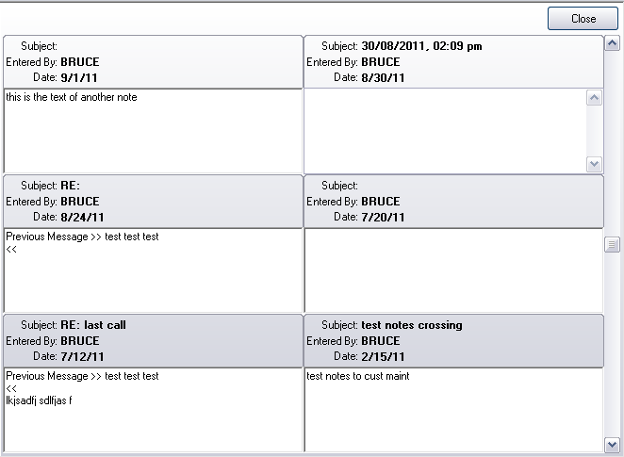

Double-clicking on any one note will display a scrolling window of all of the notes and text for that customer.

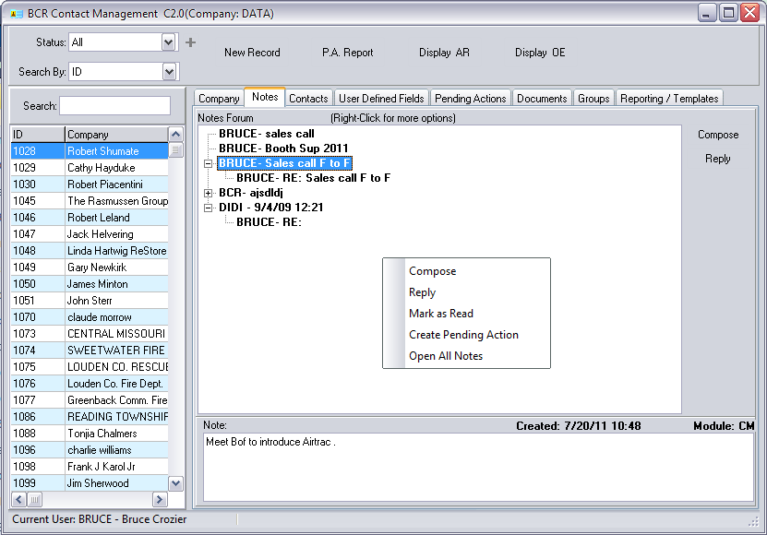

Right clicking anywhere in the tab window will display a small menu of edit choices. Compose will create a new note while Reply will post a sub-entry to the selected note. (Two buttons on the right can also be used to Compose or Reply.) Mark as Read will change the font of the Subject from **bold** to regular. Create Pending Action is covered below. Open All Notes will open the notes window above.

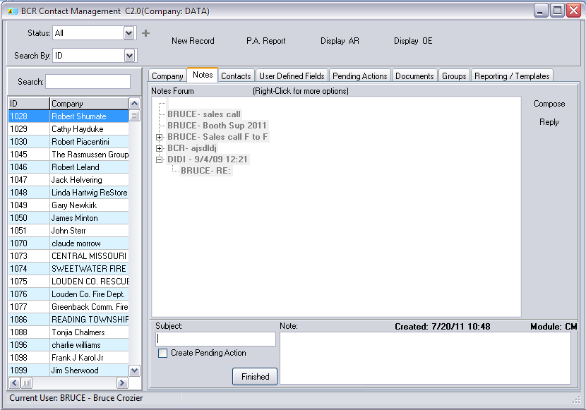

A note consists of a Subject and text entered in the Note textbox. The Subject is automatically prefixed by the user who created it and the note is dated. The Subject on a reply will automatically fill with RE: followed by the Subject of the note being replied to, but it can be overwritten.



Click the Finished button to post the note. If you check the Create Pending Action option before clicking Finish, the Pending Actions tab will be displayed with the text from the note prefilled in the Description textbox. See more on Pending Actions below.

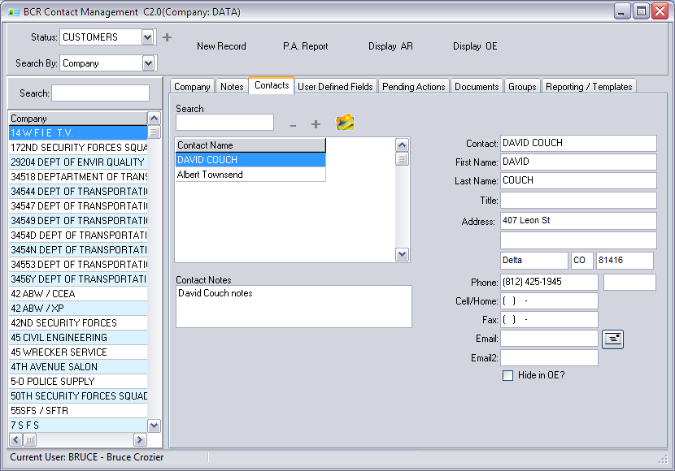

The Contacts tab allows a user to view and maintain most of the same contact fields found on the Contacts tab in Edit Customers.

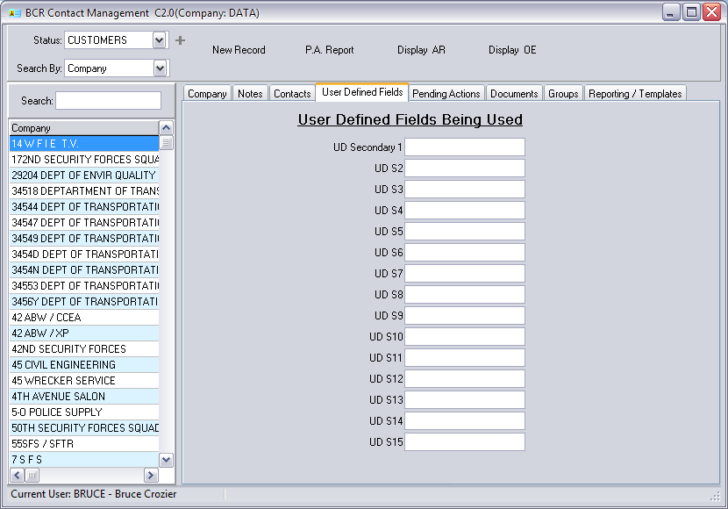

The Pending Actions tab allows you to create and manage actions that need to be taken in relation to that customer. This would typically be some form of contact with the customer, such as a call on them or sending them something, that someone within your company needs to take care of. Pending Actions can also send calendar events to specified users’ MS Outlook email accounts.

User Defined Fields displays the secondary fifteen user defined fields for the customer. Remember that UD fields are only displayed if they have been given a label in Systems Defaults.

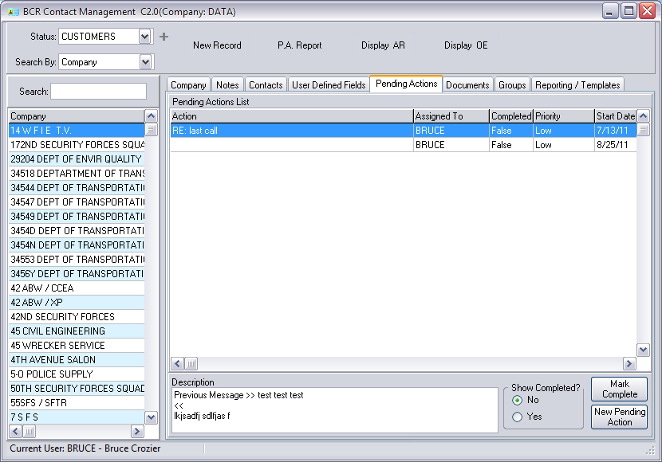



You can review prior pending action entries for this customer in the grid displayed. The Show Completed? option will filter out Completed (True) items. To mark an item as Completed = True select the item in the grid and click the Mark Complete button.

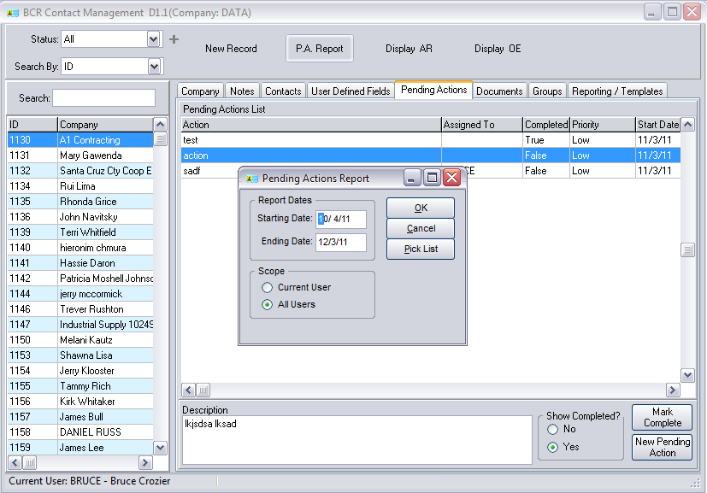

Click the PA Report button to see a report of all items for all customers for your user or for all users within a given date range.

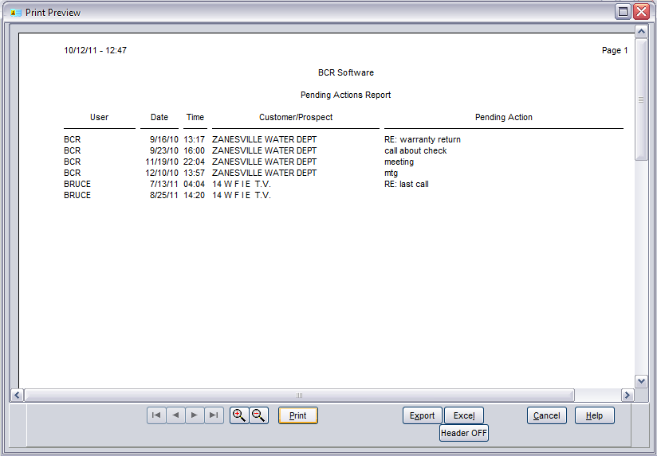



Click the New Pending Action button to enter a new action item.

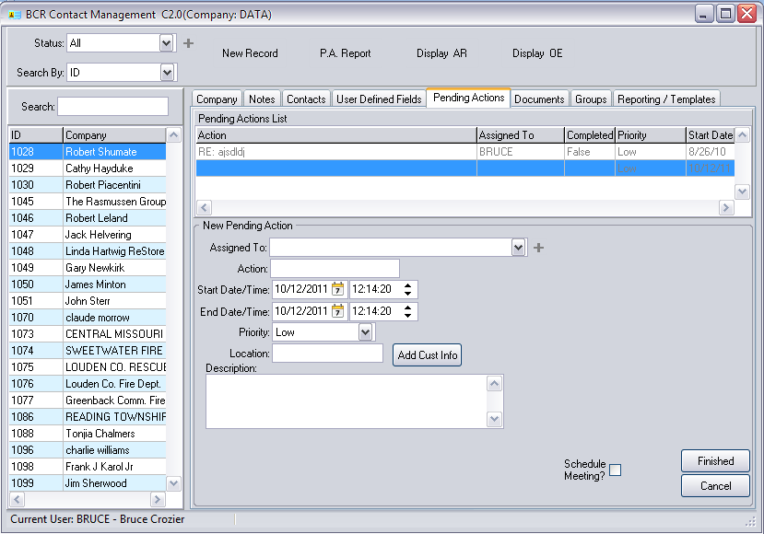

The New Pending Action panel allows you to select a user to assign the action to, title the Action (e.g., call, email, meeting, etc.), set a date/time start and end, assign a priority (Low, Medium, High), enter a Location, and a text Description of the action to be performed.

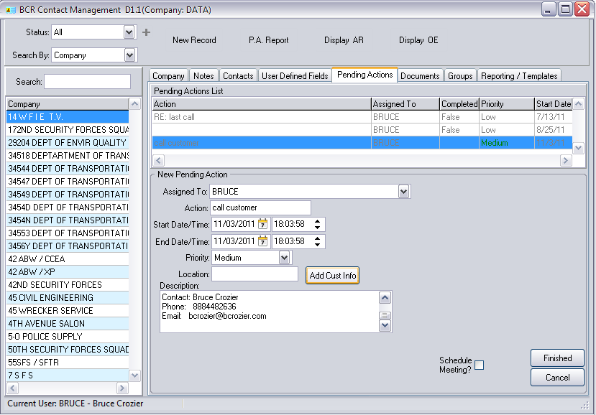

Click the Add Cust Info to insert basic contact information about the customer into the Description textbox.

Click the Finished button to file the action item in the Contact Management program.

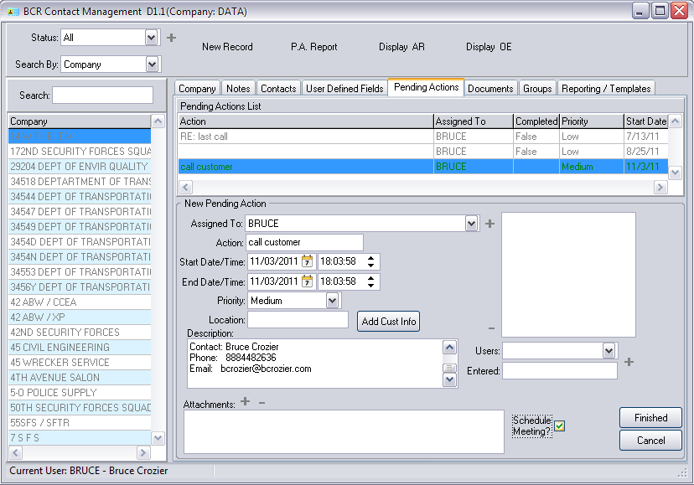

Use the Users dropdown below the list and click the plus to its right to add the email of a user to the list. Type an email address in the Entered field and click the plus to add it. Select an email in the box and click the minus (-) button above Users to remove it from the list.

If you wish to send a calendar item to someone as well, then select the Schedule Meeting? option before you click Finished. This will open additional fields where you can specify multiple users/email addresses to send the action as a meeting request to, and attach external documents to the email if you desire.

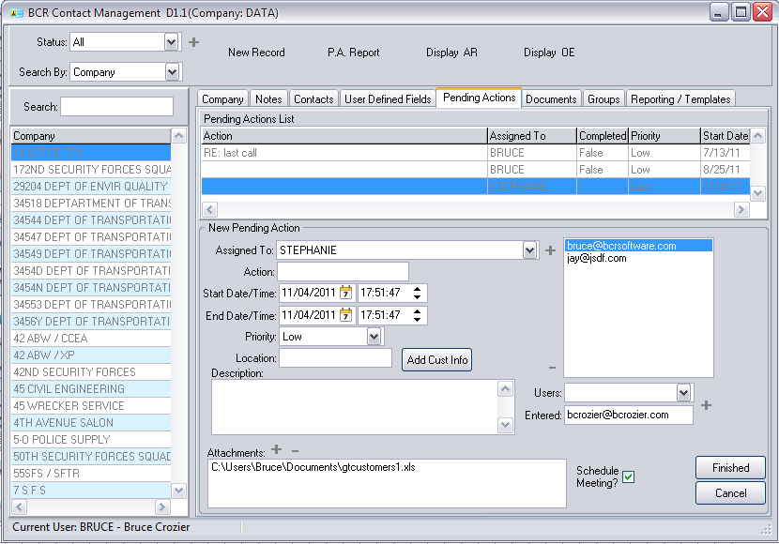

Add attachments to the email by clicking the plus button to open a file browser. Remove an attachment by selecting it in the list and clicking the minus button.

When you click Finished the action item will be filed and Contact Manager will access your MS Outlook program to send the email(s) meeting invitation. You may have to give Outlook permission for the access.



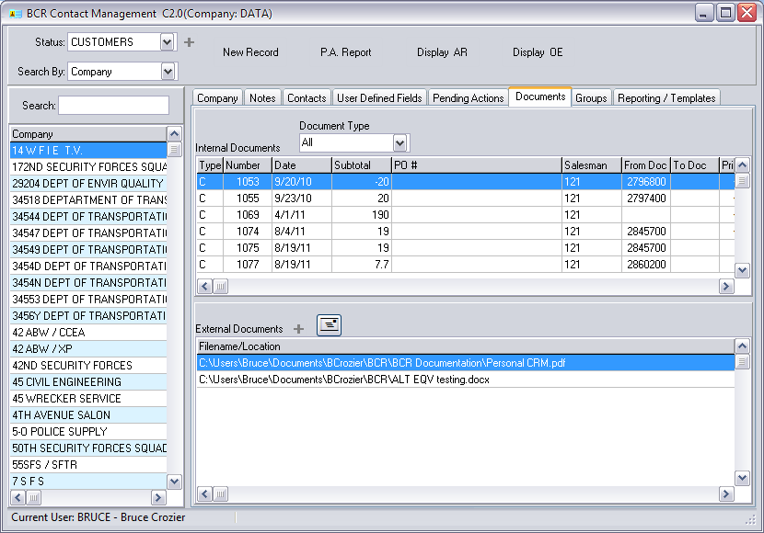

The Documents tab allows you to view all BCR transaction documents associated with the customer. Use the Document Type dropdown to filter documents. Double click on a document to view it.



You can attach external documents to the customer account. Click the plus button to open a file browser. Click the email icon to create a draft email to the customer with the selected document as an attachment.

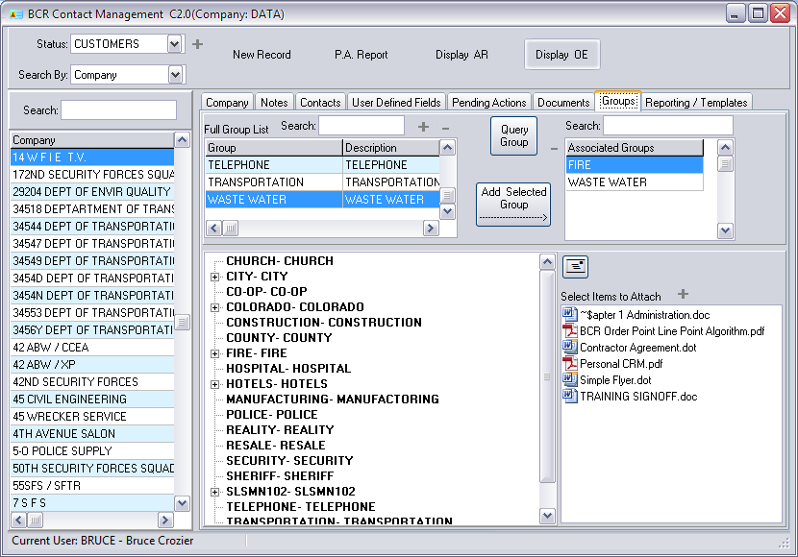

The Groups tab allows you assign the customer to any number of your user defined groups. Groups can then be used for email broadcasts or in BCR Report Writer to select customers for reports.

Groups are user defined and can be created and deleted using the plus and minus buttons on the tab or from Report Writer.

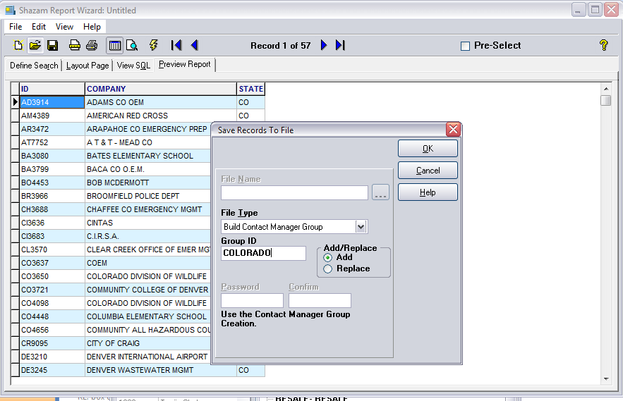

You can export a list of customers to a new or existing group in Report Writer. First create a simple report of the customers you want using a filter like a specific state or salesperson. Then select Export from the File menus and select Build Contact Manager Group from the File Type dropdown. You can select an existing Group ID or specify a new one. If you select an existing one you can choose to Add these customers or Replace the customers currently in that group.

The Query Group button will allow authorized users direct access to the Report Writer from the Contact Manager.

To add the current customer to a group select the group in the grid to the left and click the Add Selected Group button. Use the minus (-) button above it to remove a customer from the group highlighted in the Associated Groups grid. Associated Groups lists all of the groups that customer is assigned to.



In the groups directory in the center of the tab you can expand a group to see it members. Keep in mind that one customer can be assigned to any number of groups. To broadcast emails to a group select the group in the directory and click the email button to the right. This will create an email draft to the user as the primary “To” email address with all members of the group included as blind “Bcc” addresses.

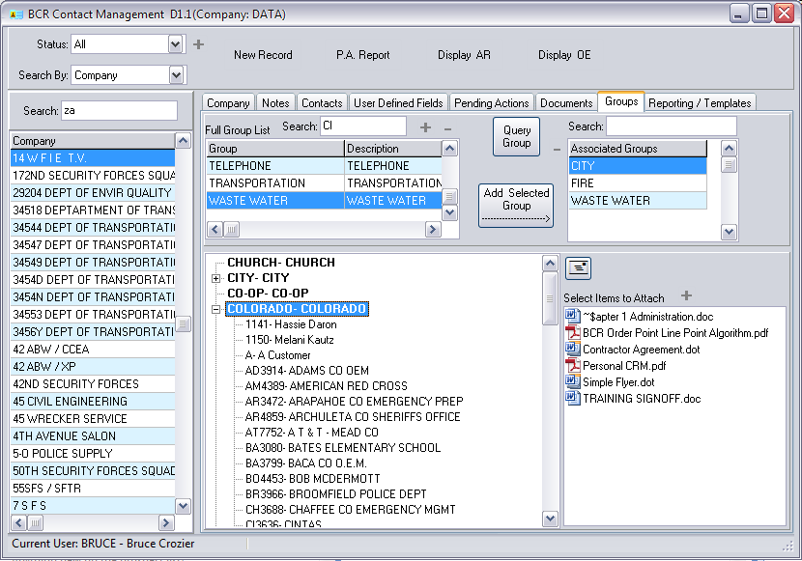



Select a file in the list to the right before clicking the email button to add the file as an attachment to the draft email. You can add files to the list using the plus (+) button to open a browser.

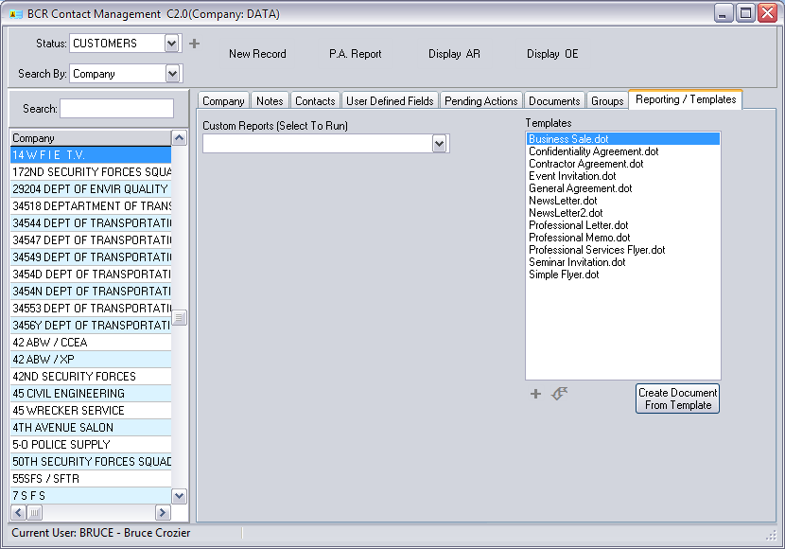

On the Reporting/Templates tab the Custom Reports dropdown can be used to run a CM related report directly from CM. Place report writer reports in the forms\reports\CM folder in your data folder to have them appear in this dropdown. Simply select the report from the dropdown to run it.



You can use MS Word templates (.dot files) to create predesigned documents to add to the customer’s external documents list on the Documents tab. You can then email the document as an attachment to the customer from there. Use the plus (+) button to browse for templates or use the arrow button to automatically download templates from the Templates folder in your data folder. You can copy .dot files into that folder from any number of sources and refresh the list by clicking the arrow button again.



If you select a template from the listing and click the Create Document From Template button you will be prompted to add a document created from the template to either the customer’s external documents (*your data folder*\ExternalDocs*user ID*) or to the Groups tab attachments list (*your data folder*\ExternalDocs). The created document will be opened using MS Word and you can save it with changes.

