Check Reconciliation
Reconciliation of your bank statements to your checking accounts is a very simple process. Any activity in a GL cash account, as a result of either cash receipts, disbursements, or adjustments, can be reconciled to your statement. The system will report what has and has not been reconciled at any time and errors in the reconciliation process easily reversed. Any adjustments found necessary at the time of reconciliation, such as for bank charges, can be made from within the reconciliation program and immediately reflected in the listing of items to be reconciled.

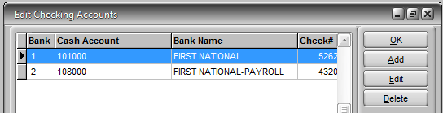
The Check Register and Check Reconciliation are functions of the GL cash accounts assigned to checking accounts (Administration>Edit>Edit Checking Accounts.) Even if checks are never written against a checking account, once a GL account (typically an asset account) is assigned then any posting against that GL number including GL journal entries will be included in the register or reconciliation listing.

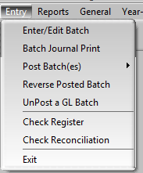
The Check Register and Check Reconciliation programs are found on the Entry menu in the General Ledger module.

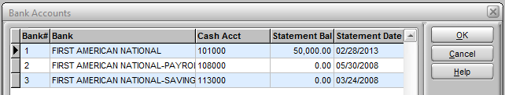
The initial prompt when either program is opened is to select a checking account (and by definition the associated GL account number). If there is only one account just click OK.

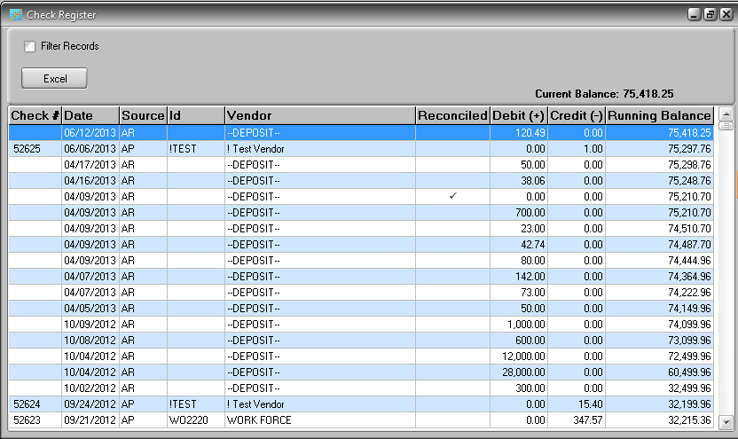
The Check Register program produces a report similar to the manual register you might keep in your checkbook. The initial unfiltered register will list all entries affecting the GL account as far back as there are records in your data. It is not necessary to run this program to perform Check Reconciliation.

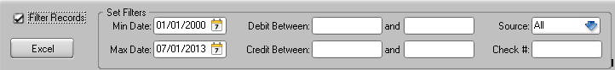
Check the Filter Records option and a number of filter choices will appear to the right. Typically you might want to set the Min Date to the date of your last reconciliation. Other entries might be useful in locating specific checks or entries when there is a problem.

The check register can be used as an on screen inquiry or you can click the Excel button to instantly create a spreadsheet of the data displayed. Note that the spreadsheet will include the additional record information not displayed on the screen.

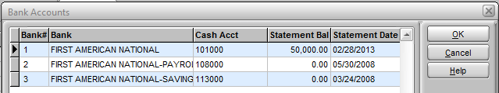
The Check Reconciliation program starts with the same prompt to select an account. Only one account can be reconciled at a time.

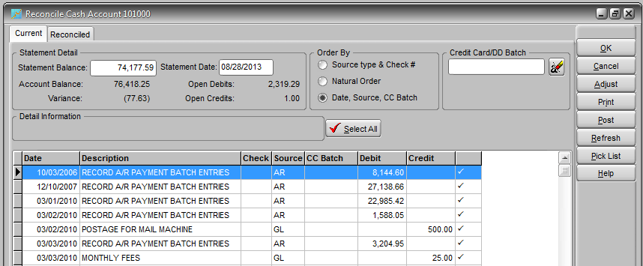
The Current tab displays all of the un-reconciled items for that account. Remember that depending on how your System Defaults are set many types of transactions do not post directly to the GL but post to a GL batch instead. It may be necessary to post GL batches before all transactions related to the account appear in this listing.

Items are reconciled by placing a check in the column on the right and then posting them. When you post the reconciliation this removes an item from the Current tab listing and places it on the Reconciled tab. All items in your data history of the GL account that have been reconciled are retained on the Reconciled tab listing. An item can be un-reconciled and it will be returned to the Current tab. Items can be checked as reconciled on the Current tab but not posted and the program exited and reopened to continue later.

Your first entry on this screen would typically be the Statement Balance and the Statement Date. Depending on how your bank statement displays items you can pick an Order By option that is most convenient.

The Variance is equal to the Account Balance minus the Open Debits plus Open Credits and minus the Statement Balance you entered. The Open Debits and Open Credits amounts reflect items that have not been checked as reconciled and therefore would not be reflected in the bank statement. In other words they have not “cleared” the bank.

The objective of reconciling the statement is to have zero variance. For example if the Account Balance is $1000 and there is one check for $50 posted that does not appear on the statement (i.e., it is an un-reconciled Open Credit) and a bank deposit for $200 (un-reconciled Open Debit) then the Statement Balance should be $850 and the variance zero. Open Credits are typically checks that have not cleared and Open Debits are typically deposits that have not cleared.
Account Balance: 1,000
- Open Debits: 200
+ Open Credits: 50
- Statement Balance: 850
= Variance: 0

The only valid reason for a variance would be an unlisted bank charge (service charges, transfer fees, check return fees, etc.) which, as will be explained, can be posted directly from the reconciliation program, bringing the variance to zero. If there is a variance and there are no items on the bank statement that have not been posted to the GL account then there must be discrepancies between the amount posted to the GL and the amount reported by the bank. Or an item has been checked, or not checked, as reconciled in error. Any variance indicates that the account and bank statement have not been completely reconciled.

Double Click or
Spacebar
to toggle
Usually when a statement is reconciled most of the items on the Current tab will match up to the statement so they can be checked. The Select All button will place check next to all of the items listed. Then the items that are not on the statement can be unchecked by double clicking anywhere on the item or by pressing the spacebar. The checkmark can be toggled by repeating this. An easy way to work through a statement is to first click the Select All button and then use a combination of the keyboard up and down arrows and the spacebar to step through items, un-checking items that are not on the statement.

If there are bank charges on the statement that you want to post immediately (allowing you to achieve the zero variance objective) you can do this directly from the reconciliation screen by clicking the Adjust button.

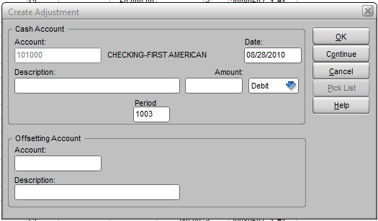
Enter the amount and type of adjustment (typically a Credit for charges) and the Offsetting Account (typically and expense account.) When you click OK the adjustment is posted directly to the GL with a source of BA and appears instantly on your Current tab. If you wish to post multiple adjustments then click Continue instead of OK to stay in the adjustments screen after entering an item. Remember to check such charges as reconciled on the Current tab.

When you have completed your reconciliation and the variance is zero you can click the Print button to see a report of the items that are still open and the items checked as reconciled on the Current tab. When you are ready you can click the Post button to move all items that have been checked as reconciled to the Reconciled tab and exit the program. Remember that until you Post the reconciliation you can exit the program and re-enter it at any time to resume work from the point you left it.
.
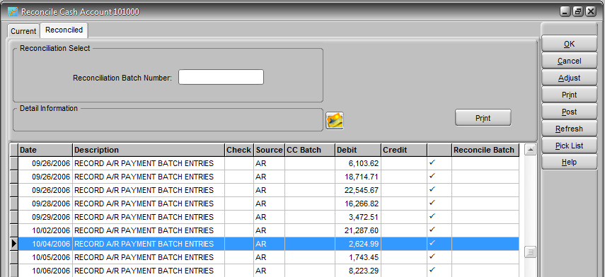
“Posting” your reconciliation only moves checked item to the Reconciled tab and it assigns a reconciliation batch number composed of the date of the posting and a serial numeric suffix if multiple postings are made on the same date. It does not affect any GL amounts or post any items to the GL in any way. Adjustments are posted to the GL instantly when you click OK in the adjustments sub-screen and are not posted by the act of clicking the Post button. When you click Post you are indicating that your reconciliation is completed and the program will close immediately. You will need to reopen the program if you wish to view the Reconciled tab with the newly reconciled items listed.
.

If you should later discover that for some reason an item was checked as reconciled and posted in error (maybe two items had the same amount and the wrong one was checked) you can easily correct this by simply locating the item on the Reconciled tab and double clicking or hitting the spacebar to remove the checkmark. You will be prompted as to whether you want to un-reconcile the item and if you respond Yes the item will immediately be removed from that tab and you will find it again on the Current tab.

