Check Printing

There are five methods of recording checks in BCR. First, most checks are printed in order to pay vendor invoices. Invoices are only eligible to be paid after they have been posted through Accounts Payable invoice batches, or debit or credit memos have been posted against vendor. There are a series of programs related to this process. Second, checks can be created manually (i.e., outside of the BCR print routine) to pay open payables and record them in the system. Third, a check can be printed or written ad hoc (i.e., there is no open payable) using the Instant Check program. A fourth method of check printing would be via the Payroll module which is documented separately. And fifth, a check can simply be posted directly to the GL as a journal entry. Any posting affecting a GL account set as the cash account for a bank will be listed in the Check Reconciliation program in the General Ledger module (Entry menu.)

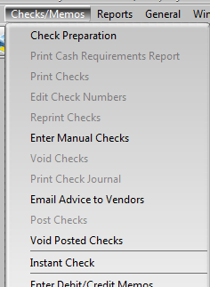
The Checks/Memos menu in Accounts Payable lists a number of programs related to check generation. If a program is grayed out it means that some other process must be completed before that program can be used. For example you cannot Print Checks until you have completed Check Preparation and printed the cash requirements report. As steps are completed other programs become activated.

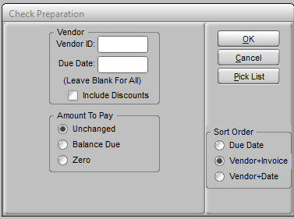
Check Preparation allows you to select payables and release them to be paid. You can first filter them by an individual vendor or only those with a due date on or before a given date. The Amount To Pay selection will either leave the amount as it was the last time you used the program, set it to equal the balance due, or set all items to zero.

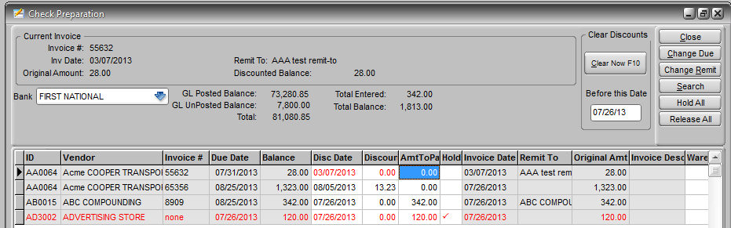
Check Preparation entails setting an amount to pay, adjusting payment due dates and terms discounts as needed, and placing holds on invoices if necessary. An invoice will only be paid if there is an amount to pay but it will not be paid if it is on hold.

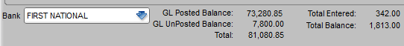
The header of the screen allows you to change the bank account that checks will be drawn on. It also displays the bank balance according to GL postings, and total of the amounts to pay that are not on hold (Total Entered) and total of balances of all items (Total Balance.)

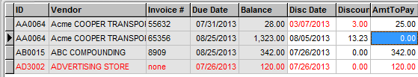
You can set the Amount to Pay to the Balance less the Discount by clicking on the item to select it and then pressing F8. Selecting the item and pressing F8 again will set the Amount to Pay back to zero. Pressing F8 will also step down to the next item. You can also use F7 (up) or F9 (down) or the keyboard arrow keys to navigate between items. You can click in the Amount to Pay field to enter a specific amount. Disc Date and Discount are displayed in red if the Disc Date has passed.

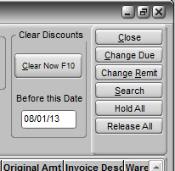
The buttons on the right of the header allow you to make a variety of changes. Clear Discounts will zero the Discount Amount of any item with a Disc(ount) Date before the date entered. The system will automatically take all discounts regardless of the discount date if you do not change them manually or use this feature. Use the Change Due button to access and edit the Due Date for the selected item using the calendar that appears. Use Change Remit to open a remit to selector sub-screen for the selected item vendor. Search will open a vendor selection list. If you select a vendor then only items assigned that vendor will be displayed. Search again and Cancel to display all items again.

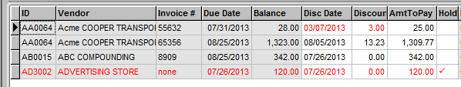
Items on hold will not be included in checks printed. An item on hold will be displayed in red. Items can be placed on hold when they are entered as payables and the hold will carry over to Check Preparation. Items’ holds can be set or removed by clicking in the field and then clicking again to change the setting. You can place holds on all items or remove all holds using the Hold All and Release All buttons. The system will print checks for any items with an amount to pay and no hold REGARDLESS OF THE DUE DATE so you must use one of these to prevent the payment of items you don’t want paid at this time.

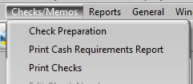
You can exit the Check Preparation screen at any time and the settings will remain as you left them. The system will print checks according to the settings at any given time. The next step in check printing is to run the Cash Requirements Report. This report will list the checks that you are about to print. If you find there are items or amounts that need correction you can return to the Check Preparation screen to make changes.

When you are satisfied with the checks that will be printed according to the Cash Requirements Report you can Print Checks. Once checks are printed you must void them or post them before you can setup new checks.

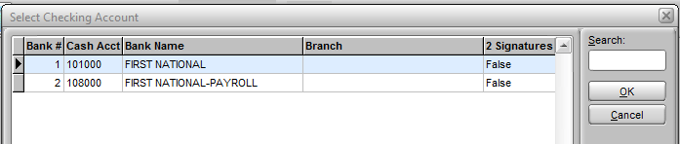
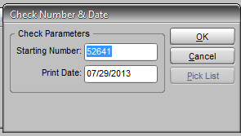
Printing checks is simply a matter of selecting a bank, verifying the starting check number and check date and printing. If you wish you can run a print to blank paper and then use Reprint Checks for the actual checks. Reprinting is also handy if there is a physical problem with the check printing.

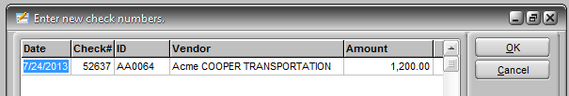
If you are using pre-numbered checks it may sometimes be necessary to change the numbers that the system has assigned to the checks after they are printed. You cannot assign a new check number if that number is assigned to another check in the run. If numerous checks were printed with the wrong check number assigned you will probably want to void them and print again.

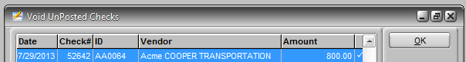
To Void Unposted Checks simply highlight the check you want to void and press the spacebar to flag it to be voided. Press the spacebar again to remove the flag. Note that if you void one check or all checks in a run you must still complete the check posting routine before you can return to Check Preparation. If all checks have been voided then nothing will actually be posted but you must still run the posting. Items paid on checks that have been voided will be returned to the preparation listing with zero amount to pay.

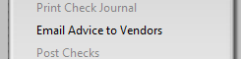
The Email Advice to Vendors program will use a special report that will be sent to selected vendor’s email addresses notifying them of your payment. Contact BCR support for additional information and assistance with this feature.

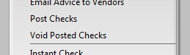
Once you are satisfied that you have printed checks correctly you must post them. Until they are posted, payables remain open and no posting is made to the GL.

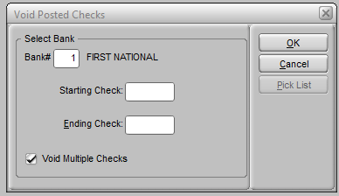
In the event you discover after posting that there is a problem with one or more checks you can void them. Simply enter the bank and check number. You can void a range of checks by checking the Void Multiple Checks box and entering starting and ending check number. Voiding checks will nullify all postings and return the payables to the Check Preparation screen

IMPORTANT! If you use both the Print Checks routine documented above, and the Manual Checks routine documented below, you should always complete either process through the posting step before you begin the other. If you enter manual check payment amounts and do not post them, and then use the Check Preparation and Print Checks program, the system will include the payables setup as manual checks in the check printing run with system assigned check numbers instead of the manual check numbers. Always post any manual checks before beginning a Check Preparation/Print Checks process.

In addition to, or in place of, checks printed using the routine described above, you can post checks to the system that you have created manually to pay bills. In order to enter a manual check an open payable must still have been entered in the system. If an item was not listed in Check Preparation it will not be listed as an item for payment with a manual check. For checks written for bills or purposes not associated with an invoice entered through accounts payable, you will need to use the Instant Check program. You cannot enter any manual checks if you have already run Print Check but not yet run Post Checks.

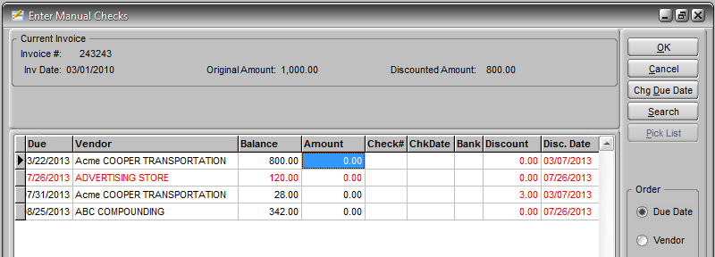
Payable invoices that are on hold will still be listed in red but that will not prevent you from entering them as paid by a manual check. Simply enter the amount paid on that invoice, the check number, date of the check, bank account the check was written on (if different from the bank you selected when you opened the program), and any discount taken. You can enter one manual check number next to as many invoices and amounts as appropriate and the system will total them as the check amount. You can also change the due date of an invoice from this program if you are not paying the invoice in full. Like the Check Preparation program, entries you make on the manual checks screen will remain there until you either post checks or change your entries.

Manual check entries are not finalized until you Post Checks. Use the same Post Checks program that you do for printed checks. If you do not post manual checks and you begin a check printing process, you will find that entries in the amount field are mirrored in the amount to pay field on Check Preparation and checks will be printed for those amounts. DO NOT START A CHECK PRINTING RUN WITHOUT FIRST POSTING ANY MANUAL CHECKS.

As with printed checks, In the event you discover after posting that there is a problem with one or more manual checks posted you can void them using the same program that you would to void printed checks.

The Instant Check program is designed for checks written for things that have not been entered as payables. This would typically be checks written immediately and for which there is no invoice entered into the system. While this could be anything, it would usually be for things like donations, small supplies purchases, one time services, etc. Instant checks can either be printed by the system or manually written.

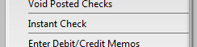

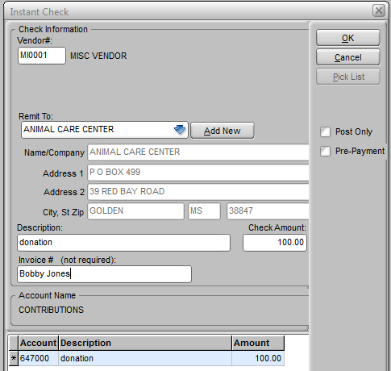
In order to post an instant check you must enter a valid vendor ID. If you do not want to create a vendor for payments to a company, organization or individual, you should create a “miscellaneous” vendor to enter. You will then need to select the remit to information, if this company has been used before, or you can use the Add New button to create a new remittance name and, optionally, address. The debit GL posting at the bottom will default to the GL account assigned to the vendor. Select a different account(s), typically an expense account, and distribute the Check Amount accordingly.
Note that after you select a remit to from the drop down, the name and address will not update until you click in another field.

If you check the Pre-Payment box the GL debit will be to the accounts payable account. This would be the equivalent of entering a debit memo to the vendor.
If you are writing a manual check then check the Post Only box. When you click OK the system will prompt you for a check number and date. Otherwise the system will print a physical check for you.

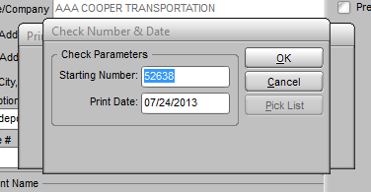
When you click OK, regardless of whether you are printing or just posting a manual check you will be prompted for a check number and date. You do not need to Post Checks. Instant checks are posted automatically.

The Print Check Register report in AP is not the same report found with the reconciliation program in GL. This report only lists checks, manual or printed, associated with a bank account. The check register in the GL module will list all entries associated with that bank account, including deposits, bank charges, etc. and is a complete ledger of the account.
