Charge order Warehouse Shipments

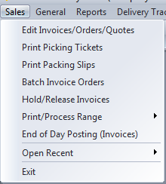

The order process flow starts with an order entered with an item that has an allocated quantity.

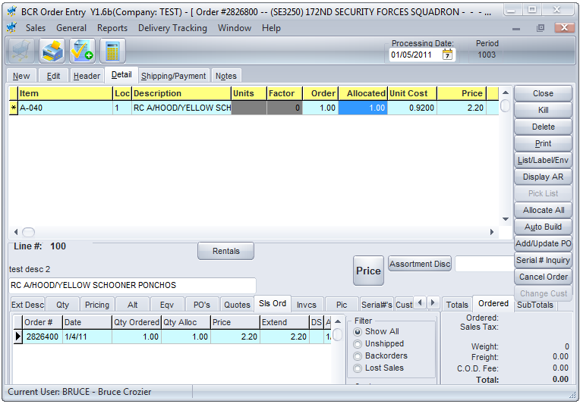

The system will automatically allocate from available stock but the order taker can change the quantity if necessary.



The warehouse can run the Picking Ticket program at any time.

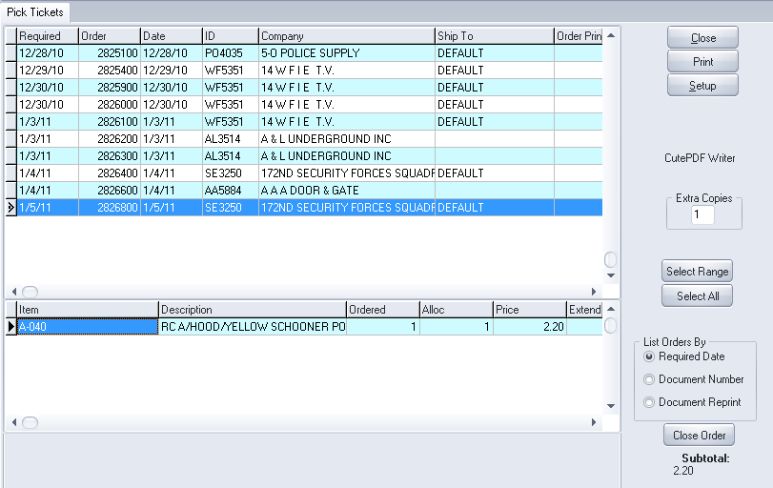

Any orders that have an item with a quantity allocated appear in the list. Individual orders, a range of orders, or all orders, can be printed.

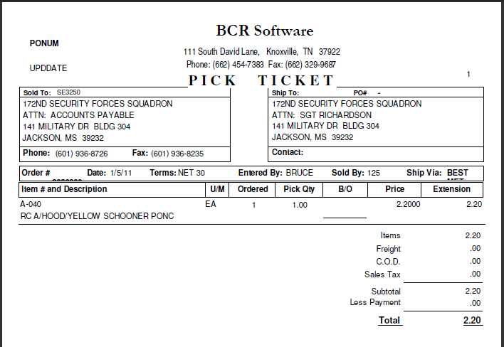

Quantities picked are confirmed or adjusted on the picking ticket manually and it is returned to the warehouse manager who checks to see if quantities were picked as expected.



The order may be edited in order entry if necessary to correct quantities.



Once the order is determined to correctly reflect the shipment, the warehouse manager runs the batch invoice program to create the invoice image of the orders picked. Quantities on invoices cannot be changed after this step, but prices can.

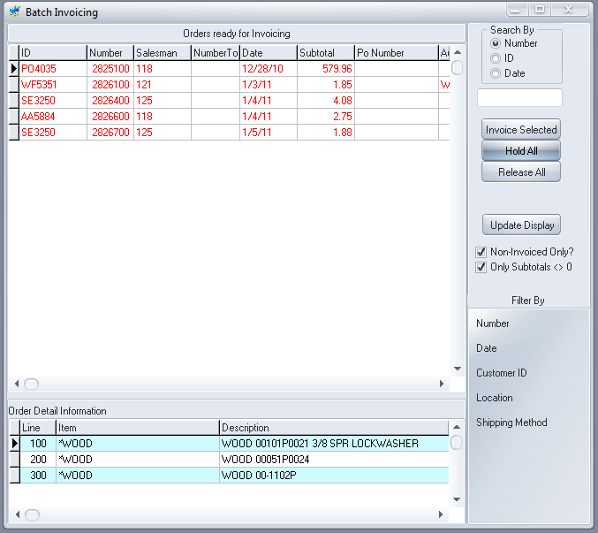

All orders with allocated quantities are listed but are on hold and displayed in red. Hold orders will not be invoiced. To release an order for invoicing the manager double clicks on it to change it to black, or releases all orders with the button provided.



The warehouse manager can then print packing slips.

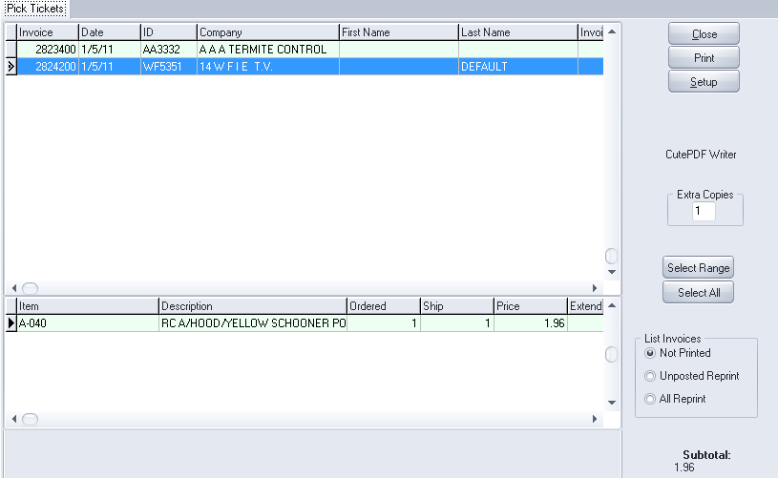

Shipments do not appear on the packing list program until an invoice has been created.

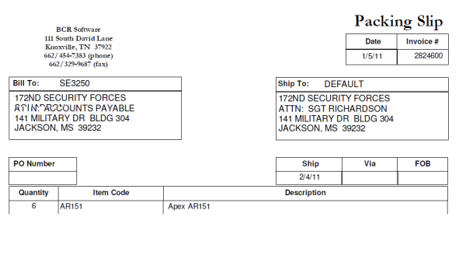



A manager reviews the invoices as needed and may edit them in order entry to change prices or other details before they are released and pre-posted. Invoices that are ready are released.

Periodically the Hold and Release program is run.

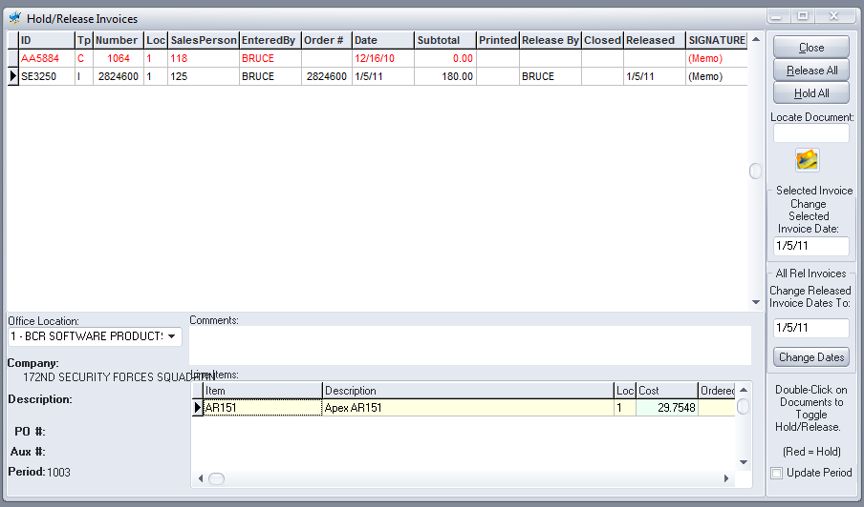

The manager is prompted to Finalize the released invoices. This step pre-posts the released invoices and no further edits can be made.

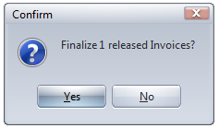



Finally the End of Day program is run.

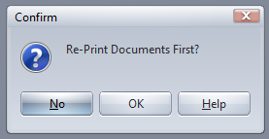

Invoices are printed at this point.

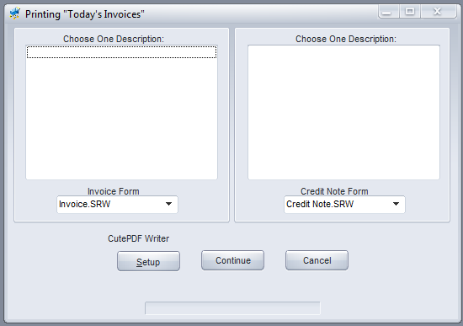

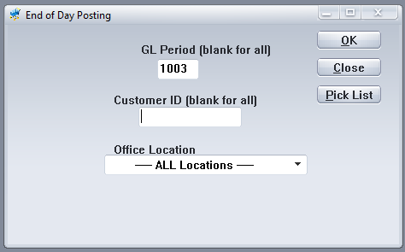

And then they are posted to the accounts receivable and as GL entry batches.