cash sales

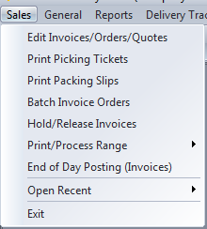

The cash sale process flow starts with an order entered for a “CASH SALE” customer account with an item that has an allocated quantity.

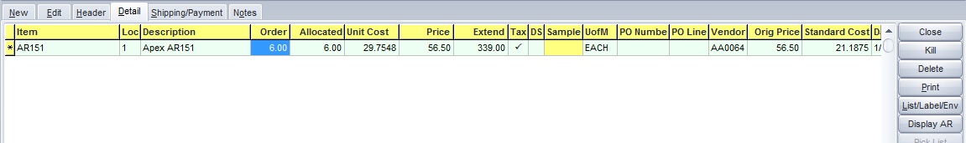

The system will automatically allocate from available stock. A cash sales customer is typically set to not allow backorders.

The amount tendered (cash, check or credit card) is entered on the Payments tab.

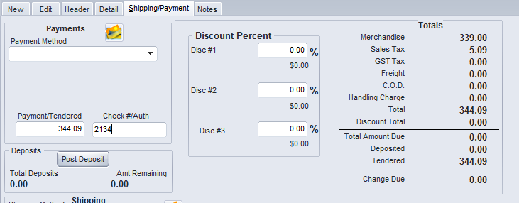

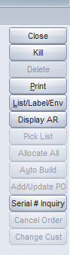

The Print button is used to Auto-invoice. This creates the invoice document. No changes can be made to the items or quantities after this.

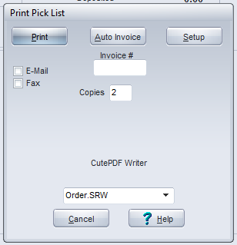

The invoice is then printed for the customer receipt.

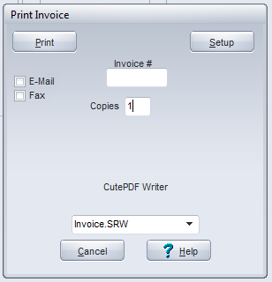

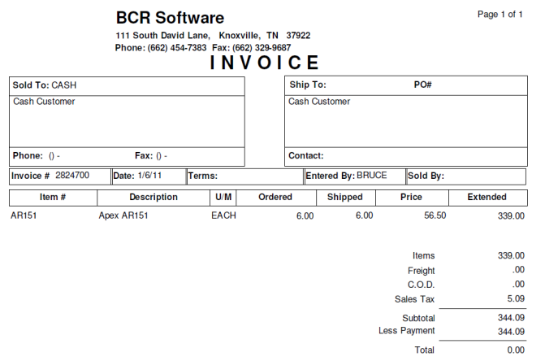



Periodically the Hold and Release program is run.

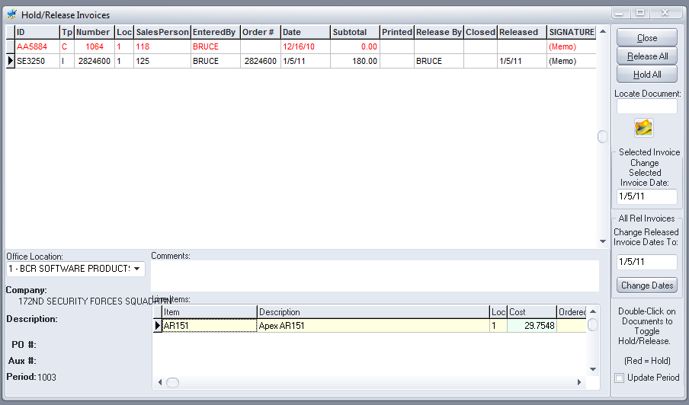

Cash sale invoices that have been auto-posted are included in the list for review. Invoices that are ready are released.

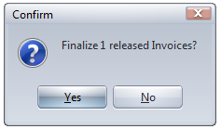

The manager is prompted to Finalize the released invoices. This step pre-posts the released invoices and no further edits can be made.



End of Day program can be run next or later.

If the form is designed not to print for zero balance invoices then cash sale invoices will not re-print..

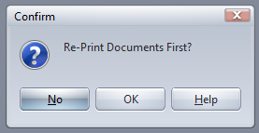

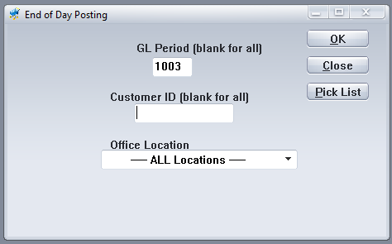

Cash sales and the cash received are automatically posted in and out of the cash customer AR, and a GL batch for posting to the GL is created.