Auto-Create Purchase Orders

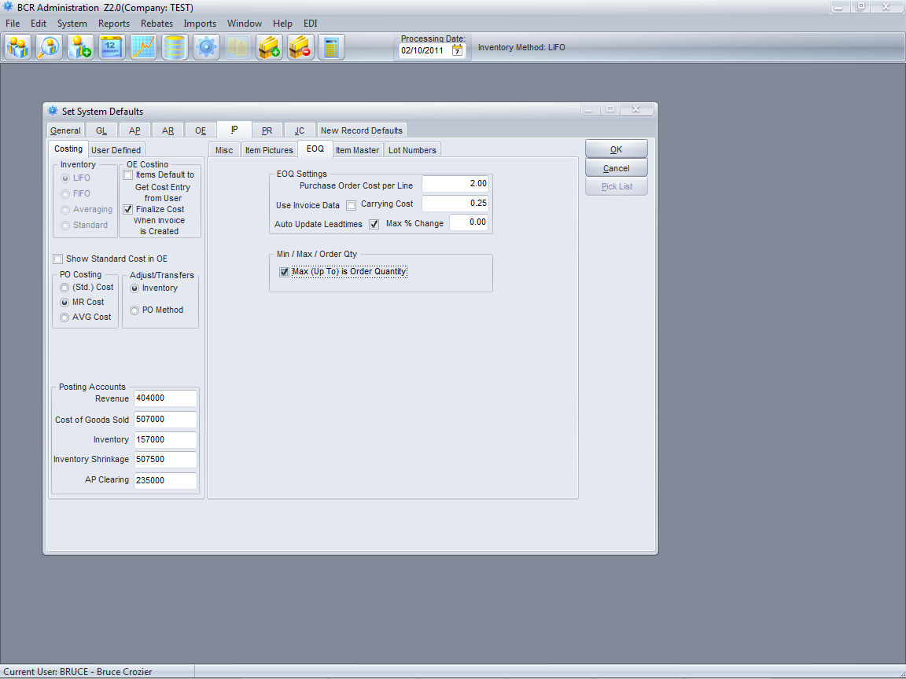

Normally an item Maximum is considered to be the “order up to quantity,” i.e., the current available and On PO subtracted from the Maximum is the suggested order quantity. In order to have the MAX function as the actual order quantity rather than an “order up to” quantity, the System Defaults IP tab must have the Max (Up To) is Order Quantity checkbox checked.

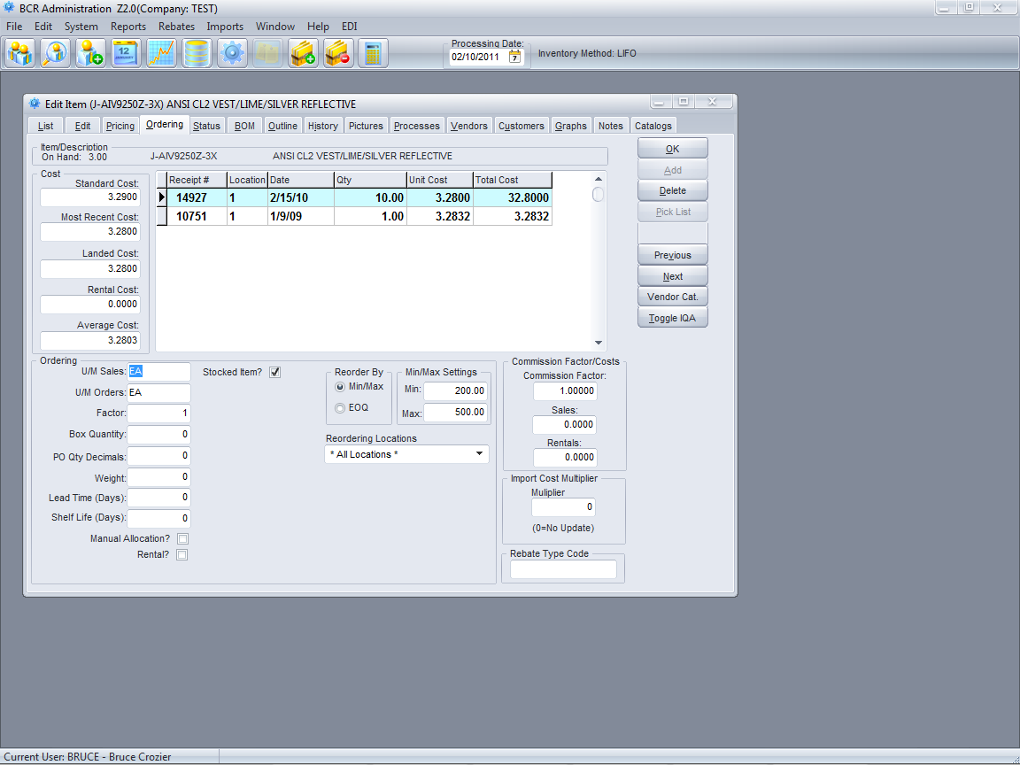

All items should have the Reorder By Min/Max option selected in Edit Item the Ordering tab.

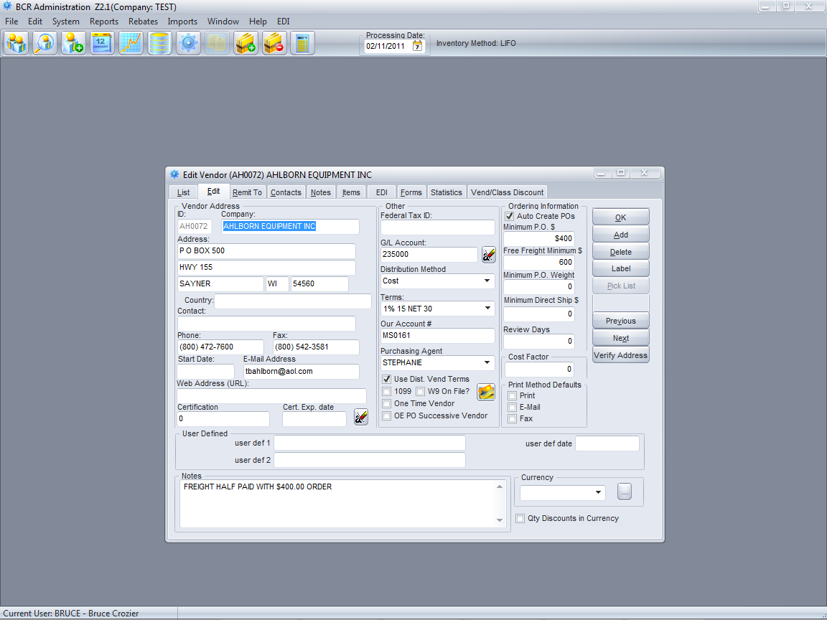

All vendors that you wish to auto-create POs for must have the Auto Create POs checkbox checked on the Edit tab in Edit Vendors.

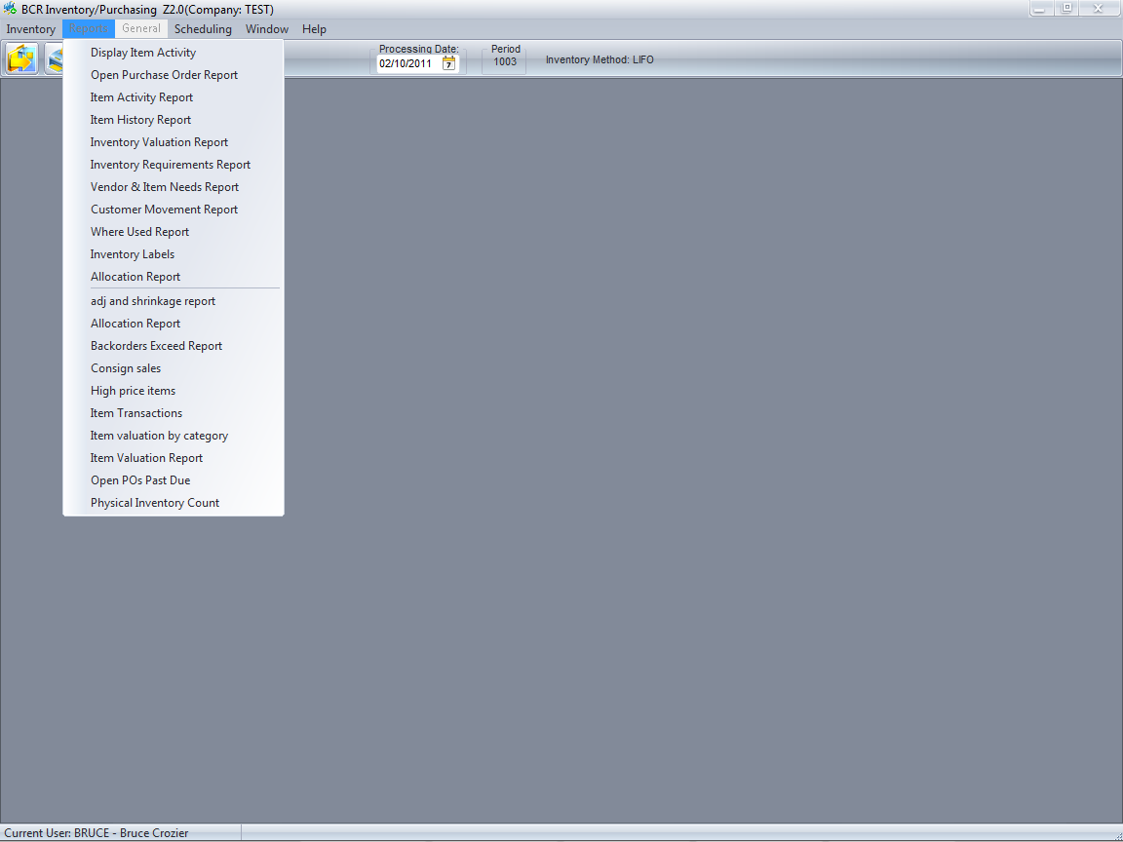

There are three primary ways to generate POs based inventory levels. If you first want to start with a report to see what POs might be generated via any of these methods you can run the Inventory Requirements Report. It is not necessary to run this report in order to auto-create POs using any method. It is simply a way to preview what items might be suggested on an auto-created PO.

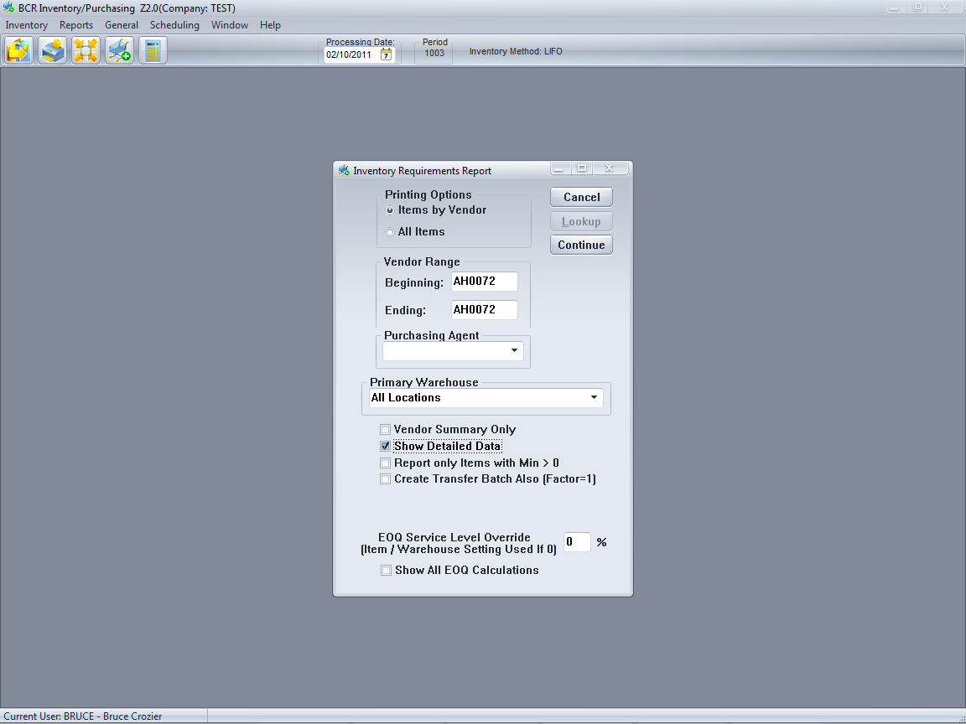

You can print the report or just view it on the screen. The report will list only items that are either below their minimums or have backorders outstanding. If MAX is set to be the order quantity It will recommend you purchase the MAX. Otherwise it will recommend you order up to the MAX.

You can run the report for all items, one vendor, a range of vendors, or only items assigned a given purchasing agent.

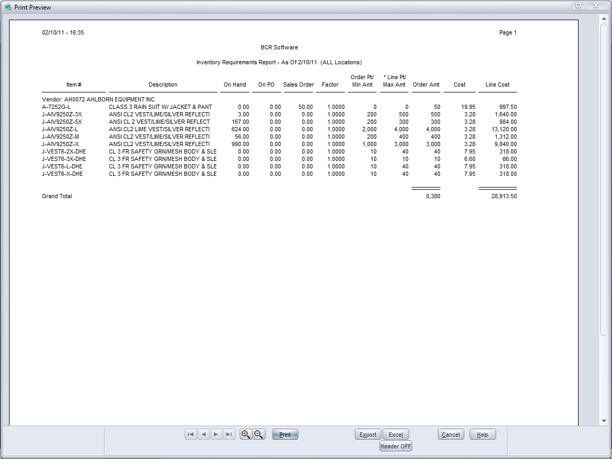

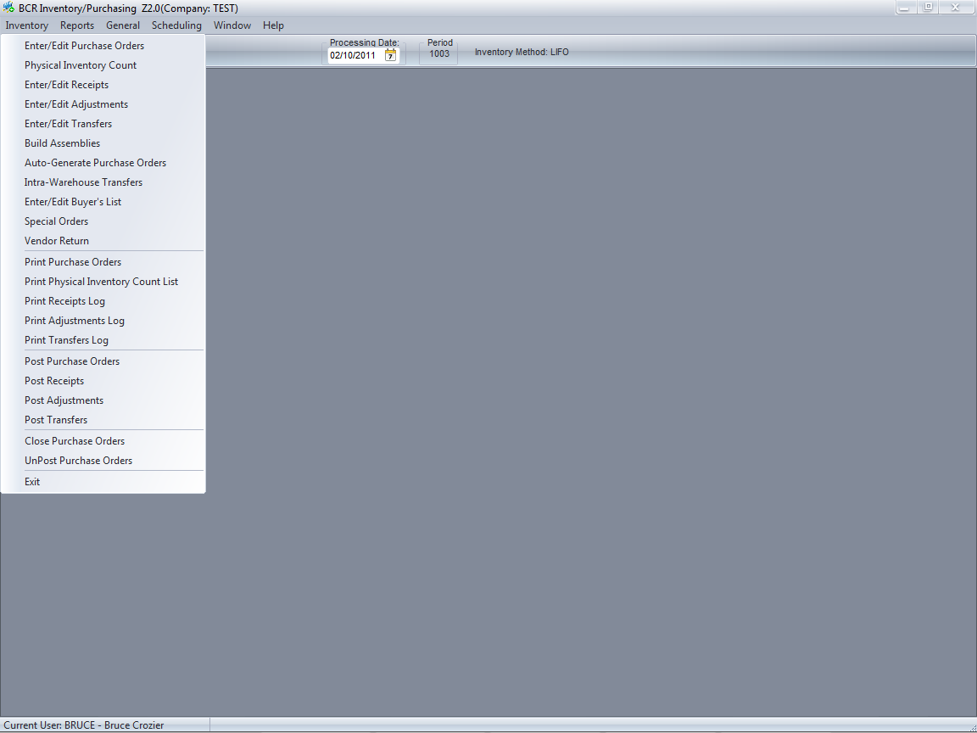

The simplest way to auto-create a PO for a single vendor is to start with a new PO in the Enter/Edit Purchase Orders program.

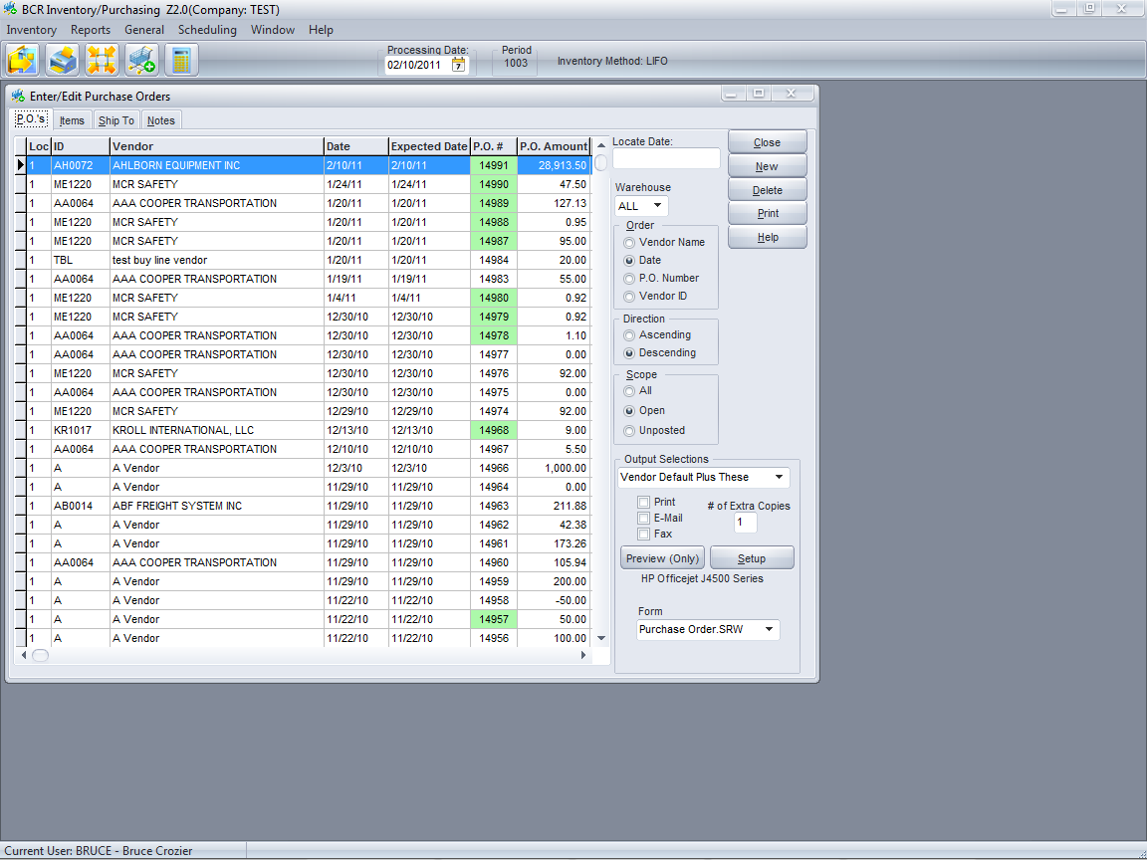

Click the New button and then select the vendor you wish to create the PO for.

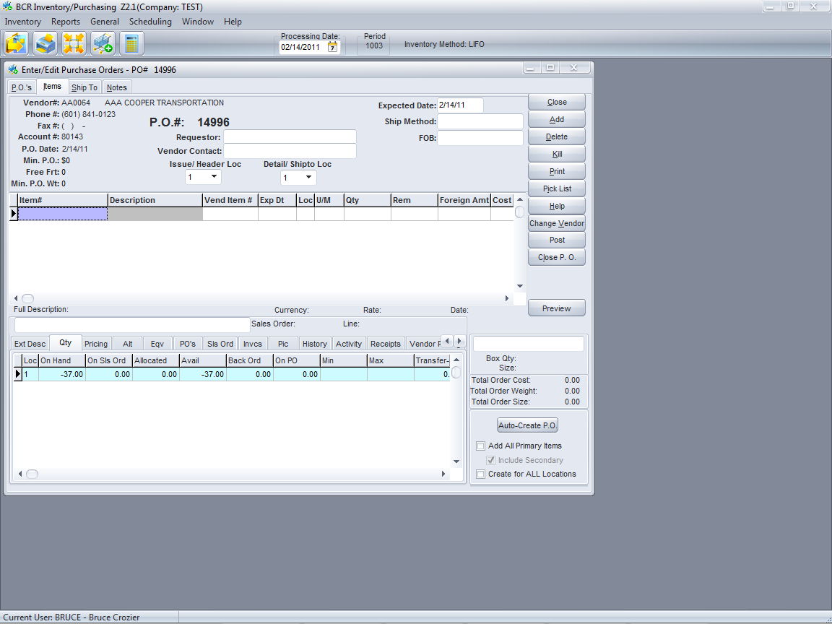

Select the options that will determine which items will populate the PO and then click the Auto-Create PO button. Add All Primary Items will populate the PO with all of the items assigned that vendor as the primary vendor regardless of their inventory levels or settings. Include Secondary will add items assigned that vendor as a secondary source. If these boxes are not checked then only items with recommended purchase quantities will populate the PO. The PO must be “posted” before the On PO quantities will be updated.



If you want to create POs for a number of vendors at one time you can run the Auto-Generate Purchase Orders program. NOTE: The Inventory report and this program are not linked. You can run the Auto-Generate program at any time and it will create POs using the same criteria as the report does for listing items. The report does not “queue” items for the Auto-Generate program.

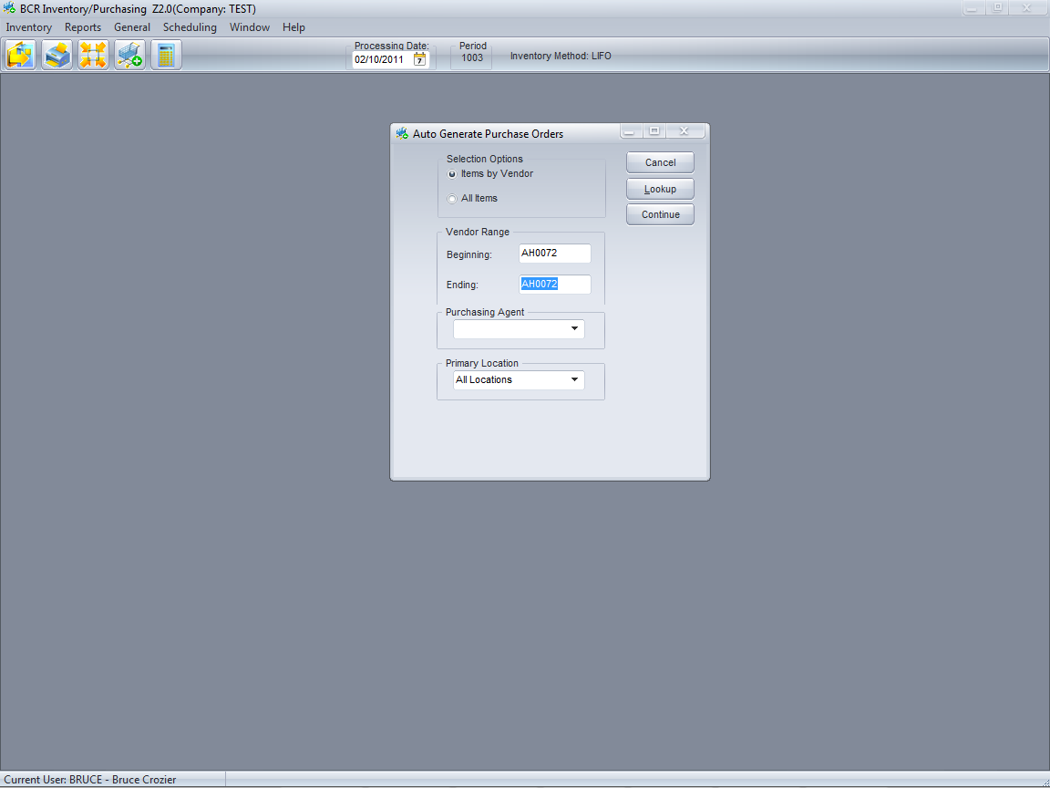

Just like the report, you can auto-create POs for all items, one vendor, etc. POs created will appear as auto-created (green highlighted) POs in the Enter/Edit Purchase Orders program (see below.) POs created are not “posted” and so they can still be edited.



You can also use the Buyer’s List program to generate POs. This program takes a worksheet approach to buying, allowing you to see a list of items that need to be purchased and allowing you to make decisions about items on an interactive screen that gives you a wide range of information before generating POs.

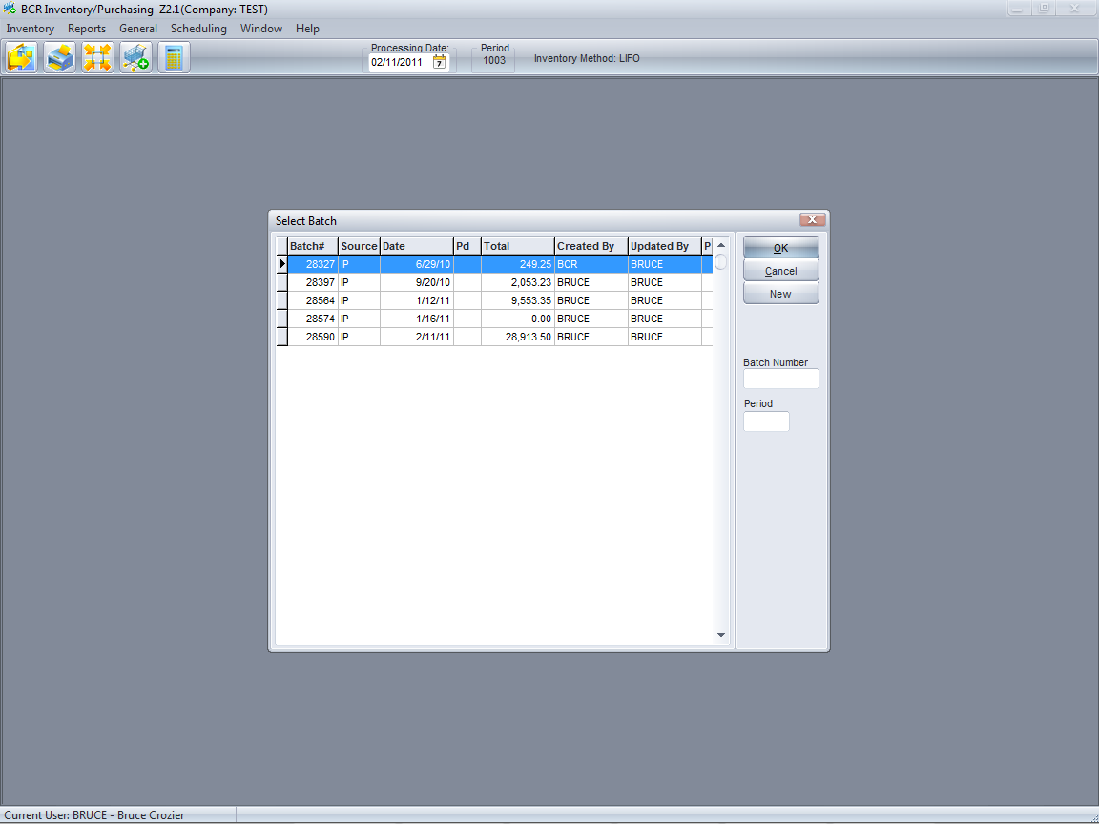

The initial screen prompts you to select an existing list (Batch#) or to create a New one. Lists are retained until they are deleted (Kill Batch.) If all of the items on the list have been purchased on a PO created from that buyer’s list, the empty batch will still be listed. So a list can be worked on and returned to later. But the recommended quantities are not updated once a list is created, so old lists may contain out of date information. The Total displayed is the total of quantities that you have set on the list to be purchased (Purch Qty.)

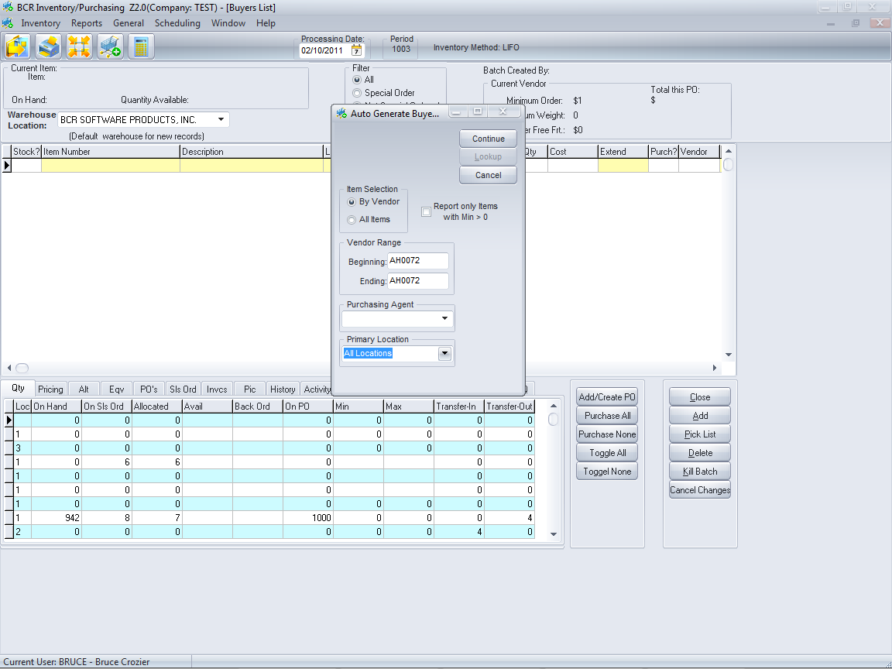

Buyer’s Lists are created just like the Inventory Requirements Report and Auto-Generate POs.

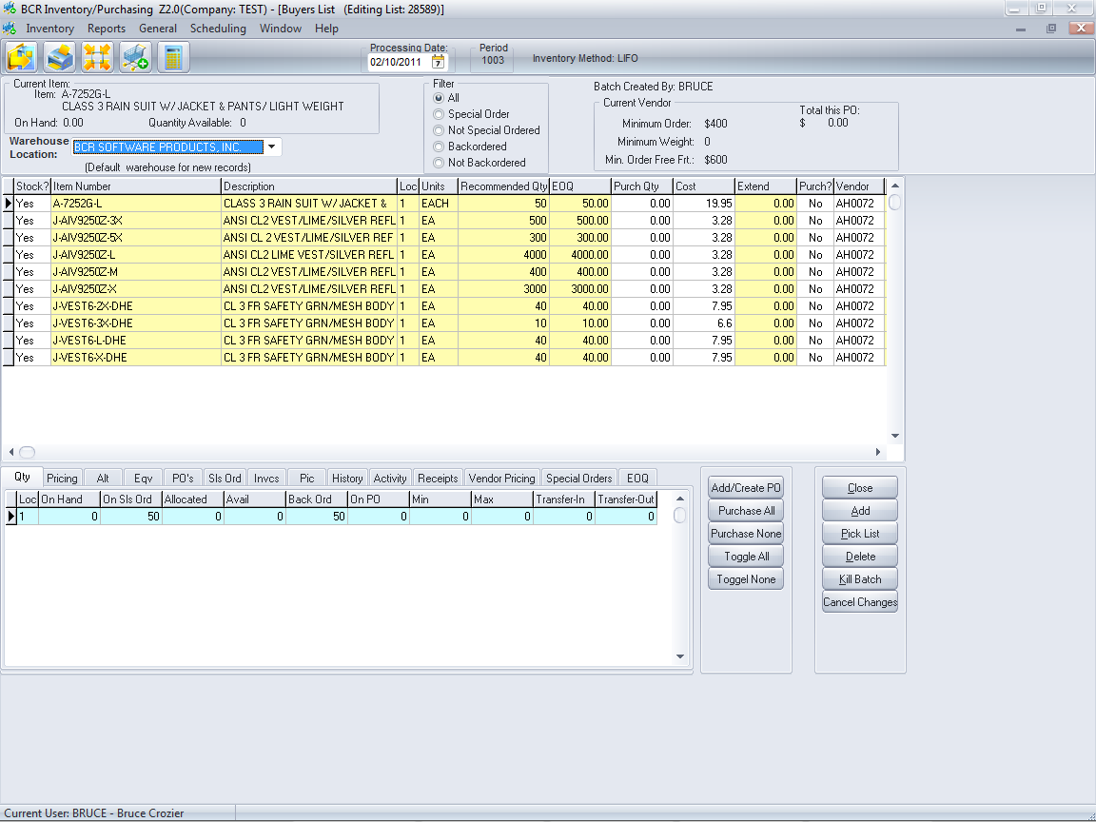

The items listed will be the same as those that would be listed in an Inventory Requirements report. The Recommended Qty will be the MAX/Order Qty if the items are set for that method. The Purch Qty will be 0 initially and the Purch? column will be No for all items listed. There must be a quantity in Purch Qty and the Purch? must be Yes for an item to appear on a PO.

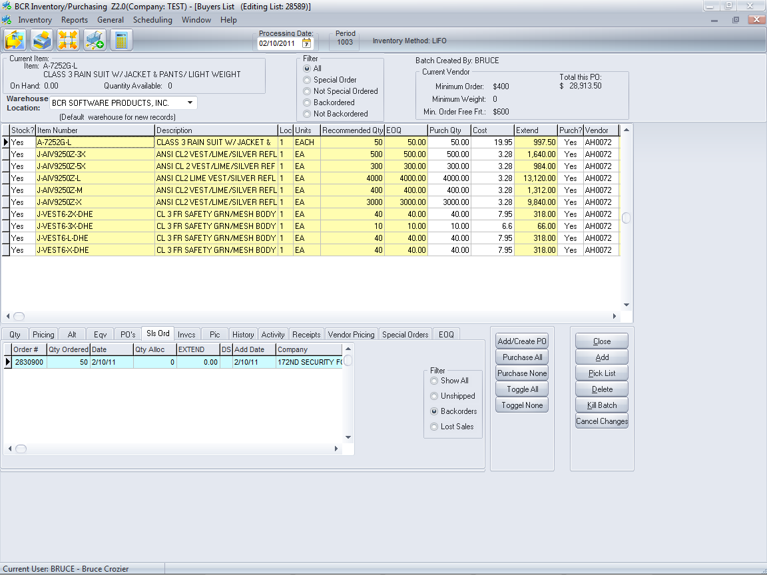

The buttons at the bottom of the screen can be used to quickly set all items to purchase or not. Purchase All will set all item Purch Qty to the Recommended Qty and Purch? to Yes. Purchase None will reverse that. Toggle All/None only changes the Purch? Yes/No. You can also double click the Recommended Qty to set the Purch Qty and double click the Purch? field to toggle its value. And you can simply type a quantity into the Purch Qty field.

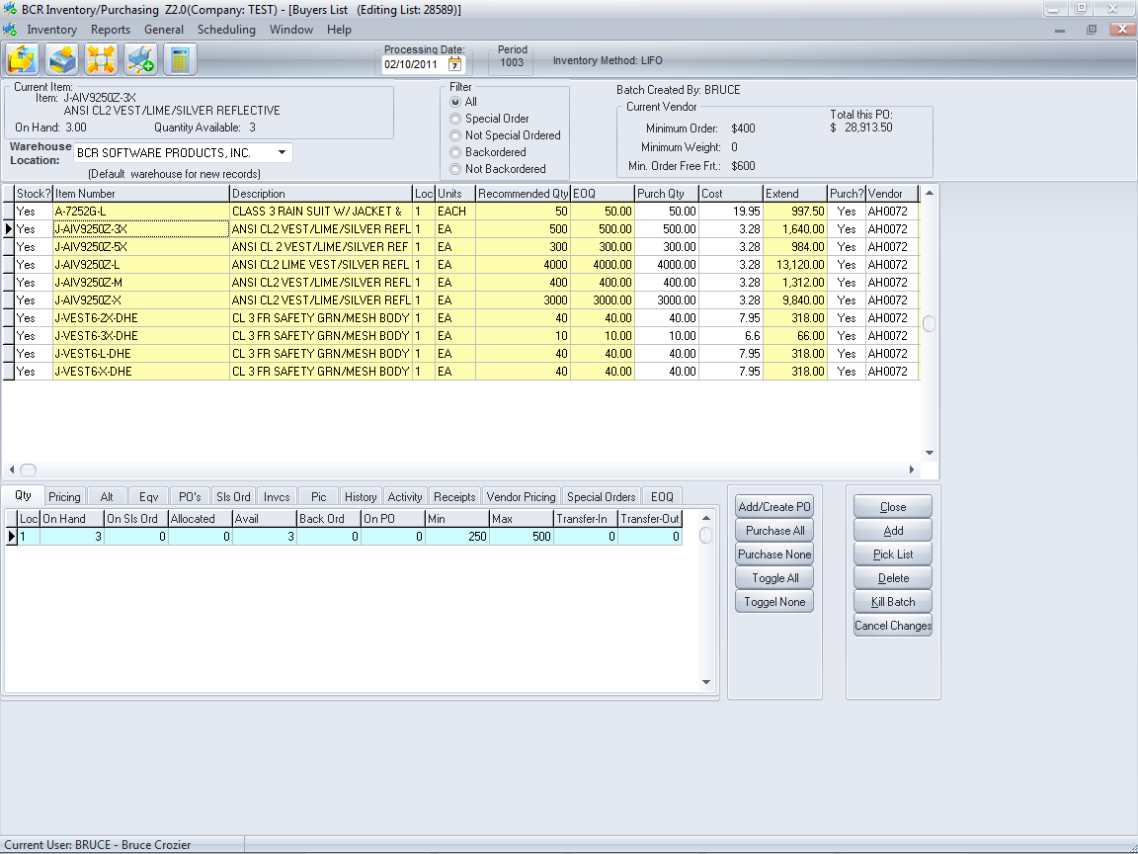

The tabs at the bottom of the screen relate to whatever item is currently selected. There is a wide variety of information available in these tabs. Note that the information on the tabs is always current, regardless of how old the list is.

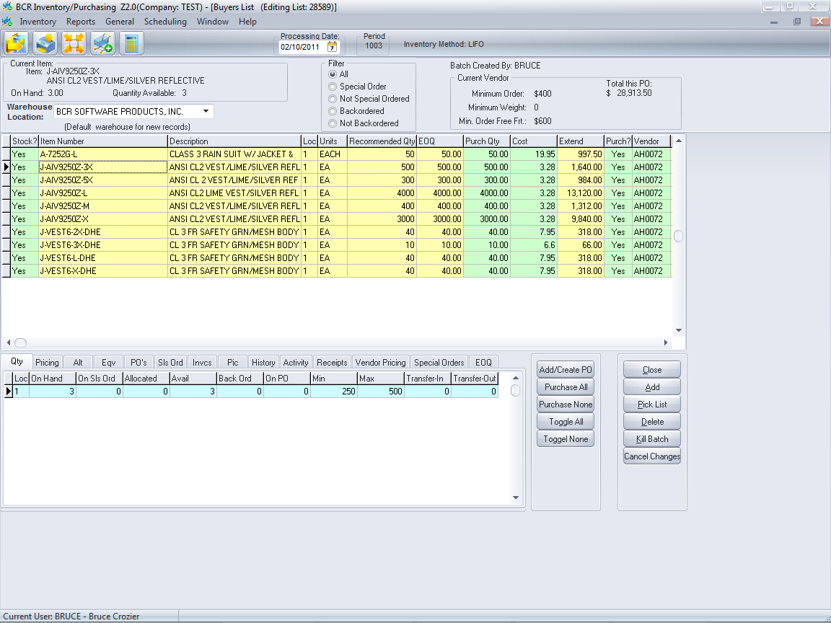

When the items have their Purch Qtys set and if the Purch? field is Yes, then the Add/Create PO button can be used to generate a PO. If there is an existing un-posted PO you will be given the option to add to that PO or create a separate new PO. Items that have been placed on a PO will now be displayed in green. Unless there is an expectation to return and create another PO, the list would typically be killed. The exception might be if you have formed a list for multiple vendors. When items from multiple vendors have purchase quantities, multiple POs are created.



The POs that have been “auto-created”, through order entry, auto-generate, or buyer’s lists, are marked in green. (POs created from with Enter/Edit Purchase Orders using the Auto-Create button are not considered auto-created.) Even though a PO has been created, any of the auto-create PO methods details above will continue to suggest those quantities be purchased. Not until a PO is posted will the On PO quantity for an item be increased and reflected in inventory levels and considered in suggested purchase quantities.

The new POs can be found in the Enter/Edit Purchase Orders program.



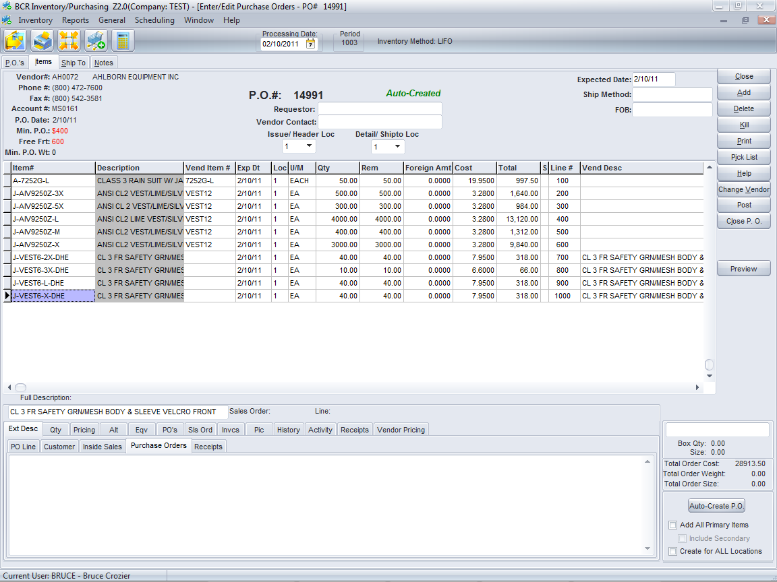

A PO that is auto-created can be edited as needed. Items can be added or deleted and quantities can be changed. Once a PO is posted it can no longer be edited and the On PO quantity of items will be updated. The UnPost Purchase Orders utility can be used to reverse the PO status if necessary.