Adding charges at time of receipt
Normally freight in costs are expensed or, if you are trying to track your inventory as a “landed” cost, it is applied to inventory instead of as an expense, at the time you post the freight bill as a payable. But if some of the items you purchase have relatively high freight or duty costs, such as imported goods, you may wish to apply the added costs, as actual charges or as estimates, as soon as you receive the goods so that you know your landed or average cost before you sell the goods. To update the cost of inventory to reflect additional freight or duty charges on receipt of goods, rather than at the time you post the payable, follow these steps. The order that the invoices for goods or other charges are entered as payables does not matter. The entry remains the same regardless. Note that failure to follow the steps below precisely may cause incorrect entries in your GL and incorrect average and landed costs.
The steps can be summarized as follows:
- Add the estimated freight/duty charges to the receipt at the time you do the receiving.
- Post the goods invoice to AP and reconcile it to the goods on the receipt, leaving the freight/duty amount open.
- When you have the actual freight/duty invoice, adjust the estimated amount on the receipt to reflect the actual amount.
- Post the freight/duty invoice to AP. Do not reconcile to the receipt but make certain that the amount posted to AP clearing equals the amount entered on the receipt.
Here is a detailed description of the steps:
- At the time you create the receipt enter the anticipated additional charges in the freight field at the bottom of the screen and post the receipt. This will immediately update the average cost including the additional charges (proportionate to the costs.) It will also debit inventory and credit AP clearing for the total of both goods received and the freight at the bottom in the GL.

- When you post the goods invoice reconcile it to the receipt(s). Do not adjust the receipt unless you need to change item costs on it. This will debit AP clearing and credit AP payables for the amount of the invoice and it will flag the reconciled receipts as “paid”, i.e., entered for payment.

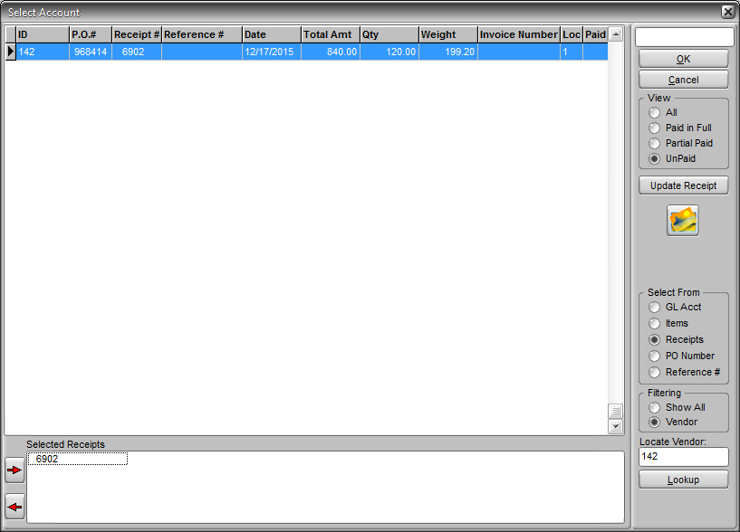

- If you did adjust costs on the receipt or posted a goods invoice that did not match the costs on the receipt, the system will determine if the goods are still in inventory or not. If they are it will post the change (+/-) to inventory and AP clearing. If they are not it will post the change to COGS and AP clearing. This may produce a number of postings to GL since each item will be considered separately.

If the receipt you are reconciling has a freight amount added to it the system will ask you if you wish to include the freight amount as reconciled to the invoice being posted. If the freight was included on the goods invoice by your vendor then you would respond Yes. If you will be posting the freight bill separately then you would respond No.

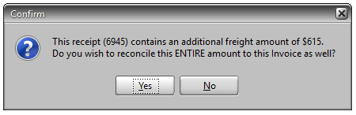

- When you post an additional charge invoice (freight or duty) if the charge is the same as the anticipated charge originally added at the time of receipt you DO NOT need to reconcile or adjust the receipt. Do not change the Dist Vendor to the goods vendor. Simply post the payable as you would any non-goods expense invoice but be sure that the distribution at the bottom is to AP clearing and not an expense UNLESS the invoice is for more than the charges related to receipts, such as freight out. Then the distribution to AP clearing must equal the amount added to the receipt and the remainder to the other expense. If the distribution does not match the amount added to the receipt then an amount will remain in your AP clearing account and never clear.

- If the additional charge invoice is different from the anticipated go the Enter/Edit Receipts in Inventory/Purchasing and change the amount on the receipt to match the invoice. This will adjust the average cost of items and debit or credit inventory and AP clearing as needed. If the invoice received completes the billing for that receipt then mark it as complete. If for some reason you need to adjust it again at a later date you can reverse the completion flag and adjust again. Keep in mind that this must match the distribution to AP clearing when an invoice is entered. Then follow the same steps as above to post the freight invoice in accounts payable. You can also post the invoice before adjusting the receipt. The order of these steps does not matter.

