Accounts Receivable Payment Entry

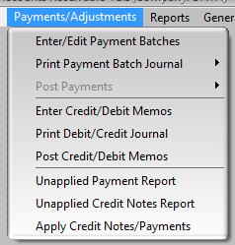

Customer payments are entered using the Enter/Edit Payment Batches screen. Payment cannot be applied to an invoice until the invoice has been posted to AR via the Post Invoice Batches program in the AR module or, if the System Defaults posting option is set, via the End Of Day program.

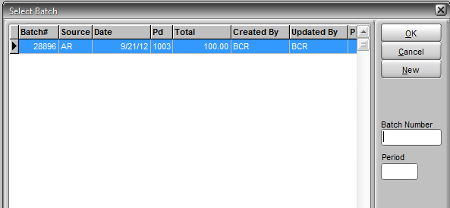

Multiple payment batches can be created and left "open" (i.e., unposted) to be edited later. Select an existing batch and click OK or click New to create a new batch. Once a batch is posted it is no longer listed.

To begin a new batch edit the Batch Date and Period if necessary. Normally the default of the current period is not changed but the date may be changed if payments were received in the past. For example, batches might just be entered weekly but as a separate batch for each day of the prior week to correspond with deposits.

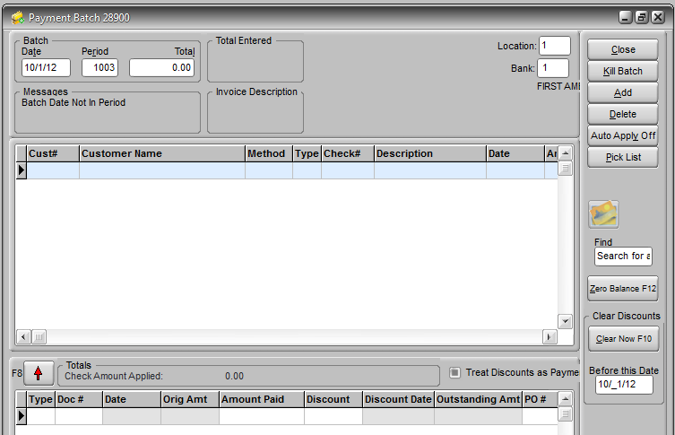

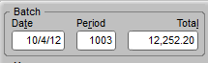

Enter the total of payments received that will be posted with this batch. This amount would typically equal the total of all receipts (cash, checks, and credit card charges) on that date. You may choose to create separate batches for CC charges, especially if they are debited to a different bank and GL account. The payments credited to AR accounts, not including discounts, must equal this total.

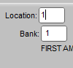

The office Location and Bank can be changed if necessary. The bank should be where the funds will be deposited and be assigned the cash GL account to be debited. The default Bank is set in System Defaults>AR under Payment Batches settings.

Before you begin to enter any payments you may want to click the Auto Apply Off/On button. The default for this button is always Off, which means that you must apply payments to invoices manually for each customer. If you click the button to turn Auto Apply On, then the payment amount will be applied to the oldest invoices automatically until it is exhausted. Then you can make manual changes as needed. You can turn the option on or off before entry of a payment for each customer. Auto Apply On generally speeds up the entry process for most users.

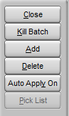

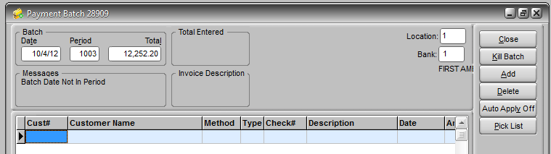

Enter a customer ID, or double-click in the cell or click the Pick List button to display a customer selector screen. **NOTE:** As you enter information in this grid the most efficient navigation is to press Enter after your entry in each field. This will automatically take you to the payment application grid after you enter the payment amount.

After you've entered the Total and changed any other header fields if necessary, then click the first Cust# cell of the grid below.



After a customer is selected the customer name, payment method, the default AR GL account, and Location will pre-fill. Type is used for credit card payments. Enter the Check# if applicable and any Description of the payment if desired. The Date will pre-fill with the Batch Date entered but can be changed for individual payment entries. The Order# and CC (credit card) Batch fields are optional.

After you've entered a payment Amount and pressed Enter, if the Auto Select Invoices option is on (System Defaults>AR under Payment Batches), the grid below will automatically fill with all of the customer's open receivables. If not you will need to enter invoices manually and Auto Apply will have no effect. If Auto Apply was On before you entered the payment Amount, then the amount will be applied as the Amount Paid beginning with the oldest (topmost) invoice and so on until all of the Amount has been applied.

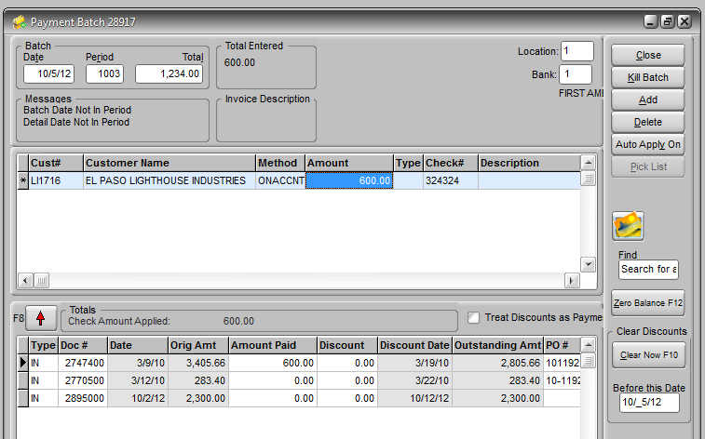

**Note:** When Auto Apply is used the system assumes that you DO NOT want to credit the customer for a payment term Discount that is past the Discount Date, though you can manually add the discount back in if you wish. And you can manually adjust the Amount Paid for any invoice.

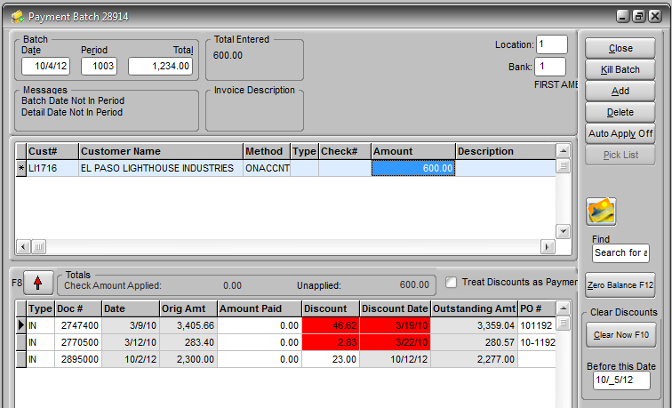

When the open invoices for the customer are displayed, and Auto Apply is Off, then any payment term discount that may have been offered on an invoice is displayed regardless of the Discount Date. Discounts that are past their Discount Date are displayed in red. You can clear discounts up to a certain date (the default is today's date) by pressing F10 or the button to the right.

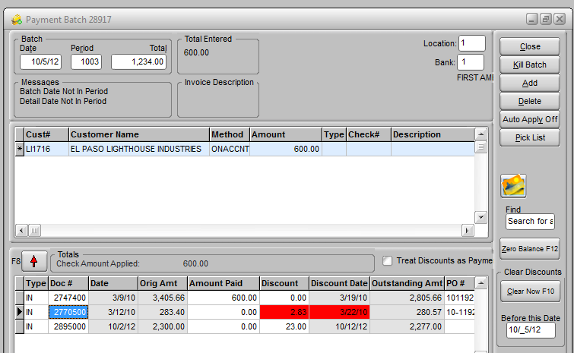

If Auto Apply is not used then you must apply the payment amount manually. You can pay an invoice by simply double-clicking in the Amount Paid field (or press F12 or click the Zero Balance button with any cell of the row highlighted.) If there is sufficient unapplied money available then all of the invoice will be paid. If not, then as much unapplied money as available will be applied, leaving the remainder of the invoice balance open. Or you can always just enter a specific amount in the Amount Paid.

**NOTE:** If there is a Discount displayed, whether it is within or beyond (red) the Discount Date, when you apply using the double-click, F12, or Zero Balance button, the Discount IS ALLOWED on the invoice. You can enter a zero in the Discount field if you want to disallow it or use F10 to Clear Discounts before applying payments.

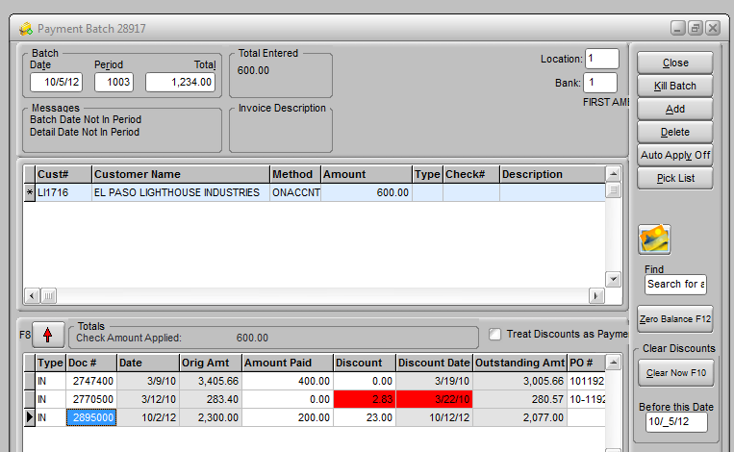

If you do not have Auto Select or you have a long list of invoices to search through to find the one you want to apply payment to you can simply enter the invoice number in any Doc# cell to access that invoice and apply payment. If Allow Order Number Entry is turned on (System Defaults>AR under Payment Batches) then you can also enter order numbers instead. You can double-click in the Doc# field to display an invoice selector screen with a search box. When you have applied all of the Payment amount entered for that customer then just press F8 or the red arrow button to return to the grid above with a new line prompting for another customer payment entry.

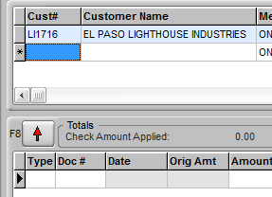

When you have applied all of the Payment amount entered for that customer then just press F8 or the red arrow button to return to the grid above with a new line prompting for another customer payment entry.

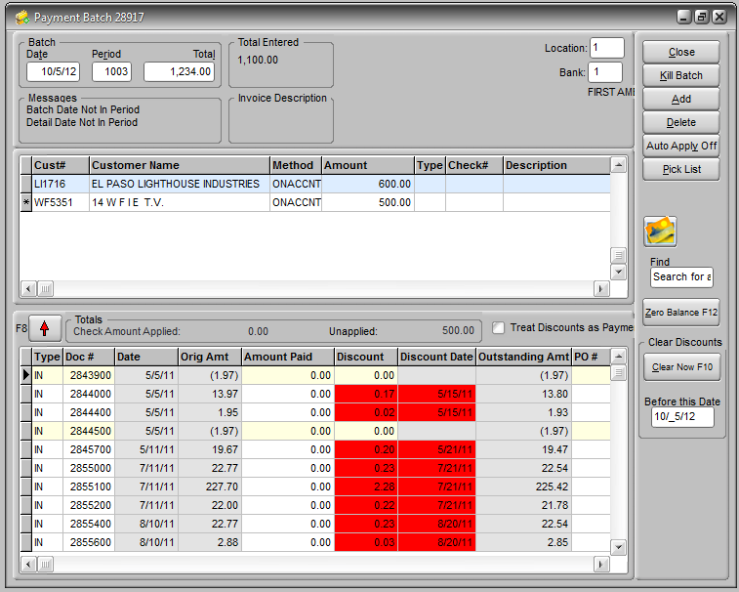

As you enter customer payments and apply them the screen will display the total of payments entered versus the batch total and the amount applied and unapplied for the current customer.

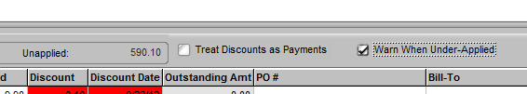

If the Warn When Under-Applied option is turned on, either as a System Default (AR>Statements tab) or manually using the option box on the entry screen, you will be warned if you attempt to move on to another customer payment without fully applying the payment amount. **NOTE:** You can leave an amount unapplied and the system will automatically create an unapplied credit in the customer's AR. This credit can be applied at a later date to new invoices.



If Treat Discounts as Payments is checked then all discounts not zeroed will be taken even if no payment is applied to the invoice. This will be true for all customer's with payments applied in this batch. This option is typically only used in special situations.

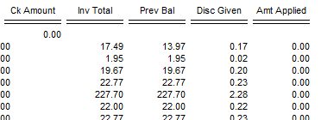

You can use the Add and Delete buttons to add or remove customers or invoices from their respective grids. Note that deleting an invoice line from the invoice grid DOES NOT remove the invoice record from receivables. It only removes it from the display. If you close the batch and reopen it, if Auto Select is on it will display the invoice again.

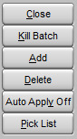



You can Close a batch at any time, even if you have not allocated all of the batch total amount to customers. You will not be able to post batch payments however until all of the batch total is entered as payments from specific customers. You can reopen the batch at any time before posting it to complete entries. If you kill a batch it will delete the entire batch entry. This DOES NOT reverse any AR entries since no entries are made until the batch is posted.

Once you're satisfied that the batch is correctly entered and ready to be posted you must at least view a copy of the Payment Batch Journal.

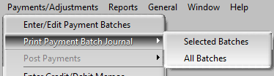

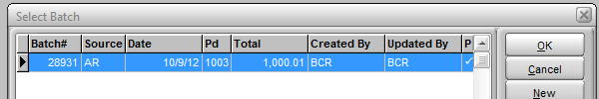

After you have viewed a journal report for the batch the batch will be flagged as printed in the batch listing. If you reopen the batch and make any changes, the flag will be removed and you will need to view the report again before you can post the batch.

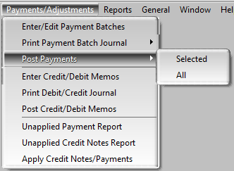

After you have viewed the journal the Post Payments selection will be available. Posting a batch updates the accounts receivable of the customers and creates the GL batch entry for posting to the general ledger.