Accounts Payable Invoice Entry

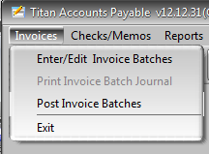

Accounts payable invoices are entered using the Enter/Edit Invoice Batches screen. Vendor invoices for goods are typically reconciled to purchases in this process. Invoices for other expenses are posted to the appropriate GL expense account.

After a batch is created and all entries total the batch total and are distributed to GL accounts, the Print Invoice Batch Journal must be run. Then the Post Invoice Batches is run to make invoices eligible for payment through the check preparation and printing routine.

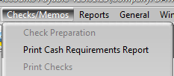

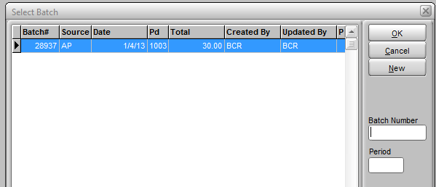

Typically invoices are entered periodically as batches, though they can be entered individually as well. When a batch it entered it remains on file until it is printed and posted or deleted. A batch can be partially entered and returned to at any time until then.

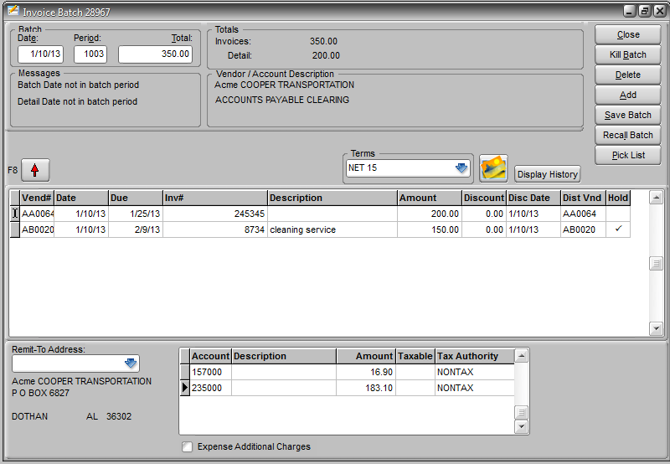

The date and period of the batch can be changed if necessary. Otherwise the first entry is the total of all invoices to be detailed in the batch. You cannot post a batch if the batch total and the individual invoices entered do not equal. The total of the invoices entered is displayed to the right of the total entered.



After entering the Batch Total, press enter to begin entering invoices. After each field entry in the invoice detail grid, press enter to proceed to the next field. The first prompt is for a vendor ID. You can use F5 or Pick List to access a vendor lookup screen. The date will pre-fill with the batch date and will be used in conjunction with the vendor Terms to calculate the Due date and Disc(ount) Date. The Terms field will default to the preset vendor terms for that vendor, but can be changed using the dropdown. Or you can override the date and discount fields manually. The Inv# field must have an entry. The Description field is optional but can be pre-filled based on the setting of the Invoice Description Default setting on the AP tab in System Defaults.



If you have DocScan you can scan the vendor’s invoice while you are on the invoice detail line. You can click the Display History button to view the Display Invoices inquiry.

The vendor entered is the vendor that will be paid. If the vendor is not the vendor from whom goods were ordered, as in the case of a buying agent, then you can enter the PO vendor as the Dist Vnd (distribution vendor). When you go to distribute the amount the system will look up receipts from the distribution vendor instead of the payment vendor.

While on the invoice line you can select a different remit address on file for the payment vendor using the dropdown in the lower left corner.



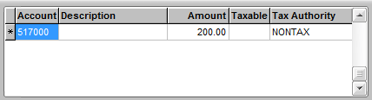

After you hit enter from the Dist Vnd field, the next prompt will be for an account in the payable debit distribution grid. The credit posting is to the accounts payable account in system defaults. If there is a GL Account set for the vendor then the initial debit is posted to it. Otherwise there is no initial posting and you must select accounts and amounts for the posting.

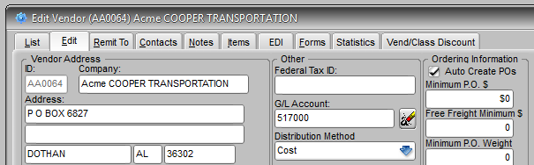

AP Clearing AP

When a PO is received and posted the standard posting of the software is a debit to increase inventory and a credit to increase AP clearing. AP clearing is typically a liability account that holds purchase amounts until the vendor invoice arrives. The invoice for goods then increases accounts payable with a credit and removes the amount from AP clearing with a debit. If the invoice is greater than the amount anticipated and posted from the PO receipt, then the difference must be accounted for by either adjusting the receipt or allocating it to a separate expense, usually freight. If the difference is not accounted for with an adjustment to the receipt or allocated to an expense, then it is posted to the inventory account. If the invoice is not for purchased goods (inventory), then there is no amount in AP clearing to be debited and the debit is typically posted to an expense account.

Or

AP Clearing AP

and Freight

Or

AP Clearing AP

and Inventory

Or

Expense AP

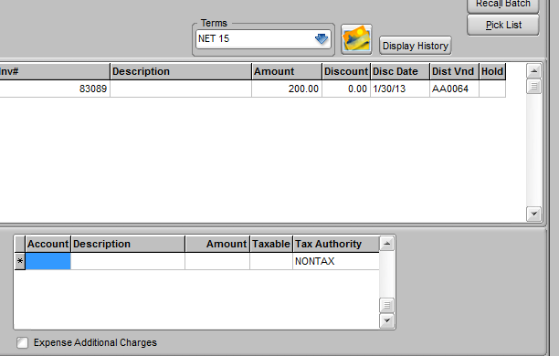

If the vendor default expense GL account is not the correct distribution then you can manually enter a distribution. If the invoice is for inventory you will probably want to reconcile the invoice amount to the appropriate purchase receipts. To select receipts click the Pick List button from the Account field.

NOTE: Additional information on default settings for AP entry can be found at the end of this document.

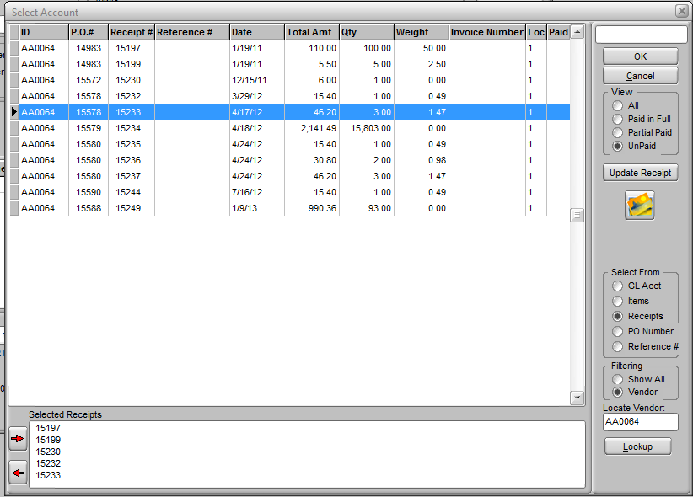

The sub-screen that appears can be used to select GL Accounts, inventory Items, or Receipts (by receipt number, PO number or Reference.)

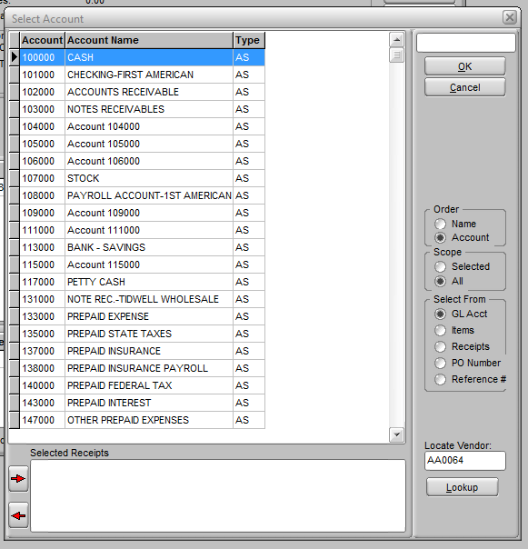

Selecting GL Acct will change the screen to a GL Account pick list. Double click on an account to enter it in the Account field of the distribution grid. If the distribution is to multiple accounts, enter the amount on the grid line and hit enter to create another grid line and continue to select accounts.

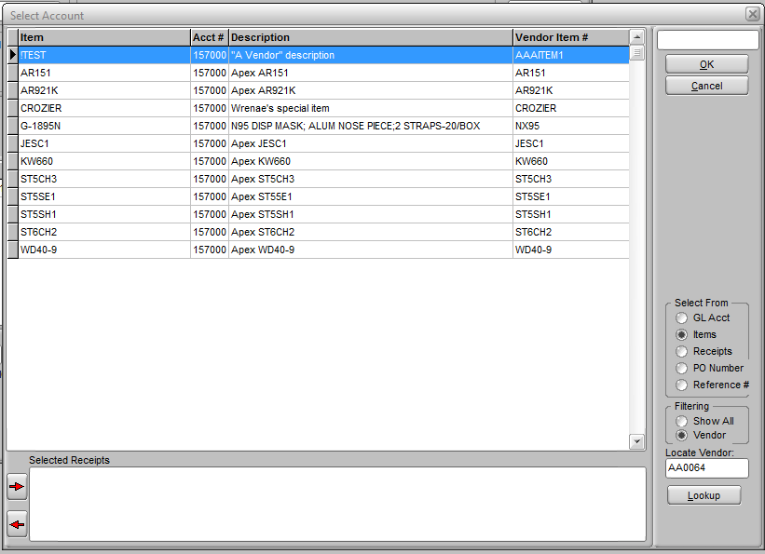

The Items selection will display either just items assigned that vendor as the primary vendor, or all items. This selection might be used if you have special items like promotional signage that has a different GL account distribution than inventory. Selecting an item just selects the GL account as the distribution account.



The view of receipts can be sorted and searched by the receipt number, the PO number, or the reference number. Use the box at the top to search for a specific number. The receipts shown will default to the distribution vendor but you can show all vendor receipts and use the Locate Vendor field to find a specific vendor. You can view all receipts or just those paid in full, partially paid, or unpaid. Usually invoices are reconciled to unpaid (the default) or partially paid receipts, but paid receipts might be listed for reference. Once an invoice reconciled to a receipt has been paid (i.e., a check printed), then the receipt will be flagged as paid.



To select a receipt to reconcile to the invoice, double click it. The receipt number will be added to the Selected Receipts box at the bottom of the screen. Click on additional receipts to add them. If you are paying to a statement and the number of receipts exceed the space in the box, you can use the arrows to the left to scroll through them.



If the invoice amount and the receipt amount do not match because the PO item cost and the invoice item cost do not match, and you do not believe the vendor invoice to be in error, you will probably want to correct the receipt item costs rather than simply post the difference to inventory. This will keep the individually calculated item costs and values accurate. To adjust the costs on a receipt click the Update Receipt button.

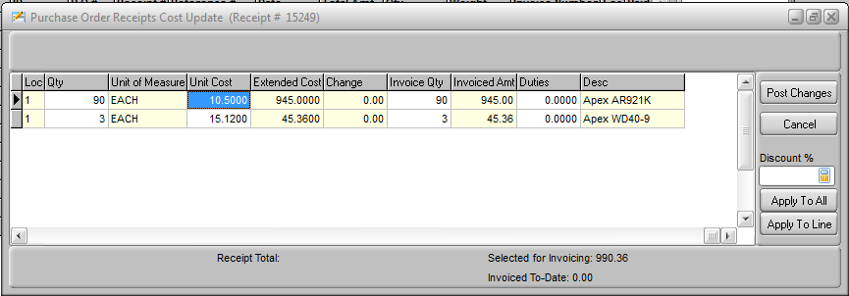

From the update receipt sub-screen you can change the quantity or the cost of an item. You can use the Discount % field to enter a percent (e.g., enter 5 to reduce the cost by 5%, -5 to increase it) to adjust either all items (Apply To All), or just the item selected (Apply To Line). You can click the icon to the right to pop a calculator to help figure the percent.

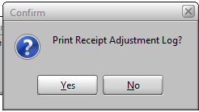

When you’ve completed the adjustment click Post Changes. Then print or view the Receipt Adjustments Log.

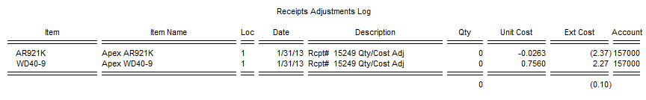

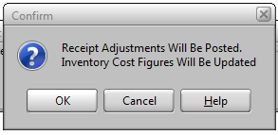

Then confirm the posting by clicking OK. This will create a GL Batch with a posting similar to the posting of a receipt.

Inventory AP Clearing

The posting of a receipt is typically a debit to inventory and credit to AP clearing. The amount of the adjustment would be posted likewise (with a negative debit if the cost was reduced). But if the system sees that the on hand of the item(s) is less than the receipt then it will assume that goods have been sold and post to the COGS instead of inventory.

Or

COGS AP Clearing



Once receipts or GL accounts have been selected for the distribution (and receipt adjustments made if necessary) click OK to return to the distribution grid. Make any further changes to the amounts distributed as needed. When done you can press F8, click the red up arrow button, or just press enter through the grid to a new line and then press enter without entering an Account.

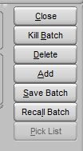

If you have payable entries that involve distributions to multiple accounts that are made regularly, you can save the current batch entry and recall it as a template for future payable entries.

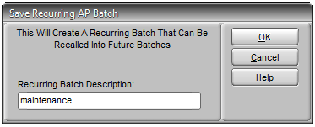

Clicking Save will prompt you to name the batch. All payable entries from the current batch are saved. So if, for example, you setup all of your monthly expense payables at one time you can same all entries and their GL account distributions. Then each month you can create a new batch, click Recall, and select the appropriate saved batch template. This will add all of the payables and distributions to the new batch. Note that you do not have to save/recall batches that you are working on but not ready to post. Simply close the batch and it will be saved.

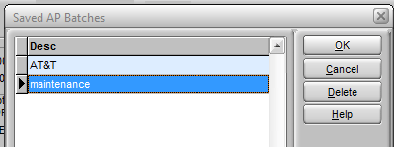

You can close a batch at any time, even if you have not completed your entries. You can print and invoice batch journal even if the batch is not completed but you will not be able to post the invoice batch until the invoice Total equals the invoices entered and the invoices have distribution equal to the invoice Amount.

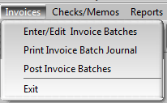

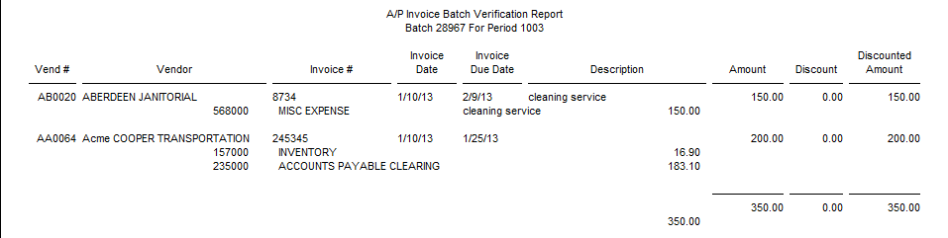

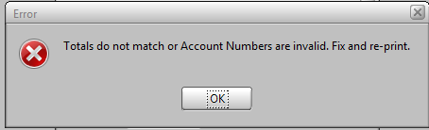

If you receive this error you must balance the batch entry and print/view the journal again. Once the journal prints without the error then you can post the batch. After a batch has posted then the invoice(s) will be available for payment, and you can move on to check preparation and printing



## Default Settings

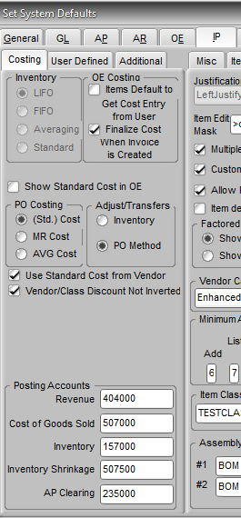 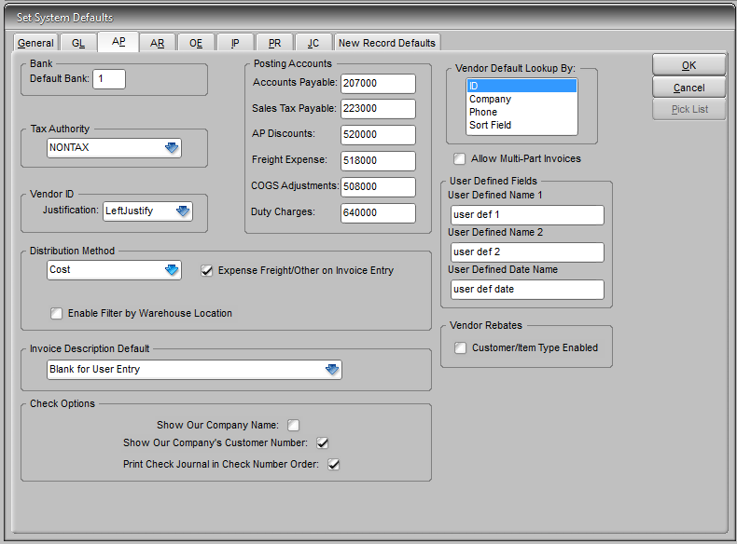

The GL postings made as distributions in AP invoice entry default to accounts entered in System Defaults. The Inventory and AP Clearing accounts are set on the Costing tab of the IP tab. Other accounts related to AP are maintained on the AP tab.



Also on the AP tab, the Distribution Method will determine how freight is distributed to the landed cost of items on a PO receipt when it is reconciled to an invoice and the difference between the invoice and the anticipated cost of the receipt differ. Options are by ratio to total cost, weight, or quantity of the total receipt. This is only done if the Expense Freight/Other on Invoice Entry option is NOT checked here or in invoice entry. The distribution method can also be set at the vendor level, which will override the system defaults setting.

