AP Distribution Wizard

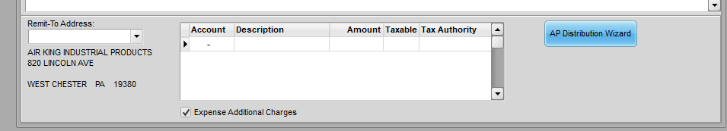
In the Enter/Edit Invoice Batches program in Accounts Payable, the distribution of payables that involve additional charges related to inventory receipts, such as freight or duty charges, can be complex if the payable is not simply expensed (e.g., a FREIGHT IN expense GL account.) Companies with significant additional charges, such as importers, may prefer to add those expenses to the cost of the items so that selling prices are more considerate of the true cost. Complexity is increased if the expense was estimated on receipt, or the invoice and receipt do not reconcile exactly. The AP Distribution feature can make these entries easier, and help to maintain their accuracy. It is not necessary to use this feature for invoices that do not relate to additional charges on receipts or that are simply expensed. Simply complete their entry as described in the AP Invoice Entry documentation.
To use the AP Distribution Wizard click the button with the invoice selected in the grid above, or when the cursor is in the distribution grid to the left. Prior entries in the distribution grid will be overwritten by the Wizard.
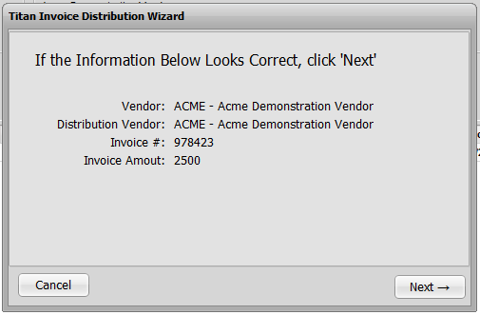
The initial screen in the Wizard will ask to verify that the invoice you wish to distribute is the one highlighted.

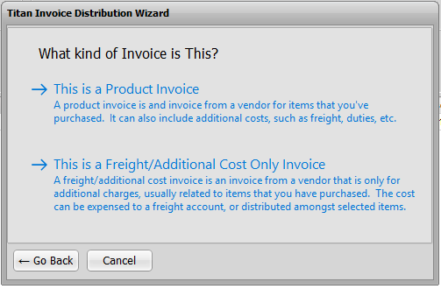
The next screen will ask what kind of invoice is being distributed. Click anywhere in the text of “Product Invoice” If it includes charges for inventory, even if there are other charges to be distributed. Click “Freight/Additional” if there are no charges for inventory on the invoice.
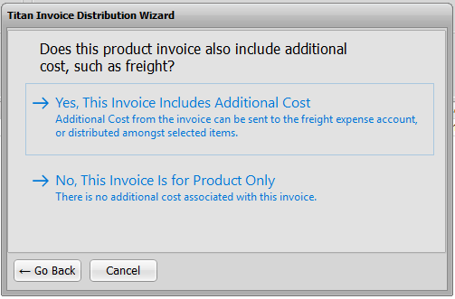
Depending on your response, the Wizard will lead you through a series of questions and entries to configure an appropriate distribution. If you said this was a product invoice, the next screen will ask if the invoice includes additional costs or is for products only.

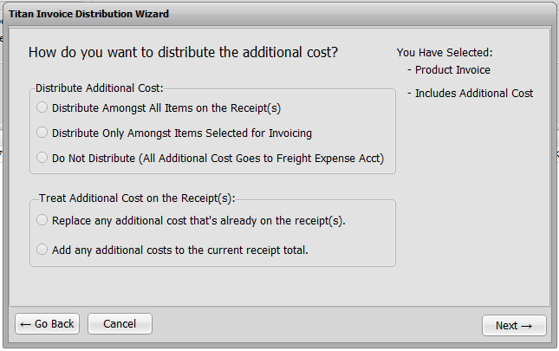
If Yes, the next screen will ask you to select how you want the additional costs handled. You can also indicate how you want to handle the added costs respective to an addition cost you previously entered on the purchase receipt (i.e., replace it or add to it.) If you choose Do Not Distribute then the Added Costs options will be disabled. Otherwise you must choose one even if you did not add costs on the purchase receipt, though in that case your selection will not matter.*

*Some companies use the Additional Cost (Freight) field at the bottom of the Enter/Edit Receipts screen to add freight or other costs to the receipt. They may have a freight bill in hand or charges indicated on the packing slip. Or the may just be estimating what those charges will be and want affect the costs of the items as soon as possible to evaluate margins. The Additional Cost (Freight) field cannot be modified once the receipt is posted.

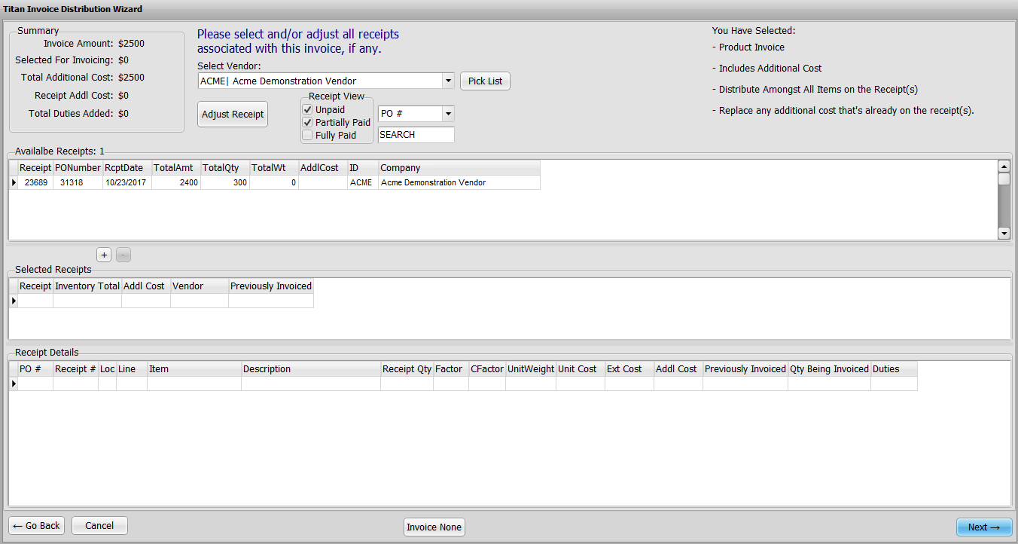
The next screen will list PO receipts to reconcile with the vendor invoice. In the top grid it lists receipts from that vendor. The default is to list receipts that are either unpaid or partially paid. Change the Receipt View to list other receipts.
On this screen and subsequent screens your selections on the earlier screens will be noted in the upper right hand corner. These are determining factors in the distribution and if at any time you realize they are not appropriate then use the Go Back button to return to your selections and correct them.

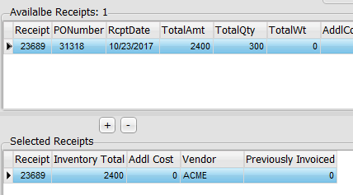
From the available receipts select the receipt(s) associated with this invoice. Double click the receipt or highlight it and click the “+” button to add it to the Selected Receipts. Highlight a selected receipt and click the “-“ button to remove it.

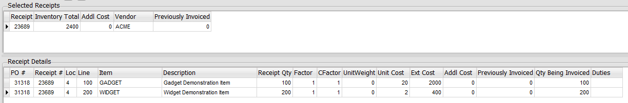
The Receipt Details grid below Selected Receipts will list the items on the selected receipt highlighted. If the quantity invoiced does not match the quantity received, you can change the Qty Being Invoiced field. You can also enter duty charges invoiced for each item.

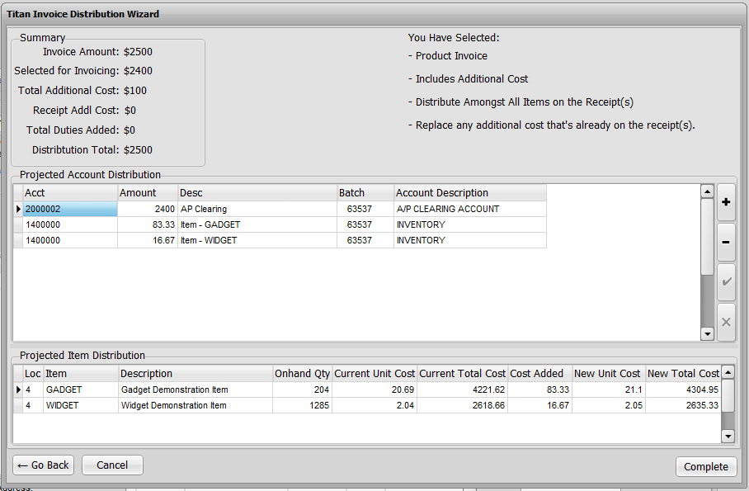
Note the Projected Item Distribution at the bottom of the screen showing inventory valuation.
When the receipts have been selected and adjusted as needed, click Next to display the account distribution that will be made. Accounts and amounts can be edited if desired though it should not be necessary if entries to this point are accurate.

When you click Complete, the primary invoice batch screen will return with the account distribution grid filled based on your Wizard entries.
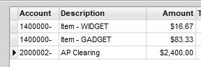

Distribution Examples
The screen shots above illustrate one set of answers to the questions posed by the Wizard. There are eleven possible answer combinations.
- Product invoice> Includes added cost> Distribute to all items/Replace added receipt cost
- Product invoice> Includes added cost> Distribute to all items/Add to receipt cost
- Product invoice> Includes added cost> Distribute to selected items/Replace added receipt cost
- Product invoice> Includes added cost> Distribute to selected items/Add to receipt cost
- Product invoice> Includes added cost> Do not distribute
- Product invoice> Product only
- Freight only invoice> Distribute to all items/Replace added receipt cost
- Freight only invoice> Distribute to all items/Add to receipt cost
- Freight only invoice> Distribute to selected items/Replace added receipt cost
- Freight only invoice> Distribute to selected items/Add to receipt cost
- Freight only invoice> Do not distribute

Each of these combinations will produce a different distribution. For example:

Product invoice> Includes added cost> Distribute to all items/Replace added receipt cost
This combination suggests that you have received a vendor invoice which bills for both the products and freight, or some other added charge. Regardless of the products itemized on the invoice, you want the cost spread over all of the items. If any cost was entered on the receipt earlier (possibly an estimate) it will be ignored. The distribution screen would look something like this:

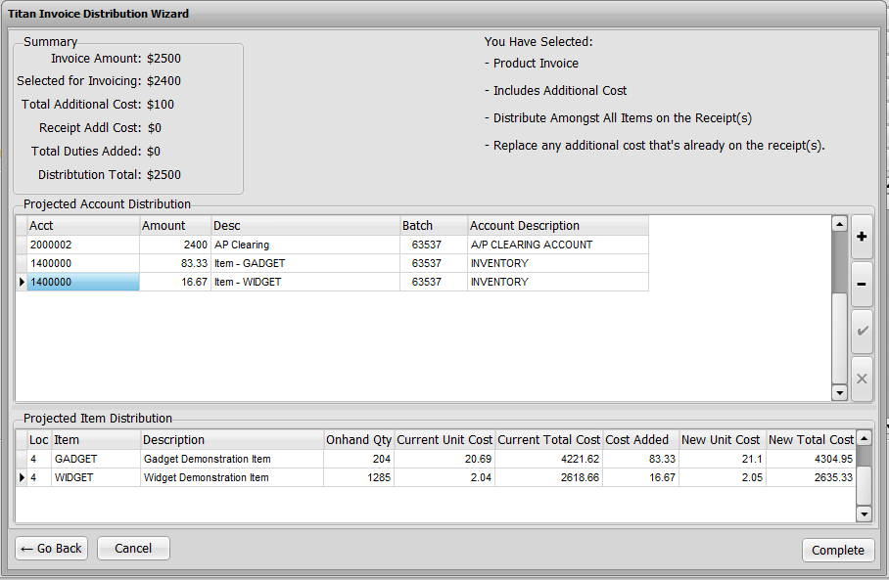
Product invoice> Includes added cost> Distribute to all items/Add to receipt cost
This combination suggests that the additional cost on the invoice does not replace the receipt cost already on the receipt, possibly because the invoice is for different charges (e.g., the invoice is for freight but the receipt cost entered was for anticipated duty charges.) The cost entered on the receipt does not appear in the distribution because it has already been posted to AP clearing and an expense GL account. It will be cleared and posted to AP when its matching invoice is posted.

Product invoice> Includes added cost> Distribute to selected items/Replace added receipt cost
Product invoice> Includes added cost> Distribute to selected items/Add to receipt cost
With this combination you will be able to select the items on the receipt that the added cost should be distributed to. This is not typical since added costs don’t usually apply to one item and not another. One possibility is that a vendor offers free freight on some items but not others.

Product invoice> Includes added cost> Do not distribute
If you expense added charges rather than adding them directly to the cost of inventory then you would use this setting. The amount of the invoice that exceeds the receipt item cost total is posted to the default expense account (e.g., FREIGHT IN.)

Product invoice> Product only
If the invoice is for inventory only, then the Wizard will create a distribution just like the normal distribution in main Enter/Edit Invoice Batch program by using the Pick List when the cursor is in the distribution grid to locate the receipt(s) to be reconciled. Receipts can be adjusted via either function.

Freight only invoice> Distribute to all items/Replace added receipt cost
Freight only invoice> Distribute to all items/Add to receipt cost
Freight only invoice> Distribute to selected items/Replace added receipt cost
Freight only invoice> Distribute to selected items/Add to receipt cost
These invoices do not reconcile the receipt. They only add to the cost of the items on the receipt in inventory. The receipt must be reconciled separately with another invoice. The receipt(s) selected only indicates the items to which the cost should be added.

Freight only invoice> Do not distribute
A freight or other invoice that is to be expensed and not applied to the cost of items can be posted using the main Enter/Edit Invoice Batch program. If the vendor is not already set with a distribution account, you will have to know which account to post the expense to. If the Wizard is used it will automatically distribute to the default freight expense account.

